*H2R Ranking Script*

1. Define the folder where the ranking-related files and output folder are located.
2. Load the aggregated data (e.g., LGA-level).
3. Load the (excel) file with the list of indicators to be ranked.
4. Load the (excel) file defining the KoBo-option names (“old” names) with full definitions (“new” names)

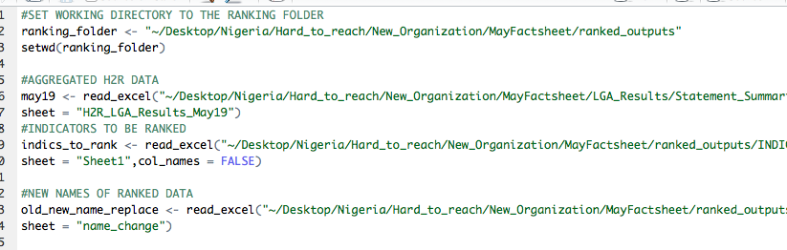

1. Scroll to the bottom and run this function:



The parameters are generically defined before the “rank_indicators” function, but parameters specified above mean the following:

1. “may19” is the aggregated dataset
2. “LGA” is the level of aggregation of the aggregated dataset; in this case, the LGA-level.
3. “percent” indicates that the percentages for each indicator will be exported.
4. “processed_ranked_outputs” is the name of the folder in the working directory where the ranked indicator files will be sent.
5. “indics_to_rank” is the dataframe with the list of indicators to be ranked.
6. “old_new_name_replace” is the dataframe of “old” and “new” names.

**Select-all and run.**