**Folder Structure for Hard-to-REACH**

The folders contain the following:

* **Raw_to_Cleaning_Process**: The script that applies the cleaning log: “H2R_Profiling_one_to_many_Cleaning.R”
  + **Raw_Data:** The ***raw data file***and***cleaning log*** (same or different excel sheets).
  + **HQ_Cleaning**: “H2R_Profiling_HQ_Cleaning.R” and the outputs from the script in the folder:
  + **updated_cleaning_log**: The updated cleaning log output from “H2R_Profiling_one_to_many_Cleaning.R”
  + **updated_data**: The updated/cleaned dataset output from “H2R_Profiling_one_to_many_Cleaning.R”
* **Analysis**: “H2R_all_in_one.R” and the outputs from that script.
  + **Settlements_Merged**: Folder where the settlement-level aggregated data will be stored.
  + **Global_Results**: Folder where the global-level aggregated data will be stored.
  + **LGA_Results**: Folder where the LGA-level aggregated data will be stored.
  + **Ward_Results**: Folder where the Ward-level aggregated data will be stored.
  + **GIS_Settlement_list**: Folder where the GIS data (master list of settlements) is stored.
  + **Indicator_Ranking:** Folder where “H2R_Indicator_Ranking.R” is located along with the necessary “INDICATORS_TO_RANK.xlsx” file.
    - A copy of **the last month’s** LGA-level aggregated results (.csv) should be placed in this folder.
    - **processed_ranked_outputs:** Folder where the rankings for each indicator are stored after processing.

**STEP #1.** Find outliers using “H2R_Profiling_HQ_Cleaning.R”

**FIRST:** Run the entire “FIRST_H2R_PROFILE_FUNCTIONS.R” script to load functions.

**Step 1a.**

1. Ensure the working directory is set to the “Raw_to_Cleaning_Process” folder.
2. Copy the name of the raw data excel file.
   1. NOTE: In this case the “folder” in the cleaning log should be defined as “Raw_Data” (this is where the KoBo output is located).
3. Copy the name of the excel sheet where the raw data is located.
4. Check the parameters of the “hq_cleaning_checks” function.
5. Run the whole script.

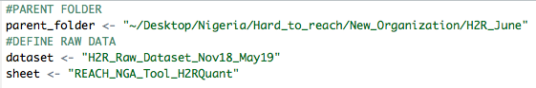

The following error will occur:



However, a .csv file ending in “outlier_id” is produced. Open this file.

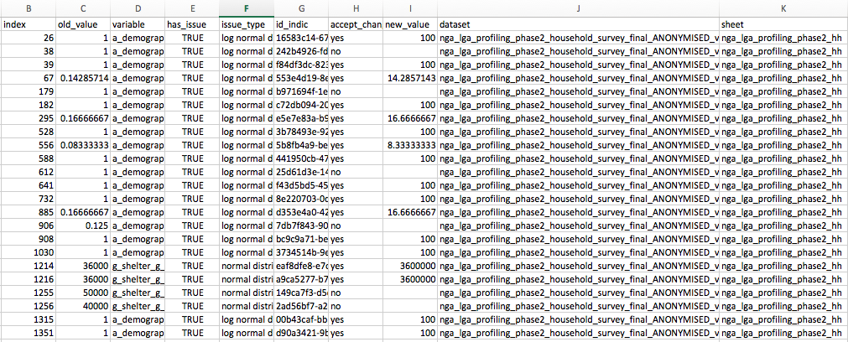

**Step 1b.**

1. Examine the proposed edits and write “yes” or “no” in the “accept_change” column.
2. Then place the corrected value in the “new_value” column.
   1. If the entry (survey) must be removed, write NULL (all caps) in the “new_value” column.
3. Leave the “new_value” cell blank if the change was not accepted.
4. Save this file as an “.xlsx” file using the exact same name in the “HQ_Cleaning” folder.
5. Run the script again.
6. Open the “.csv” file ending in “hq_changes” and copy and paste the contents of that file into the cleaning log.

**Step 2:** Apply the cleaning log to the raw data using “H2R_Profiling_one_to_many_Cleaning.R”

1. NOTE: IN THE RAW DATA, CHANGE “N_info_source” to “N_info_source_main”
   1. This ensures the ranking function works properly.
   2. **Please change the name in the tool to avoid this manual effort.**
2. Set the working directory to the “Raw_to_Cleaning_Process” folder.
3. Copy the name of the cleaning sheet excel (or .csv) file.
4. Copy the name of the excel sheet where the cleaning log is located.
5. Define how the column names are separated—typically usuing “/”.
6. Define an alternative ID column header, other than “uuid” column.
   1. Example: “_index” for KoBo loops edits—This is the default and generally should not be changed.

Run the whole script and find the updated data in the “updated_data” folder and the updated cleaning log in the “updated_cleaning_log” folder.

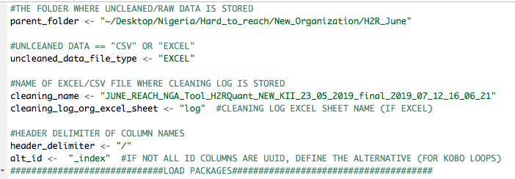

**Step 3.** Settlement-level aggregation using “**Settlements_Merged.R**”

**Step 1.**

1. Set the working directory to the “parent” folder (“H2R_June”).
2. Define the name of the excel file and sheet of the GIS settlement list data.
3. Define the name of the file (excel or .csv) file that contains the cleaned KoBo data.
4. Define a “short name” of for the settlement-level aggregation output file.
   1. Output files have the prefix “consensus” to indicate that this **is a settlement-level file based on the consensus of many KIs.**
5. Define the year of the dataset (2019= “19”); write “ALL” if data combining multiple months.
6. Define the month of the dataset (June = “06”); write “ALL” if data combining multiple months.
7. Define the threshold (percentage) of settlements per-ward to qualify for “enough” to be flagged in the settlement-level aggregation (5% threshold = 0.05).

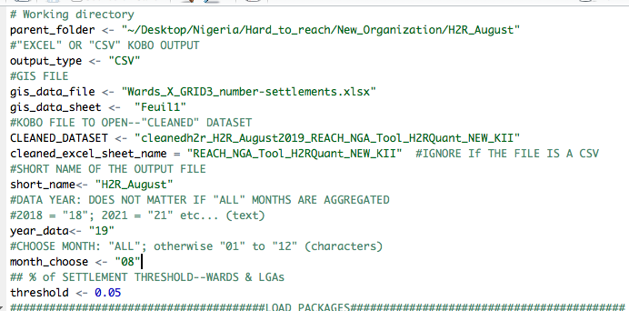

**Step 4.** Ward & LGA-level aggregation using “**Ward_LGA_Results.R**”

**Step 1.**

1. Set the working directory to the “parent” folder (“H2R_August”).
2. Define the name of the aggregated settlement-level data.
3. Define the name of the excel file and sheet of the GIS settlement list data.
4. Define the threshold (percentage) of settlements per-ward and per-LGA to qualify for “enough” to be retained in the aggregated output (5% threshold = 0.05).
5. Define the month of the dataset (June = “06”); write “ALL” if data combining multiple months.

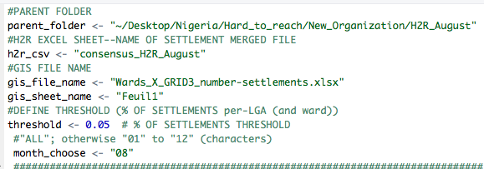

**Step 5.** Global-level aggregation using “**Global_Results.R**”

**Step 1.**

1. Set the working directory to the “parent” folder (“H2R_June”).
2. Define the name of the aggregated settlement-level data.
3. Define the timeframe of the data (month or window [multiple months]).

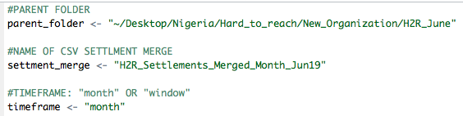

**Step 6.** Rank multiple option indicators, add GIS map links, add the complete list of indicators, and calculate month-over-month raw differences (month-last_month) using “**Indicator_Ranking.R**”

1. Define the parent folder of the H2R edition.
2. Define the name of .csv file with the aggregated (LGA or Ward-level) data.
3. Define the column name with the geographic aggregation units.
4. Define whether to report counts or percentages.
5. Define the name of last month’s LGA/Ward results file, which should be copied in the current month’s “Indicator_Ranking” folder.
6. Define the name of the GIS settlement-level excel file and sheet (should not change).

**The remaining parameters of the function will be defined *as long as the folder structure is exactly followed.***

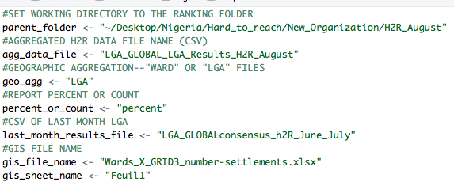

**Select-all and run.**

***Output****: AN UPDATED AGGREGATED DATASET WITH RANKED VARIABLES WILL BE FOUND IN THE FOLDER WHERE THE AGGREGATED DATASET IS FOUND (i.e., “LGA_Result if “geo_agg” = “LGA”)*

***NOTE****: Indicator names must not be sub-strings other indicators in the list to be ranked. For example, if “N_info_source” and “N_info_source_who” are included in the list, then “N_info_source” will not rank correctly because it includes the “N_info_source_who” values as well because ““N_info_source_who” contains the string “N_info_source.” In short, the script will not be able to identify the difference between “N_info_source” and “N_info_source_who.”*

*Avoid these indicators (if possible) or create a distinct column header for troublesome indicators; for example, “N_info_source” becomes “N_info_source_main.”*

**INDICATORS_TO_RANK.xlsx**

The Excel file must be located inside the “Indicator_Ranking” folder. It should be structured as follows:

* One sheet must be named “name_change” and contain two columns, one titled “old_names” and the other named “new_names.”
  + “old_names” is the way that the indicator & answer option column header combination is delivered in the aggregated LGA/Ward-level data.
  + “new_names” is the meaning of the answer option in a format readable for deliverables (i.e., data-merge).

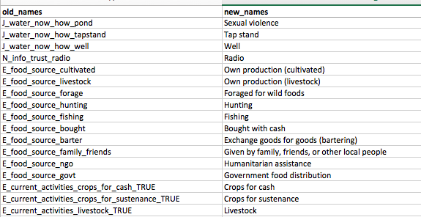

**NOTE**: “old_names” must match the answer options as displayed in the aggregated data file, including suffixes such as “_TRUE”—so that it removes the suffix.

* One sheet must be named “list_to_rank” and contain one column with no column header.
  + The content is simply a list of the indicators that must be ranked, as they are found in the aggregated dataset.
  + **NOTE**: This is the indicator and NOT the answer option. For example, the column “E_current_activities_fishing_TRUE” indicates that fishing is a current livelihood activity. However, we need all the current activity options, so we simply add “E_current_activities” to the list to select all the answer options.

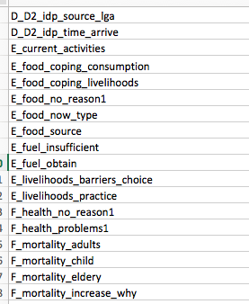

* One sheet must be named “complete_response_list” and contain one columns with no column header.
  + The first and only column contains all the KoBo-output styled names **for every possible relevant answer option** (except “no_response” and “dont_know).
  + To add to this list, simply write the missing KoBo-output styled name in list. I recommend to insert the option near the indicators other options in the list for organizational simplicity.