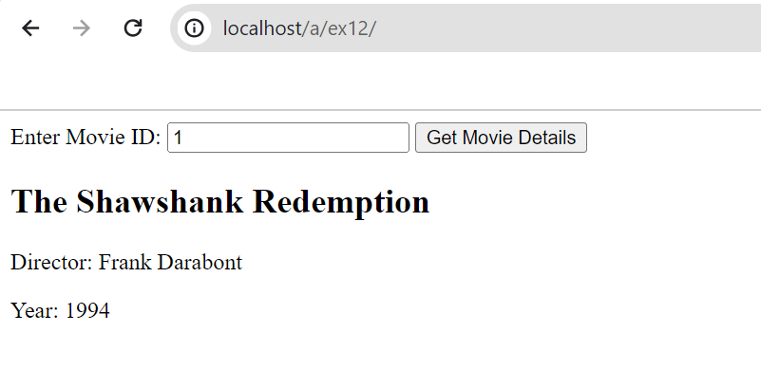EX:12 XML/AJAX

DATE:24.04.2024