1.Write a JavaScript program to create a Clock. Note: The output will come every  
second. [use Objects]  
Expected Console Output :  
"14:37:42"  
"14:37:43"  
"14:37:44"  
"14:37:45"  
"14:37:46"  
"14:37:47"

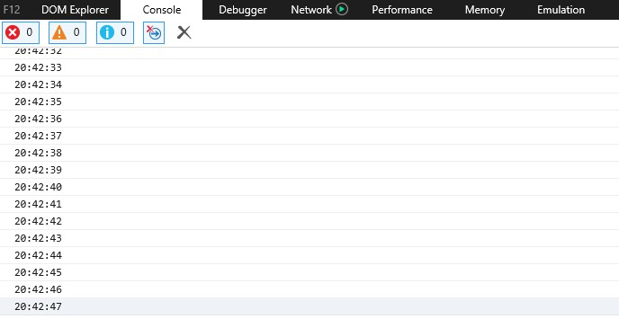

2.Write a JavaScript program which accepts a string as input and swap the case of each  
character. For example if you input 'The Quick Brown Fox' the output should be 'tHE  
qUICK bROWN fOX

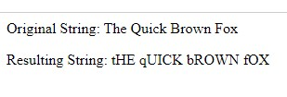

3.Write a JavaScript Program to get the current data.  
Expected Output  
mm-dd-yyyy, mm/dd/yyyy or dd-mm-yyyy, dd/mm/yyyy

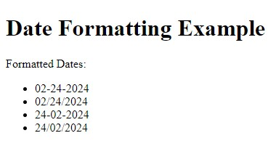

4.Write a Java Script program to compare two objects to determine if the first one  
contains the same properties if the first one contains the same properties as the second  
one

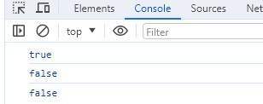

5.Write a JavaScript function that accepts a string as a parameter and counts the number  
of vowels within the string

