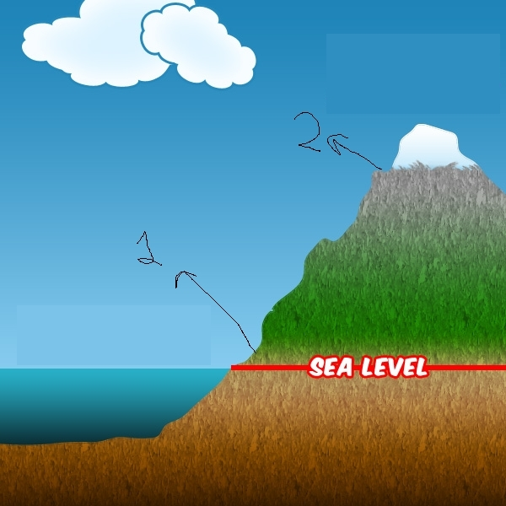

The Researcher seeks to measure oxygen percentage changes in the troposphere at different altitude levels. In the Image above, it can be seen, there are two areas selected by the researchers: Area 1 and Area 2. The researchers like to measure one point and guess the other one. They find Area 1’s oxygen perchantage as 20.9%. What they would find, if they were to measure Area 2’s oxygen percentage? (ε: epsilon)

**A)** 20.9%+- **ε**

**B)** 25.9%+- **ε**

**C)** 15.9%+- **ε**

**D)** 30.9%+- **ε**

Correct Answer:

A) **20.9%+-** **ε**