Makefile Commands:

clean: cleans build directory
cleandoc: deletes javadoc directory (if exist)
compile: compiles java source files in src directory, output files take place in a directory called build in project root.
doc: creates javadoc directory in docs directory
run: run java files that compiled during “compile” command

JavaDoc:

implementation detail specified in javadoc please look javadoc for further detail info
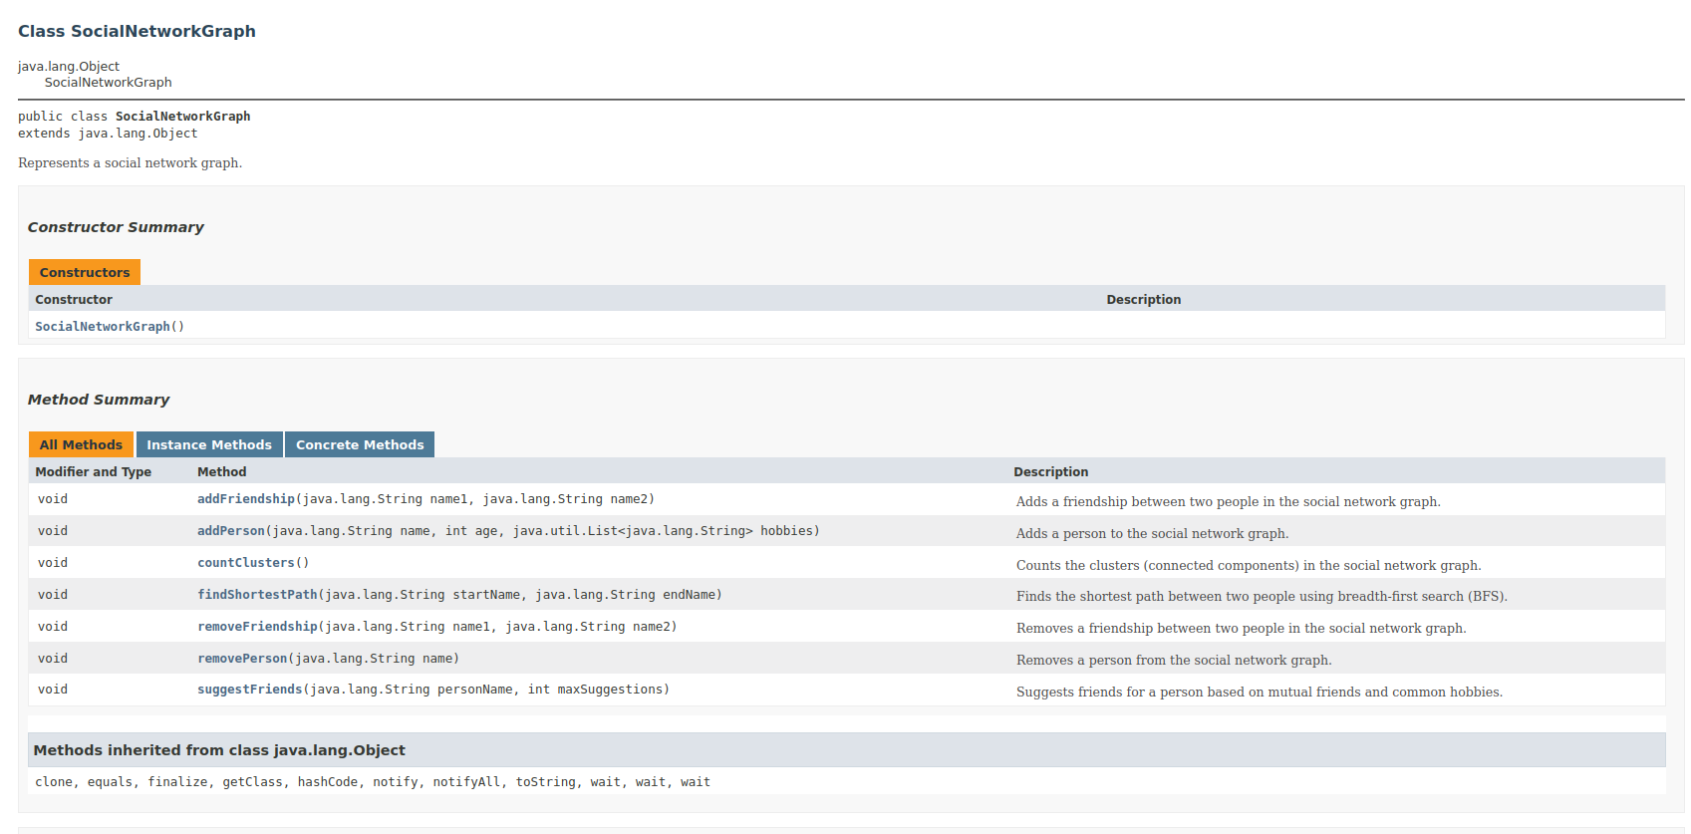
(sample screenshoot of javadoc)
Git Commits:
(git commits during studiying on the projects)
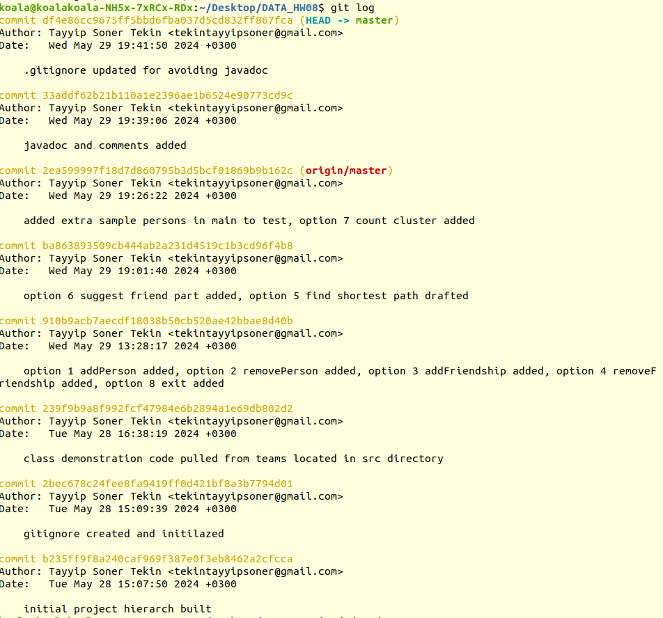

Output:

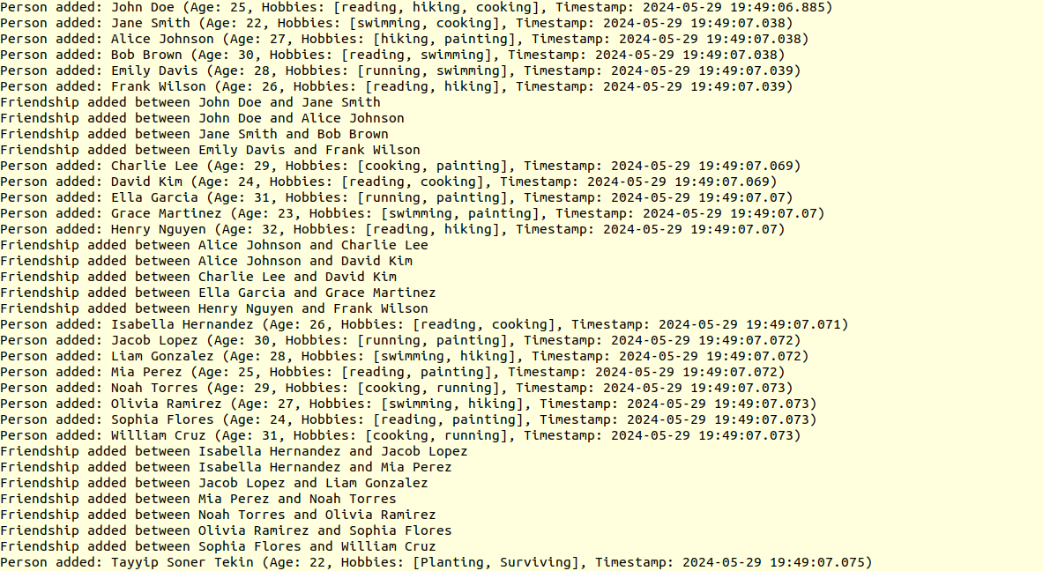
(initial added persons)

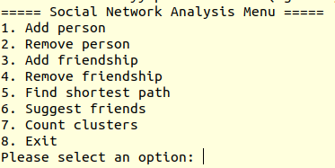

(menu)

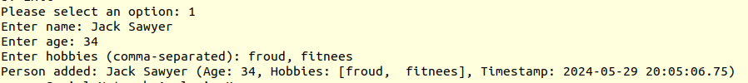
(option 1 add person output)

(option 2 remove person output)

(option 3 add friendship output)

(option 4 remove friendship output)

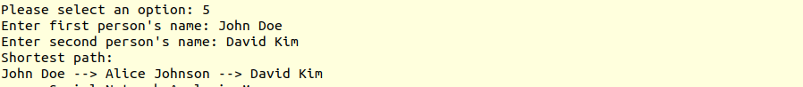
(option 5 the shortest path output (if there is a mutual connecttion otherwise it prints empty))

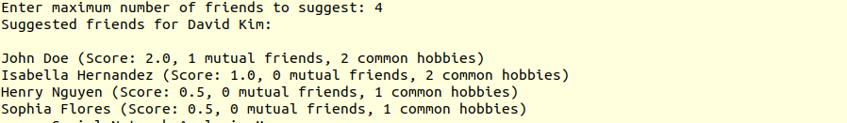
(option 6 suggest friend output )
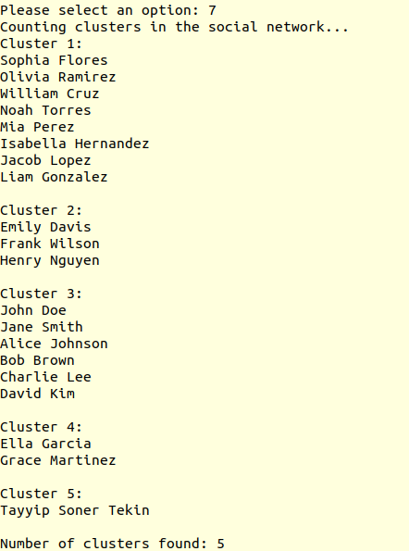

(option 7 count cluster output )

(option 8 exit output )

Side Effects:

-During counting cluster if a person no connection it still counts as cluster own by own

-During passing names to operations, if names not valid, it gives error message and continue for further operations

-Timestamp has pretty much no use, to make timestamp look like it in pdf f homework type of it changed (from Date to Timestamp)

