Done by: Muhammad Ismail Soboute
Supervisor: Mrs Elham Sheikhian
School subject: Project
Institute: Payam Noor University, Damavand Branch
Completion date: 30 June 2017

Solutions to 5 of the problems at the end of chapter 11 of the book Digital Image Processing, Second Edition, by Rafael C. Gonzalez and Richard E. Woods. The accompanying source code uses libncurses to display a text mode menu through which the user can select the solution to which problem to view. The complete source code for the program can be downloaded from the repository at https://github.com/misoboute/dip-repr-desc.
Here is a snapshot of the initial screen of the program offering the 5 problems:
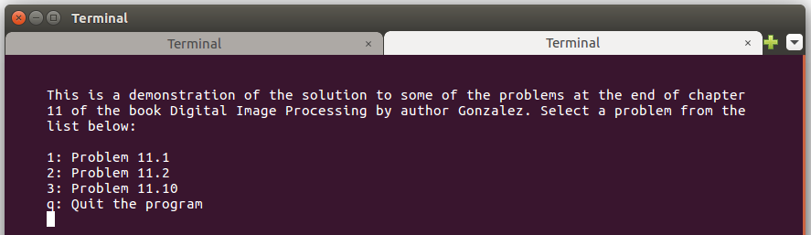

Excerpts of the the original book showing each individual problem along with an explanatory solution to each will follow:

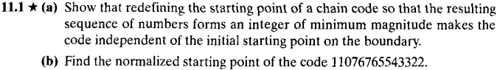
Solution:
a) The key to this problem is to recognize that the value of every element in a chain code is relative to the value of its predecessor. The code for a boundary that is traced in a consistent manner (e.g., clockwise) is a unique circular set of numbers. Starting at different locations in this set does not change the structure of the circular sequence. Selecting the smallest integer as the starting point simply identifies the same point in the sequence. Even if the starting point is not unique, this method would still give a unique sequence. For example, the sequence 101010 has three possible starting points, but they all yield the same smallest integer 010101.
b) The normalized chain point was computed by the accompanying computed program. Here is a snapshot of the program giving the solution 07676554332211
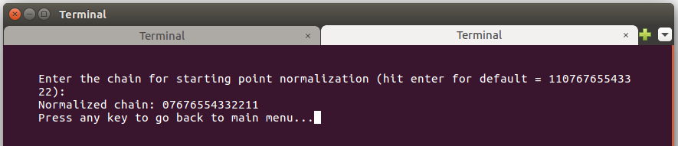

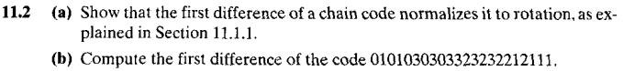
Solution:
a) The first difference only counts the number of directions that separate adjacent elements of the code. Since the counting process is independent of direction, the first is independent of boundary rotation.
b) The first difference code for the 4-coded chain 0101030303323232212111 was computed by the accompanying computed program as 3131331313031313031300. Here is a snapshot of the program showing the answer.
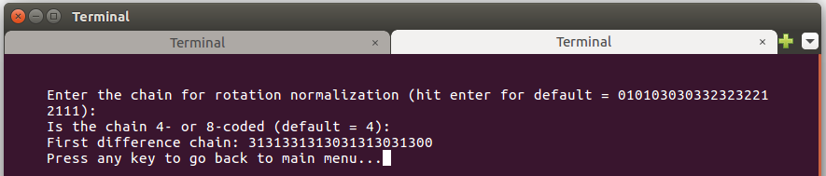

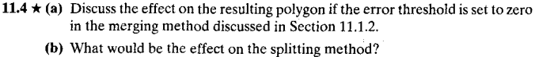
Solution:
a) The resulting polygon would contain all the boundary pixels.
b) Actually, in both cases the resulting polygon would contain all the boundary pixels.

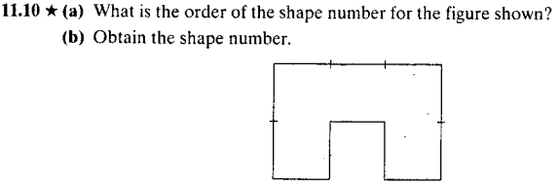
Solution:
a) The number of symbols in the first difference is equal to the number of segment primitives in the boundary, so the shape order is 12.
b) Starting at the top left corner, the chain turns out to be 000332123211. Feeding this to the accompanying program, the first difference and the shape number are calculated as 300303311330 and 003033113303. Here is a snapshot of the program showing the answer.
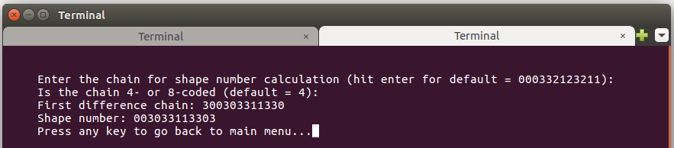

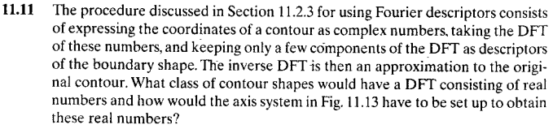
Solution:
With reference to the discussion in Section 4.6.1, the DFT can be real only if the data sequence is conjugate symmetric. Only contours that are symmetric with respect to the origin have this property. The axis system of Fig. 11.13 would have to be set up so that this condition is satisfied for symmetric figures. This can be accomplished by placing the origin at the center of gravity of the contour.

Done by: Muhammad Ismail Soboute
Supervisor: Mrs Elham Sheikhian
School subject: Project
Institute: Payam Noor University, Damavand Branch
Completion date: 30 June 2017

