Part 2: Python Data Pipeline and Traffic Application
Smart City Traffic Intelligence Capstone
Misato Niwa

Purpose and workflow
Part 2 converts the Metro Interstate Traffic Volume data into a reproducible Python workflow. The raw CSV is cleaned and validated, transformed into a model-ready feature dataset, used to generate three visual summaries and explored through a menu-based command-line application. Each major stage, warning, output path and application command is recorded in pipeline.log. The findings reinforce the Part 1 conclusion that time of day is a particularly important operational signal, while weather comparisons require careful interpretation. Part 2 demonstrates these patterns programmatically using a cleaned, feature-engineered dataset and a reproducible workflow.

Stage | Method | Output
Cleaning | Schema and date checks; text standardisation; 17 exact duplicates removed; 10 zero-K temperature values and one extreme rainfall value replaced using monthly medians. | traffic_cleaned.csv: 48,187 rows and 9 columns
Features | Hour, day of week, month, cyclical time terms, weekend/holiday/weather/peak indicators, quartile congestion groups, scaling and one-hot encoding. | traffic_features.csv: 48,187 rows and 34 columns
Application | Four analytical queries with input validation, clear ERROR messages and logging. | Date lookup, busiest periods, day-type comparison and quieter-hour recommendations

Finding 1: travel demand is strongly time-dependent
Weekday traffic is bimodal, peaking at about 6,030 vehicles near 07:00 and 6,190 near 16:00. Weekend demand rises more gradually and forms a broad plateau of roughly 4,350 vehicles from midday to late afternoon. For the mobility team, signal timing and incident-response staffing should therefore target distinct weekday commuter peaks, while weekend planning should cover a longer and flatter demand window.
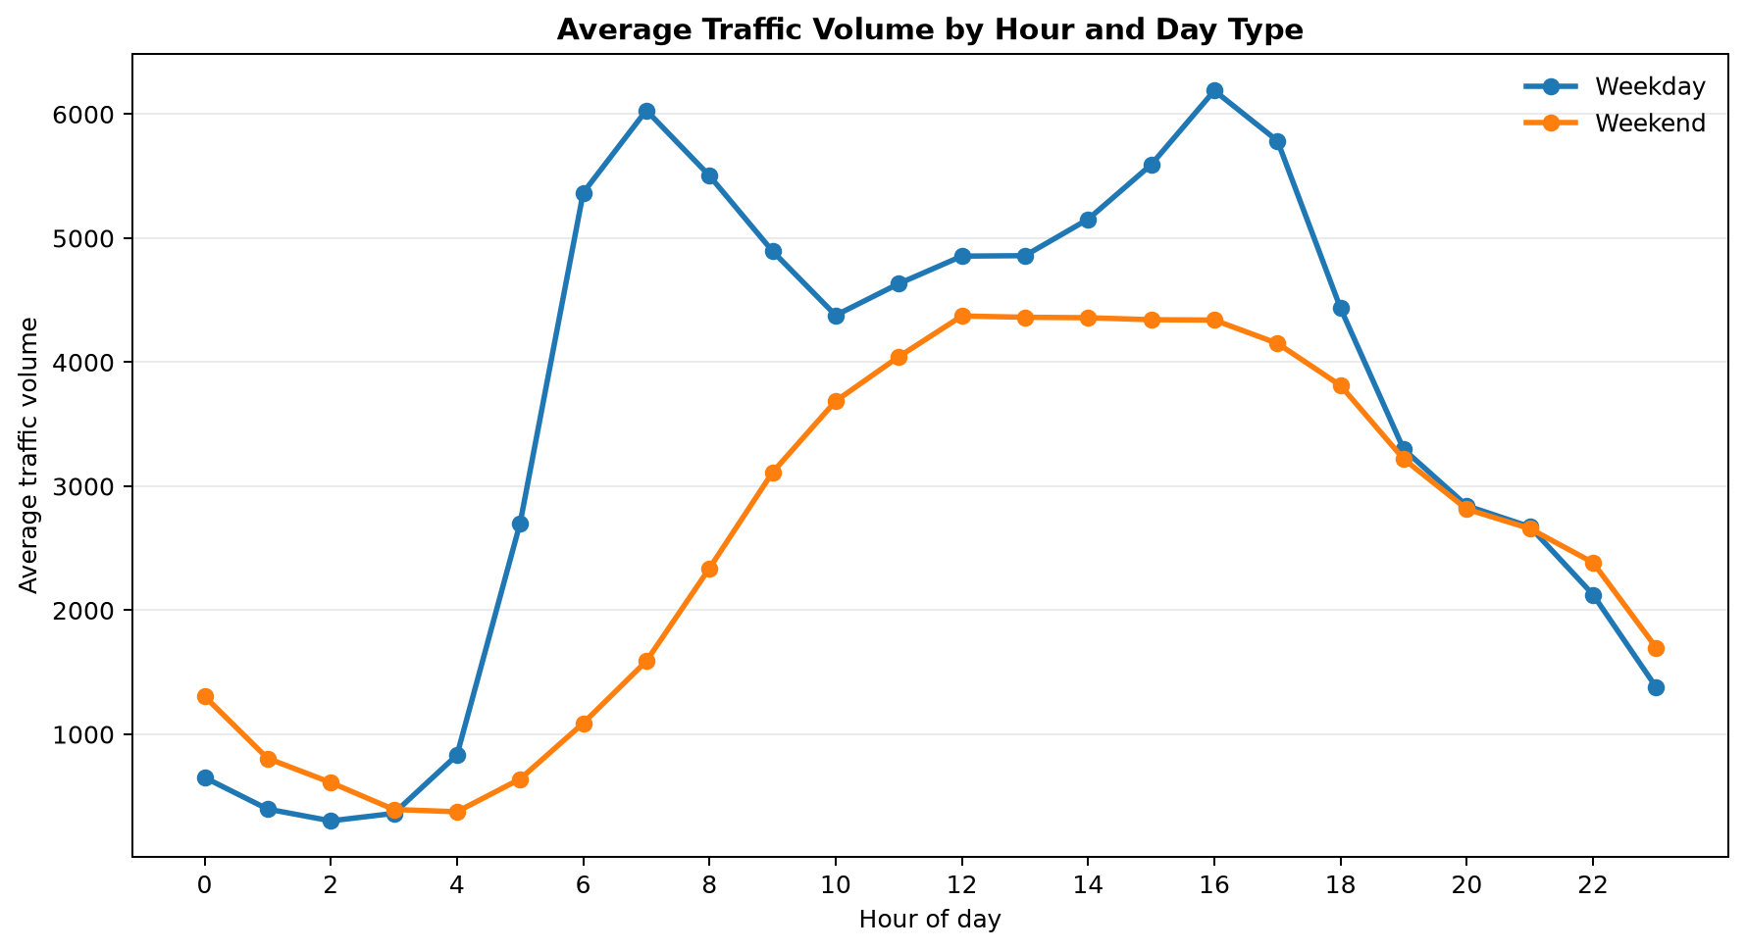
Figure 1. Average traffic volume by hour and day type.

Finding 2: traffic volume has two main operating states
The distribution is bimodal, with a large group of low overnight readings and a second concentration around daytime traffic levels. The mean is 3,260 and the median is 3,379 vehicles, with only slight negative skew. A single overall average therefore hides the corridor's recurring low-demand and high-demand states.
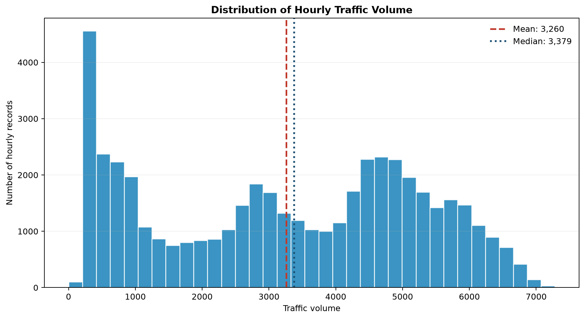
Figure 2. Distribution of hourly traffic volume, with mean and median.

Finding 3: weather comparisons require context
Clouds has the highest average traffic volume at approximately 3,618, while Squall has the lowest at approximately 2,062, a difference of about 1,556 vehicles. However, Squall is represented by only four records. Weather should not be treated as a sole predictor because sample size, time of day and travel behaviour may confound the comparison.
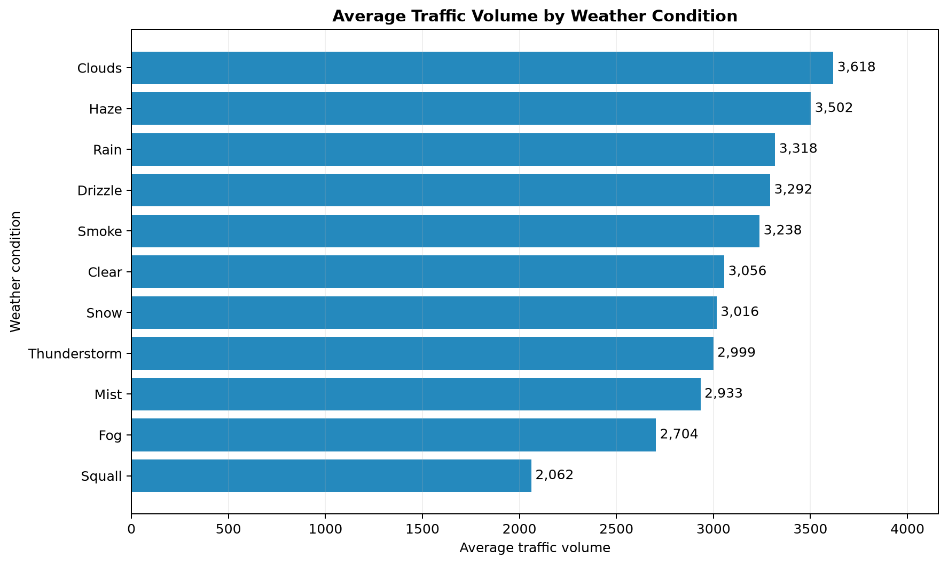
Figure 3. Average traffic volume by recorded weather condition.

Conclusion and practical implications
The strongest operational signal is the repeated difference between weekday commuting peaks, weekend patterns and overnight demand. Traffic-management resources should be scheduled around these time-based patterns, while weather-based actions should account for category frequency and other contextual factors. The command-line application makes the processed results accessible through date lookup, peak-period review, weekday/weekend comparison and lower-traffic travel-hour recommendations. Its outputs are historical rather than real-time, so they support planning but do not replace live incident and network monitoring.

