Smart City Traffic Intelligence
Part 1 Data Analytics Insights Report
Misato Niwa

Purpose and approach
This analysis transforms 48,204 traffic and weather records from the westbound I-94 corridor near Minneapolis-St Paul into evidence for traffic planning. SQLite was used for annual and holiday analysis, Python was used for statistics and probability, and Power BI was used to create an interactive dashboard for non-technical stakeholders. The central finding is that time of day is a much clearer operational signal than temperature alone.

Data quality and preparation
The raw file contains 48,204 rows and 9 columns. Seventeen exact duplicate rows were identified. The holiday column has 48,143 blanks because ordinary dates are not holidays; no other column has missing values. Numeric and date-time types were checked in Power Query, Hour was extracted, temperature was converted to Celsius, and traffic was categorised as Low below 4,500, Medium from 4,500 to 5,500, and High above 5,500. Ten impossible 0 Kelvin readings and one rainfall value of 9,831.3 mm were flagged. The 0 Kelvin readings were excluded from the temperature scatter plot.

Annual SQL analysis
Year | Recorded rows | Total traffic | Change | Change percent
2012 | 2,559 | 8,208,767 | Not applicable | Not applicable
2013 | 8,573 | 28,177,412 | +19,968,645 | +243.26%
2014 | 4,839 | 15,731,289 | -12,446,123 | -44.17%
2015 | 4,373 | 14,181,206 | -1,550,083 | -9.85%
2016 | 9,306 | 29,494,821 | +15,313,615 | +107.99%
2017 | 10,605 | 35,428,156 | +5,933,335 | +20.12%
Two findings stand out. First, 2017 recorded the highest total traffic volume and the highest average hourly volume. Among the two complete consecutive years, total recorded traffic increased by 20.12% from 2016 to 2017, while average hourly traffic rose from approximately 3,169 to 3,341 vehicles. Second, several of the larger year-to-year changes reflect unequal data coverage rather than genuine changes in traffic demand. The 2012 data begins in October, the 2014 data ends in August and the 2015 data begins in June, while 2013, 2016 and 2017 cover complete calendar years. Changes involving the partial years should therefore be interpreted cautiously.

Holiday temperature comparison
Holiday | 2015 temperature and traffic | 2016 temperature and traffic | 2017 temperature and traffic
New Year's Day | No labelled record | -7.21°C and 1,513 | -2.53°C and 798
Labor Day | 21.87°C and 973 | 20.02°C and 1,064 | 22.39°C and 1,026
New Year's Day was 4.68°C warmer in 2017 than 2016 while traffic fell by 715 vehicles. Labor Day temperatures varied by only 2.37°C and traffic stayed near 1,000. Each available holiday-year cell contains one labelled observation, and 2015 New Year's Day is absent, so weather relevance cannot be inferred reliably from these isolated records.

Descriptive statistics and correlation
Mean | Median | Standard deviation | Variance | Range | Correlation
3,259.82 | 3,380 | 1,986.86 | 3,947,615.32 | 7,280 | r = 0.130
The median traffic volume of 3,380 is slightly higher than the mean of 3,259.82, suggesting that some periods of very low traffic pull the mean downwards. The standard deviation of 1,986.86, variance of 3,947,615.32 and range of 7,280 demonstrate substantial variation in traffic volume across different hours. The correlation coefficient between temperature and traffic volume is positive but weak at r = 0.130. This means that traffic volume tends to increase slightly as temperature rises, but the relationship is small and temperature alone explains little of the variation in traffic. Correlation does not establish causation because other factors, including hour of the day, commuting patterns, season, holidays and weather conditions, may influence both temperature and traffic volume. The result should therefore be interpreted as an association rather than evidence that higher temperatures cause higher traffic.

Probability and congestion
Probability measure | Result
P congestion above 5,500 vehicles | 14.73%
P clear weather | 27.78%
P congestion and clear weather | 3.66%
P clear weather given congestion | 24.83%
P temperature above 292 K given congestion | 26.30%
Independence product P congestion x P clear | 4.09%
Odds ratio for clear versus cloudy weather | 0.735
Congestion occurred in 14.73% of all records. Clear weather occurred in 27.78% of all records but in only 24.83% of congested records, suggesting that clear weather was slightly less common during congestion. If clear weather and congestion were independent, their expected joint probability would be 4.09%, compared with the observed joint probability of 3.66%. The values are not equal, so the events should not be treated as strictly independent in this dataset. The odds ratio of 0.735 means that the observed odds of congestion under clear weather were approximately 26.5% lower than under cloudy weather. However, these differences do not demonstrate that cloudy weather causes congestion because traffic volume is also strongly affected by hour, weekday, season and commuting behaviour. Overall, weather appears to have some association with congestion, but it is unlikely to be a strong predictor when considered alone.

Dashboard findings
The dashboard shows 40,575 distinct timestamps, an average traffic volume of 3,260 vehicles and an average temperature of 8.1°C. Traffic is lowest overnight, rises sharply from the early morning and reaches its strongest afternoon peak around 16:00 to 17:00 in 2017. This supports time-targeted congestion management and traveller messaging. Hour-range, weather-condition and traffic-category slicers allow users to filter the relevant page visuals interactively.

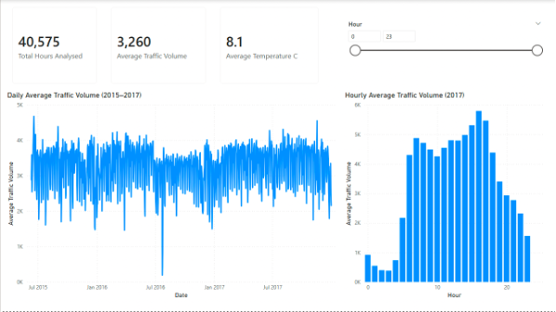  Figure 1 Traffic overview | 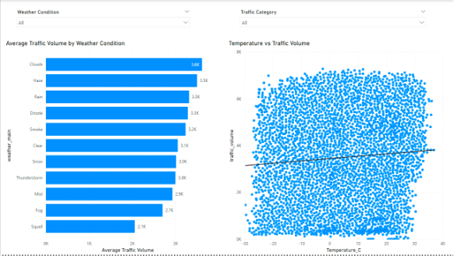  Figure 2 Weather analysis

Weather findings and mobility implications
Clouds produced the highest average traffic volume at 3,618 vehicles, while Squall produced the lowest at 2,062 vehicles, a difference of approximately 1,557. However, the Squall category contains only four records, so its average should be interpreted cautiously. The temperature scatter plot and fitted trend line show only a weak positive relationship. Among congested records, 90% of valid temperatures fall approximately between -11.66°C and 27.71°C, which is too broad to support a narrow high-traffic temperature band. Ten records contained an impossible temperature of 0 Kelvin and were excluded from this visual. Temperature should therefore not be used as a stand-alone predictor of traffic volume.

These findings suggest that the smart-city mobility team should prioritise time-based traffic management because hour of the day provides a clearer operational signal than temperature alone. Monitoring and traveller-information systems should focus particularly on the afternoon peak around 16:00 to 17:00, when average traffic is highest. The city could use historical hourly patterns to schedule congestion alerts, adjust operational monitoring and advise travellers about lower-traffic travel periods. Weather information should remain a supporting input, especially when combined with hour, weekday, holiday and seasonal variables, but it should not independently determine traffic-management decisions. The weak temperature correlation and probability results indicate that weather alone cannot reliably predict congestion. Data-quality checks should also flag impossible temperatures, extreme rainfall and incomplete time coverage before information is used for planning or future predictive models.

