- A sinusoidal signal 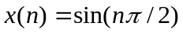is applied to a second-order linear predictor（FIR filter） as in Fig.1 . Calculate the theoretical ACF(Auto-Correlation Function) of the signal and the prediction coefficients (FIR filter coefficients). Verify that the zeros of the FIR prediction filter are on the unit circle at the right frequency.
Using the LMS algorithm with 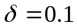, show the evolution of the coefficients from time 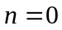 to 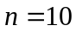. How is that evolution modified if the sign algorithm is used instead.

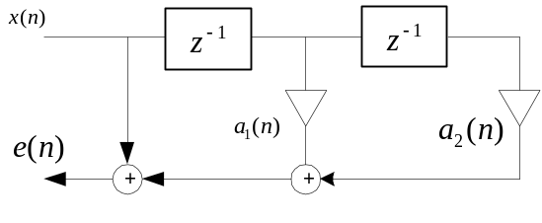
Fig.1. Second-order prediction filter

- A second-order LMS adaptive FIR filter has the input as and
as reference signal. Calculate the coefficients, starting from zero initial values, from time n=0 to n = 10 . Calculate the theoretical residual error and the time constant and compare with the experimental results.(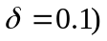

- Adaptive line enhancer. Consider an adaptive third-order FIR predictor. The input signal is
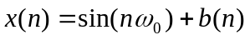
where 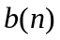 is a white noise with power 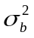.Calculate the optimal coefficients 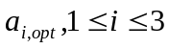. Give the noise power in the sequence
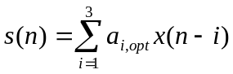
as well as the signal power. Calculate the SNR enhancement.

