Computer Experiments:

1. Consider an AR process x(n) defined by the difference equation
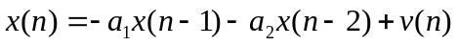
where v(n) is an additive white noise of zero mean and variance 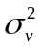.The AR parameters 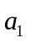and 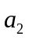 are both real valued:
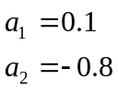
- Calculate the noise variance such that the AR process x(n) has unit variance .Hence , generate different realization of the process x (n).
- Given the input x (n), an LMS filter of length M = 2 is used to estimate the unknown AR parameters and . The step size is assigned the value 0.05. Compute and plot the ensemble average curve of and by averaging the value of parameters and over an ensemble of 100 different realization of the filter. Calculate the time constant according to the experiment results and compare with the corresponded theoretical value.
- For one realization of the LMS filter, compute the prediction error
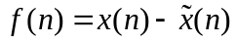
And the two tap-weight errors
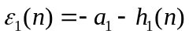
and
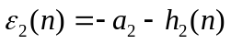
Using power spectral plots of 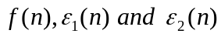, show that f(n) behaves as white noise, whereas 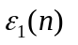and 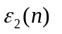behave as low-pass process. Explain the reason for this phenomenon.
- Compute the ensemble average learning curve of the LMS filter by averaging the square value of the prediction error f(n) over an ensemble of 100 different realization of the filter. Calculate the time constant and residual power according to the experiment results and compare with the corresponded theoretical values.

2. 设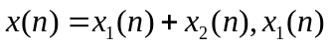是窄带信号，定义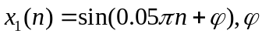是在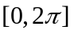区间上均匀分布的随机相位。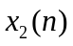是寬带信号，它是一个零均值、方差为1的白噪音信号e(n)激励一个线性滤波器而产生，其差分方程为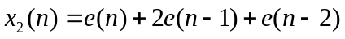。
  - 计算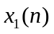和各自的自相关函数，并画出其函数图形。根据此选择合适的延时，以实现谱线增强。
  - 产生一个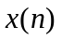序列。选择合适的值。让通过谱线增强器。画出输出信号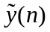和误差信号e(n)的波形，并分别与和比较。

