$ python 01_nl.py

---PART 1---

['country', 'beer_servings', 'spirit_servings', 'wine_servings', 'total_litres_of_pure_alcohol', 'continent']

---PART 2---

beers == [0, 89, 25, 245, 217, 102, 193, 21, 261, 279, 21, 122, 42, 0, 143, 142, 295, 263, 34, 23, 167, 76, 173, 245, 31, 231, 25, 88, 37, 144, 57, 147, 240, 17, 15, 130, 79, 159, 1, 76, 0, 149, 230, 93, 192, 361, 0, 32, 224, 15, 52, 193, 162, 6, 52, 92, 18, 224, 20, 77, 263, 127, 347, 8, 52, 346, 31, 133, 199, 53, 9, 28, 93, 1, 69, 234, 233, 9, 5, 0, 9, 313, 63, 85, 82, 77, 6, 124, 58, 21, 0, 31, 62, 281, 20, 82, 19, 0, 343, 236, 26, 8, 13, 0, 5, 149, 0, 0, 98, 238, 62, 0, 77, 31, 12, 47, 5, 376, 49, 5, 251, 203, 78, 3, 42, 188, 169, 22, 0, 306, 285, 44, 213, 163, 71, 343, 194, 1, 140, 109, 297, 247, 43, 194, 171, 120, 105, 0, 56, 0, 9, 283, 157, 25, 60, 196, 270, 56, 0, 225, 284, 16, 8, 128, 90, 152, 185, 5, 2, 99, 106, 1, 36, 36, 197, 51, 51, 19, 6, 45, 206, 16, 219, 36, 249, 115, 25, 21, 333, 111, 6, 32, 64]

len(beers) == 193

---PART 3---

NA_beers == [102, 122, 143, 263, 240, 149, 93, 52, 193, 52, 199, 53, 1, 69, 82, 238, 78, 285, 194, 171, 120, 197, 249]

len(NA_beers) == 23

EU_beers == [89, 245, 21, 279, 21, 142, 295, 76, 231, 230, 192, 361, 224, 224, 263, 127, 52, 346, 133, 234, 233, 313, 85, 281, 343, 236, 149, 0, 31, 251, 169, 343, 194, 109, 297, 0, 283, 196, 270, 284, 152, 185, 106, 206, 219]

len(EU_beers) == 45

---PART 4---

NA_avg == 145.43

EU_avg == 193.78

---PART 5---

wrote output to C:\Users\Nelson\homework\NelsonLau\01\avg_beer.csv

---PART 6---

Working on Melbourne in AU (lat -37.813999 and lon 144.963318)

(datetime.datetime(2016, 1, 19, 15, 0), 22.28, 35)

(datetime.datetime(2016, 1, 19, 18, 0), 24.49, 38)

(datetime.datetime(2016, 1, 19, 21, 0), 25.72, 46)

(datetime.datetime(2016, 1, 20, 0, 0), 21.45, 83)

(datetime.datetime(2016, 1, 20, 3, 0), 25.51, 71)

(datetime.datetime(2016, 1, 20, 6, 0), 26, 70)

(datetime.datetime(2016, 1, 20, 9, 0), 23.56, 75)

(datetime.datetime(2016, 1, 20, 12, 0), 20.68, 87)

(datetime.datetime(2016, 1, 20, 15, 0), 19.55, 91)

(datetime.datetime(2016, 1, 20, 18, 0), 18.33, 94)

(datetime.datetime(2016, 1, 20, 21, 0), 17.91, 96)

(datetime.datetime(2016, 1, 21, 0, 0), 18.96, 90)

(datetime.datetime(2016, 1, 21, 3, 0), 20.61, 82)

(datetime.datetime(2016, 1, 21, 6, 0), 22.91, 71)

(datetime.datetime(2016, 1, 21, 9, 0), 21.14, 72)

(datetime.datetime(2016, 1, 21, 12, 0), 17.8, 81)

(datetime.datetime(2016, 1, 21, 15, 0), 16.15, 88)

(datetime.datetime(2016, 1, 21, 18, 0), 15.05, 92)

(datetime.datetime(2016, 1, 21, 21, 0), 16.14, 84)

(datetime.datetime(2016, 1, 22, 0, 0), 20.45, 69)

(datetime.datetime(2016, 1, 22, 3, 0), 23.23, 56)

(datetime.datetime(2016, 1, 22, 6, 0), 23.74, 50)

(datetime.datetime(2016, 1, 22, 9, 0), 21.22, 53)

(datetime.datetime(2016, 1, 22, 12, 0), 16.72, 76)

(datetime.datetime(2016, 1, 22, 15, 0), 13.96, 96)

(datetime.datetime(2016, 1, 22, 18, 0), 13.13, 100)

(datetime.datetime(2016, 1, 22, 21, 0), 15.88, 87)

(datetime.datetime(2016, 1, 23, 0, 0), 18.68, 71)

(datetime.datetime(2016, 1, 23, 3, 0), 22.74, 59)

(datetime.datetime(2016, 1, 23, 6, 0), 23.66, 55)

(datetime.datetime(2016, 1, 23, 9, 0), 21.02, 62)

(datetime.datetime(2016, 1, 23, 12, 0), 17.02, 83)

(datetime.datetime(2016, 1, 23, 15, 0), 15.08, 97)

(datetime.datetime(2016, 1, 23, 18, 0), 16.15, 91)

(datetime.datetime(2016, 1, 23, 21, 0), 16.37, 88)

---PART 7---

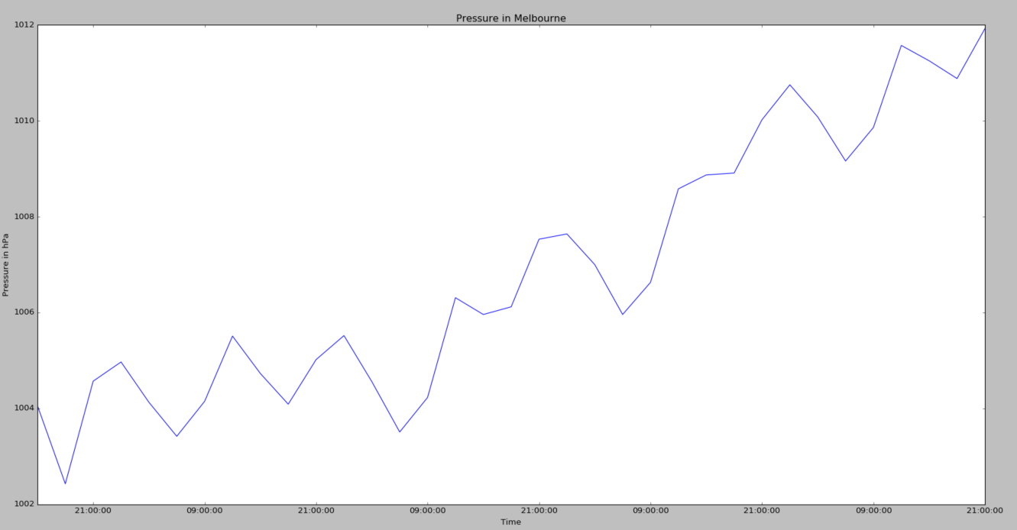

---PART 8---

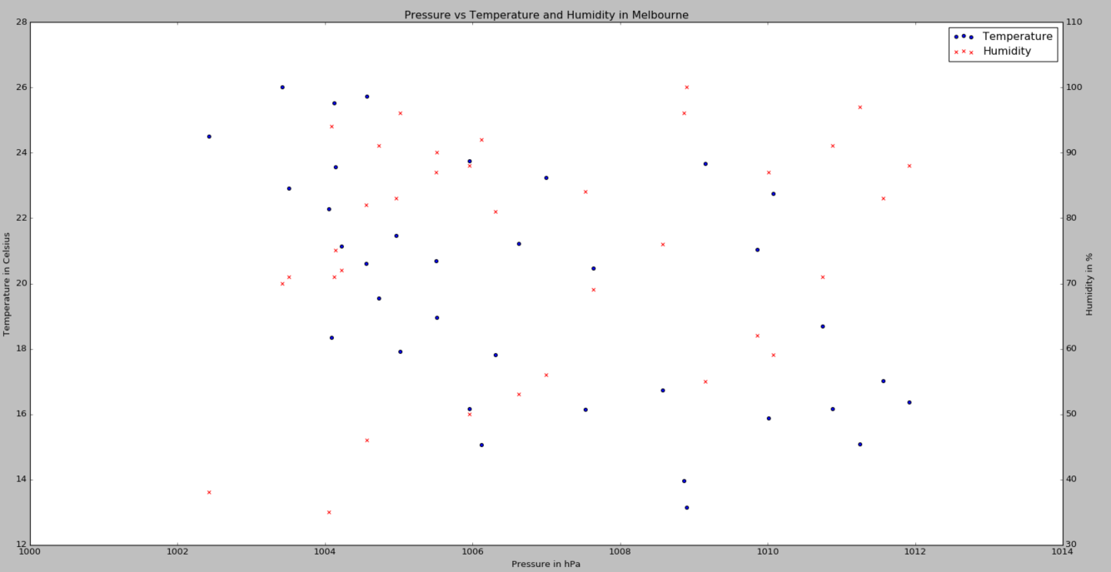

---BONUS: PART 1---

['country', 'beer_servings', 'spirit_servings', 'wine_servings', 'total_litres_of_pure_alcohol', 'continent']

---BONUS PART 2---

beers == [0, 89, 25, 245, 217, 102, 193, 21, 261, 279, 21, 122, 42, 0, 143, 142, 295, 263, 34, 23, 167, 76, 173, 245, 31, 231, 25, 88, 37, 144, 57, 147, 240, 17, 15, 130, 79, 159, 1, 76, 0, 149, 230, 93, 192, 361, 0, 32, 224, 15, 52, 193, 162, 6, 52, 92, 18, 224, 20, 77, 263, 127, 347, 8, 52, 346, 31, 133, 199, 53, 9, 28, 93, 1, 69, 234, 233, 9, 5, 0, 9, 313, 63, 85, 82, 77, 6, 124, 58, 21, 0, 31, 62, 281, 20, 82, 19, 0, 343, 236, 26, 8, 13, 0, 5, 149, 0, 0, 98, 238, 62, 0, 77, 31, 12, 47, 5, 376, 49, 5, 251, 203, 78, 3, 42, 188, 169, 22, 0, 306, 285, 44, 213, 163, 71, 343, 194, 1, 140, 109, 297, 247, 43, 194, 171, 120, 105, 0, 56, 0, 9, 283, 157, 25, 60, 196, 270, 56, 0, 225, 284, 16, 8, 128, 90, 152, 185, 5, 2, 99, 106, 1, 36, 36, 197, 51, 51, 19, 6, 45, 206, 16, 219, 36, 249, 115, 25, 21, 333, 111, 6, 32, 64]

len(beers) == 193

---BONUS PART 3---

NA_beers == [102, 122, 143, 263, 240, 149, 93, 52, 193, 52, 199, 53, 1, 69, 82, 238, 78, 285, 194, 171, 120, 197, 249]

len(NA_beers) == 23

EU_beers == [89, 245, 21, 279, 21, 142, 295, 76, 231, 230, 192, 361, 224, 224, 263, 127, 52, 346, 133, 234, 233, 313, 85, 281, 343, 236, 149, 0, 31, 251, 169, 343, 194, 109, 297, 0, 283, 196, 270, 284, 152, 185, 106, 206, 219]

len(EU_beers) == 45

$ python 01_optional_nl.py

Unnamed: 0 name age gender raceethnicity month day \

0 0 A'donte Washington 16 Male Black February 23

1 1 Aaron Rutledge 27 Male White April 2

2 2 Aaron Siler 26 Male White March 14

3 3 Aaron Valdez 25 Male Hispanic/Latino March 11

4 4 Adam Jovicic 29 Male White March 19

year streetaddress city state \

0 2015 Clearview Ln Millbrook AL

1 2015 300 block Iris Park Dr Pineville LA

2 2015 22nd Ave and 56th St Kenosha WI

3 2015 3000 Seminole Ave South Gate CA

4 2015 364 Hiwood Ave Munroe Falls OH

lawenforcementagency cause armed county_income

0 Millbrook Police Department Gunshot No 54766

1 Rapides Parish Sheriff's Office Gunshot No 40930

2 Kenosha Police Department Gunshot No 54930

3 South Gate Police Department Gunshot Firearm 55909

4 Kent Police Department Gunshot No 49669

---1---

Unnamed: 0 name age gender race month day \

0 0 A'donte Washington 16 Male Black February 23

1 1 Aaron Rutledge 27 Male White April 2

2 2 Aaron Siler 26 Male White March 14

3 3 Aaron Valdez 25 Male Hispanic/Latino March 11

4 4 Adam Jovicic 29 Male White March 19

year streetaddress city state \

0 2015 Clearview Ln Millbrook AL

1 2015 300 block Iris Park Dr Pineville LA

2 2015 22nd Ave and 56th St Kenosha WI

3 2015 3000 Seminole Ave South Gate CA

4 2015 364 Hiwood Ave Munroe Falls OH

agency cause armed county_income

0 Millbrook Police Department Gunshot No 54766

1 Rapides Parish Sheriff's Office Gunshot No 40930

2 Kenosha Police Department Gunshot No 54930

3 South Gate Police Department Gunshot Firearm 55909

4 Kent Police Department Gunshot No 49669

---2---

Unnamed: 0 0

name 0

age 0

gender 0

race 0

month 0

day 0

year 0

streetaddress 4

city 0

state 0

agency 0

cause 0

armed 0

county_income 0

dtype: int64

---3---

>>>ORIGINAL rows with missing values:

Unnamed: 0 name age gender race \

50 50 Billy Patrick 29 Male White

280 280 Kenneth Brown 18 Male White

379 379 Ricky Hall 27 Male Black

405 405 Santos 'Cuate' Cortez Hernandez 24 Male Hispanic/Latino

month day year streetaddress city state \

50 April 26 2015 NaN Bunch OK

280 January 4 2015 NaN Guthrie OK

379 March 30 2015 NaN Fort Meade MD

405 April 20 2015 NaN Mission TX

agency cause \

50 Oklahoma Department of Wildlife Conservation Gunshot

280 Oklahoma State Police Gunshot

379 NSA Police Department Gunshot

405 Hidalgo County Sheriff's Office Gunshot

armed county_income

50 Firearm 32556

280 Non-lethal firearm 53591

379 Firearm 87430

405 Firearm 34146

>>>UPDATED rows with missing values:

Unnamed: 0 name age gender race \

50 50 Billy Patrick 29 Male White

280 280 Kenneth Brown 18 Male White

379 379 Ricky Hall 27 Male Black

405 405 Santos 'Cuate' Cortez Hernandez 24 Male Hispanic/Latino

month day year streetaddress city state \

50 April 26 2015 Unknown Bunch OK

280 January 4 2015 Unknown Guthrie OK

379 March 30 2015 Unknown Fort Meade MD

405 April 20 2015 Unknown Mission TX

agency cause \

50 Oklahoma Department of Wildlife Conservation Gunshot

280 Oklahoma State Police Gunshot

379 NSA Police Department Gunshot

405 Hidalgo County Sheriff's Office Gunshot

armed county_income

50 Firearm 32556

280 Non-lethal firearm 53591

379 Firearm 87430

405 Firearm 34146

---4---

467

---5---

gender

Female 22

Male 445

dtype: int64

---6---

102

---7---

21.84% of all killings were unarmed

---8---

state

CA 74

TX 46

FL 29

AZ 25

OK 22

dtype: int64

---9---

race

Asian/Pacific Islander 10

Black 135

Hispanic/Latino 67

Native American 4

Unknown 15

White 236

dtype: int64

---10---

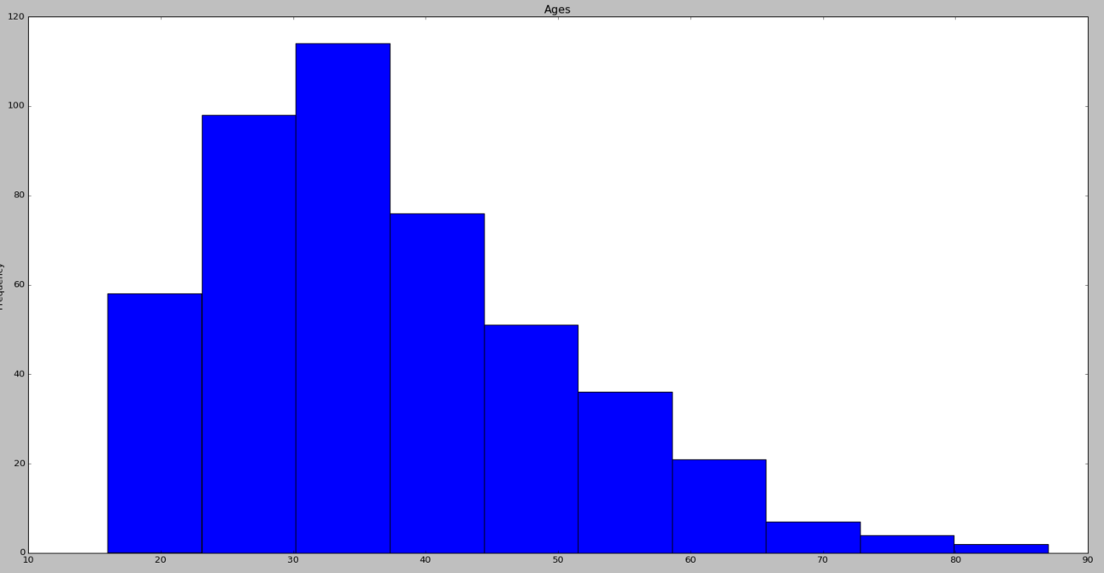

---11---

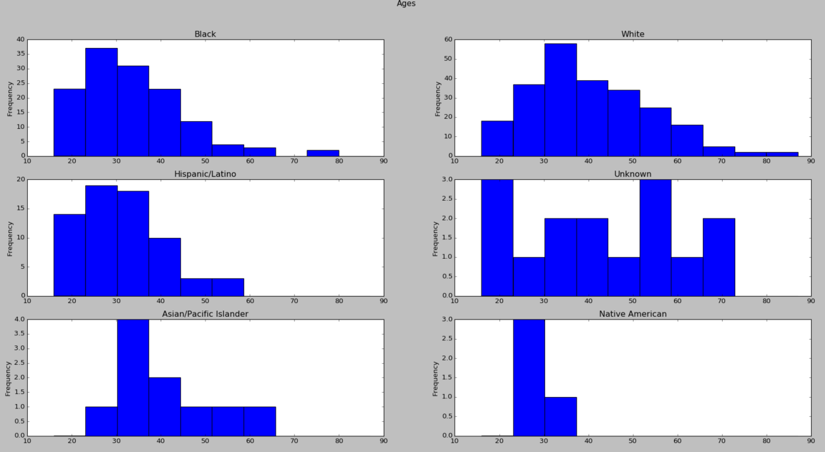

---12---

race

Asian/Pacific Islander 40.800000

Black 34.044444

Hispanic/Latino 31.716418

Native American 27.750000

Unknown 43.533333

White 40.466102

Name: age, dtype: float64

---13---

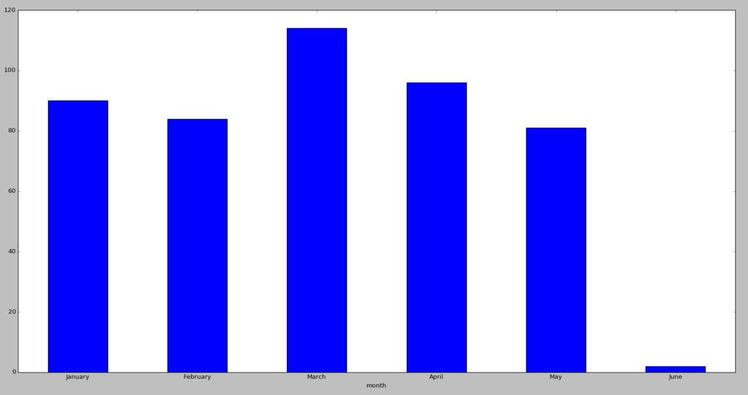

$ python 01_optional2_nl.py

Unnamed: 0 Major_code Major \

0 0 1100 GENERAL AGRICULTURE

1 1 1101 AGRICULTURE PRODUCTION AND MANAGEMENT

2 2 1102 AGRICULTURAL ECONOMICS

3 3 1103 ANIMAL SCIENCES

4 4 1104 FOOD SCIENCE

Major_category Total Employed \

0 Agriculture & Natural Resources 128148 90245

1 Agriculture & Natural Resources 95326 76865

2 Agriculture & Natural Resources 33955 26321

3 Agriculture & Natural Resources 103549 81177

4 Agriculture & Natural Resources 24280 17281

Employed_full_time_year_round Unemployed Unemployment_rate Median \

0 74078 2423 0.026147 50000

1 64240 2266 0.028636 54000

2 22810 821 0.030248 63000

3 64937 3619 0.042679 46000

4 12722 894 0.049188 62000

P25th P75th

0 34000 80000

1 36000 80000

2 40000 98000

3 30000 72000

4 38500 90000

---1---

Unnamed: 0 Major \

0 0 GENERAL AGRICULTURE

1 1 AGRICULTURE PRODUCTION AND MANAGEMENT

2 2 AGRICULTURAL ECONOMICS

3 3 ANIMAL SCIENCES

4 4 FOOD SCIENCE

Major_category Total Employed Unemployed \

0 Agriculture & Natural Resources 128148 90245 2423

1 Agriculture & Natural Resources 95326 76865 2266

2 Agriculture & Natural Resources 33955 26321 821

3 Agriculture & Natural Resources 103549 81177 3619

4 Agriculture & Natural Resources 24280 17281 894

Unemployment_rate Median P25th P75th

0 0.026147 50000 34000 80000

1 0.028636 54000 36000 80000

2 0.030248 63000 40000 98000

3 0.042679 46000 30000 72000

4 0.049188 62000 38500 90000

---2---

Unnamed: 0 0

Major 0

Major_category 0

Total 0

Employed 0

Unemployed 0

Unemployment_rate 0

Median 0

P25th 0

P75th 0

dtype: int64

---3---

Major

PETROLEUM ENGINEERING 125000

PHARMACY PHARMACEUTICAL SCIENCES AND ADMINISTRATION 106000

NAVAL ARCHITECTURE AND MARINE ENGINEERING 97000

METALLURGICAL ENGINEERING 96000

NUCLEAR ENGINEERING 95000

MATHEMATICS AND COMPUTER SCIENCE 92000

MINING AND MINERAL ENGINEERING 92000

ELECTRICAL ENGINEERING 88000

CHEMICAL ENGINEERING 86000

GEOLOGICAL AND GEOPHYSICAL ENGINEERING 85000

Name: Median, dtype: int64

---4---

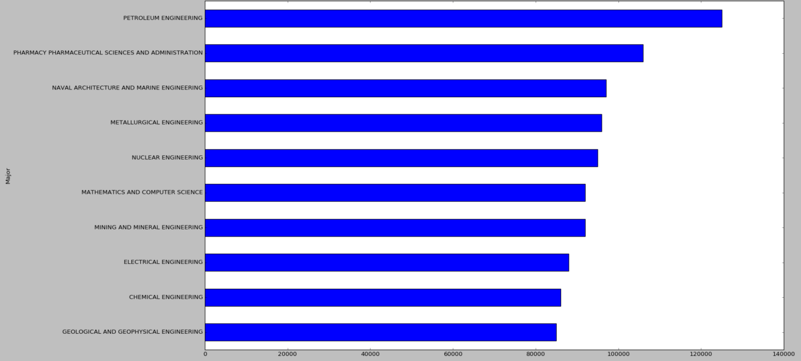

---5---

Major_category

Agriculture & Natural Resources 55000.000000

Arts 43525.000000

Biology & Life Science 50821.428571

Business 60615.384615

Communications & Journalism 49500.000000

Computers & Mathematics 66272.727273

Education 43831.250000

Engineering 77758.620690

Health 56458.333333

Humanities & Liberal Arts 46080.000000

Industrial Arts & Consumer Services 52642.857143

Interdisciplinary 43000.000000

Law & Public Policy 52800.000000

Physical Sciences 62400.000000

Psychology & Social Work 44555.555556

Social Science 53222.222222

Name: Median, dtype: float64

---6---

Major_category

Engineering 77758.620690

Computers & Mathematics 66272.727273

Physical Sciences 62400.000000

Business 60615.384615

Health 56458.333333

Name: Median, dtype: float64

---7---

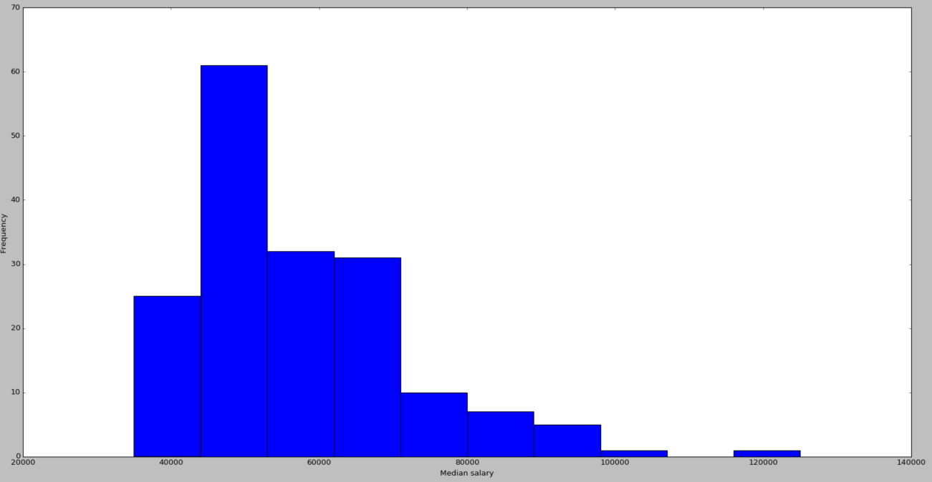

---8---

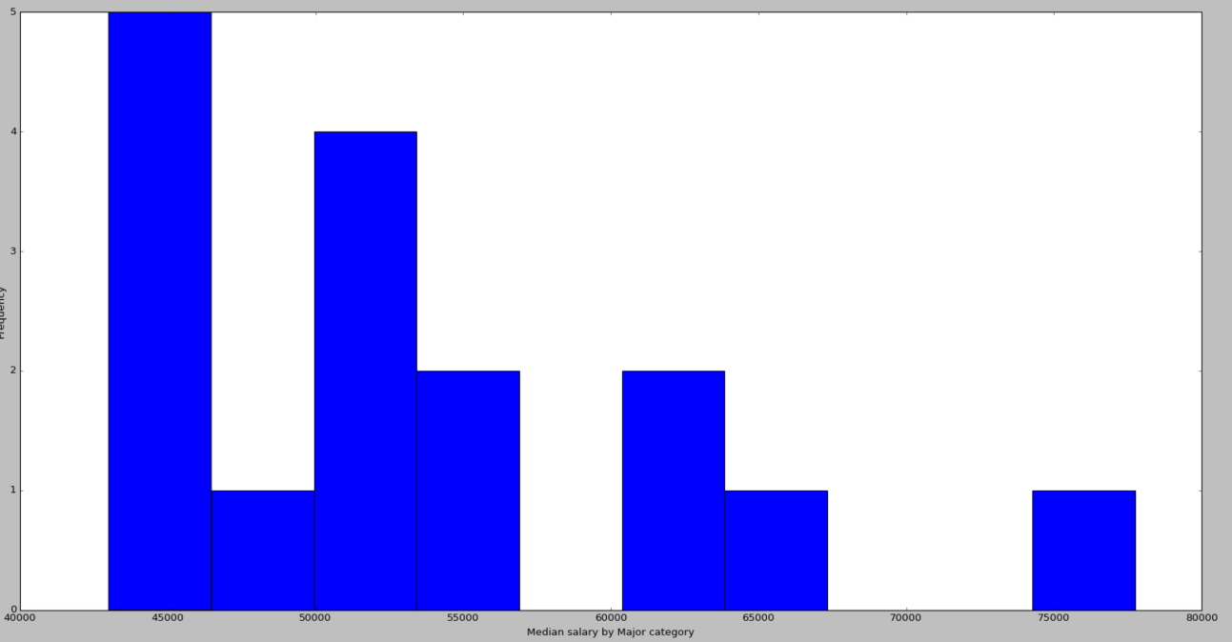

---9---

Major Unemployment_rate

MISCELLANEOUS FINE ARTS 0.156147

CLINICAL PSYCHOLOGY 0.102712

MILITARY TECHNOLOGIES 0.101796

SCHOOL STUDENT COUNSELING 0.101746

LIBRARY SCIENCE 0.094843

VISUAL AND PERFORMING ARTS 0.094658

COMPUTER PROGRAMMING AND DATA PROCESSING 0.090264

SOCIAL PSYCHOLOGY 0.087336

ASTRONOMY AND ASTROPHYSICS 0.086022

ARCHITECTURE 0.085991

---10---

Major_category

Arts 0.087601

Psychology & Social Work 0.077867

Interdisciplinary 0.077269

Humanities & Liberal Arts 0.069429

Communications & Journalism 0.069125

Law & Public Policy 0.067854

Social Science 0.065686

Computers & Mathematics 0.059437

Industrial Arts & Consumer Services 0.058546

Physical Sciences 0.054541

Name: Unemployment_rate, dtype: float64

Unnamed: 0 Major \

0 0 GENERAL AGRICULTURE

1 1 AGRICULTURE PRODUCTION AND MANAGEMENT

2 2 AGRICULTURAL ECONOMICS

3 3 ANIMAL SCIENCES

4 4 FOOD SCIENCE

Major_category Total Employed Unemployed \

0 Agriculture & Natural Resources 128148 90245 2423

1 Agriculture & Natural Resources 95326 76865 2266

2 Agriculture & Natural Resources 33955 26321 821

3 Agriculture & Natural Resources 103549 81177 3619

4 Agriculture & Natural Resources 24280 17281 894

Unemployment_rate Median P25th P75th sample_employment_rate

0 0.026147 50000 34000 80000 0.704225

1 0.028636 54000 36000 80000 0.806338

2 0.030248 63000 40000 98000 0.775173

3 0.042679 46000 30000 72000 0.783948

4 0.049188 62000 38500 90000 0.711738

Unnamed: 0 Major \

0 0 GENERAL AGRICULTURE

1 1 AGRICULTURE PRODUCTION AND MANAGEMENT

2 2 AGRICULTURAL ECONOMICS

3 3 ANIMAL SCIENCES

4 4 FOOD SCIENCE

Major_category Total Employed Unemployed \

0 Agriculture & Natural Resources 128148 90245 2423

1 Agriculture & Natural Resources 95326 76865 2266

2 Agriculture & Natural Resources 33955 26321 821

3 Agriculture & Natural Resources 103549 81177 3619

4 Agriculture & Natural Resources 24280 17281 894

Unemployment_rate Median P25th P75th sample_employment_rate \

0 0.026147 50000 34000 80000 0.704225

1 0.028636 54000 36000 80000 0.806338

2 0.030248 63000 40000 98000 0.775173

3 0.042679 46000 30000 72000 0.783948

4 0.049188 62000 38500 90000 0.711738

sample_unemployment_rate

0 0.295775

1 0.193662

2 0.224827

3 0.216052

4 0.288262