**Drugs:**

**Statins (lowers chloresterol):**

**- Simvastatin (Zocor)**

**- Atorvastatin(Lipitor)**

**- Fluvastatin(Lescol)**

**- Lovastatin (Mevacor)**

**- Pravastatin (Pravachol)**

**- Rosuvastatin (Crestor)**

**- Cerivastatin (Baycol)**

**-Amiodarone (Cordarone)** - antiarrhythmic drug

-Tegretol –anticonvulsant

Additional code:

VKORC1.1= VKORC1 genotype: -1639 G>A (3673); chr16:31015190; rs9923231; C/T

VKORC1.1_QC =VKORC1 QC genotype: -1639 G>A (3673); chr16:31015190; rs9923231; C/T

VKORC1.2 = VKORC1 genotype: 497T>G (5808); chr16:31013055; rs2884737; A/C

VKORC1.2_QC = VKORC1 QC genotype: 497T>G (5808); chr16:31013055; rs2884737; A/C

VKORC1.3 = VKORC1 genotype: 1173 C>T(6484); chr16:31012379; rs9934438; A/G

VKORC1.3_QC = VKORC1 QC genotype: 1173 C>T(6484); chr16:31012379; rs9934438; A/G

VKORC1.4 = VKORC1 genotype: 1542G>C (6853); chr16:31012010; rs8050894; C/G

VKORC1.4_QC = VKORC1 QC genotype: 1542G>C (6853); chr16:31012010; rs8050894; C/G

VKORC1.5 = VKORC1 genotype: 3730 G>A (9041); chr16:31009822; rs7294; A/G

VKORC1.5_QC = VKORC1 QC genotype: 3730 G>A (9041); chr16:31009822; rs7294; A/G

VKORC1.6 = VKORC1 genotype: 2255C>T (7566); chr16:31011297; rs2359612; A/G

VKORC1.6_QC = VKORC1 QC genotype: 2255C>T (7566); chr16:31011297; rs2359612; A/G

VKORC 1.7 = VKORC1 genotype: -4451 C>A (861); Chr16:31018002; rs17880887; A/C

VKORC 1.7_QC = VKORC1 QC genotype: -4451 C>A (861); Chr16:31018002; rs17880887; A/C

“The nomenclature for the *CYP2C9* SNPs is unique: the normal, or wild-type, variant is referred to as *1 ("star 1"), the two polymorphic versions are *2 ("star 2") and *3 ("star 3"), and each person can carry any two versions of the SNP. For example, a person with two normal copies would be *1/*1, a person with only one polymorphism could be *1/*2, and a person with both polymorphisms could be *2/*3. The prevalence of each variant varies by race; 10% and 6% of Caucasians carry the *2 and *3 variants, respectively, but both variants are rare (< 2%) in those of African or Asian descent.[[1]](javascript:showrefcontent('refrenceslayer');)

CYP2C9*1 metabolizes warfarin normally, CYP2C9*2 reduces warfarin metabolism by 30%, and CYP2C9*3 reduces warfarin metabolism by 90%. Because warfarin given to patients with *2 or *3 variants will be metabolized less efficiently, the drug will remain in circulation longer, so lower warfarin doses will be needed to achieve anticoagulation.”

**http://emedicine.medscape.com/article/1733331-overview**

**-** carriers of the **rs9923231**(T) allele require significantly reduced doses of [warfarin](http://www.snpedia.com/index.php/Warfarin)

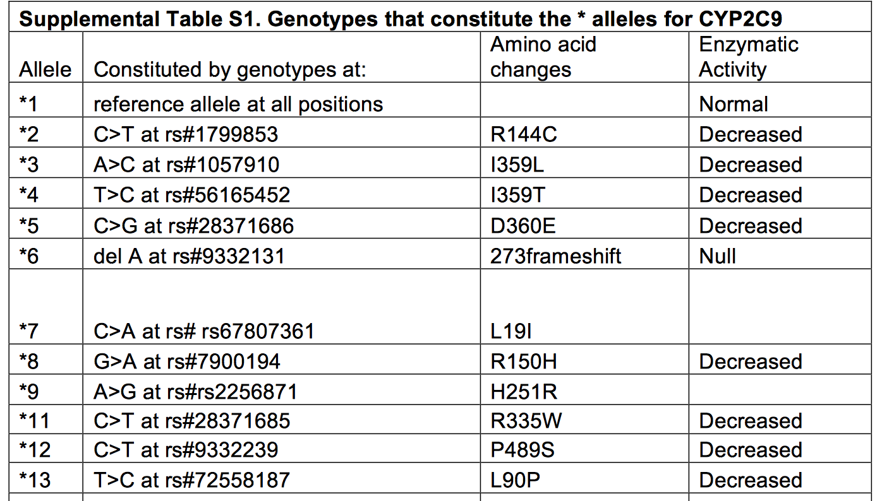

|  |  |  |
| --- | --- | --- |
|  | VKORC1.4_consensus | 2.217014e-98 |
| **6** | VKORC1.4 | 9.884794e-96 |
| **7** | VKORC1.1_consensus | 1.654173e-79 |
| **8** | VKORC1.1 | 2.569691e-75 |
| **9** | VKORC1.3_consensus | 3.400368e-65 |
| **10** | VKORC1.6_consensus | 2.665948e-55 |
| **11** | VKORC1.6 | 2.540785e-45 |

|  |  |  |
| --- | --- | --- |
| VKORC1.3_QC | 5.813834e-23 |  |
| **15** | VKORC1.6_QC | 5.307887e-20 |
| **16** | VKORC1.5 | 9.511256e-14 |
| **17** | VKORC1.5_consensus | 1.780490e-13 |

|  |  |
| --- | --- |
| VKORC1.1_QC | 1.083740e-08 |
| VKORC1.5_QC | 5.648013e-07 |
| VKORC1.2_consensus | 9.391104e-07 |
| Genotyped.QC3.Cyp2C9 | 1.138241e-06 |
| Genotyped.QC2.Cyp2C9 | 9.465153e-06 |
| VKORC1.2 | 1.208646e-05 |
| VKORC1.4_QC | 1.234486e-05 |

|  |  |
| --- | --- |
| VKORC1 QC genotype: 497T>G (5808); chr16:31013055; rs2884737; A/C | 4.704791e-03 |
| VKORC1 consensus genotype: -4451 C>A (861); Chr16:31018002; rs17880887; A/C | 6.792003e-03 |
| VKORC1 QC genotype: -4451 C>A (861); Chr16:31018002; rs17880887; A/C | 1.298133e-02 |
| VKORC1 genotype: -4451 C>A (861); Chr16:31018002; rs17880887; A/C | 2.964215e-02 |
| VKORC1 genotype: 1173 C>T(6484); chr16:31012379; rs9934438; A/G | 5.807836e-01 |
| CYP2C9 consensus | 9.296477e-01 |
| Cyp2C9 genotype | 9.297612e-01 |