eco-3
Links: ecologism-moc, politics

Deep green
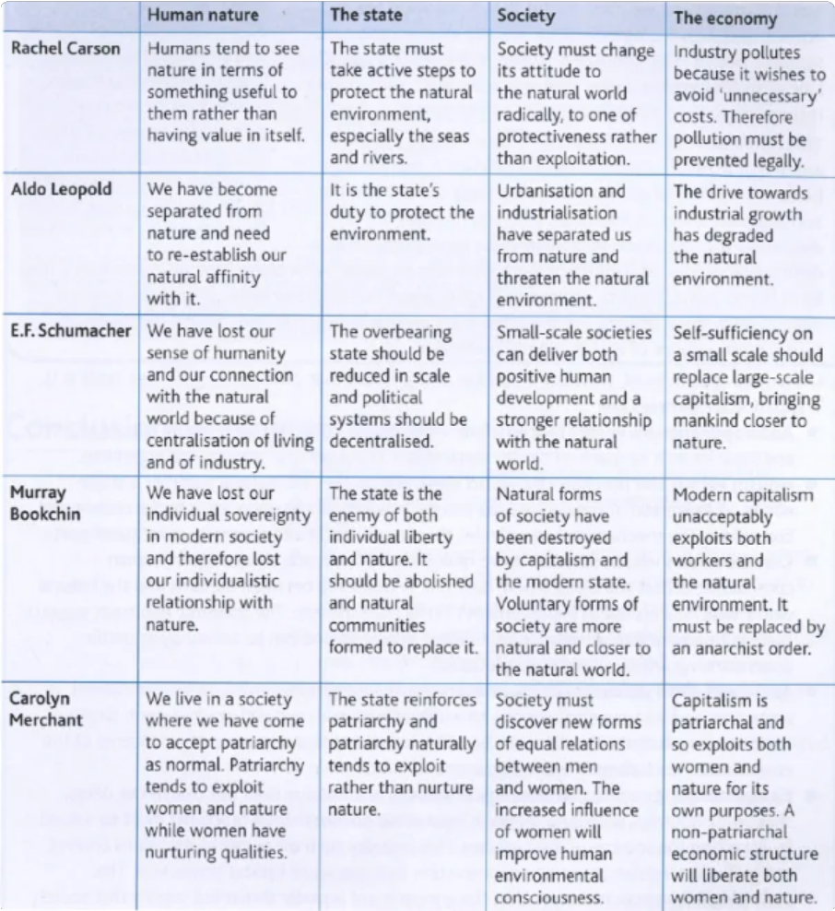

humans must develop a radical ecocentric (rather than anthropocentric) vision for state,
Shallow green
enlightened anthropocentrism humans must ‘steward’ the environment by improving existing systems
Social ecology

radical ecological change must be achieved by over-turning specific social constructs (e.g. capitalism, patriarchy)

ecologism-human-nature

