Gifts

Cake

2 Tables  
 No Chairs

2 Tables  
 No Chairs

Tables are $20 each

Chairs are $10 each

The numbers inside the boxes are the Chairs

You have to calculate the numbers of Tables

You only have SQUARE Tables  
You combine them to create the Rectangles

2

Dance Floor

No Tables

40 Chairs

Bride & Groom

10

9

5

6

6

9

7

4

4

3

8

10

3

4

4

CSC-251 GROUP PROJECT

Susanna Quayle, Ashley Jackson, Hannah Martin, David McCarthy, and Johnny Nguyen

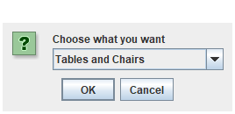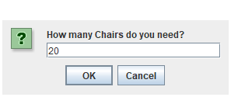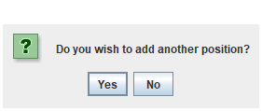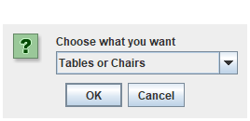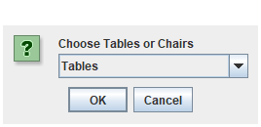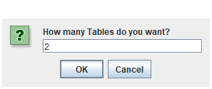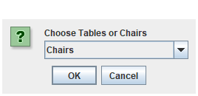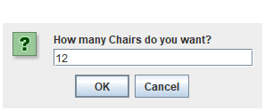 USER CLICKS NO – RETURNS RECEIPT FRAME AND TXT FILE

