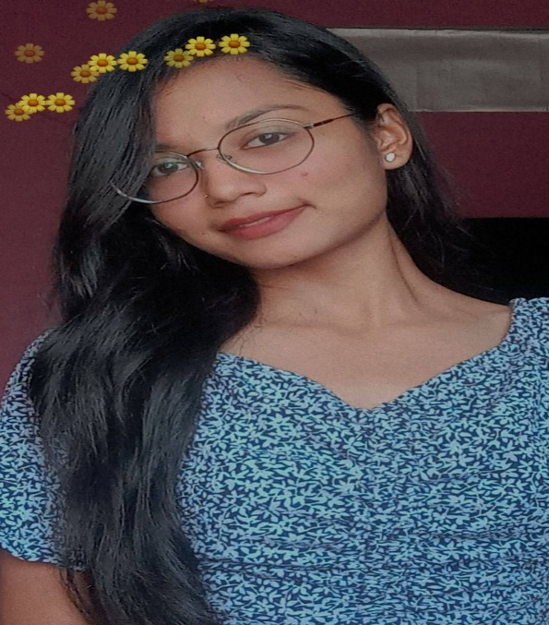 |  |  | Sneha Nikhare
 |  |  | Software Tester
contact  9687198349  snehank2305@gmail.com  https://github.com/miss-sneha  DOB – 21 may 2006  LANGUAGES  English  Hindi  Gujarati  Marathi  Skills  customer relationship management team leader classroom management professional communication educational curriculum developer  INTREST  I listening music and learning new skills, I like cooking and reading book. |  |  | summary  My self sneha . I am pursuing B.A. at mtb arts college, surat . Currently I am doing diploma in software testing and automation, at tops technologies. I have one year teaching experience at sense academy. so I have good communication skills and problem solving skill. accomplished social marketing influencer at dynamic beneficial accord private limited, excelling in social media strategy and team leadership. I am quick learner. My hobbies are cooking and listening music .  EDUCATION  M.T.B. Arts collage ,surat  Bachelor of Arts (ongoing)  TOPS TECHNOLOGIES  Diploma in software testing and automation(ongoing)  URVASHI’S MAKEOVER  Certified beautician (2024)  VANITA VISHRAM UNIVERSITY , SURAT  HSC (2023)  WORK EXPERIENce  Dynamic Beneficial Accord Private Limited (surat)  Social marketing influencer  August 2024 - June 2025  Sense academy  Teacher (April 2023 – January 2024)

