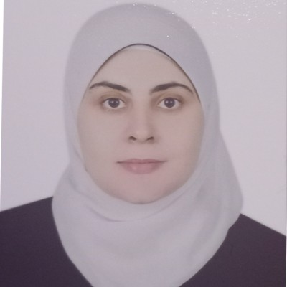 | ALAA SALAH  Junior Data Analyst | AI and Machine Learning Specialist  Heliopolis, Cairo, Egypt | +20 1289919230 | miss.alaa.salah@gmail.com | LinkedIn | Portfolio

PROFESSIONAL SUMMARY
I am a Junior Data Analyst with hands-on experience in Python, SQL, Power BI, Tableau, and SPSS through the competitive Digilians initiative at the Ministry of Communications and Information Technology (MCIT) and the Egyptian Military Academy. I am proficient in data cleaning, exploratory data analysis, statistical modeling, and machine learning including regression and classification. I have experience building automated KPI dashboards and applying Generative AI technologies such as large language models, retrieval-augmented generation, and LangChain. I am committed to transforming raw data into actionable business intelligence that supports data-driven decision-making.
EDUCATION
Bachelor of Arts in Philosophy | Suez Canal University 2012 – 2015
Grade: Good
PROFESSIONAL EXPERIENCE
Applied AI and Data Analytics Trainee | Digilians Initiative, MCIT and Egyptian Military Academy December 2025 – Present
- Analyzed 20+ structured datasets using Python, SQL, and SPSS to uncover business trends and produce statistical reports for stakeholders.
- Built 10+ automated interactive dashboards in Power BI and Tableau to monitor KPIs and present data insights to non-technical audiences.
- Performed end-to-end data pipeline tasks including data cleaning, preprocessing, feature engineering, and exploratory data analysis to ensure high data quality.
- Developed and evaluated predictive machine learning models including regression and classification; documented model performance metrics and technical findings.
- Applied Generative AI techniques including large language model fine-tuning, retrieval-augmented generation, and LangChain to create intelligent natural language processing applications.
- Presented data findings to cross-functional teams, translating complex analytical results into clear business recommendations and strategic insights.

PROJECTS
Generative AI Applications with Retrieval-Augmented Generation | Personal Project 2023
- Designed and developed a Generative AI application leveraging retrieval-augmented generation to enhance large language model responses with real-time data retrieval.
- Fine-tuned large language models for domain-specific use cases using advanced fine-tuning techniques.
- Integrated LangChain framework to build end-to-end natural language processing pipelines.

Interactive KPI Dashboards | Digilians Initiative 2025 – Present
- Built 10+ automated Power BI and Tableau dashboards tracking key performance indicators across multiple business domains.
- Processed and cleaned 20+ structured datasets using Python and SQL, reducing data preparation time significantly.

CERTIFICATIONS AND TRAINING
- IBM AI Engineering Professional Certificate
- Google Data Analytics Professional Certificate
- Generative AI Engineering and Fine-Tuning
- Generative AI Language Modeling with Transformers
- AI Agents Using Retrieval-Augmented Generation and LangChain
- Generative AI Applications with Retrieval-Augmented Generation (Project)
- Generative AI Advanced Fine-Tuning for Large Language Models
- Generative AI Foundational Models for Natural Language Processing
- AI Capstone Project with Deep Learning
- Machine Learning with Python, IBM
- Deep Learning with PyTorch and TensorFlow
- Google Data Analytics Capstone Case Study
- Data Analysis with R Programming, Google
- Process Data from Dirty to Clean, Google
- Artificial Intelligence Engineer Level 2
- Data Analyst Level 1, Coursera
- AI Skills for Women, Saudi Arabia
- Delivering Quality Work with Agility
- Accelerate Your Job Search with AI
- International Computer Driving License (ICDL)

TECHNICAL SKILLS
- Python: Data analysis, automation, data manipulation, machine learning
- SQL: Database querying, joins, aggregation, data extraction
- Power BI: Interactive dashboards, KPI reports, data modeling
- Tableau: Data visualization, storytelling, insight reporting
- Excel: Advanced formulas, pivot tables, charts, data cleaning
- SPSS: Descriptive and inferential statistics, hypothesis testing
- Machine Learning: Regression, classification, model evaluation and validation
- Generative AI: Large language models, retrieval-augmented generation, LangChain, prompt engineering
- Deep Learning: Neural networks, PyTorch, TensorFlow
- Statistics: Exploratory data analysis, probability, statistical interpretation
- Orange: Visual data mining and machine learning workflows
- R Programming: Statistical computing and data analysis

SOFT SKILLS
Analytical Thinking • Critical Thinking • Problem-Solving • Data Storytelling • Communication • Presentation Skills • Attention to Detail • Continuous Learning • Time Management
LANGUAGES
Arabic: Native | English: Good Working Knowledge

