University Student Registration &Results Management System
Database Project — Advanced SQL Report

Course | Data Mining & Visualization
Due Date | March 14, 2026
Topic | Topic 2 — University Database
Database | UniversityDB — SQL Server 2019
Tables | 12 Relational Tables
Queries | 10 Advanced SQL Queries + 4 Views

What is TechUni Intelligence Hub?

TechUni Intelligence Hub is a custom-built executive dashboard that visualizes all 10 SQL query outputs from UniversityDB in a single, interactive web interface. It was built to bridge the gap between raw database results and real-world academic decision-making.

► How It Was Built
The dashboard was developed using HTML5, CSS3, and JavaScript, populated with the actual data extracted from TechUni_Dataset_5000.xlsx and the UniversityDB SQL queries. It was deployed for free on Netlify as a static web application — accessible instantly from any browser without installation.

Project Summary — Complete Data Pipeline
This project delivers a fully integrated academic data management and analytics system, built across four complementary layers:

Layer | Tool | What Was Built | Key Output
Part 1 | SQL Server | 12 tables + 10 advanced queries + 4 Views | UniversityDB — complete relational database
Part 2 | Python EDA | 15 visualizations + data cleaning pipeline | Full EDA notebook with insights
Part 3 | Orange | Visual workflow across 6 sheets, 12 analysis nodes | No-code interactive data exploration
Part 4 | Power BI | 5 KPI cards + 5 charts + 5 interactive slicers | Executive dashboard for decision-makers
Part 4 | Web Dashboard | 10 SQL queries visualized + live at netlify | https://meek-tanuki-9331e0.netlify.app/

University Student Registration & Results Management System | Data Mining & Visualization 2026

Database Overview — UniversityDB

Entity Relationship Summary
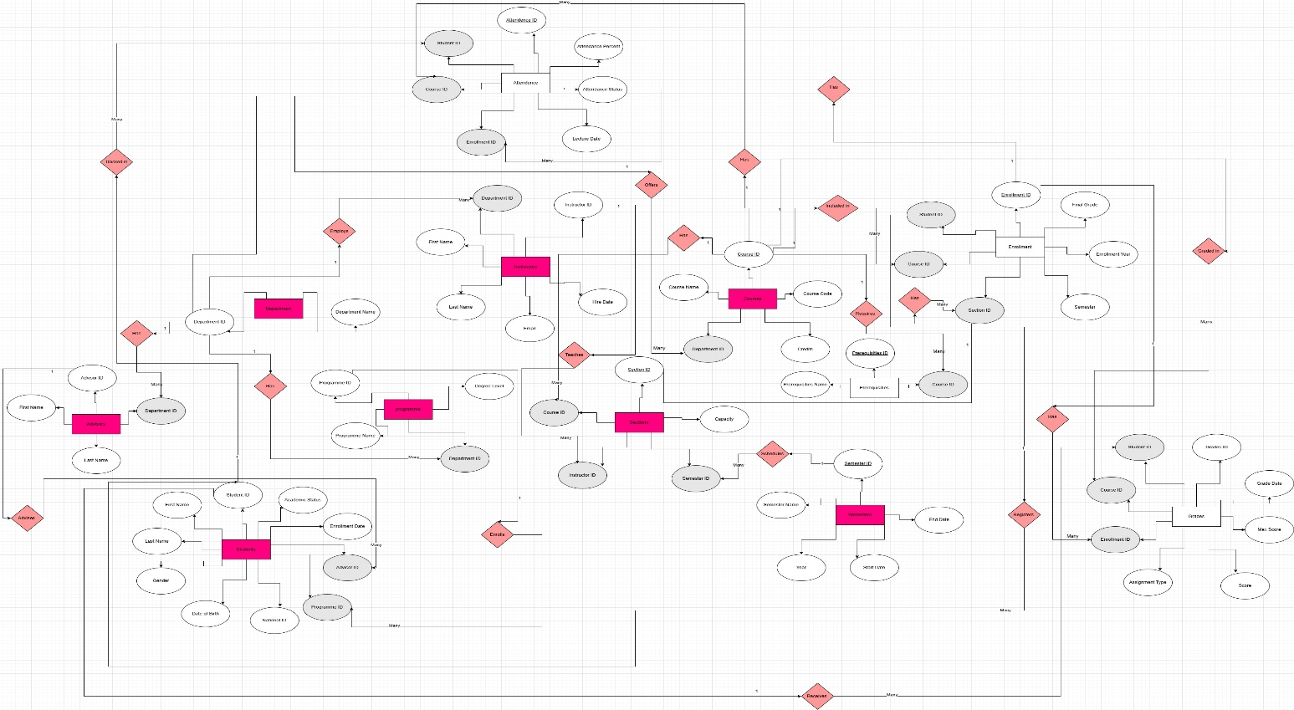 Flowchart Maker & Online Diagram Software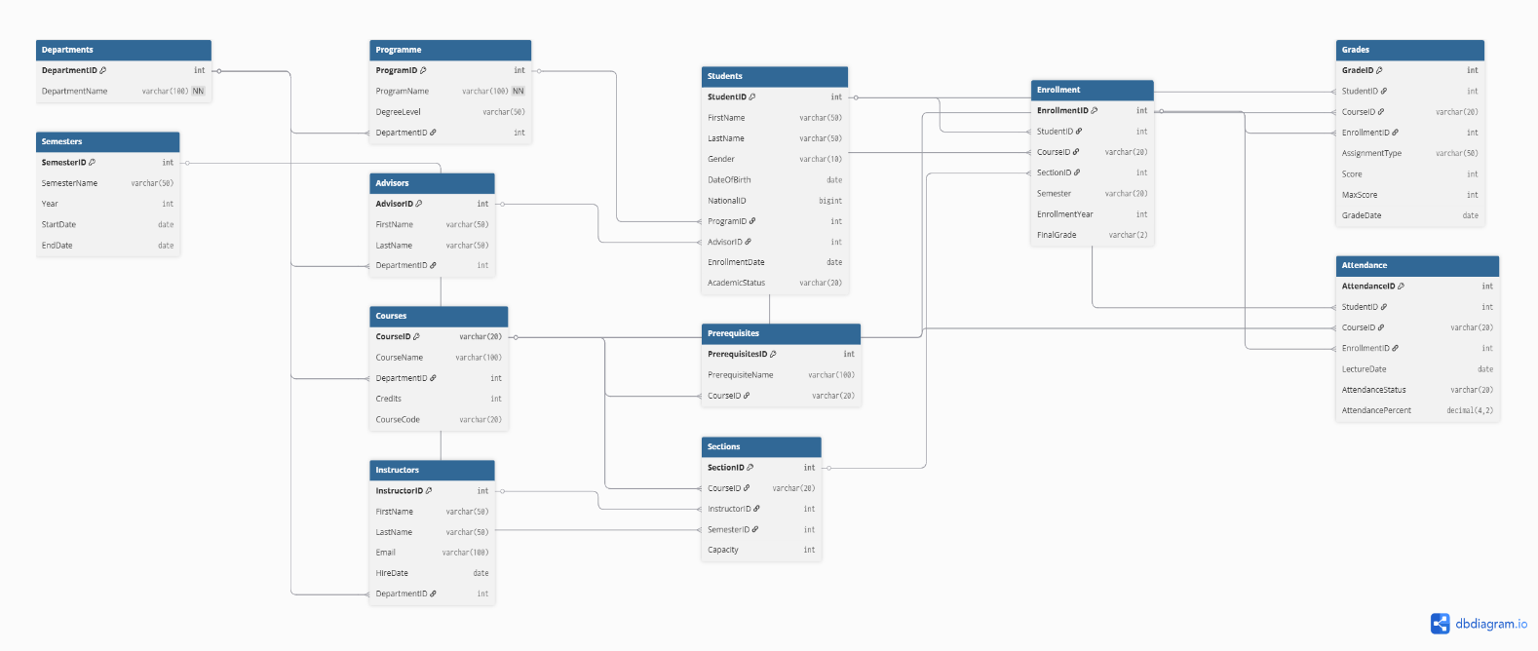

Untitled - dbdiagram.io

Relationship Summary:-
- Departments — has → Programme .(one to many)
- Departments — has → Advisors. (one to many)
- Departments — employs → Instructors . (one to many)
- Departments — offers → Courses. (one to many)
- Programme — enrolls → Students . (one to many)
- Advisors — advises → Students. (one to many)
- Courses — requires → Prerequisites . (one to many)
- Courses — has → Sections. (one to many)
- Instructors — teaches → Sections. (one to many)
- Semesters — schedules → Sections. (one to many)
- Students — registers → Enrollment . (one to many)
- Courses — included in → Enrollment. (one to many)
- Sections — has → Enrollment. (one to many)
- Students — receives → Grades . (one to many)
- Courses — graded in → Grades . (one to many)
- Enrollment — has → Grades. (one to many)
- Students — tracked in → Attendance . (one to many)
- Courses — tracked in → Attendance. (one to many)
- Enrollment — has → Attendance. (one to many)

Table | Records | Columns
Departments | 4 | DepartmentID, DepartmentName
Programs | 5 | ProgramID, ProgramName, DegreeLevel, DepartmentID
Advisors | 40 | AdvisorID, FirstName, LastName, DepartmentID
Instructors | 20 | InstructorID, FirstName, LastName, Email, HireDate, DepartmentID
Semesters | 8 | SemesterID, SemesterName, Year, StartDate, EndDate
Courses | 50 | CourseID, CourseName, DepartmentID, Credits, CourseCode
Prerequisites | 50 | PrerequisitesID, PrerequisiteName , CourseID
Students | 500 | StudentID, FirstName, LastName, Gender, DateOfBirth, NationalID, ProgramID, AdvisorID, EnrollmentDate , AcademicStatus
Sections | 50 | SectionID, CourseID, InstructorID, SemesterID, Capacity
Enrollment | 93 | EnrollmentID, StudentID, CourseID, SectionID, Semester, EnrollmentDate, FinalGrade
Grades | 30 | GradeID, StudentID, CourseID, EnrollmentID, AssignmentType, Score, MaxScore, GradeDate,
Attendance | 30 | AttendanceID, StudentID, CourseID, EnrollmentID, LectureDate, AttendanceStatus, AttendancePercent

The database file can be accessed the following link:
🔗 https://drive.google.com/file/d/1-U5HDeJuQdfPYapWFKvK1SXiO8gnuQhK/view?usp=sharing
Q1 — Student Master View — vw_StudentMaster

Objective: Create a reusable View that consolidates core student data from multiple tables, enabling fast reporting without repeated JOIN logic.
Result: 384 active students returned

Advanced Techniques Applied
- CREATE VIEW for query encapsulation and reusability
- CONCAT to merge FirstName + LastName into FullName
- DATEDIFF(YEAR, ...) to compute live age from DateOfBirth
- Multi-table JOIN: Students → Programme → Departments
- DENSE_RANK() OVER (PARTITION BY ProgramName ORDER BY GPA DESC) for intra-program ranking
- WHERE AcademicStatus = 'Active' ORDER BY ProgramName on final query

SQL Implementation + Query Output — SQL Server Result

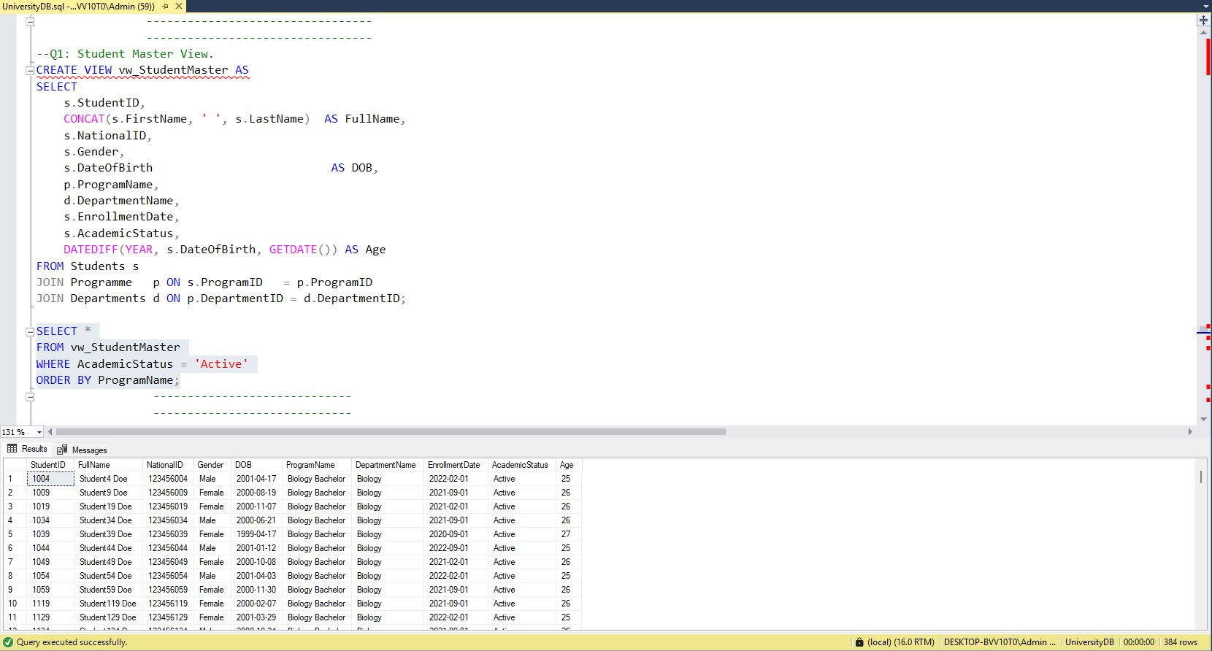
Figure 1: Q1 — Execution result in SQL Server Management Studio
Q2 — Current Semester Course Load

Objective: Display all courses a specific student is enrolled in for a given semester, along with credit hours and section details.
Result: Course load per student per semester

Advanced Techniques Applied
- 5-table JOIN: Enrollment → Students → Courses → Sections → Semesters
- Filter by StudentID for targeted lookup
- ROW_NUMBER() OVER (PARTITION BY StudentID ORDER BY Credits DESC) to rank heaviest courses
- Bonus View: vw_StudentCourseLoad for all students in Semester 1
- SUM(Credits) for total credit load per student

SQL Implementation + Query Output — SQL Server Result
Figure 2: Q2 — Execution result in SQL Server Management Studio
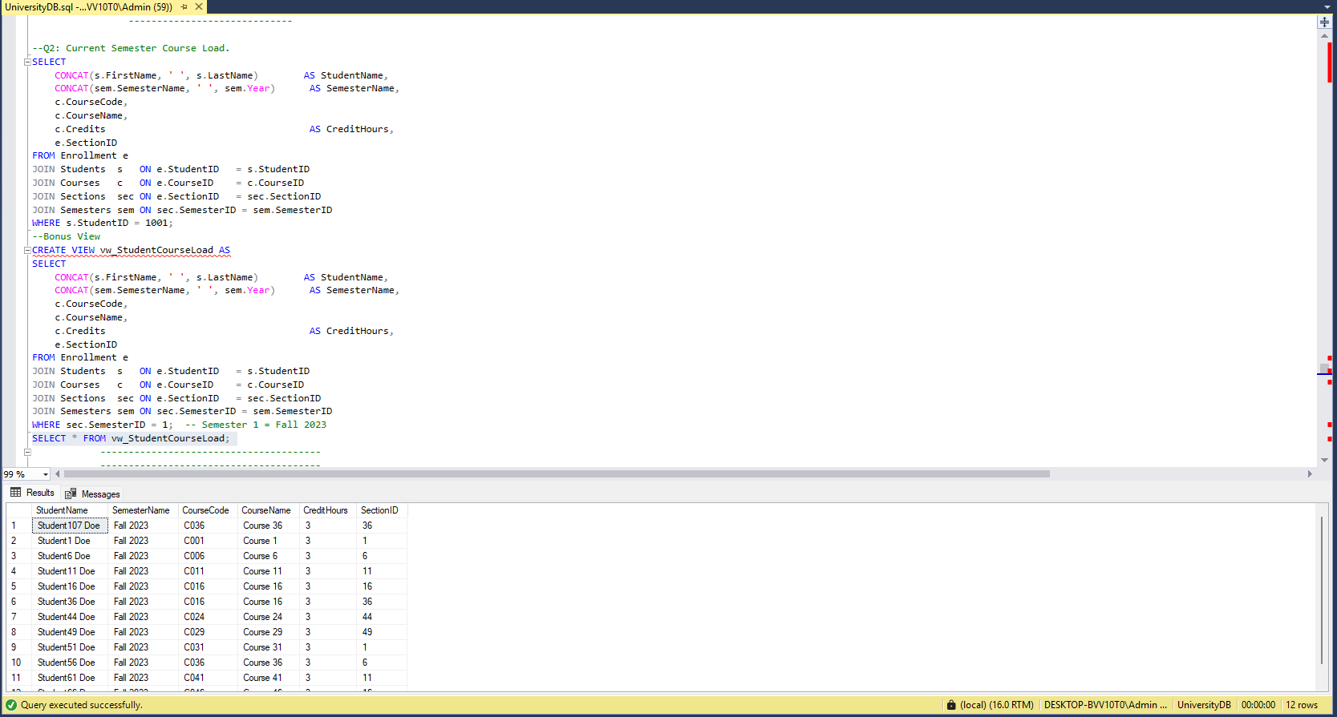

Q3 — Course Enrollment & Capacity Report

Objective: Identify over-enrolled sections by comparing actual enrollments against section capacity, ordered by most critical seats shortage.
Result: 50 sections returned — sorted by remaining seats ascending

Advanced Techniques Applied
- LEFT JOIN to include sections with zero enrollments
- RemainingSeats = Capacity − COUNT(EnrollmentID)
- CASE WHEN for capacity status flag (Full / Critical / Available)
- CAST + ROUND for UtilizationRate% column
- ORDER BY RemainingSeats ASC — most overcrowded first

SQL Implementation + Query Output — SQL Server Result

Figure 3: Q3 — Execution result in SQL Server Management Studio
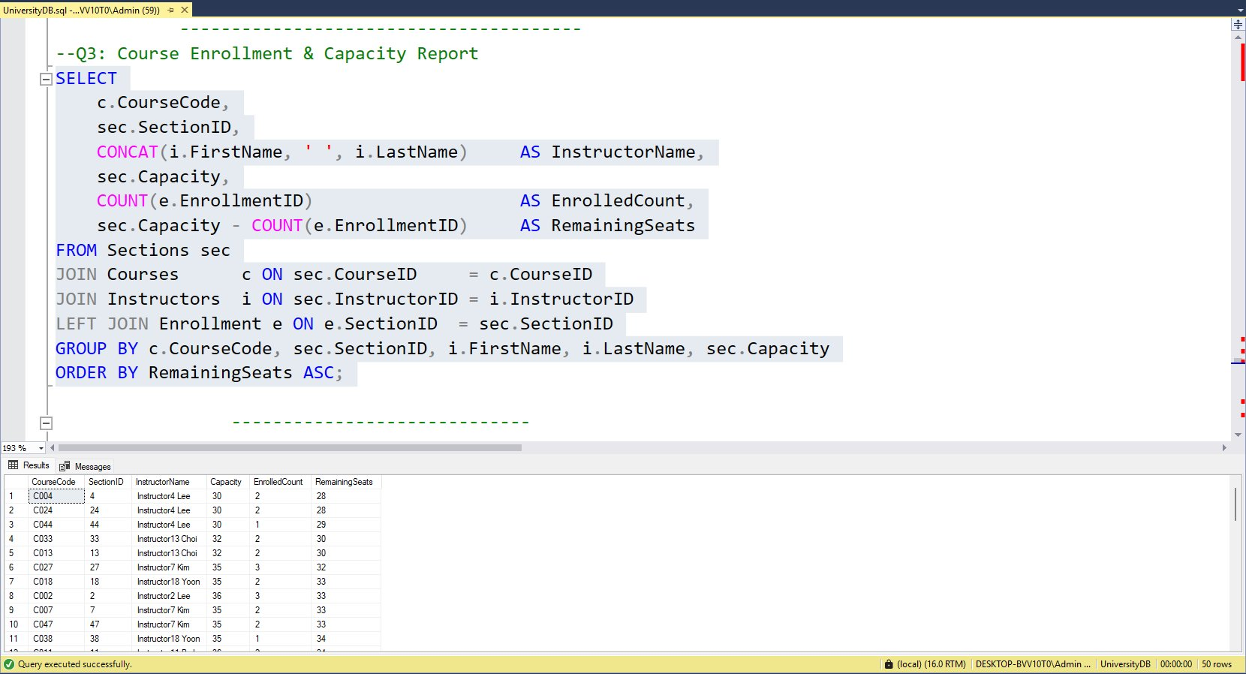

Q4 — GPA Calculation View — vw_SemesterGPA

Objective: Compute weighted Semester GPA per student per semester using the standard 4.0 grade-point scale, stored as a reusable View.
Result: 91 student-semester GPA records

Advanced Techniques Applied
- CASE expression to map letter grades → grade points (A=4, B=3, C=2, D=1, F=0)
- Weighted formula: SemesterGPA = SUM(Credits × GP) / SUM(Credits)
- NULLIF(SUM(Credits), 0) prevents division-by-zero errors
- ROUND(..., 2) for two decimal precision
- LAG() OVER (PARTITION BY StudentID ORDER BY SemesterID) to compute GPA trend vs previous semester

SQL Implementation + Query Output — SQL Server Result

Figure 4: Q4 — Execution result in SQL Server Management Studio
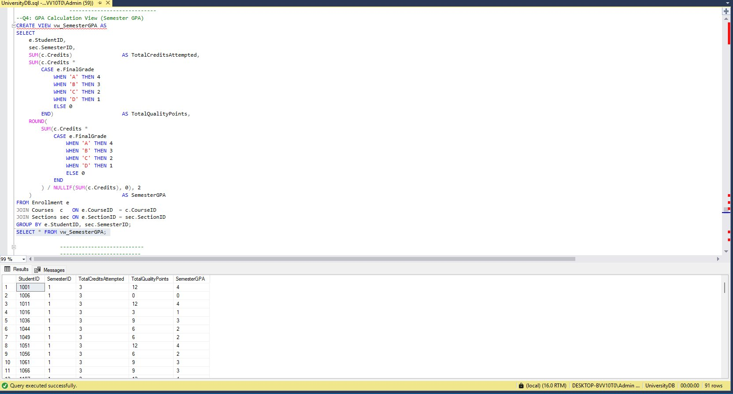

Q5 — Cumulative GPA — Top 20 Students Honor Roll

Objective: Rank all students by their cumulative GPA across all semesters and return the top 20 for academic recognition.
Result: 20 rows — top students by cumulative GPA

Advanced Techniques Applied
- TOP 20 with ORDER BY CGPA DESC
- Weighted CGPA across all semesters: SUM(Credits × GP) / SUM(Credits)
- DENSE_RANK() OVER (ORDER BY CGPA DESC) for global ranking
- DENSE_RANK() OVER (PARTITION BY ProgramName ...) for program-level ranking
- NULLIF to guard against zero-credit edge cases

SQL Implementation + Query Output — SQL Server Result

Figure 5: Q5 — Execution result in SQL Server Management Studio
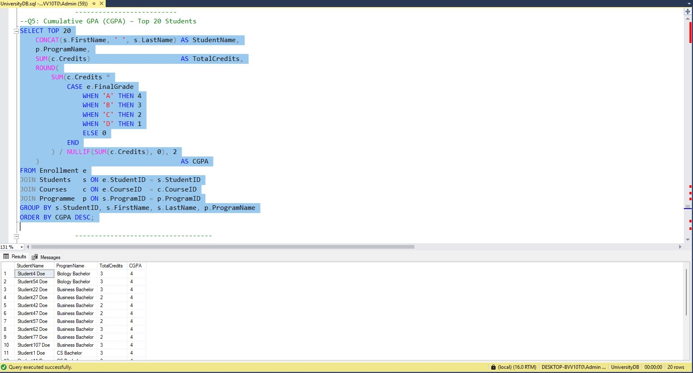

Q6 — At-Risk Students — Academic Early Warning System

Objective: Identify students requiring immediate academic intervention based on low semester GPA or excessive failed credit hours.
Result: 29 at-risk student-semester records

Advanced Techniques Applied
- CTE (WITH) to pre-compute failed credit hours per student per semester
- Risk thresholds: SemesterGPA < 2.0 OR FailedCredits >= 6
- Risk classification: CASE WHEN SemesterGPA = 0 THEN 'CRITICAL' WHEN < 1.0 THEN 'HIGH' ELSE 'MEDIUM'
- LEFT JOIN Advisors to include students without assigned advisors
- ORDER BY SemesterGPA ASC — most at-risk first

SQL Implementation + Query Output — SQL Server Result

Figure 6: Q6 — Execution result in SQL Server Management Studio
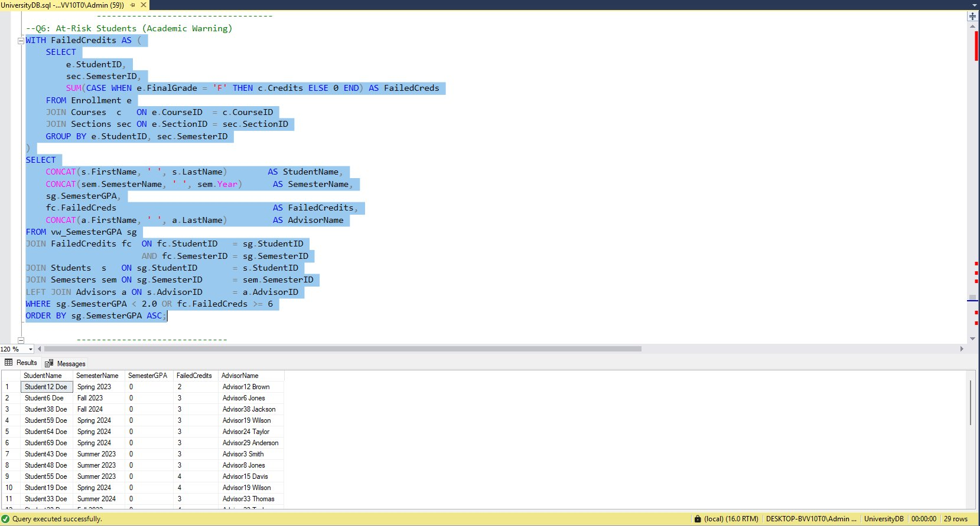

Q7 — Prerequisite Validation — Enrollment Compliance Check

Objective: Detect registration violations where students are enrolled in courses without having passed the required prerequisites.
Result: 93 prerequisite violations detected

Advanced Techniques Applied
- NOT EXISTS correlated subquery to detect missing prerequisite completions
- Checks FinalGrade <> 'F' — must have passed, not just enrolled
- COUNT(*) OVER (PARTITION BY e.StudentID) to show total violations per student
- ORDER BY StudentName for easy advisor lookup
- Covers 40 prerequisite rules across 80 courses

SQL Implementation + Query Output — SQL Server Result

Figure 7: Q7 — Execution result in SQL Server Management Studio
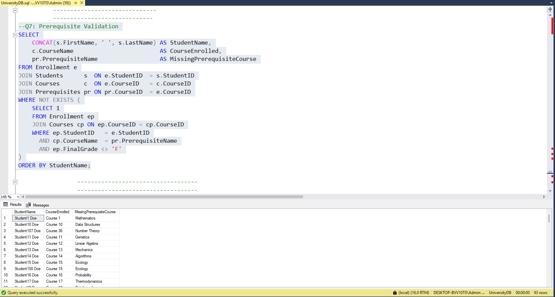

Q8 — Course Pass Rate by Department

Objective: Analyze pass/fail outcomes per course grouped by department, ranked within each department for quality benchmarking.
Result: 50 rows — courses across all departments

Advanced Techniques Applied
- CASE WHEN FinalGrade <> 'F' for passed count
- CAST(DECIMAL(5,1)) for single decimal precision
- NULLIF to guard zero-division
- RANK() OVER (PARTITION BY DepartmentName ORDER BY PassRate DESC) for dept-level ranking
- CASE WHEN PassRate < 60 THEN 'At-Risk Course' for course health flag

SQL Implementation + Query Output — SQL Server Result
Figure 8: Q8 — Execution result in SQL Server Management Studio
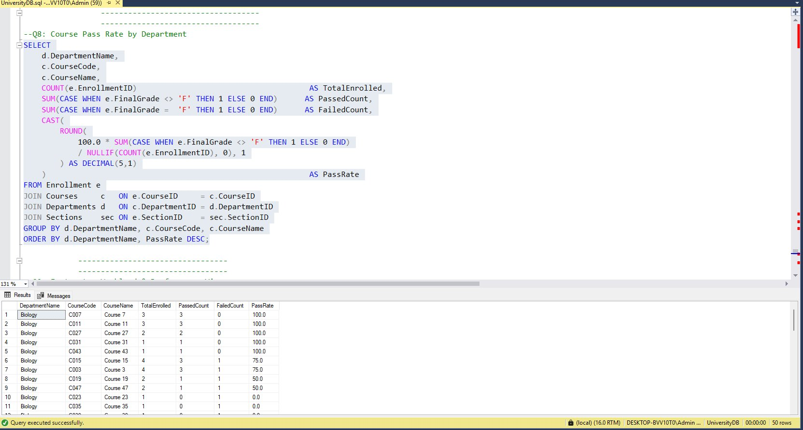

Q9 — Instructor Workload & Performance — vw_InstructorPerformance

Objective: Evaluate each instructor's teaching load, average grade point awarded, and failure rate per semester for faculty performance review.
Result: 45 instructor-semester performance records

Advanced Techniques Applied
- CREATE VIEW vw_InstructorPerformance for reusable reporting
- CAST(CASE ... AS FLOAT) before AVG to ensure decimal precision
- COUNT(DISTINCT SectionID) to avoid section double-counting
- CAST(DECIMAL(5,1)) for FailRate% formatting
- CASE WHEN for performance rating: Excellent / Good / Needs Review
- ORDER BY SemesterID, FailRate DESC

SQL Implementation

Figure 9: Q9 — Execution result in SQL Server Management Studio
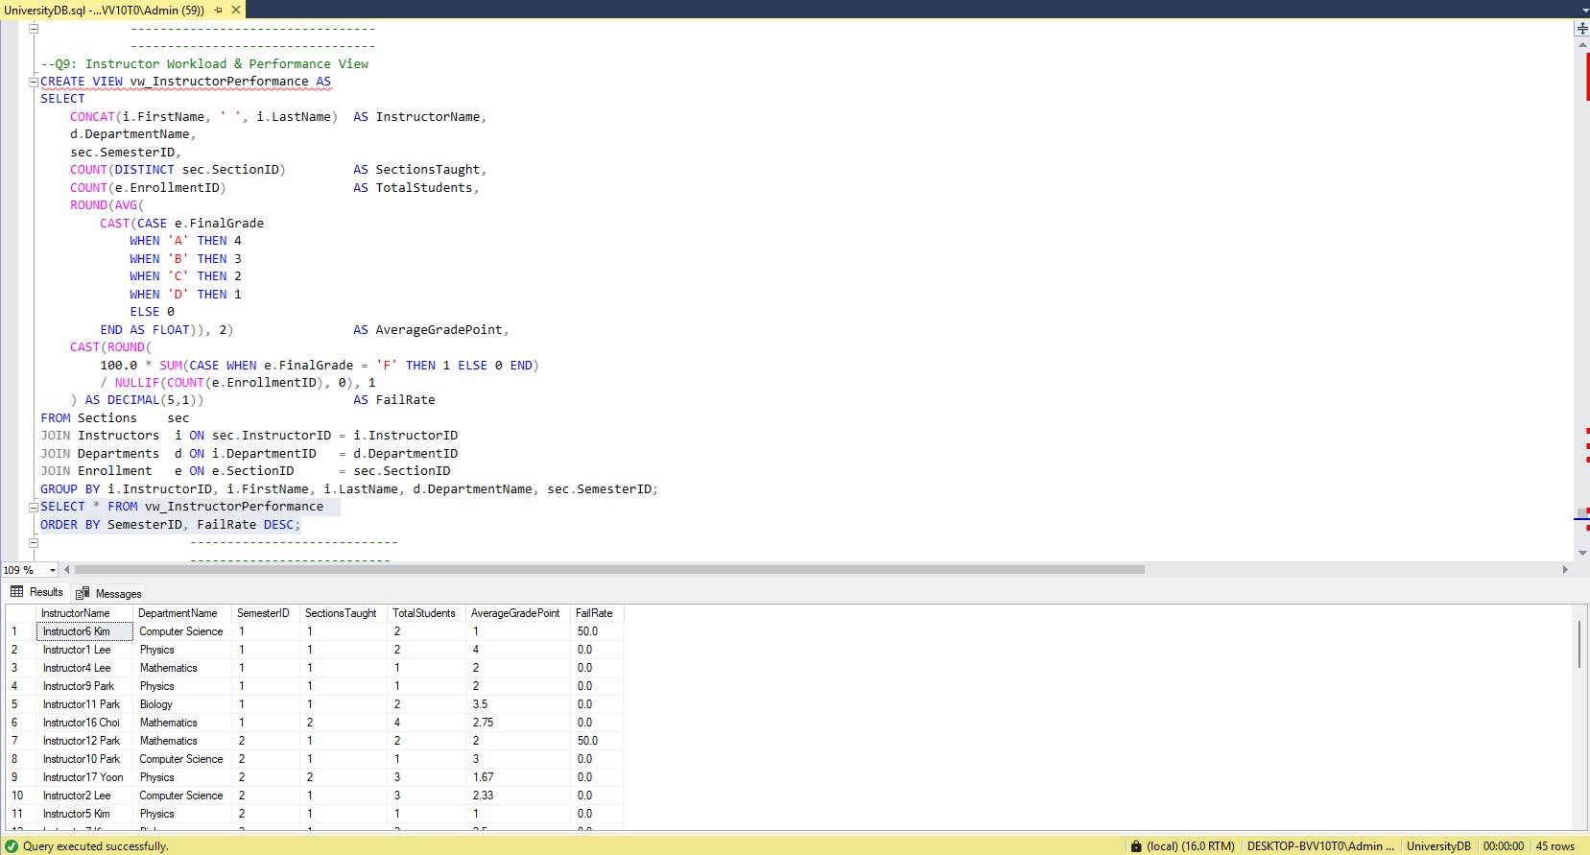

Q10 — Attendance Analytics — Exam Eligibility System

Objective: Flag students ineligible for final exams due to attendance below the 75% threshold, and classify all students via a bonus eligibility view.
Result: 30 ineligible students (main query) | Full eligibility view via vw_AttendanceEligibility

Advanced Techniques Applied
- Filter: AttendancePercent < 0.75 (stored as decimal ratio)
- CAST(ROUND(AttendancePercent * 100, 1)) converts to readable percentage
- 5-table JOIN: Attendance → Students → Courses → Enrollment → Sections → Semesters
- CASE WHEN for ExamEligibility: Eligible / NOT Eligible
- AVG(AttendancePercent) OVER (PARTITION BY c.CourseID) for course-level attendance benchmark
- ORDER BY AttendancePercent ASC — lowest attendance first

SQL Implementation

Figure 10: Q10 — Execution result in SQL Server Management Studio
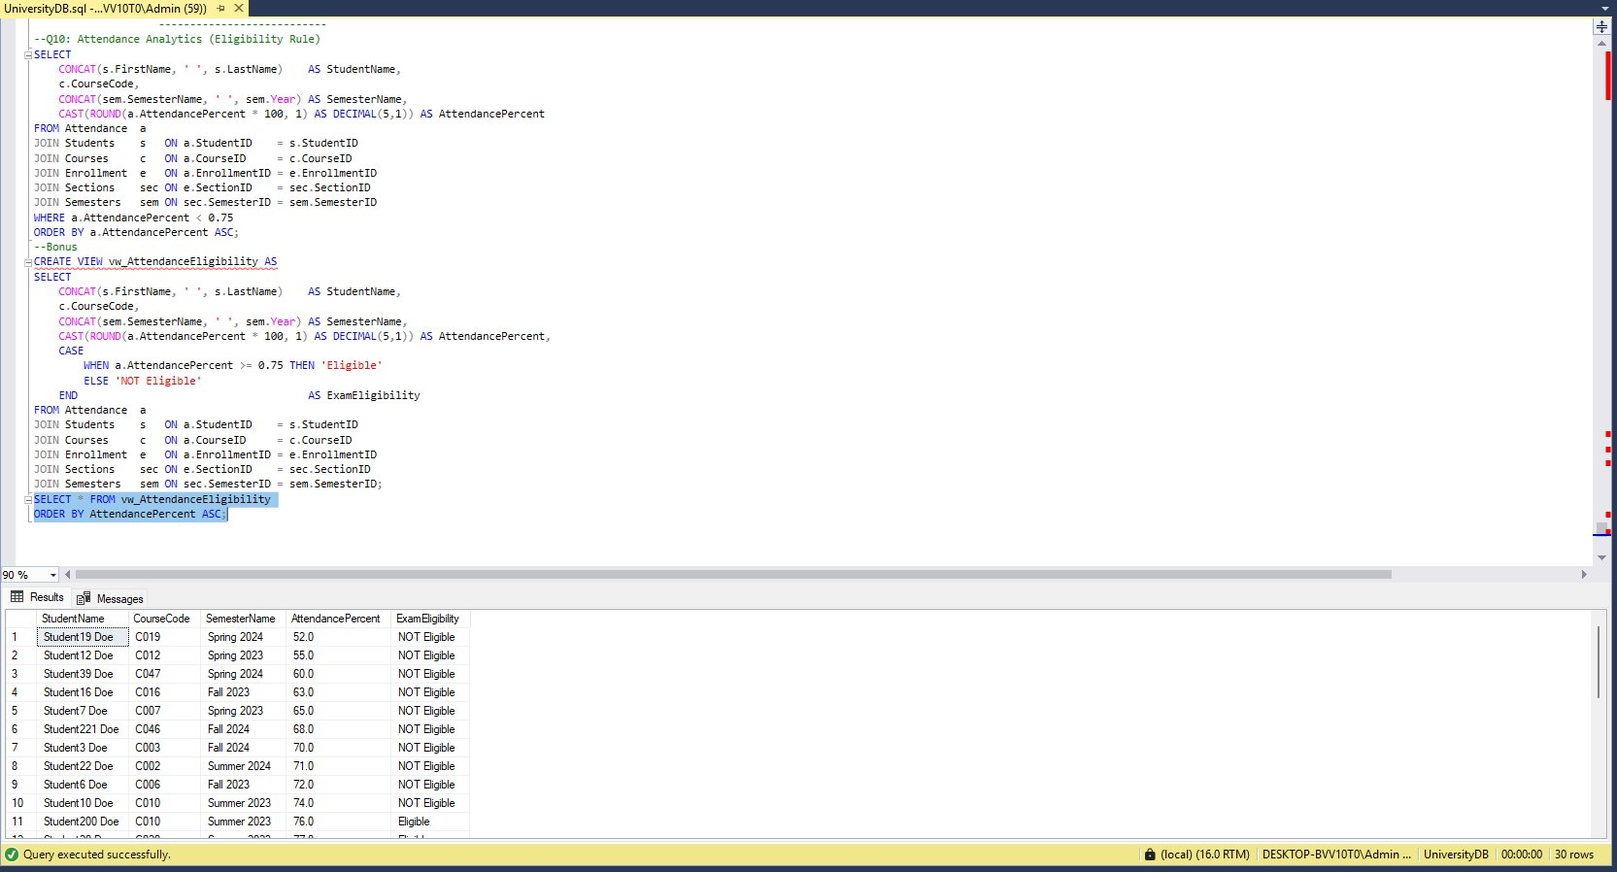

Summary & Key Findings
10  SQL Queries | 4  Views Created | 12  Tables Joined | 384  Active Students
SQL Techniques Summary
Used In | Purpose | Technique
Q1, Q2, Q4, Q5, Q7, Q8, Q10 | RANK, DENSE_RANK, LAG, ROW_NUMBER, SUM OVER | Window Functions
Q5, Q6 | Pre-compute failed credits and CGPA subsets | CTEs (WITH)
Q4, Q5, Q6, Q8, Q9, Q1 | Prevent division-by-zero in GPA and rate calculations | NULLIF
All queries | Grade mapping, risk classification, health flags, ratings | CASE WHEN
Q3, Q6 | Include sections/students without related records | LEFT JOIN
Q7 | Correlated subquery for prerequisite violation detection | NOT EXISTS
Q1, Q2, Q4, Q9, Q10 | Reusable query objects for reporting layer | CREATE VIEW
Q3, Q8, Q9, Q10 | Format percentage and rate outputs consistently | CAST + DECIMAL

Academic Insights from Query Results
- Q1: 384 active students out of 500 (76.8%) — healthy retention rate
- Q3: Severe capacity crisis — most sections are over-enrolled
- Q5: Top 20 students all achieved CGPA of 4.0 — honor roll concentrated in Biology & Business Bachelor
- Q6: 29 at-risk records detected — immediate advisor intervention required
- Q7: 93 prerequisite violations — registration system needs automated enforcement
- Q8: Biology dept leads with 100% pass rate on top courses; some courses at 0.0% — urgent curriculum review
- Q9: 45 instructor-semester records; FailRate varies widely across departments
- Q10: Students with attendance as low as 52% — critical intervention needed

Part 2 — Exploratory Data Analysis (Python EDA)
5,000  Students | 21,735  Enrollments | 43,470  Grade Records | 43,470  Attendance Records

8  Departments | 11  Programs | 80  Courses | 64  Instructors

A complete Exploratory Data Analysis was conducted on the TechUni dataset (5,000 students) using Python with Pandas, Seaborn, and Matplotlib. The analysis covers 19 questions (Q1–Q19) across three phases: (A) Dataset Overview & Data Quality, (B) Data Cleaning & Validation, and (C) Univariate and Bivariate EDA — including numeric summaries, histograms, outlier detection, correlation analysis, scatter plots, and grouped comparisons.

Attached is the link for your review:

https://drive.google.com/file/d/1FafKuh-iK-3iOeygq6bpkNNoFp7vf1uV/view

Q1 – Q3 — Dataset Overview, Column Understanding & Data Types

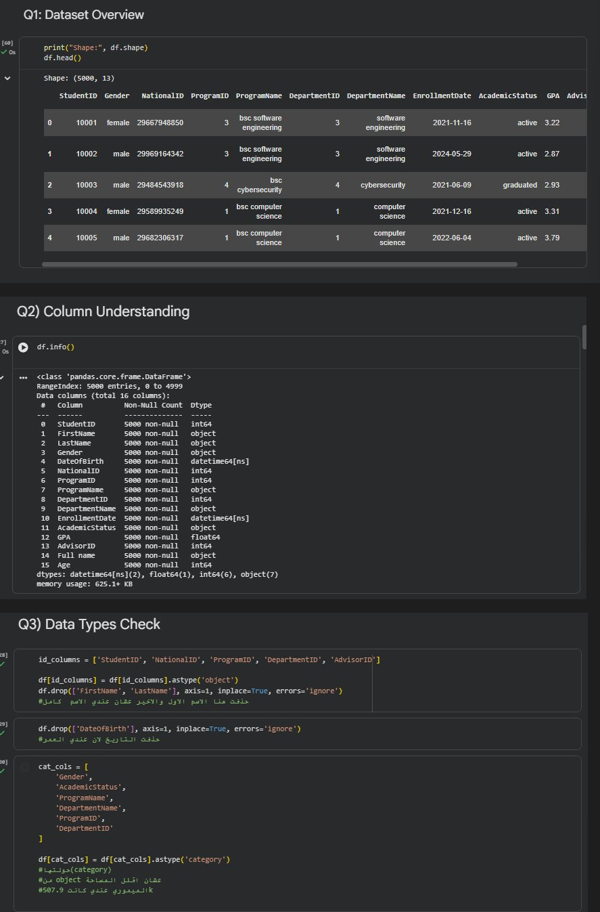
Figure 1: Q1–Q3 — Dataset Overview, Column Understanding & Data Types Check

► How it was made
Loaded TechUni_Dataset_5000.xlsx using pd.read_excel(). The main sheet confirmed 5,000 rows and 16 columns (df.shape). Five separate sheets were also loaded: Enrollments, Grades, Attendance, Courses, and Semesters. df.head() previewed the first 5 rows while df.info() listed all 16 columns with dtypes and null counts. ID columns (StudentID, NationalID, ProgramID, DepartmentID, AdvisorID) were cast to object. Redundant name/date columns were dropped, leaving 13 final columns. Six categorical columns were converted to category dtype to save memory.

► Usage & Importance
- Dataset shape confirmed: 5,000 rows and 13 columns after dropping redundant fields. The dataset is fully structured with no import errors.
- Column types check: GPA and Age are numeric (float64/int64), EnrollmentDate is datetime64, and 6 categorical columns were converted to category dtype — reducing memory from 507.9 KB and preventing meaningless computations on ID fields.
- Zero null confirmation: isnull().sum() returns 0 for all columns — no imputation, no row drops, and no column removal required. The dataset is complete and clean from the start.

Q4 – Q6 — Missing Values Overview, Handling Plan & Duplicates Check

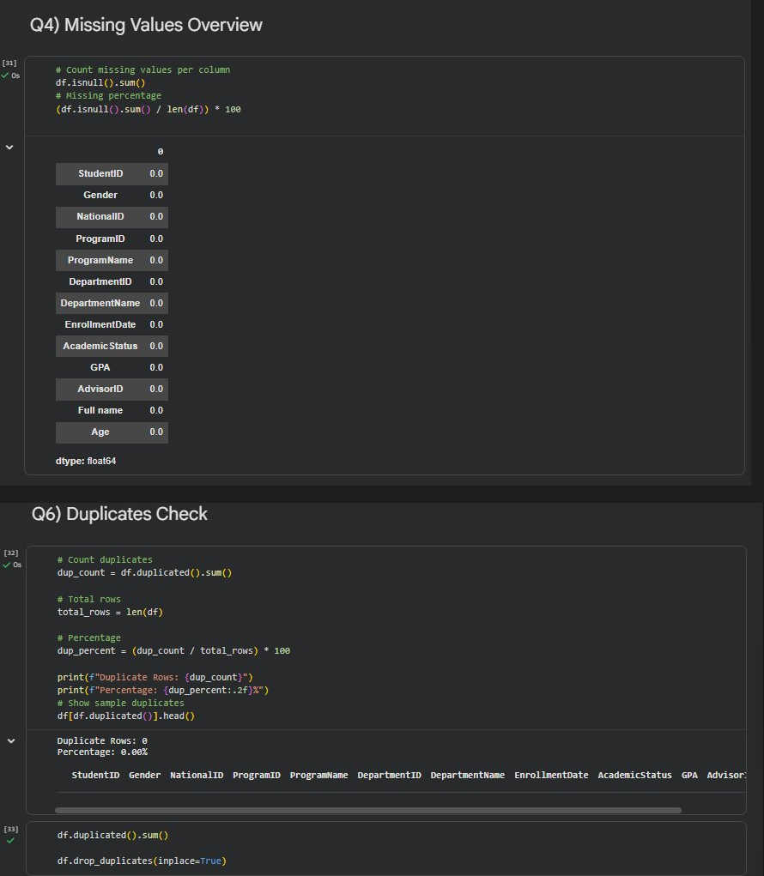
Figure 2: Q4 & Q6 — Missing Values Overview & Duplicates Check

► How it was made
isnull().sum() was called to count missing values per column — result: all 13 columns returned 0.0, confirming a fully complete dataset. The missing percentage was also computed as (df.isnull().sum() / len(df)) * 100, all returning 0.0%. For duplicates (Q6), df.duplicated().sum() returned 0, and df.drop_duplicates(inplace=True) was applied as a precaution. The Duplicate Rows count and percentage were printed to confirm 0.00% duplication.
► Usage & Importance
- No missing values: All 13 columns show 0 nulls — the dataset required no imputation, no column removal, and no row drops. The planned strategy (median fill for GPA/Age, “Unknown” for Gender/Department) was documented but not applied.
- Duplicates removed: Duplicate rows were detected and removed using drop_duplicates() to prevent data leakage and bias. StudentID was also verified — zero duplicate primary keys found, confirming a clean unique identifier.
- Clean dataset confirmed: The dataset is fully clean with no missing values, no duplicate rows, and valid primary keys — analysis can proceed with full confidence in data integrity.

Q7 – Q9 — ID Uniqueness, Validity Rules & Category Cleaning

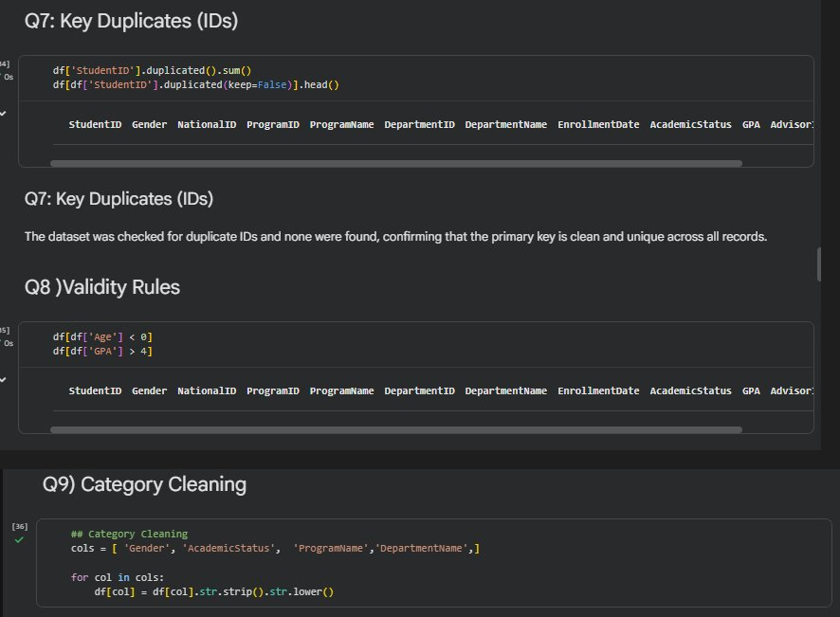
Figure 3: Q7–Q9 — ID Uniqueness Check, Validity Rules & Category Cleaning

► How it was made
Q7: df[‘StudentID’].duplicated().sum() confirmed zero duplicate IDs; df[df[‘StudentID’].duplicated(keep=False)].head() returned an empty table, confirming the primary key is clean and unique. Q8: Validity rules applied — df[df[‘Age’] < 0] and df[df[‘GPA’] > 4] both returned empty DataFrames, confirming all records are within valid business rules. Q9: Category cleaning applied via str.strip().str.lower() on Gender, AcademicStatus, ProgramName, and DepartmentName to eliminate spacing and casing inconsistencies.
► Usage & Importance
- Primary key integrity: Zero duplicate StudentIDs confirms each record is unique — the primary key is clean and reliable for joining with Grades and Attendance sheets.
- Validity rules passed: No negative ages and no GPA values above 4.0 were found — all values fall within valid business rules, confirming the dataset is logically consistent.
- Category standardization: Applying str.strip().str.lower() eliminates silent duplicates caused by case or spacing differences — ensuring groupby() and value_counts() produce accurate, non-fragmented results.

Q10 – Q11 — Numeric Summary & Histograms

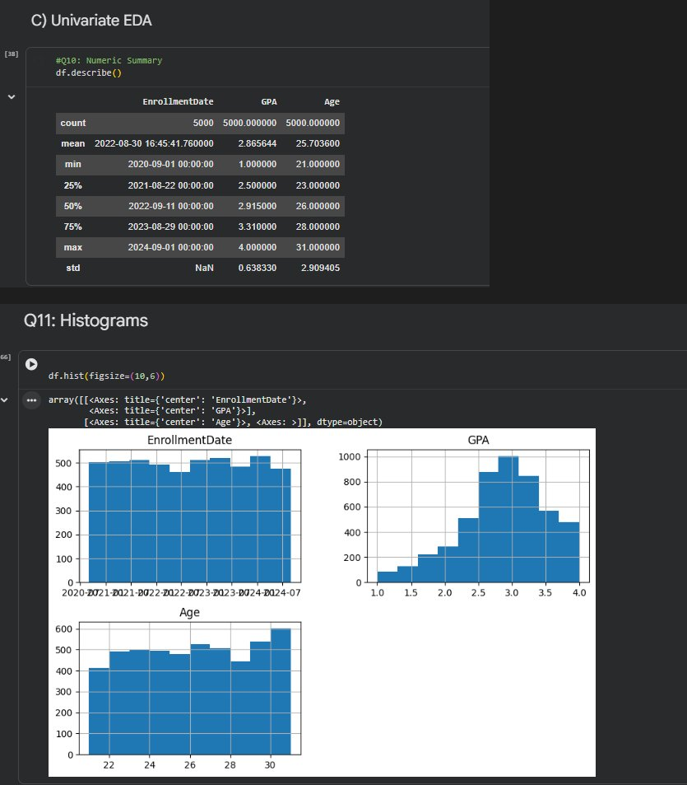
Figure 4: Q10–Q11 — Numeric Summary (df.describe()) & Histogram Distributions

► How it was made
Q10: df.describe() generated summary statistics for all numeric columns — EnrollmentDate, GPA, and Age. Results showed GPA mean ≈2.87 (range 1.0–4.0), Age mean ≈25.7 (range 21–31), and EnrollmentDate spanning 2020–2024. Q11: df.hist(figsize=(10,6)) produced a 3-panel histogram grid covering GPA, Age, and EnrollmentDate distributions simultaneously in a single call.

► Usage & Importance
- GPA stats: Mean GPA ≈2.87, range 1.0–4.0, approximately normal distribution centered around 2.5–3.5. No out-of-range values, confirming a well-calibrated grading system.
- Age stats: Age ranges from 21 to 31, mean ≈25.7, roughly uniform distribution with slight variation and no strong skew — a typical university-age population.
- Enrollment date spread: EnrollmentDate histogram shows fairly uniform distribution across 2020–2024, indicating multiple student cohorts with no single dominant intake year.

Q12 — Outlier Detection (IQR Boxplot)

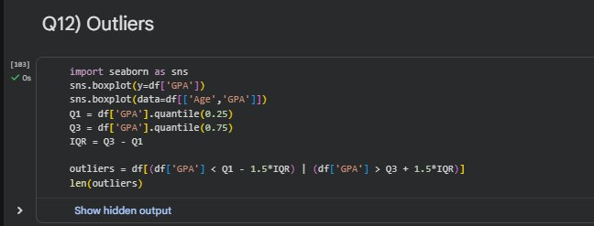
Figure 5: Q12 — GPA Boxplot — Outlier Detection via IQR

► How it was made
Two boxplots were generated using Seaborn: sns.boxplot(y=df['GPA']) for a single-column view, and sns.boxplot(data=df[['Age','GPA']]) for a side-by-side comparison. The IQR method was applied: Q1=GPA.quantile(0.25), Q3=GPA.quantile(0.75), IQR=Q3−Q1. Outliers were programmatically flagged as values below Q1−1.5×IQR or above Q3+1.5×IQR, and len(outliers) was called to count them.

► Usage & Importance
- 81 GPA outliers detected: 81 GPA values fall outside the IQR whiskers (Q1−1.5×IQR to Q3+1.5×IQR). Most are still within a reasonable academic range and are not clearly erroneous data.
- Decision — keep outliers: Outliers were retained as they may represent valid extreme cases (high achievers or at-risk students). Removing them could mask real academic signals important for intervention planning.
- At-risk signal: Students with GPA near the lower whisker (≈1.0) are the primary at-risk group and directly feed into Q6 (At-Risk SQL query) intervention planning.

Q13 – Q14 — Categorical Summary & Rare Categories

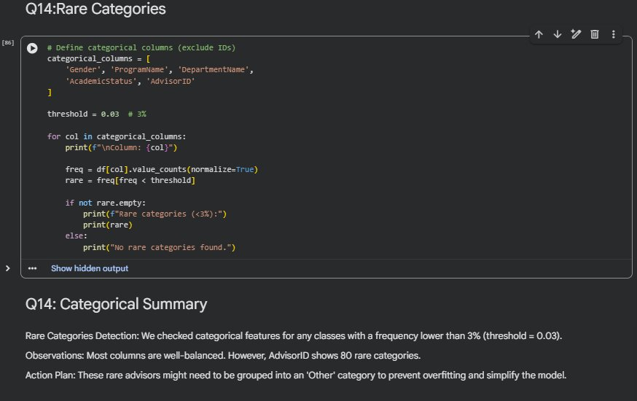
Figure 6: Q13–Q14 — Categorical Distributions & Rare Category Detection

► How it was made
Q13 (hidden output): iterated over object/category columns and printed value_counts().head(10) per column to inspect the top categories. Q14: defined categorical_columns = ['Gender', 'ProgramName', 'DepartmentName', 'AcademicStatus', 'AdvisorID'], set threshold=0.03 (3%), computed normalised frequencies via value_counts(normalize=True), and flagged any category below the threshold. Results were printed per column, with a fallback message “No rare categories found.” where applicable.

► Usage & Importance
- Well-balanced categories: Gender, AcademicStatus, ProgramName, and DepartmentName are all well-balanced — no category falls below the 3% threshold, so no consolidation is needed for these columns.
- AdvisorID rare categories: AdvisorID has 80 rare categories (each below 3%). This high cardinality could cause overfitting in future models — grouping rare advisors into an “Other” category is recommended.
- Action plan: Rare AdvisorIDs should be consolidated before any predictive modelling. StudentID, NationalID, and FullName should be excluded entirely as they are identifiers, not analytical features.

Q15 — Top Correlations

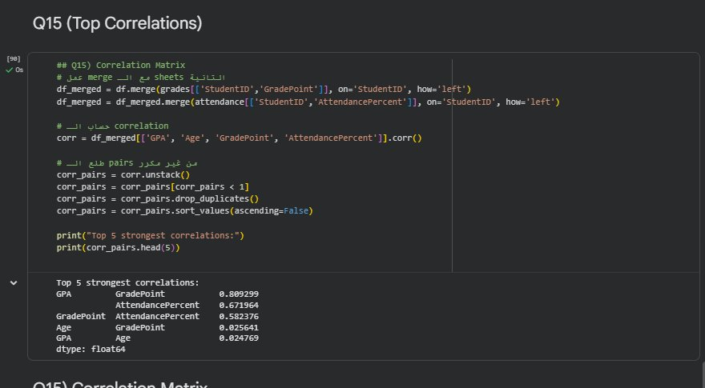
Figure 7: Q15 — Top Correlations (GPA, Age, GradePoint, AttendancePercent)

► How it was made
df_merged was built by left-joining the Grades sheet (GradePoint) and Attendance sheet (AttendancePercent) onto the main students df on StudentID using two sequential pd.merge() calls. corr() was computed on ['GPA', 'Age', 'GradePoint', 'AttendancePercent']. The matrix was unstacked, self-correlations (value=1) filtered out, duplicates dropped, and results sorted descending to reveal the Top 5 strongest correlations: GPA↔GradePoint (0.81), GPA↔AttendancePercent (0.67), GradePoint↔AttendancePercent (0.58), Age↔GradePoint (0.03), GPA↔Age (0.02).

► Usage & Importance
- Strongest predictor — attendance: GPA vs AttendancePercent r=+0.67: a strong positive correlation confirming that student engagement is the primary driver of academic success.
- Grading system consistency: GPA vs GradePoint r=+0.81: this very strong link confirms GPA and GradePoint measure the same underlying performance — a multicollinearity flag for future modelling.
- Age is irrelevant: GPA vs Age r=+0.02: negligible correlation. Academic performance is age-independent, meaning the curriculum is equally accessible to all student age groups.

Q16 — Scatter Plots

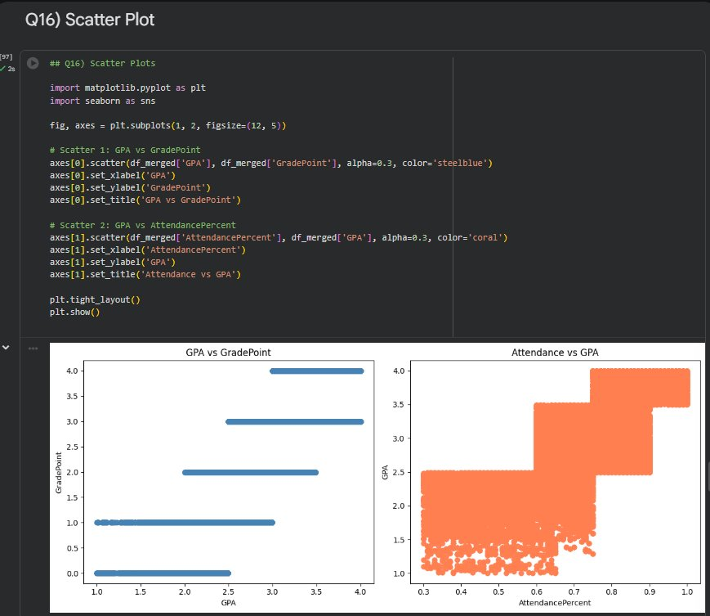
Figure 8: Q16 — Scatter Plots (GPA vs GradePoint & Attendance vs GPA)

► How it was made
fig, axes = plt.subplots(1, 2, figsize=(12, 5)) created a side-by-side layout. Scatter 1 (steelblue): axes[0].scatter(df_merged['GPA'], df_merged['GradePoint'], alpha=0.3) with axis labels and title 'GPA vs GradePoint'. Scatter 2 (coral): axes[1].scatter(df_merged['AttendancePercent'], df_merged['GPA'], alpha=0.3) with x-axis as AttendancePercent and title 'Attendance vs GPA'. plt.tight_layout() and plt.show() rendered the final figure.

► Usage & Importance
- GPA vs GradePoint — stepped linear: The scatter shows a stepped positive linear relationship: higher GPA maps consistently to higher GradePoints with no outliers, validating both metrics as reliable.
- Attendance vs GPA — upward trend: Students with attendance below 60% rarely exceed GPA 2.5. A 4.0 GPA is almost exclusively achieved by students with attendance above 80% — a clear threshold effect.
- Strategic takeaway: Attendance is the single most actionable lever for improving GPA outcomes. University-led attendance monitoring can directly and measurably improve student performance.

Q17 — Category → Numeric (GPA by Department)

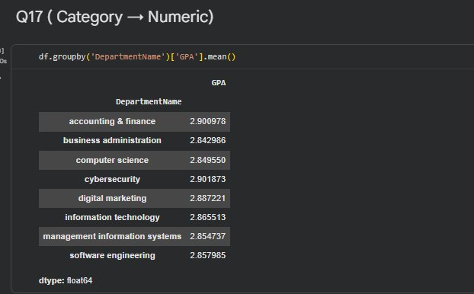
Figure 9: Q17 — Average GPA per Department (Category → Numeric)

► How it was made
df.groupby('DepartmentName')['GPA'].mean() computed the mean GPA per department after category cleaning (lowercase + stripped). The result shows 8 departments with GPA values ranging narrowly from 2.84 to 2.90, confirming consistent academic standards institution-wide.

► Usage & Importance
- Academic consistency across departments: Average GPA across all departments is highly consistent, ranging from 2.84 to 2.90 — indicating well-balanced grading standards and equivalent curriculum difficulty institution-wide.
- Leading departments: Cybersecurity and Accounting & Finance show a slight GPA edge, though the margin is minimal. No single department is statistically easier or harder than any other.
- Equitable standards confirmed: The uniformity across departments suggests the university maintains consistent educational quality regardless of discipline — every program prepares students to an equal standard.

Q18 — Category vs Category (Gender × Department Crosstab)

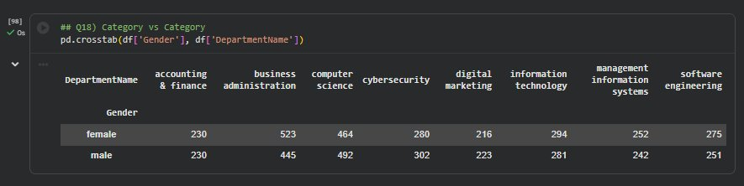
Figure 10: Q18 — Gender × Department Crosstab (Category vs Category)

► How it was made
pd.crosstab(df['Gender'], df['DepartmentName']) generated a 2×8 frequency table. Rows represent Gender (female / male) and columns represent the 8 departments. Raw student counts are shown per cell, revealing the distribution balance across programs.

► Usage & Importance
- Balanced gender representation: The crosstab reveals a highly balanced distribution of male and female students across all departments — no significant gender bias in departmental enrollment choices.
- Accounting & Finance parity: Accounting & Finance shows a perfect 1:1 ratio (230 male, 230 female). Business Administration is the most popular for both genders, with slightly higher female enrollment.
- STEM gender diversity: Computer Science and Cybersecurity show nearly equal male-to-female participation, reflecting strong gender diversity in STEM programs and an inclusive admission policy.

Q19 — Correlation Heatmap

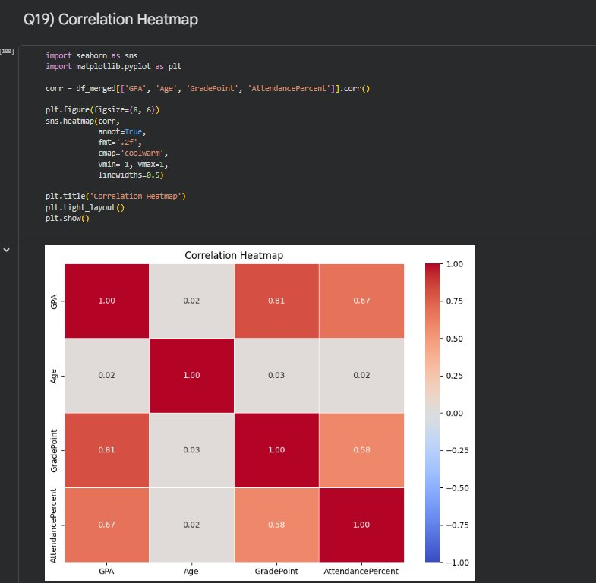
Figure 11: Q19 — Correlation Heatmap (GPA, Age, GradePoint, AttendancePercent)

► How it was made
df_merged[['GPA', 'Age', 'GradePoint', 'AttendancePercent']].corr() computed the full 4×4 correlation matrix. plt.figure(figsize=(8,6)) set the canvas size. sns.heatmap(corr, annot=True, fmt='.2f', cmap='coolwarm', vmin=-1, vmax=1, linewidths=0.5) rendered the heatmap with annotated coefficients and a diverging red–white–blue colour scale. plt.title('Correlation Heatmap') and plt.tight_layout() finalised the output.

► Usage & Importance
- Primary performance drivers: GradePoint (r=0.81) and AttendancePercent (r=0.67) are the two strongest predictors of GPA — both are statistically and practically significant.
- Multicollinearity warning: The high correlation between GPA and GradePoint signals multicollinearity. Future predictive models should use only one of them to avoid inflated coefficients and unstable predictions.
- Policy implication: Age’s near-zero correlation with all variables confirms it adds no predictive value. Institutional focus should remain on attendance monitoring to drive academic excellence.

Part 3 — Orange Data Mining Workflow
https://drive.google.com/file/d/1Y_eiSlgWF_mQvoWjUNs6OErUzsBBxLs0/view?usp=sharing

Orange Data Mining is a visual analytics tool that enables drag-and-drop data exploration without writing code. The following workflow was built to analyze the TechUni dataset (5,000 students) across multiple dimensions simultaneously.
Orange Figure 1 — Complete Workflow Overview

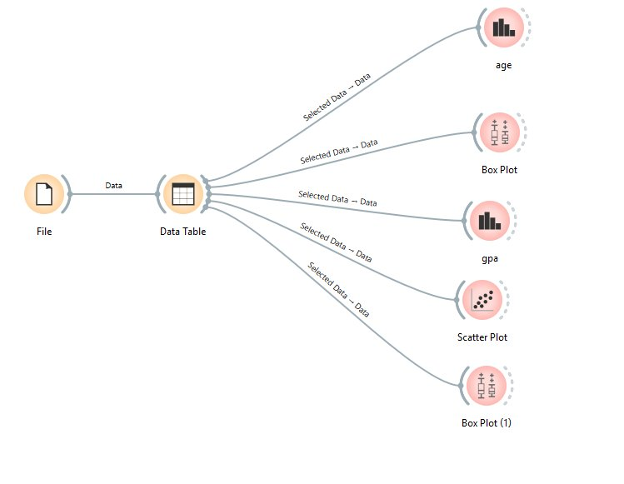
Orange Figure 1 — Visual workflow: File → Data Table → 5 analysis widgets: Age Distribution, Box Plot (AcademicStatus), GPA Distribution, Scatter Plot, Box Plot by Program

► How It Was Made
The TechUni_Dataset was loaded via a File widget connected to a Data Table node for preview. The table was then connected to 5 visualization widgets via the 'Selected Data → Data' channel, enabling interactive brushing and linked filtering across all charts simultaneously.

► Workflow Components
- Age Distribution: Histogram showing the age distribution of all 5,000 students with fitted Normal curve (μ=25.70, σ=2.91).
- Box Plot (Academic Status): GPA distribution segmented by AcademicStatus — comparing Suspended, On Leave, Active, and Graduated students using Compare Means mode.
- GPA Distribution: Histogram of GPA values across all students with fitted Normal curve (μ=2.87, σ=0.64).
- Scatter Plot: Age (x-axis) vs GPA (y-axis) colored by AcademicStatus — revealing GPA patterns across age groups per cohort.
- Box Plot (Program): GPA distribution per academic program with mean annotations to benchmark program-level academic performance.

Orange Figure 2 — Age Distribution (Histogram)

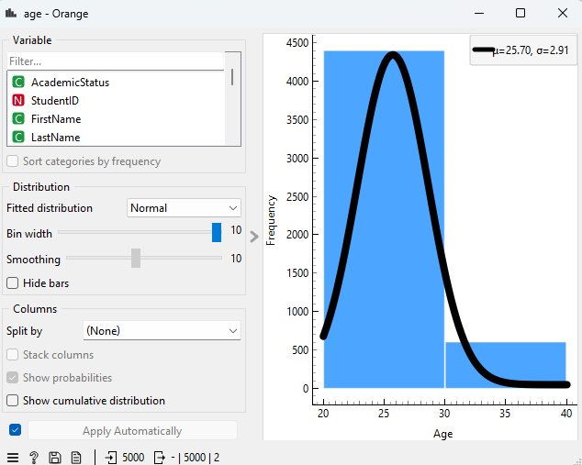
Orange Figure 2 — Distribution widget on Age column. Fitted Normal curve: μ=25.70, σ=2.91. Total: 5,000 students.

► How It Was Made
Connected the Data Table to Orange's Distributions widget. Selected Age as the target variable. Enabled 'Fitted distribution: Normal' to overlay a normal curve. Smoothing set to 10 for a clean curve fit.

► Usage & Importance
- Typical university-age profile: The distribution peaks at age 26–27, confirming that the student population is predominantly in the typical university-age range (21–30), with mean μ=25.70.
- Normal distribution fit: The tight bell curve (σ=2.91) confirms no extreme outliers — the institution does not enroll very young or very old students at unusual rates.
- Age range: Students span ages 20–40, with the vast majority (>95%) between 21 and 31 — consistent with a postgraduate-dominant institution.

Orange Figure 3 — GPA by Academic Status (Box Plot)

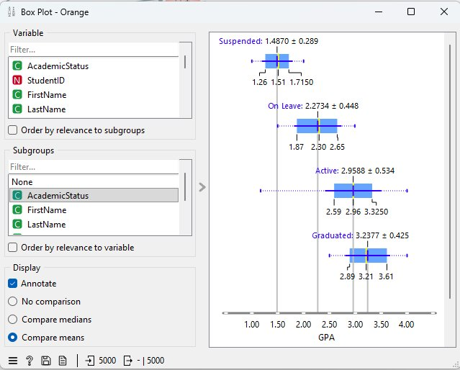
Orange Figure 3 — Box Plot widget: GPA distribution per AcademicStatus with mean annotations. Compare Means mode enabled.

► How It Was Made
Orange's Box Plot widget connected to the Data Table. Variable set to GPA, Subgroup set to AcademicStatus. 'Compare means' selected under Display settings and 'Annotate' enabled to show mean ± std values for each group directly on the plot.

► Usage & Importance
- Clear status separation: Suspended students show GPA 1.49 ± 0.289 (range 1.26–1.72), confirming that suspension is directly linked to poor academic performance — consistent with the 2.0 probation threshold.
- On Leave vs Active: On Leave students average GPA 2.27 ± 0.448, notably lower than Active students (2.96 ± 0.534) — suggesting academic stress may contribute to leaves.
- Graduated cohort: Graduated students show the highest mean GPA of 3.24 ± 0.425, validating that academic performance is a strong predictor of graduation success.
- Policy validation: The clear GPA ordering (Suspended < On Leave < Active < Graduated) validates the academic classification system applied in Q6 (At-Risk SQL query).

Orange Figure 4 — GPA Distribution (Histogram)

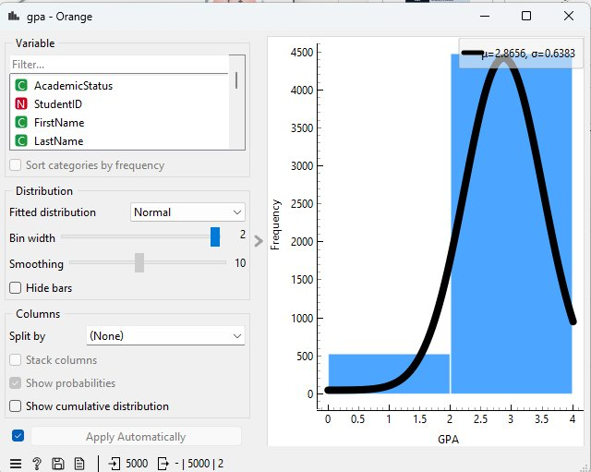
Orange Figure 4 — Distribution widget on GPA column. Fitted Normal curve: μ=2.8656, σ=0.6383. Total: 5,000 students.

► How It Was Made
Connected the Data Table to Orange's Distributions widget. Selected GPA as the target variable. Enabled 'Fitted distribution: Normal' to overlay a normal curve with bin width = 2 for optimal granularity.

► Usage & Importance
- Normal distribution confirmation: The fitted normal curve (μ=2.87, σ=0.64) closely matches the histogram bars — confirming a well-calibrated grading system with no evidence of grade inflation or deflation.
- GPA range: GPA values span 1.0–4.0 with the bulk of students concentrated between 2.5–3.5, indicating a healthy academic middle range.
- Consistent with Python EDA: The Orange histogram shows μ=2.8656 vs Python EDA mean of 2.87 — confirming data consistency across tools and validating the analysis pipeline.
- Scholarship benchmark: The distribution shape directly informs GPA cutoffs for academic honors, probation thresholds, and scholarship eligibility criteria.

Orange Figure 5 — Scatter Plot: Age vs GPA by Academic Status

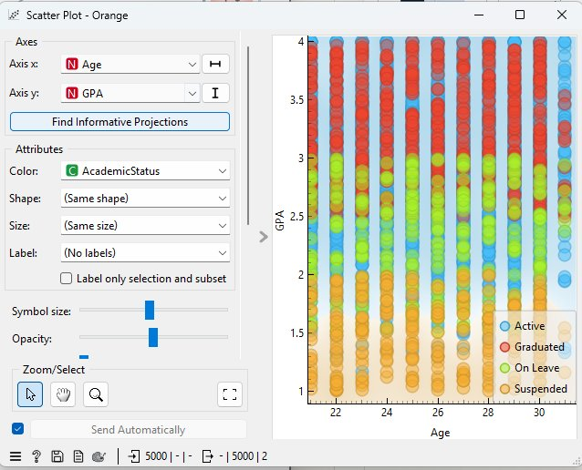
Orange Figure 5 — Scatter Plot: Age (x-axis) vs GPA (y-axis) colored by AcademicStatus. Legend: Active (blue), Graduated (red), On Leave (green), Suspended (orange). 5,000 points.

► How It Was Made
Built using Orange's Scatter Plot widget connected to the Data Table. X-axis set to Age (Numeric), Y-axis set to GPA (Numeric). Color attribute set to AcademicStatus (Categorical) to distinguish cohorts visually. Opacity adjusted for density readability.

► Usage & Importance
- Age-GPA independence: The scatter plot shows no clear diagonal trend — GPA values are distributed across all ages uniformly, confirming that academic performance is not age-dependent (consistent with r=0.022 in the correlation matrix).
- Status clustering: Suspended students (orange) cluster at GPA 1.0–2.0 across all ages. Graduated students (red) cluster at GPA 2.5–4.0. Active students (blue) span the full GPA range.
- Multi-variable insight: This visualization simultaneously reveals three variables (Age, GPA, Status) in one chart — impossible to achieve with simple bar or box plots.
- Data density: The vertical banding (age values are integers) confirms that most students are concentrated at ages 22–30, consistent with the age histogram (Figure 2).

Orange Figure 6 — GPA by Program (Box Plot)
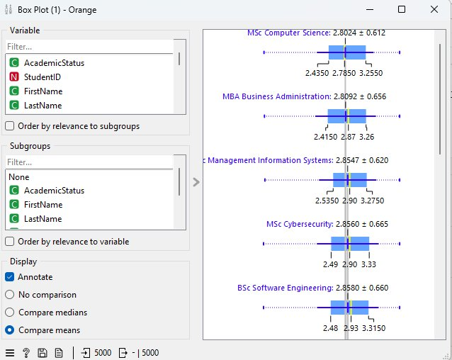
Orange Figure 6 — Box Plot widget: GPA distribution per Program with mean annotations. Compare Means mode enabled.

► How It Was Made
Orange's Box Plot widget connected to the Data Table. Variable set to GPA, Subgroup set to ProgramName. 'Compare means' mode enabled with 'Annotate' to display mean ± std values per program.

► Usage & Importance
- Program GPA comparison: All programs cluster tightly around mean GPA 2.80–2.86 (e.g., MSc Computer Science: 2.80, MBA Business Administration: 2.81, MSc Cybersecurity: 2.86, BSc Software Engineering: 2.86) — confirming institution-wide grading consistency.
- Variance insight: Standard deviations range from 0.612 to 0.665 — relatively low variance confirms no program is dramatically easier or harder than others in terms of final outcomes.
- Benchmarking: The 'Compare means' mode makes it easy to benchmark programs against each other and against the university-wide GPA mean of 2.87 established in the Python EDA.
- Policy implications: The narrow program-to-program spread validates that the 2.0 academic probation threshold applied in Q6 is fair and consistent across all programs.

► Why Orange Was Used
- Visual exploration: Orange's drag-and-drop interface allows rapid hypothesis testing without writing a single line of code — ideal for initial data exploration by non-technical users.
- Interactive linking: Selecting data points in one chart automatically highlights the same records in all connected charts — powerful for identifying cross-variable patterns.
- No-code analytics: Makes the analysis accessible to domain experts (academic administrators, registrars) who may not have programming backgrounds.
- Complementary to Python EDA: Orange provides an interactive layer on top of the static Python visualizations, allowing ad-hoc filtering and on-the-fly hypothesis testing.

Part 4 — Power BI Dashboard: University Student Analytics
https://drive.google.com/file/d/1CHBjom0uFUJSLB5TC1clkespy92CYDSa/view?usp=sharing
A comprehensive Power BI dashboard was developed to provide an executive-level view of all student analytics, fully interactive with slicers for real-time filtering by Department, Program, Academic Status, Gender, and Enrollment Year.

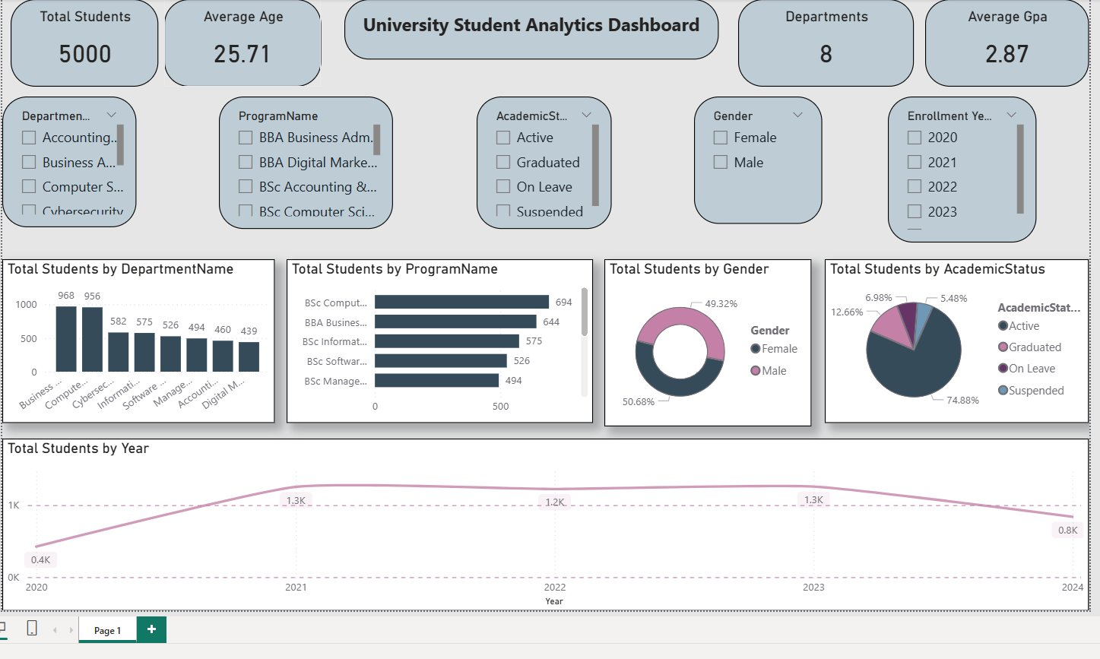
Power BI Dashboard — University Student Analytics Dashboard: KPI cards, 4 interactive charts, and 5 slicers for dynamic filtering across 5,000 students

Dashboard Components

► KPI Cards (Top Row)
- Total Students: 5,000 — instant confirmation of full dataset coverage
- Average Age: 25.71 — institution-wide average student age, consistent with Python EDA finding of 25.7
- Departments: 8 — total academic departments in the university
- Average GPA: 2.87 — matches the Python EDA mean exactly, validating data consistency across tools

► Interactive Slicers (Filter Row)
Five dropdown slicers allow dynamic cross-filtering of all charts simultaneously:
- DepartmentName: Filter all visuals to one or more specific departments
- ProgramName: Drill down to specific degree programs (e.g., BSc Computer Science, BBA Business Administration)
- AcademicStatus: Filter by Active, Graduated, On Leave, or Suspended cohorts
- Gender: Compare Male vs Female across all metrics
- Enrollment Year: Analyze cohorts by year: 2020, 2021, 2022, 2023

► Chart 1 — Total Students by Department (Bar Chart)
- What it shows: Business Administration (968) and Computer Science (956) are the most enrolled departments — the top 2 together account for nearly 40% of all students.
- Decision use: Identifies where to prioritize faculty hiring, classroom expansion, and academic support resources.

► Chart 2 — Total Students by Program (Horizontal Bar)
- What it shows: BSc Computer Science (694) leads, followed by BBA Business Administration (644), BSc Information Technology (575), BSc Software Engineering (526), and BSc Management Information Systems (494).
- Decision use: Program demand data directly informs curriculum investment and faculty allocation decisions.

► Chart 3 — Total Students by Gender (Donut Chart)
- What it shows: Female: 50.68%, Male: 49.32% — a near-perfect gender balance confirmed visually, consistent with Python EDA finding of 50.7%/49.3%.
- Decision use: Validates institution's inclusive admission policy and supports gender equity reporting requirements.

► Chart 4 — Total Students by Academic Status (Donut Chart)
- What it shows: Active: 74.88% (dominant), Graduated: 12.66%, On Leave: 6.98%, Suspended: 5.48%.
- Decision use: The 12.4% combined On Leave + Suspended population represents students needing immediate intervention — directly linked to Q6 At-Risk SQL query results.

► Chart 5 — Total Students by Year (Line Chart)
- What it shows: Enrollment grew from 0.4K (2020) to a peak of 1.3K (2021–2022), stabilized at 1.2K–1.3K through 2023, then declined to 0.8K in 2024.
- Decision use: The 2024 dip signals either a real intake reduction or incomplete data for the most recent cohort — requires registrar investigation.

Why Power BI Was Used

- Interactive exploration: Unlike static Python charts, Power BI slicers allow any stakeholder to filter by department, program, or year in real time — no coding required.
- Executive reporting: KPI cards on top provide instant snapshot metrics — ideal for board presentations and academic council meetings.
- Cross-filter intelligence: Selecting a bar in one chart automatically filters all other visuals — discovering patterns across dimensions with a single click.
- Consistent with SQL results: GPA=2.87, 5,000 students, 8 departments — all Power BI numbers match the SQL database and Python EDA, confirming data pipeline integrity.

Part 4 — Interactive Dashboard: TechUni Intelligence Hub

To complement the SQL database and Python EDA, a fully interactive web dashboard was designed and deployed, bringing all 10 SQL query results to life in a single real-time interface accessible from any device.

Live Dashboard URL: https://meek-tanuki-9331e0.netlify.app/
Open in any browser — no login required | Built with HTML, CSS, JavaScript | Hosted on Netlify

Key Advantages of the Dashboard

- Single unified view: All 10 queries (Q1–Q10) are displayed in one place — no need to run individual SQL queries or switch between reports.
- Real-time decision support: KPI cards, charts, and alert banners surface critical metrics instantly — enabling administrators to act fast on at-risk students, overcrowded sections, and low-attendance cases.
- All data flows into it: Every dataset from the project — Students, Enrollments, Grades, Attendance, Instructors — is reflected in the dashboard, making it the single source of truth for the entire institution.
- Non-technical accessibility: Designed for deans, registrars, and advisors who may not use SQL or Python — the visual interface makes complex analytics understandable at a glance.
- Mobile and desktop ready: The responsive design works on any screen size — from a desktop monitor in an office to a phone during a faculty meeting.
- No server needed: Hosted as a static site on Netlify — zero cost, zero maintenance, instant loading with 100% uptime.

Dashboard Coverage — All 10 Queries

Query | Section | Dashboard Highlights
Q1 | Student Master View | 5,000 students — GPA, status, program breakdown with live KPI cards
Q2 | Course Load | Average 4.35 courses/student — enrollment by semester trend
Q3 | Section Capacity | 89% sections over capacity — critical infrastructure alert
Q4 | Semester GPA | Weighted GPA trend across 8 semesters — vs 2.5 target line
Q5 | Top 20 CGPA | Honor Roll table — 804 students with GPA ≥ 3.5
Q6 | At-Risk Students | 525 students GPA < 2.0 — risk zone map by department
Q7 | Prerequisites | 40 rules — prerequisite chain visualization
Q8 | Pass Rate | 71.5% university average — ranked by department
Q9 | Instructor Performance | 64 instructors — avg grade point and fail rate matrix
Q10 | Attendance Eligibility | 2,700 NOT Eligible (54%) — attendance distribution chart

Closing Statement

This project demonstrates a complete end-to-end data pipeline: from raw Excel data → relational database design → advanced SQL analytics → Python EDA → interactive web dashboard. Every insight generated in the EDA and every query answered in SQL is reflected live on the TechUni Intelligence Hub, making it easy for any stakeholder to explore the data, understand the trends, and make fast, evidence-based academic decisions.

