**Problem 1:**

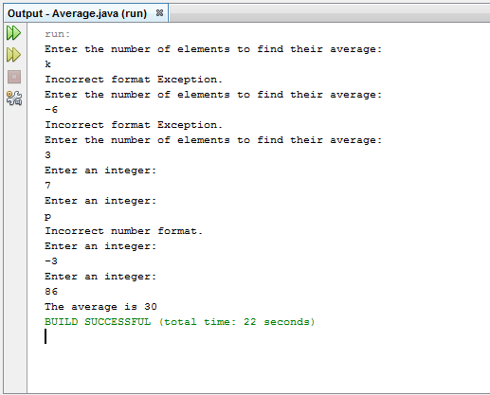

**Problem 2:**

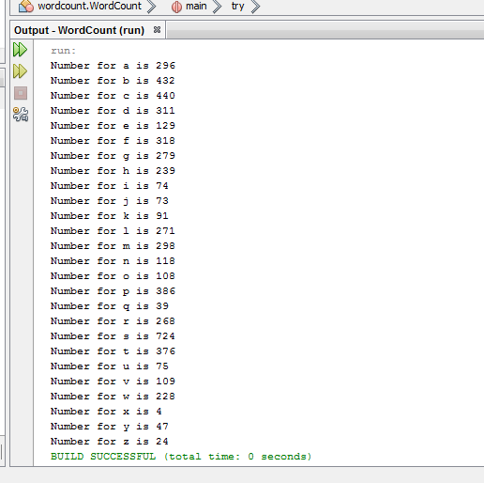

**Problem 3:**

**File on the right, named “star – Copy”, is the copy of the original file (w/ multiple spaces.)**

**File on the left, named “star”, is the file Java has been dealing with.**

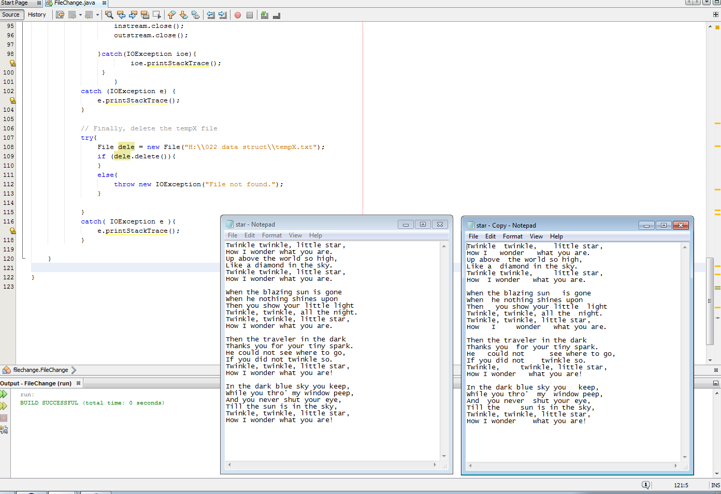

**Also, there’s no more “tempX” file in the folder after running the program.**

