**1. MATLAB Code & Plots:**

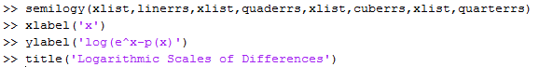**Check the differences:**

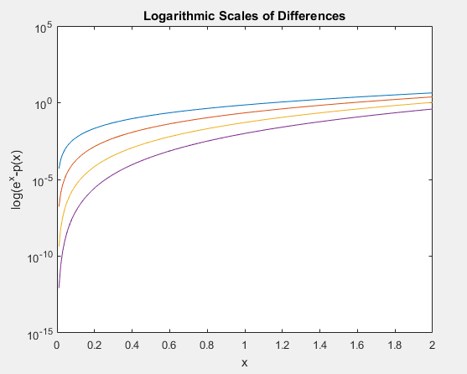

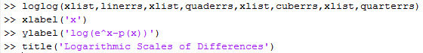

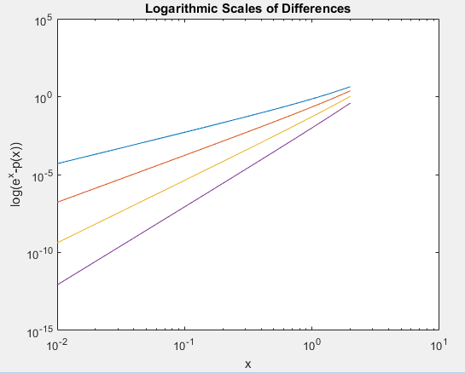

**2. Textbook Problem 2:**

**(a) $f\left(x\right)=\sqrt{x}, a=1$**

Linear tp: $p\left(x\right)=1+\frac{1}{2}(x-1)$

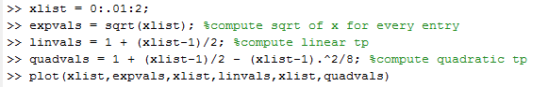Quadratic tp: $p\left(x\right)=1+\frac{1}{2}(x-1)-\frac{1}{8}{(x-1)}^{2}$

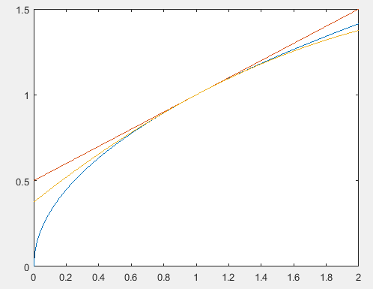

Where the blue line represent the **function**, the red line represents the **linear** Taylor polynomial, and the yellow line represents the **quadratic** Taylor polynomial.

**(b) $f\left(x\right)=sin\left(x\right), a= \frac{π}{4}$**

Linear tp: $p\left(x\right)=\sin\left(\frac{π}{4}\right)+\cos\left(\frac{π}{4}\right)*(x-\frac{π}{4})=\frac{1}{\sqrt{2}}+\frac{1}{\sqrt{2}}(x-\frac{π}{4})$

Quadratic tp:

$p\left(x\right)=\frac{1}{\sqrt{2}}+\frac{1}{\sqrt{2}}\left(x-\frac{π}{4}\right)-\frac{1}{2}\sin\left(\frac{π}{4}\right)*{\left(x-\frac{π}{4}\right)}^{2}=\frac{1}{\sqrt{2}}+\frac{1}{\sqrt{2}}\left(x-\frac{π}{4}\right)-\frac{1}{2\sqrt{2}}{(x-\frac{π}{4})}^{2}$

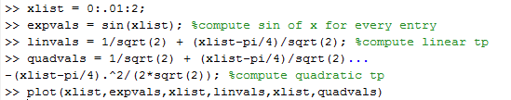

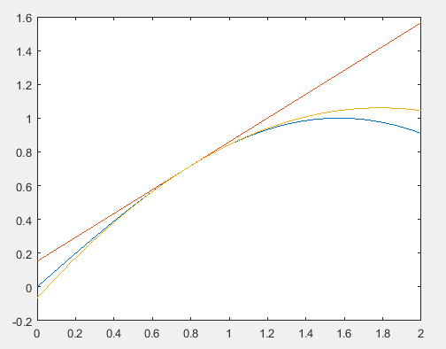

Where the blue line represent the **function**, the red line represents the **linear** Taylor polynomial, and the yellow line represents the **quadratic** Taylor polynomial.

**(c) $f\left(x\right)=e^{cos(x)}, a=0$**

Linear tp: $p\left(x\right)=e+\left(-\sin\left(0\right)*e^{\cos\left(0\right)}\right)*\left(x-0\right)=e$

Quadratic tp:

$$p\left(x\right)=e+0+\frac{1}{2}(-\cos\left(0\right)*e^{\cos\left(0\right)}+\left(-{\sin\left(0\right)}^{2}*e^{\cos\left(0\right)}\right)*{\left(x-0\right)}^{2}=e-e*\frac{1}{2}x^{2}$$

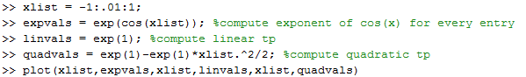

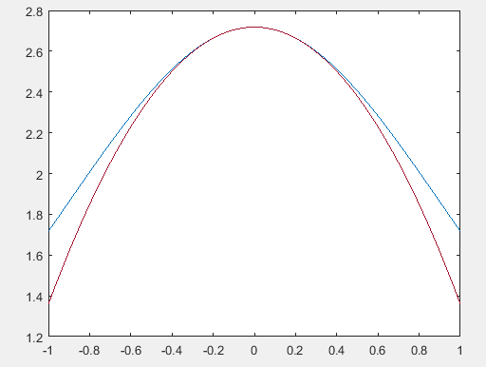

Where the blue line represent the **function**, the red line represents the **quadratic** Taylor polynomial. (The Taylor polynomials of this function only has even powers.)

**(d) $f\left(x\right)=log\left(1+e^{x}\right), a=0$**

Linear tp: $p\left(x\right)=\log\left(2\right)+\frac{e^{0}}{e^{0}+1}*\left(x-0\right)=\log\left(2\right)+\frac{1}{2}x$

Quadratic tp: $p\left(x\right)=\log\left(2\right)+\frac{1}{2}x+\frac{1}{2}x*\frac{e^{0}\left(1+e^{0}\right)-e^{0}e^{0}}{{\left(1+e^{0}\right)}^{2}}=\log\left(2\right)+\frac{1}{2}x+\frac{1}{8}x^{2}$

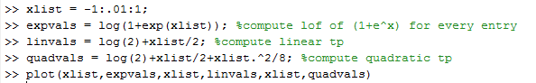

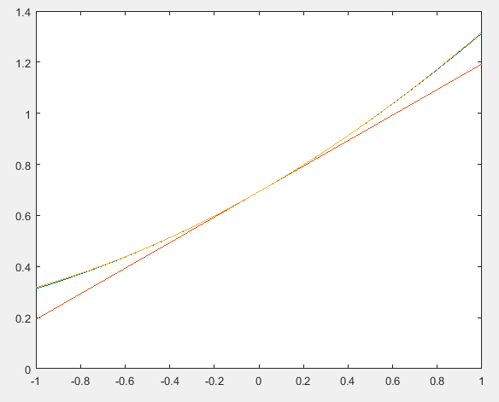

Where the blue line represent the **function**, the red line represents the **linear** Taylor polynomial, and the yellow line represents the **quadratic** Taylor polynomial.

(The quadratic Taylor polynomial is very close to the original function.)