**Problem 1:**

Since $b^{2}≫4ac$, $\sqrt{b^{2}-4ac}$ will be very close to $\left|b\right|$. To get the smaller root, we subtract the $\left|b\right|$.

When b is positive, for the x+, the numerator would be close to $-b+(b)$, and subtracting a nearly equal quantity will result in large relative errors.

When b is negative, for the x-, the numerator would be close to $-b-(-b)$, and subtracting a nearly equal quantity will result in large relative errors.

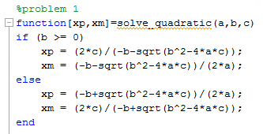

$$(a) x^{2}-{10}^{6}x+1=0$$

The x+ is $1.0*{10}^{6}$, the x- is $1.0*{10}^{-6}$.

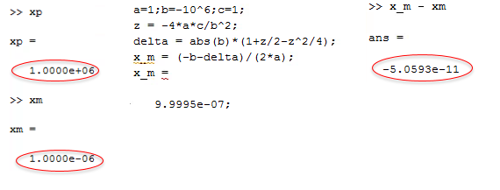The error in the smaller root is $-5.0593*{10}^{-11}$

$\left(b\right) x^{2}+{10}^{6}x+1=0$ (codes and results are on the next page)

The x+ is $-1.0*{10}^{-6}$, the x- is $-1.0*{10}^{+6}$.

The error in the smaller root is $0$

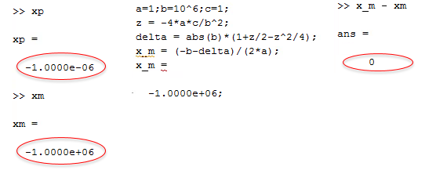

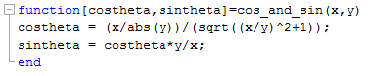**Problem 2:**

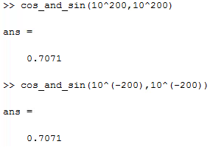

The answers are 0.7071. By reducing the power of x and y, we prevent the overflow.

**Problem 3:**

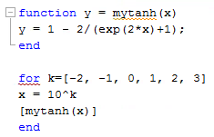

The results are on the next page.

k = -2, -1: k = 0, 1: k = 2, 3:

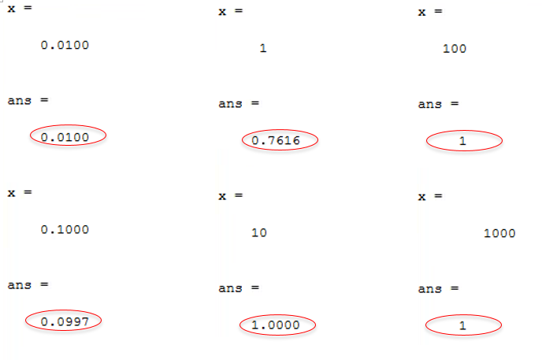

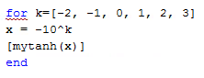

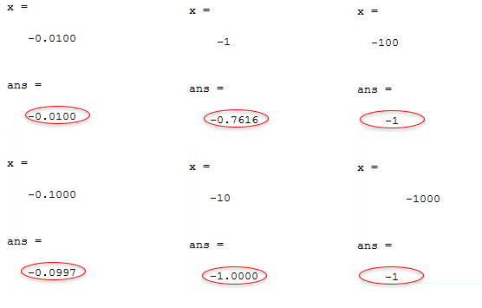k = -2, -1: k = 0, 1: k = 2, 3:

**Problem 4:**

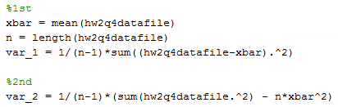

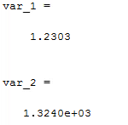

The second variance = 1.324e+03 is more accurate. Since all entries are the same, we expect the variance to be 0. In the first function, we keep adding ${\left(x_{i}-\overline{x}\right)}^{2}$, the subtracting will lead to a large relative error.