**Problem 1:**

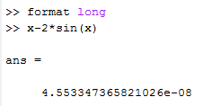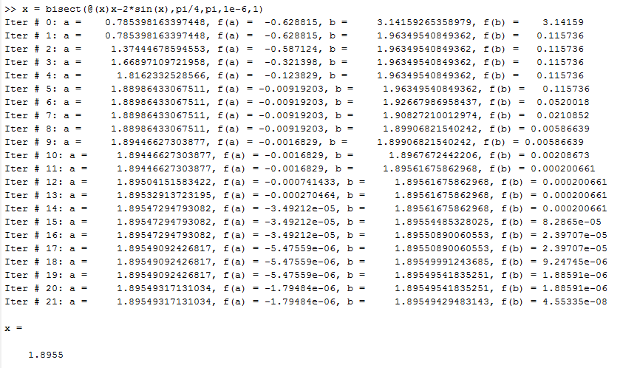

The initial interval is $[\frac{π}{4} , π]$. The computed solution is **1.8955**. Error is **4.5533 $e^{-8}$.**

**Problem 2:**

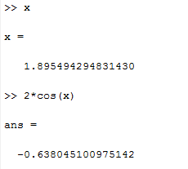**1. xn+1 = 2sin(xn):**

;

Since $\left|g^{'}(x^{*})\right|$ < 1, it **converge** to a solution and the rate of convergence is controlled by **0.6380**.

**2. xn+1 = 2(xn - sin(xn)):**

;

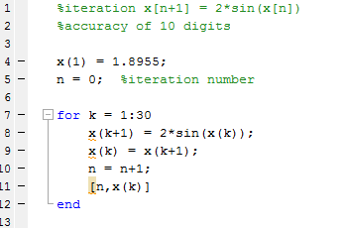Since $\left|g^{'}(x^{*})\right|$ > 1, it **diverges.**

ans =

1.000000000000000 1.895490609112251

2.000000000000000 1.895496600940147

…

25.000000000000000 1.895494266958182

26.000000000000000 1.895494267082344

27.000000000000000 1.895494267003123

The solution is **1.8954942670**, with an accuracy of 10 digits.

**Problem 3:**

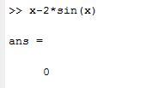The solution is approximately **1.8955**.

The number of iterations is **5**.

The value is **0.**

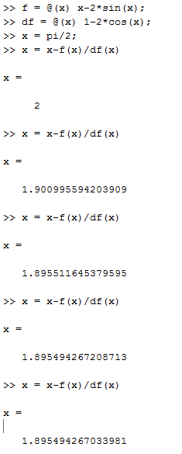

**Problem 4:**

The solution is **4.4934**. It’s computed using the **bisection method**.

The stopping criterion is when $\left|a-b\right|$ is small enough --- ε less than $1*e^{-6}$**.**

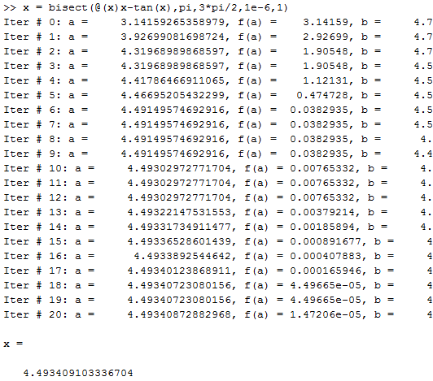The value of x – tan(x) is $7.1591*e^{-6}$**.**

