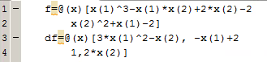**Problem 1:**

$$∇f\left(x\right)=\left[\begin{matrix}3{x_{1}}^{2}-x_{2} & -x_{1}+2 \\ 1 & 2x_{2}\end{matrix}\right]$$

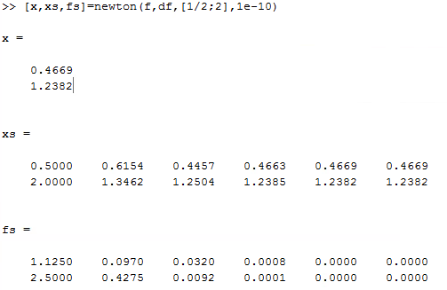

The solution is x=0.4669, y=1.2382.

Four iterations are needed. The method does converge quadratically.

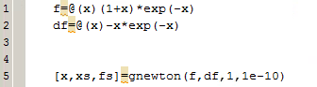**Problem 2:**

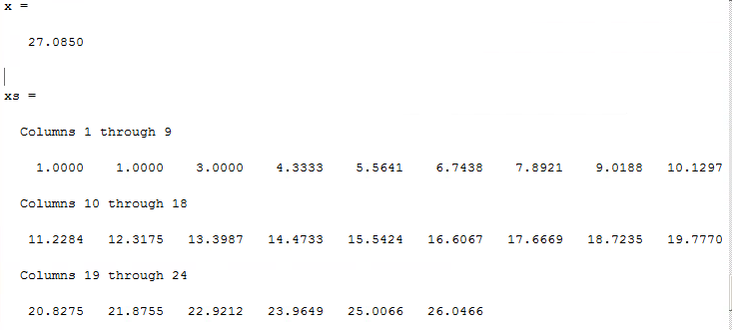

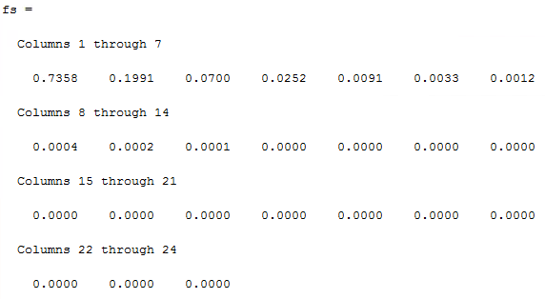

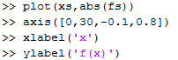



For an error of 1e-10, it takes 23 steps to get the final answer. The ideal solution to this problem is ∞.

The function value (fs) converges to 0.

For the given solution 27.085, f(x) = 4.86e-11.