**Problem 1:**

$$P1\left(x\right)=y_{0}\left(\frac{x-x_{1}}{x_{0}-x_{1}}\right)+ y_{1}\left(\frac{x-x_{0}}{x_{1}-x_{0}}\right)=1\left(\frac{x-1}{0-1}\right)+0.1839\left(\frac{x-0}{1-0}\right)=1-x+0.1839x=1-0.8161x$$

The maximum absolute error for P1(x) is **0.1948**

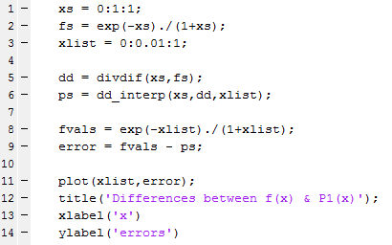

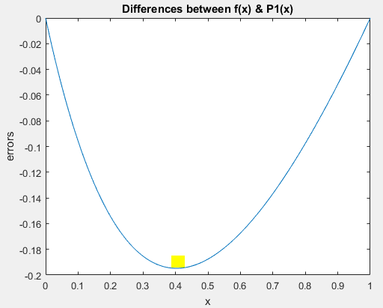

$P2\left(x\right)=1\left(\frac{(x-.5)(x-1)}{(0-.5)(0-1)}\right)+.4044\left(\frac{\left(x-0\right)\left(x-1\right)}{\left(.5-0\right)\left(.5-1\right)}\right)+.1839\left(\frac{\left(x-0\right)\left(x-.5\right)}{\left(1-0\right)\left(1-.5\right)}\right)$

$$=2(x-1)(x-\frac{1}{2})-1.7616x(x-1)+0.3678x(x-\frac{1}{2})$$

The maximum absolute error for P2(x) is **0.0345**



(change only one place for different ns)

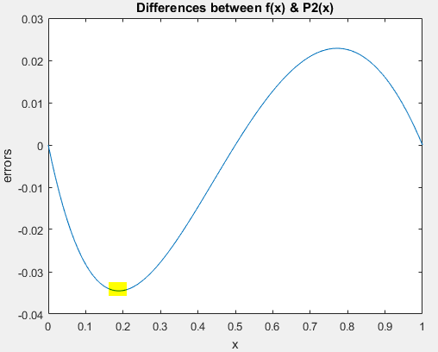

$P3\left(x\right)=1\left(\frac{\left(x-\frac{1}{3}\right)\left(x-\frac{2}{3}\right)\left(x-1\right)}{\left(0-\frac{1}{3}\right)\left(0-\frac{2}{3}\right)\left(0-1\right)}\right)+.5374\left(\frac{x\left(x-\frac{2}{3}\right)\left(x-1\right)}{\frac{1}{3}\left(\frac{1}{3}-\frac{2}{3}\right)\left(\frac{1}{3}-1\right)}\right)+.3081\left(\frac{x\left(x-\frac{1}{3}\right)\left(x-1\right)}{\frac{2}{3}\left(\frac{2}{3}-\frac{1}{3}\right)\left(\frac{2}{3}-1\right)}\right)+.1839\left(\frac{x\left(x-\frac{1}{3}\right)\left(x-\frac{2}{3}\right)}{1\left(1-\frac{1}{3}\right)\left(1-\frac{2}{3}\right)}\right)$

$$=-4.5\left(x-\frac{1}{3}\right)\left(x-\frac{2}{3}\right)\left(x-1\right)+7.2549x\left(x-\frac{2}{3}\right)\left(x-1\right) -4.1594x\left(x-\frac{1}{3}\right)\left(x-1\right)+.8276x(x-\frac{1}{3})(x-\frac{2}{3})$$

The maximum absolute error for P2(x) is **0.0066**



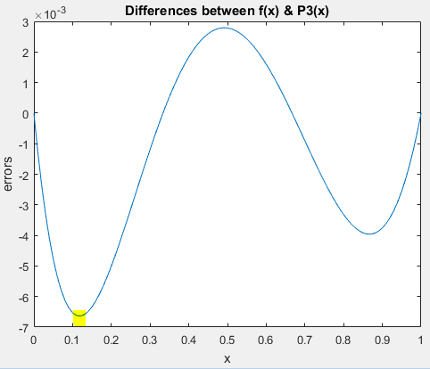

**Problem 2:**

**(1). $a0=1, a1=0, a2= -3, a3=2$**

$$h\left(x\right)=1-3x^{2}+2x^{3}, h^{'}\left(x\right)= -6x+6x$$

**(2). $a0=0, a1=1, a2=-2, a3=1$**

$$h\left(x\right)=x-2x^{2}+x^{3}, h^{'}\left(x\right)= 1-4x+3x^{2}$$

**(3). $a0=0, a1=0, a2=3, a3=-2$**

$$h\left(x\right)=3x^{2}-2x^{3}, h^{'}\left(x\right)= 6-6x^{2}$$

**(4). $a0=0, a1=0, a2=-1, a3=1$**

$$h\left(x\right)=-x^{2}+x^{3}, h^{'}\left(x\right)= -2x+3x$$

Since for x = 0 in p(x), h2, h3, h4 = 0 and h1 =1. Then $p\left(0\right)=y0*h1\left(0\right)=y0*1=y0$

Since for x = 0 in p’(x), h’1, h’3, h’4 = 0 and h’2 =1. Then $p'\left(0\right)=y0'*h2'\left(0\right)=y0'*1=y0$

Since for x = 1 in p(x), h1, h2, h4 = 0 and h3 =1. Then $p\left(0\right)=y1*h3\left(1\right)=y1*1=y1$

Since for x = 1 in p’(x), h’1, h’2, h’3 = 0 and h’4 =1. Then $p'\left(0\right)=y1'*h4'\left(1\right)=y1'*1=y1'$

**Problem 3:**

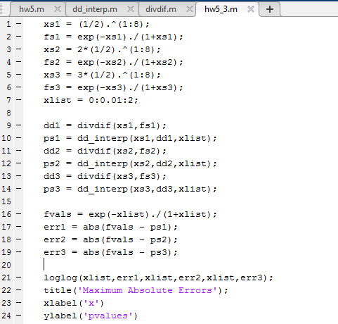



The maximum error for linear interpolant is 1.11e-16. The value α is about 53.

The maximum error for quadratic interpolant is 6.18e-10. The value α is about 30.

The maximum error for cubic interpolant is 8.95e-5. The value α is about 13.

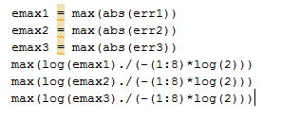

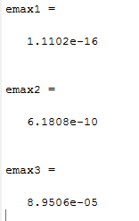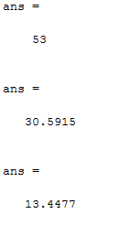

**Problem 4:**

**Plots on [-2,2]:**

As we can see from the plot, there’re no big differences between different ns’. The interpolants gave us very close outcomes. The zoomed out plot shows that the interpolants are almost the same as the original function (represented by the green line) when n is more than 5. Using high-degree interpolants is **not very useful for a narrow interval.**





**Plots on [-5,5]:**

On the other hand, the plots on [-5, 5] differ more than the plots on [-2,2]. The zoomed out plot shows that the interpolants still differ for n=10, 15 and 20. As a result, we say the **high-degree interpolation is more useful in a wider interval**.



