**Problem 1:**

$$\frac{\left\|\hat{x}-x\right\|}{\left\|x\right\|}≤\left\|A^{-1}\right\|\left\|A\right\|\left(\frac{\left\|d\right\|}{\left\|b\right\|}+\frac{\left\|E\right\|}{\left\|A\right\|}*\frac{\left\|\hat{x}\right\|}{\left\|x\right\|}\right)≈{10}^{6}*\left({10}^{-11}+{10}^{-10}\right)={10}^{-4}$$

Four digits of accuracy is expected.

**Problem 2:**

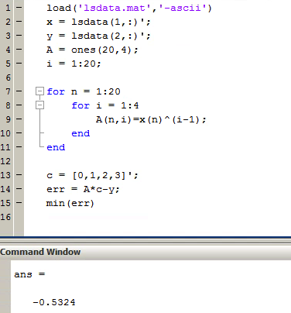

**Problem 3:**

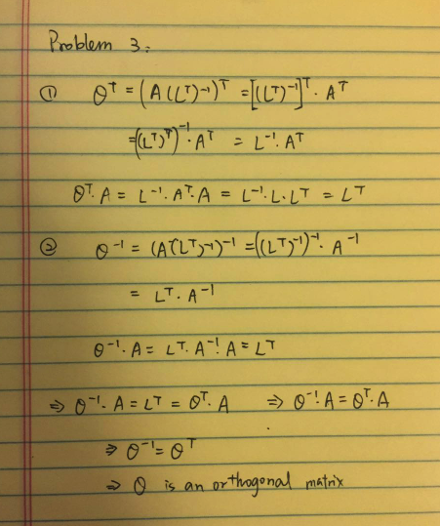

**Problem 4:**

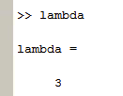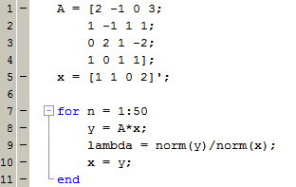

The estimated eigenvalue is 3.