1. (a) Line plot (or time plot) (b) 77 inches

(c) The winning jump heights over these years shows an upward trend.

2. (a)Quantitative discrete (b)Binary (c)Nominal

(d)Quantitative continuous (e) Ordinal

3. Line Plots:

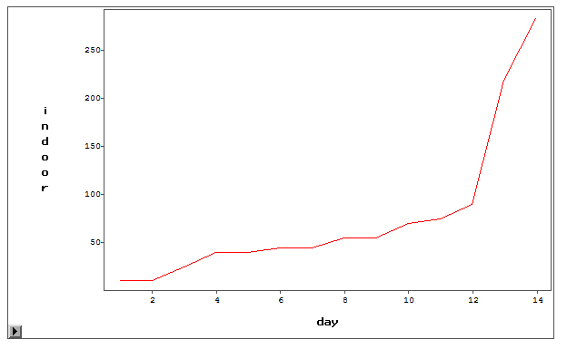

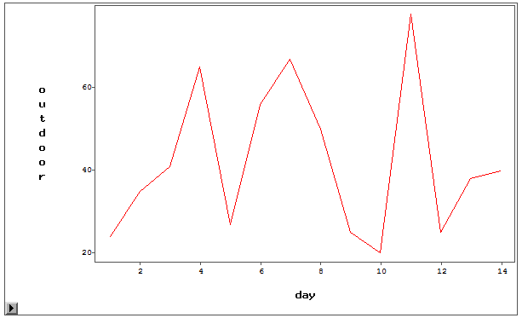

Textbook problems:

1.26: