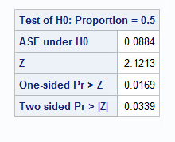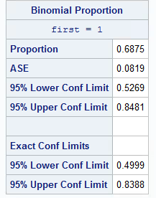**Section 20**

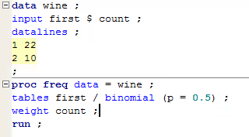**(40, 42)**

95% CI is (0.4999, 0.8388)

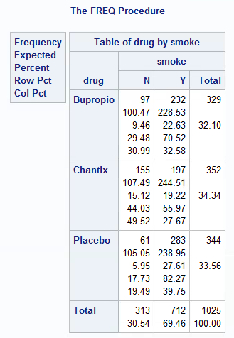**Section 23**

**(28) b. Proportions:**

P(nonsmk/Bupropio) = 29.48%

P(nonsmk/Chantix) = 44.03%

P(nonsmk/Placebo) = 17.73%

**Hypo:** Η0: p1 = p2 = p3 vs Ha: p1 ≠ p2 or p1 ≠ p3 or p2 ≠ p3

**P value:** <0.0001 under Chi-square test w/ degree of freedom = 2 equal to 56.9919

We can reject the null hypothesis and say there’s sufficient evidence that there are significant differences among these proportions.

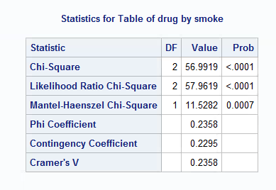

**(c)** It is an experiment because subjects are assigned different treatments from the investigators. We can manipulate the variables and test the differences as we want in an experiment. In observational study, we cannot control the things of our interest.

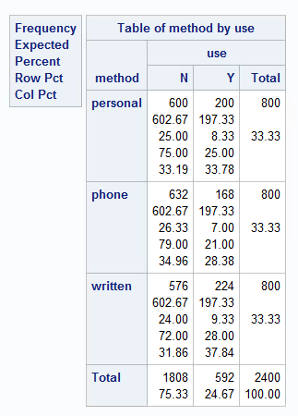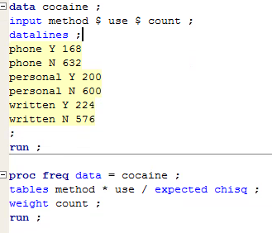**(30)**

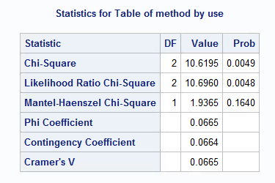

**Hypo:** Η0: p1 = p2 = p3 vs Ha: p1 ≠ p2 or p1 ≠ p3 or p2 ≠ p3

**Test stat: (**X2)2 = 10.6195 a chi-square test with degree of freedom = 2

**P-value:** 0.0049 < α = 0.05

With the small p-value. We can reject the null hypothesis and say there’s sufficient evidence to say that there’re significant differences among the proportions.