(27)

(a) Scatterplot:

The explanatory variable is diatance.

The pattern of the scatterplot shows a roughly linear, positive, moderately strong association between distance and time.

**data** ebola;

input distance time;

datalines ;

1 4

…

5 46

;

**run**;

**proc** **sgplot** data=ebola;

scatter x=distance y=time;

**run**;

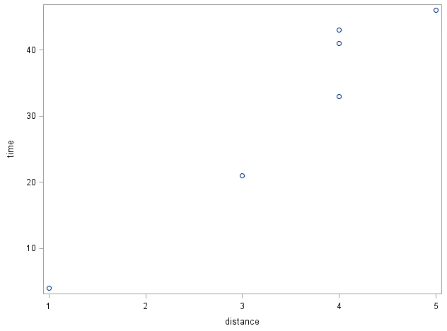

(b) Correlation:

**proc** **corr** data =ebola;

var time distance ;

**run** ;

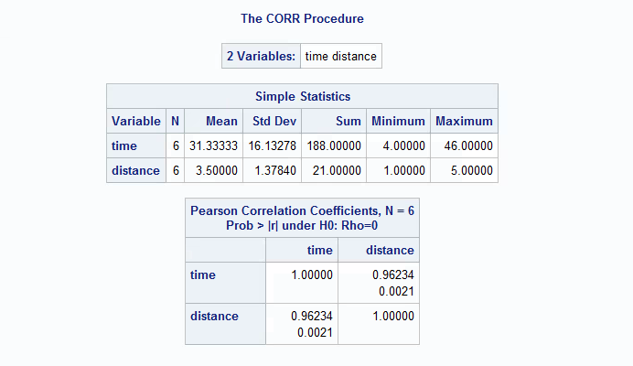

The correlation r between distance and time is 0.96234.

(c) If the time changes into weeks, the linear relationship between time and distance will not be changed. Since r has no units and it uses standardized values, when we change days into weeks, the correlation between distance and time will not change.