**(7) Ancient air**

* 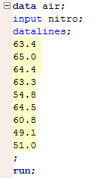Input data:

The data are selected using SRS.

The sample size is 9, which is not very large.



* 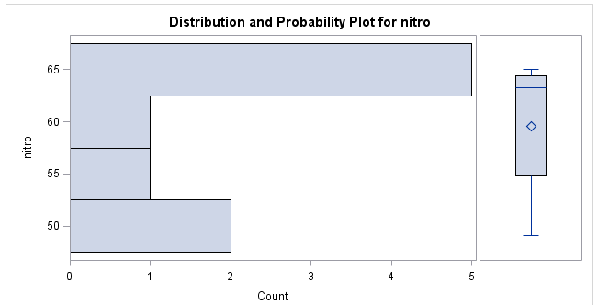Check normality:

The histogram does not implies a good normality of the data set.



* Calculation

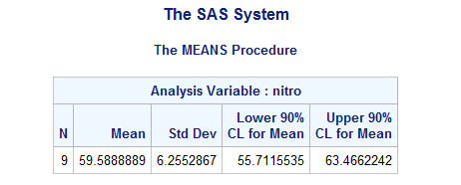

The 90% confidence interval to estimate the mean percent is between 55.71% and 63.47%.

* 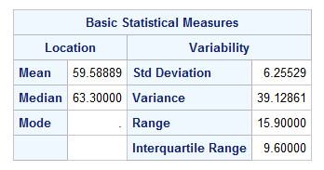(Check calculation)

$\overline{x}$ = 59.5889

$s$ = 6.2553

df = 9-1 = 8

t* = 1.860

+ t $\frac{s}{\sqrt{n}}$* = 59.5889 ± 1.860 $\frac{6.2553}{\sqrt{9}}$

=55.711 and 63.467 (verified)

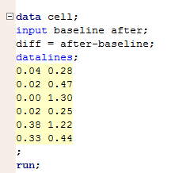**(46) Recruiting T cells**

* Input data:

The sample is selected by SRS.

The sample size is 6, which is not very large.



* Check normality:

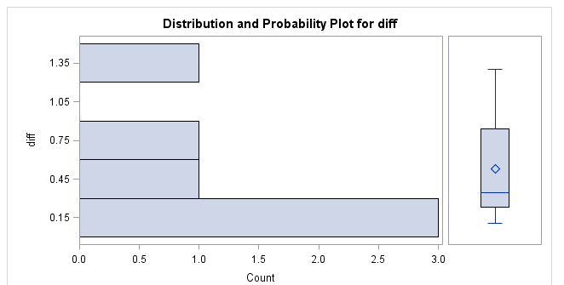

The histogram does not implies a good normality of the data set.

* Hypothesis testing: H0: µ = 0 vs. Ha: µ > 0

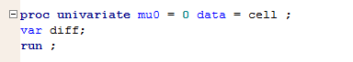

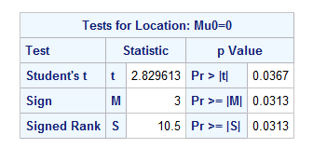

For t score = 2.83 and df = 5, the P-value is 0.0367÷2 = 0.01835 < α=0.05.

Since the P-value is less than the significant level 0.05, we say there’s sufficient evidence to reject the null hypothesis and say the mean is larger than 0.

In other words, we say there’s convincing evidence that the mean count of T cell is higher after 20 days on blinatumomab.

* 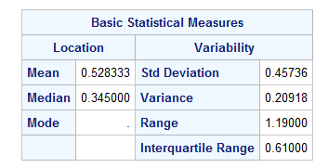(Check the hypo. testing)

$\overline{x}$ = 0.5283

$s$ = 0.45736

df = 6-1 = 5

t* = $\frac{\overline{x}-0}{\frac{s}{\sqrt{n}}}$ = 2.829

P-value is t(5) 2.829 = 0.0184 (verified)