**(49) Each day I am getting better in math**

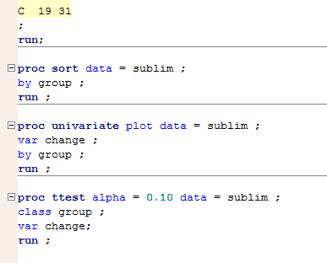

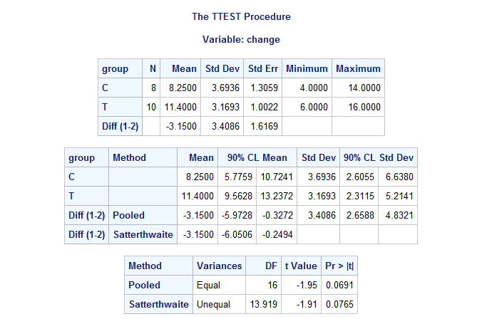

**(a**) The corresponding null hypothesis verses alternative hypothesis is:

H0: µ1 - µ2 = 0 vs. Ha: µ1 - µ2 > 0

For the two sample t test (with unequal variances for two groups):

The resulting t-stat is 1.91 (with df = 13.919).

P-value = P(t > 1.91) = 0.0765 ÷ 2 = 0.03825 (P-value < α=0.05)

Since the p-value is relatively small, we say that we have sufficient evidence to reject the null hypothesis and declare that the treatment brought a greater improvement in math scores than the neutral message.

**(b)** The 90% CI for the mean difference is (0.2494, 6.0506).

**(3) Active vs. Passive**:

(1) Hypothesis:

H0: µa - µp ≤ 0 vs. Ha: µa - µp > 0

Null hypothesis stats that active learning is not good as, or as good as passive learning. Alternative hypothesis states that active learning is better than passive learning.

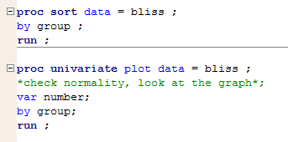Graphs:

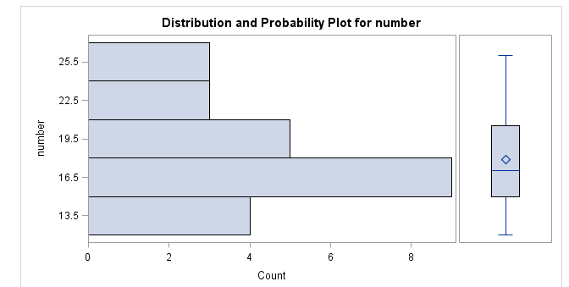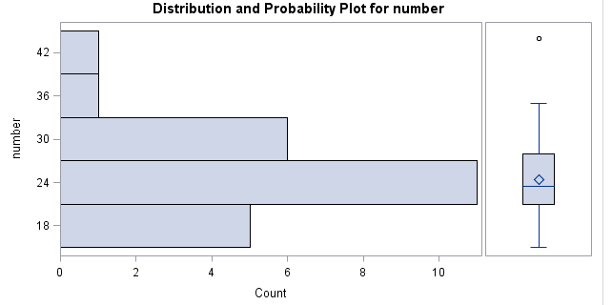

There are no clear departures from Normality such as extreme outliers or skewness.

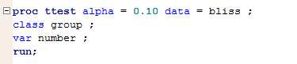Test:

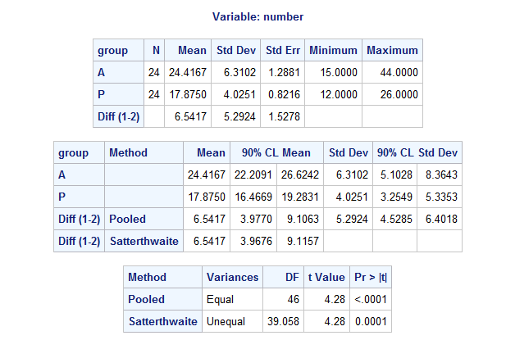

For t-test with df = 46:

T-stat = 4.28, p-value = <0.0001 (< α=0.05)

Conclusion:

Since the p-value is very small, we have sufficient evidence to reject the null hypothesis and say active learning is better than passive learning.

(2) 90% CI for the mean difference is (3.977, 9.1063).

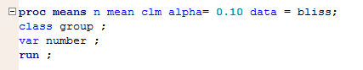(3) 90% CI for mean number of group “active” is (22.2091, 26.6242).

