**Problem 3.1:**

1. $α=2，β=7$

The mean is

The mode is

2. The median is **0.2011**

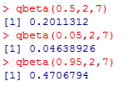The 90% central interval is **[0.0464, 0.4707]**

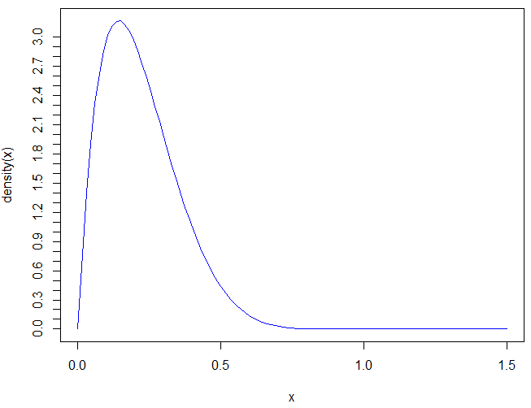3. The beta(2,7) plot is:

**Problem 3.3:**

1. uniform(0,1) = **beta (1,1)**

2. Since the desired sample size for beta (1,1) is 1+1-2 = 0. The desired equivalent prior sample size for U(0,1) is also 0.

**Problem 3.4:**

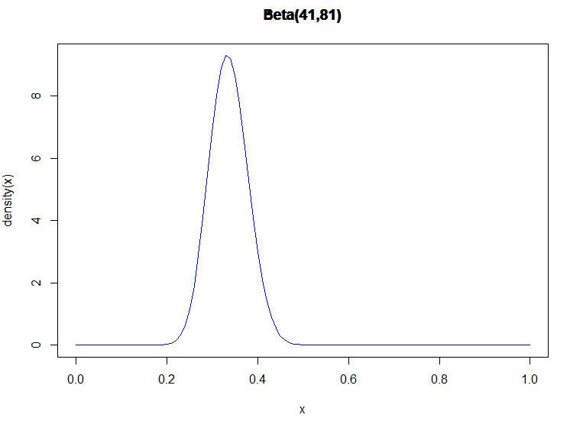1. $α-1=40, β-1=80$, we plot the density function of beta (41, 81):

We notice that the distribution is concentrated between 0.3 to 0.4.We need to use the probability of a sample high school student getting hit to estimate $θ$.

The probability P(getting hit) $=\frac{40}{120}=0.333$. It’s within the interval of [0.3, 0.4]. Therefore **the guess of beta(41,81) is good**.

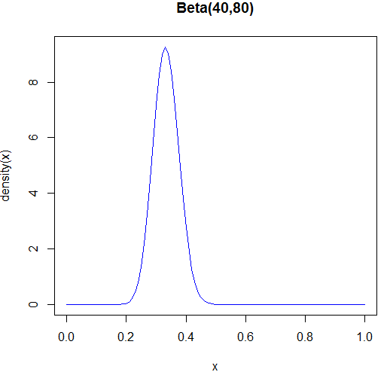2. The player’s mother’s belief would probability want a steady hit, therefore we want the prior mean to be 0.333. We could try beta(40,80), beta(20,40), beta (10,20) and beta(5,10).

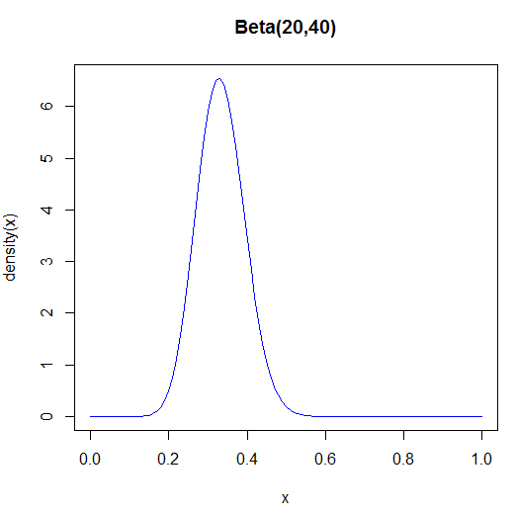

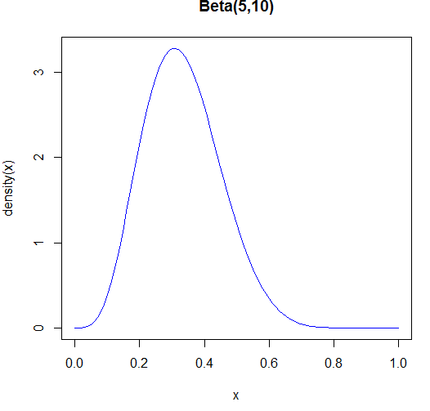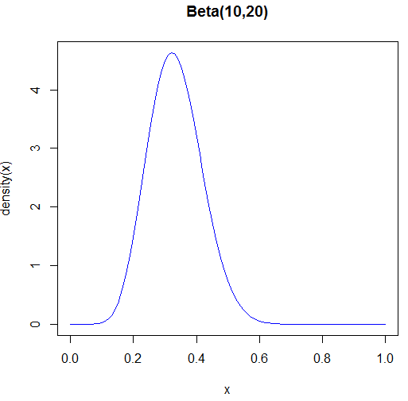

The plots indicate that, when the sum of $α andβ$ is larger, the distribution is more concentrated. To get a more certain outcome of getting a hit at bat, the **beta(40,80) would be the best fit** in all.

3. One of the reason of dependence might be that the players’ performances would go down since the eight college-levels games are very exhausting. **The model might not be independent**.

4. (a) Posterior: probability of getting a hit at bat based on player’s latest record.

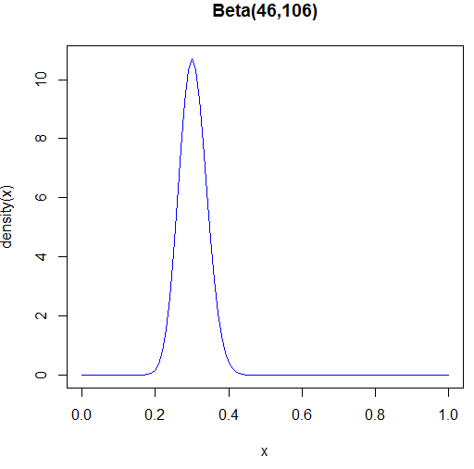The likelihood function is $L\left(θ\right)=\left(\begin{matrix}30 \\ 5\end{matrix}\right)θ^{5}{\left(1-θ\right)}^{25}$. The posterior $P\left(θ⋮y\right)$ is proportional to beta($α+y, β+n-y)$.

(b) Here we plot **Beta(46,106).**

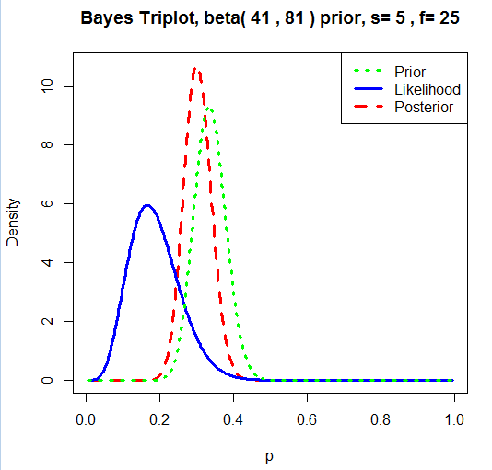(c)

(1)

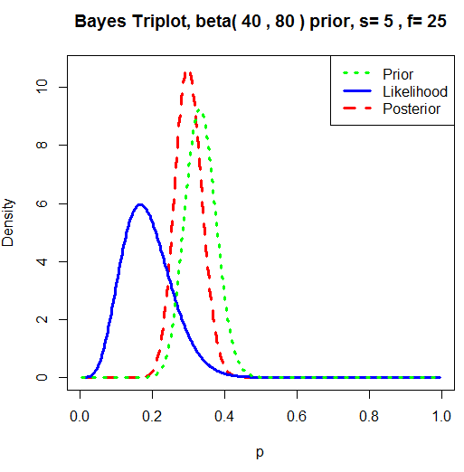(2)

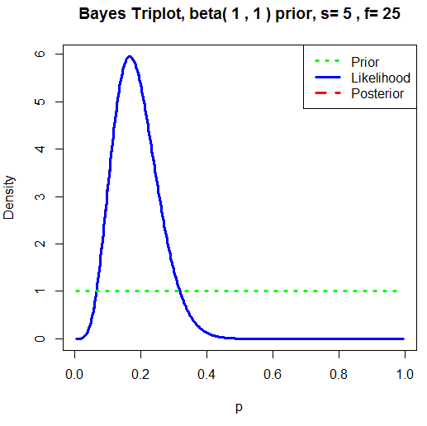

(3)