**Problem 5.4:**

**1. $fy\left(y1…yn\left|λ\right.\right)=\prod_{i=0}^{n}{\frac{e^{-λ}λ^{yi}}{yi!}}=\frac{e^{-nλ}λ^{n\overline{y}}}{\prod_{i=1}^{n}{(yi!)}}$**

**2. $\overline{y}=\frac{1}{5}\left(2+5+1+0+3\right)=2.2$**

$$L\left(λ\right)=\prod_{i=0}^{5}{\frac{e^{-λ}λ^{yi}}{yi!}}=\frac{e^{-5λ}λ^{5*2.2}}{2!5!1!0!3!}=\frac{e^{-5λ}λ^{11}}{1440}$$

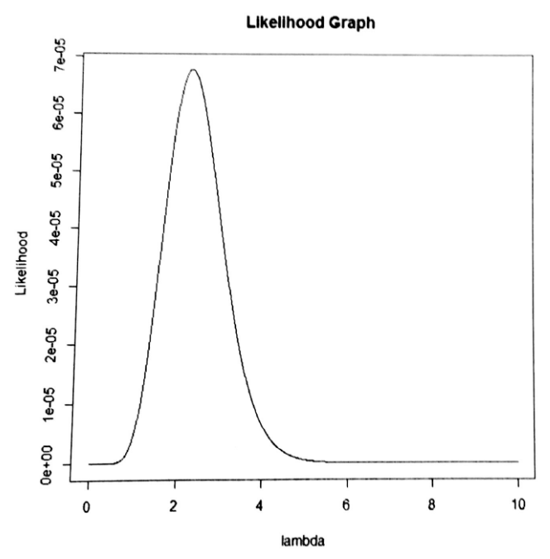

**3. $\frac{∂L(*)}{∂x}=\frac{∂}{∂x}\left(\frac{e^{-5λ}λ^{11}}{1440}\right)=\frac{-5e^{-5λ}λ^{10}(-5λ+11)}{1440}=0$**

$$\frac{∂^{2}}{∂x^{2}}\left(\frac{e^{-5λ}λ^{11}}{1440}\right)<0$$

Therefore, $\hat{λ}=\frac{11}{5}=2.2=\overline{y}$ is **the mle of $λ$** .

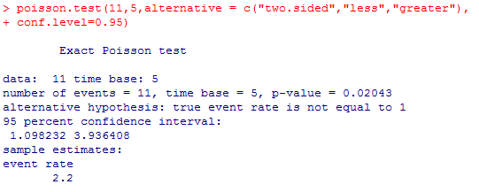

The R output has a same **mle of 2.2**. The 95% CI for $λ$ is **(1.0982, 3.9364)**

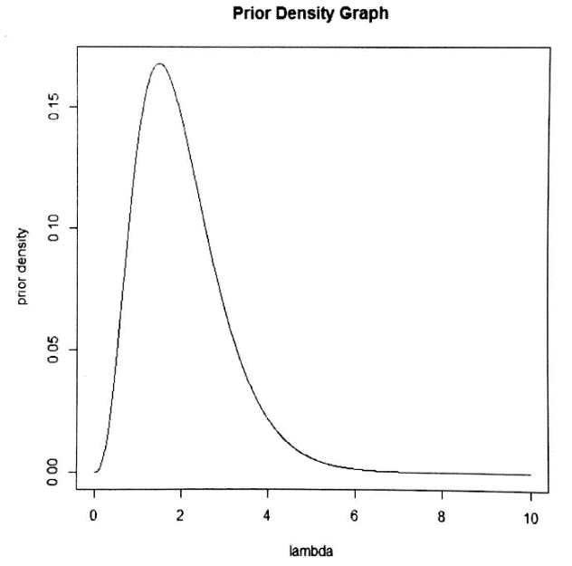**Problem 5.5:**

**1.** The prior is a member of **Gamma (4,2).**

**2.** The plot indicates that the president’s prior belief about rate parameter is maximized around somewhere between 1.6 to 2.5. The majority of expected number of breakdowns are distributed around 0 to 5.

**3. $p\left(λ\left|y\right.\right)=p\left(λ\right)L\left(λ\right)∝λ^{3}e^{-2λ}\left(\frac{e^{-5λ}λ^{11}}{1440}\right)=\frac{λ^{14}e^{-7λ}}{1440}=Gamma(15,7)$**

**4.** Mean is 15/7 = **2.143**

**5. Yes**, it was. It’s a Poisson distribution because they have the same likelihood as the one in problem 5.4.

**Problem 5.6:**

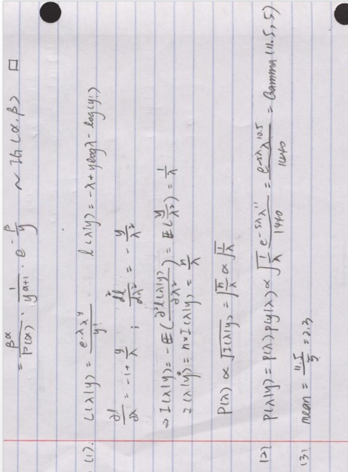

The 95% credible set is **(1.1689, 3.8076).**

**4.** The Bayesian point estimate is **larger** than the classical estimate (2.3 > 2.2). In addition, the interval estimate is **wider** than the classical interval estimate.

**5.** The employee’s estimate is **larger** than that of the president since the employee has larger $λ$.

**6.** Employee:



**7.** President:



**(problems in Section 6 are on next page)**