**Problem 8.2:**





Comparing to the result of 6.2.8.3, the mean is quite similar. We obtained -2.589 here and -2.586 in 6.2.8.3. Standard deviation here is 0.6481 while the sd is 1/60 =0.01667 is 6.2.8.3. The difference indicates that the **Openbugs output is more spread out**. In other words, the distribution is 6.2.8.3 is more concentrated around the center of -2.586.

**Problem 8.4:**

**1.** Since the conjugate family of the prior is IG(38,444), the conjugate family prior for normal precision is **Gamma(38,444).** Presidion = 1/variance.

**2.**

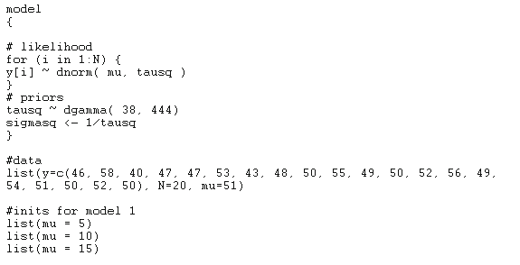

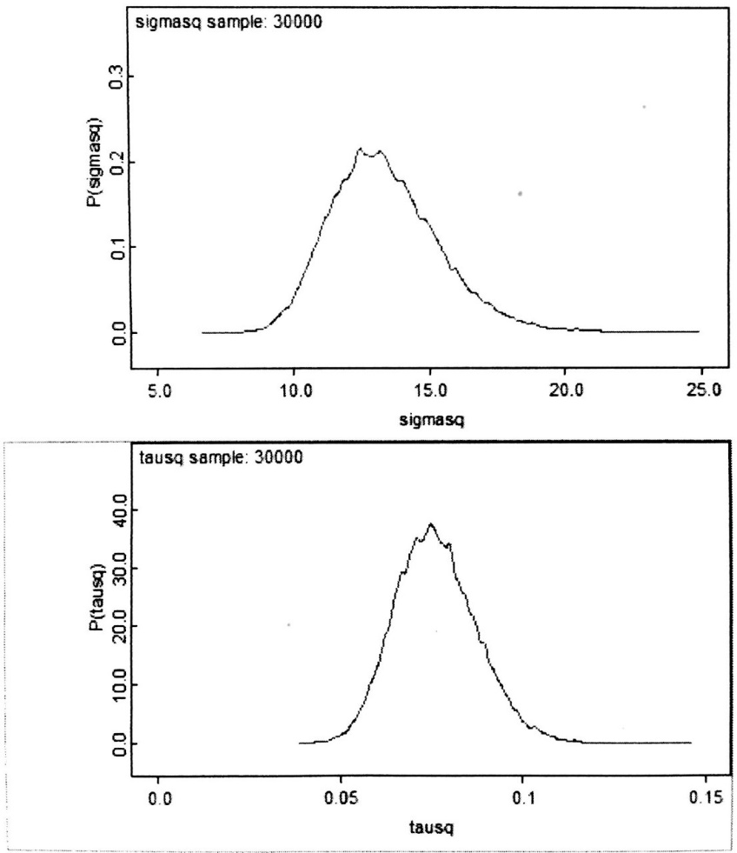

The stat output is:

**mean sd MC_error val2.5pc median val97.5pc start sample**

sigmasq 13.37 1.975 0.01074 10.04 13.19 17.73 1 30000 tausq 0.07641 0.01109 6.012E-5 0.05639 0.07582 0.09961 1 30000

Sigmasq mean in 6.2 is 13.362, which is very close to that of Openbugs but **slightly smaller** than what Openbugs generates. It makes sense because Openbugs drew a large sample size to make the result more preciously. For variance, the estimated posterior variance is ${1.975}^{2}=3.901$, which is **consistent with** the previous result.