**Problem 8.3:**

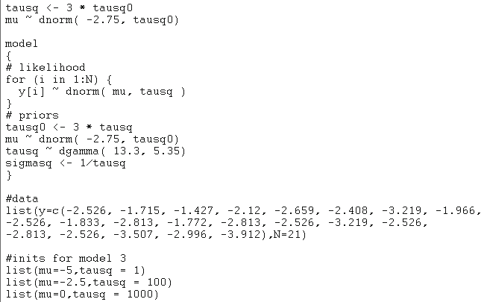

**mean sd MC_error val2.5pc median val97.5pc start sample**

mu -2.586 0.1304 0.001018 -2.844 -2.587 -2.329 1001 18000

tausq 2.576 0.5303 0.003576 1.649 2.54 3.72 1001 18000

The output in Sect. 7.1.1 is -2.563, while the OpenBugs output is **-2.586**. Since Markov Chain error is less than 1/20, the rule of thumb is satisfied. Also, the **95% cs for mu is (-2.844, -2.329)**, which is close to (-2.845, -2.280) of 7.1.1.

**Problem 9.1:**

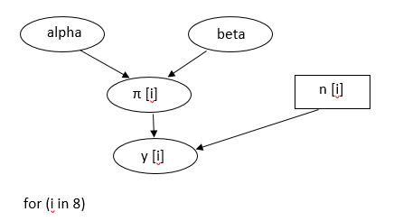

**Problem 9.4:**

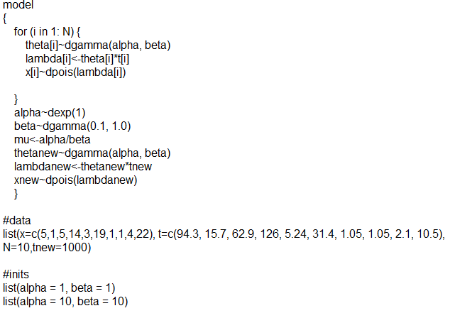

**mean sd MC_error val2.5pc median val97.5pc start sample**

alpha 0.6966 0.2741 0.00582 0.2954 0.654 1.353 1001 6000

beta 0.9312 0.5438 0.01215 0.1867 0.8333 2.296 1001 6000

mu 0.9398 0.612 0.01068 0.3631 0.8036 2.253 1001 6000

theta[1] 0.05992 0.02502 3.481E-4 0.02112 0.05627 0.1176 1001 6000

theta[2] 0.1025 0.08003 0.001095 0.009112 0.08235 0.3132 1001 6000

theta[3] 0.08911 0.03726 4.456E-4 0.03137 0.08406 0.1767 1001 6000

theta[4] 0.1156 0.03006 3.89E-4 0.06502 0.1132 0.1812 1001 6000

theta[5] 0.5995 0.3113 0.004031 0.1542 0.5418 1.344 1001 6000

theta[6] 0.6104 0.138 0.001976 0.3686 0.6004 0.9121 1001 6000

theta[7] 0.8781 0.7159 0.00949 0.07644 0.6888 2.687 1001 6000

theta[8] 0.8964 0.7366 0.01054 0.0724 0.712 2.862 1001 6000

theta[9] 1.588 0.7716 0.01088 0.4722 1.467 3.496 1001 6000

theta[10] 1.99 0.425 0.005854 1.243 1.965 2.922 1001 6000

**(a).** The failure rate mean is **0.9398** with the MC error to be **0.01068**.

**(b) & (c).**

**mean sd MC_error val2.5pc median val97.5pc start sample**

lambdanew 921.5 1475.0 14.75 1.167 439.0 4713.0 1001 9200

thetanew 0.9215 1.475 0.01475 0.001167 0.439 4.713 1001 9200

xnew 920.9 1475.0 14.75 1.0 441.0 4700.0 1001 9200

Since the x* ~ Poisson(λ*), analytically, **mean of x* = that of λ\***. From the OpenBugs output we can see that the mean of λ* = 921.5 and the mean of x* = 920.9. Those outcomes generated from MC are **very close to the analytic results**. Also, the **median and the credible set** are very similar. The **mean of λ = mean of (1000θ)**.