**Problem 9.5:**

My OpenBugs have some problem on directed graph, I will draw the graph by hand on separate file.

**1.** All the $y_{ij}'s$ are not considered exchangeable because i and j are sampling from different loops in graph. The probability distribution on the $y_{1j}'s$ is different from that of $y_{2j}'s$.

**2.** All the $y_{2j}'s$ are considered exchangeable because they are all sampling from the same distribution with $μ_{2}$ and precision $τ_{with.}^{2}$.

**3. $μ_{i}'s$** are exchangeable because they have the same probability distributions which are drawn from the $Normal(θ,τ.btw)$.

**4.**

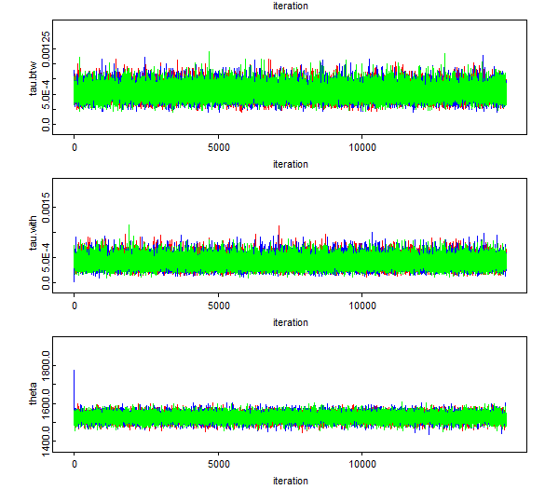

Both single chain and multi-chains show its convergence.

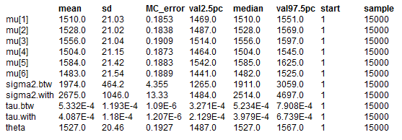

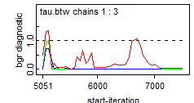

The bgr diagnostic of tau.btw doesn’t seems good. The high values indicate that there might be extreme values.

**5.** After running another iterations autocorrelation plots, the outcome doesn’t seem to be changed.

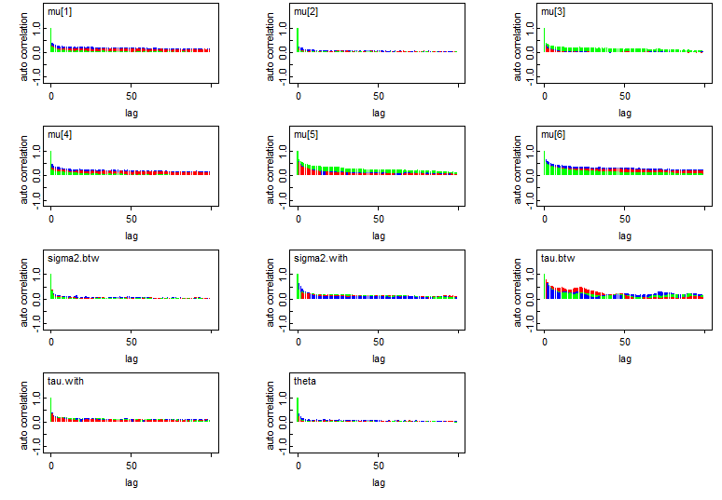

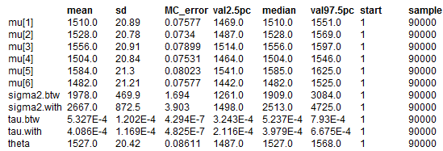

However, the MC error decreases for additional iterations.

**6. $\frac{β}{α-1}=2000,\frac{β^{2}}{{\left(α-1\right)}^{2}(α-2)}=250000. α=18, β=34000.$**

**7.** Change tau.btw to be ~dgamma (18, 34000)

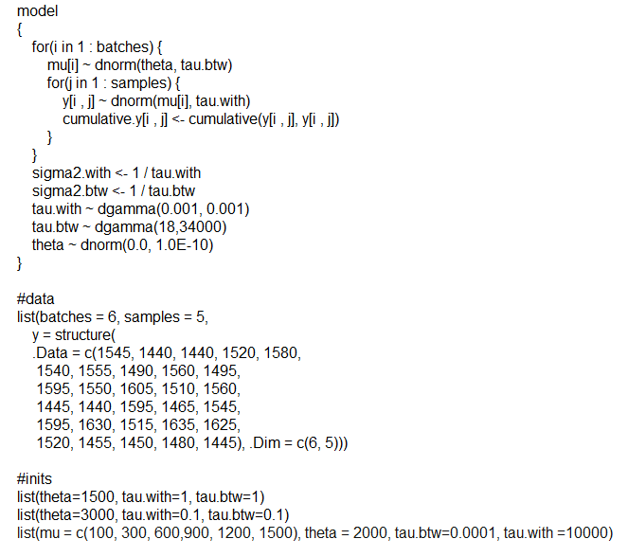

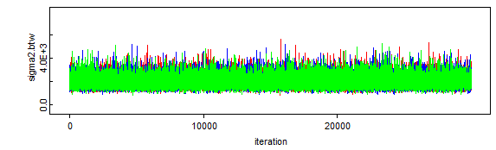

There are no big changes for other plots. And for sigma2.btw, it seems to be converging, comparing to the previous one.

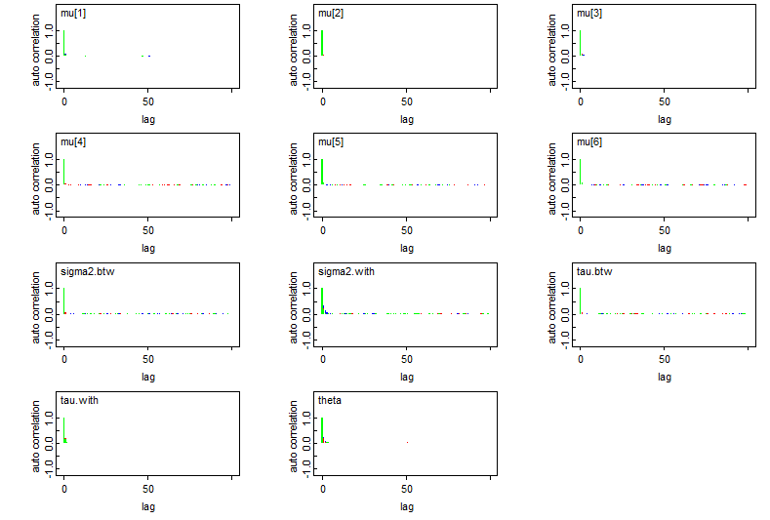

Both autocorrelation plots and bgr diagnostics show convergence of nodes.

**Problem 10.1:**

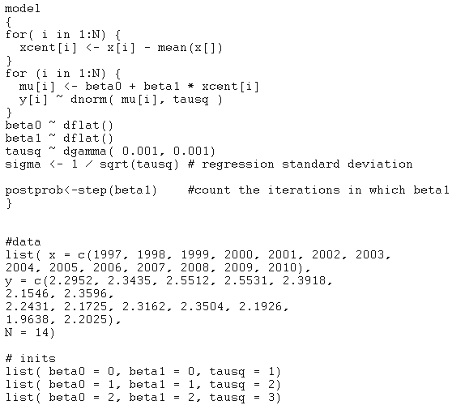

History:

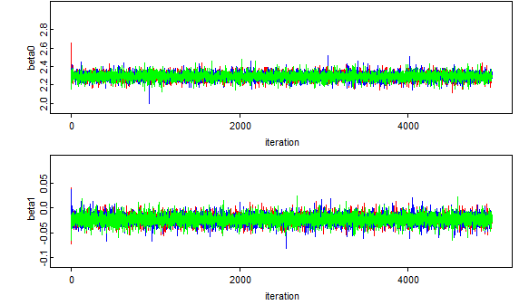

Auto-cor:

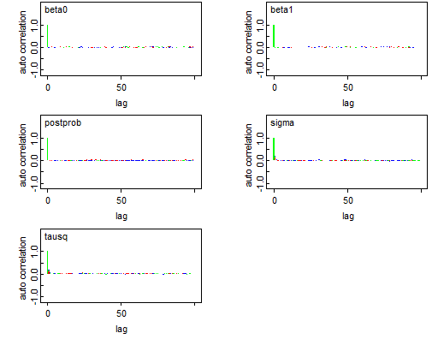

Stats:

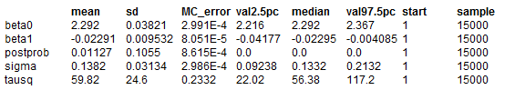

**1.** If we look at the autocorrelation plots, we can find the three chains are immediately converging.

**2.** Frequentists’ outputs are:

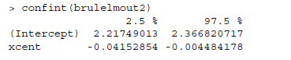

By comparison we find the mean of beta0 from OpenBugs is identical to the result in book, ignoring the rounded decimal places. Beta1 is quite similar but mean of beta1 from OpenBugs is a slightly larger than the result in the book.

**3.** Based on “stats”, the mean of postprob is 0.0113, which is the posterior probability of H0 if we ran 5000 iterations. The p-value is 0.00955, which is smaller than Bayesians got. If we ran more iterations, p-value would decrease as the number of iterations increase. That’s because of the random sampling variability in the MCMC output.

Bayesians’ P(beta1>0|y) = 0.0113. Frequentists’ P is 0.00955 for one-sided test.

**Problem 10.2:**

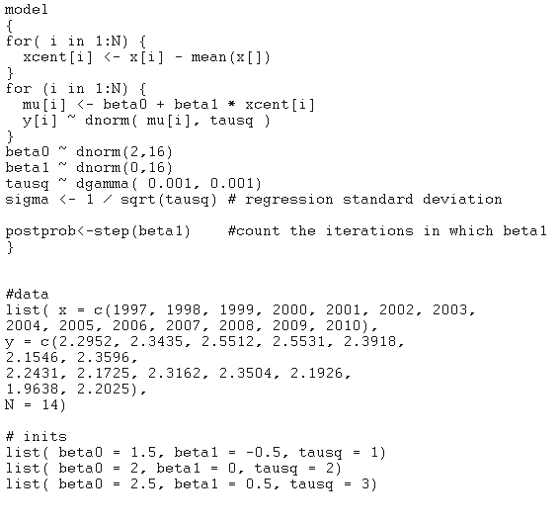

The history, auto-cor, bgr all show pretty good convergence.

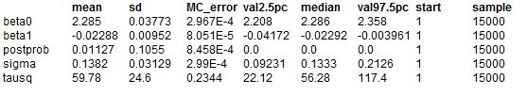

The estimate of population intercept and slope don’t change. It makes sense because these two estimates in previous questions are exactly in the interval provided in this question. The mean posterior probability of H0 decrease just a little bit. It also makes sense since the previous prior is unif (0,1) and the coding shifts it.