**Problem 10.3:**

**1.**

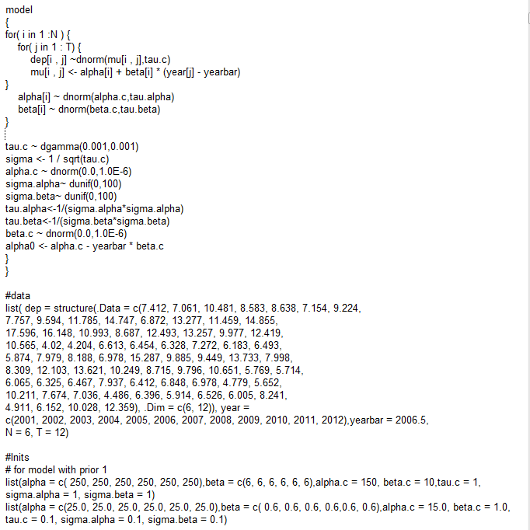

**2.** According to bgr, auto-correlation, and history plots, **all the parameters converge** quickly.

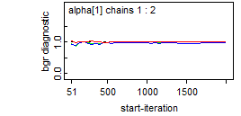

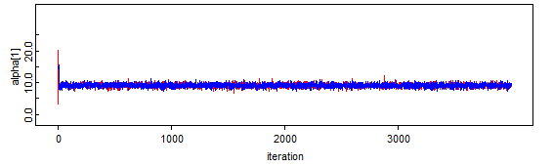

**3.**

**(a)** The posterior mean is **-157.7** and 95% CS is **(-843.5, 493.5)**.



**(b)** The post. mean of estimated slop is **0.126** and 95% CS is **(-0.152, 0.420)**.



**(c)** The post. mean of Sd. around regression line is **2** and 95% CS is **(1.665, 2.410)**.



**(d)** The post mean. of Sd. variability captured is **0.146** and 95% CS is **(0.014, 0.398)**.



**(e)** The individual intercept-slope pair for site 2:

