**1. Logit (p):**

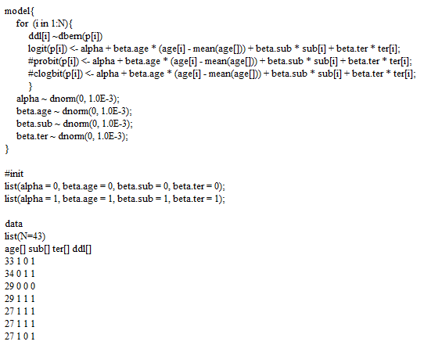

(a) History:

The history plots indicate that the **data are converging** well.

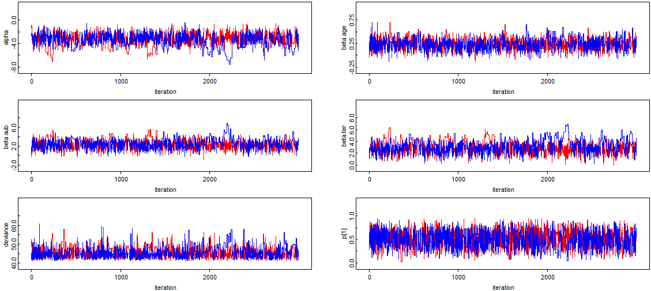

(b) DIC:

The DIC for logit link function is **45.47**.

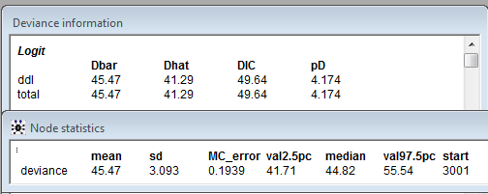

**2. Probit (p):**

While using the probit function, OpenBugs gave an error message. Therefore, I used the equivalent expression on prior.

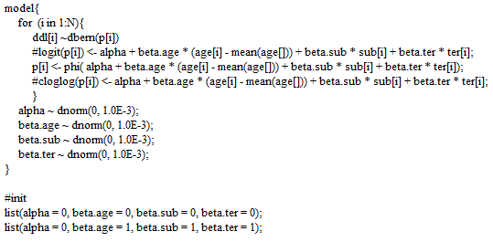

(a) History:

The history plots indicate that the **data are converging** well.

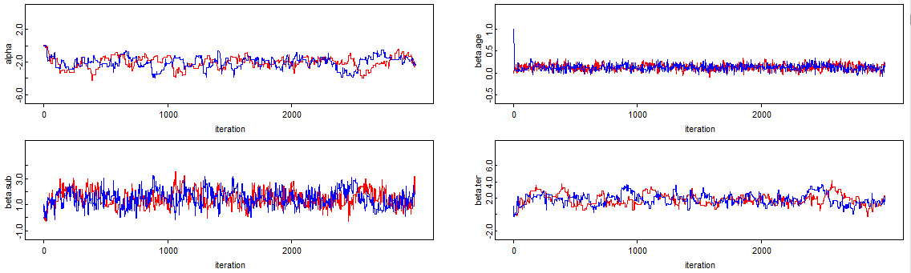

(b) DIC:

The DIC for logit link function is **44.98**.

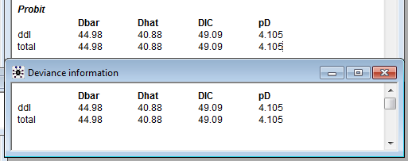

**3. Cloglog(p):**

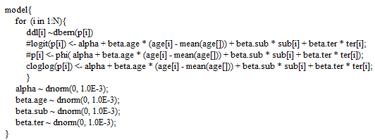

(a) History:

The history plots indicate that the **data are converging** well.

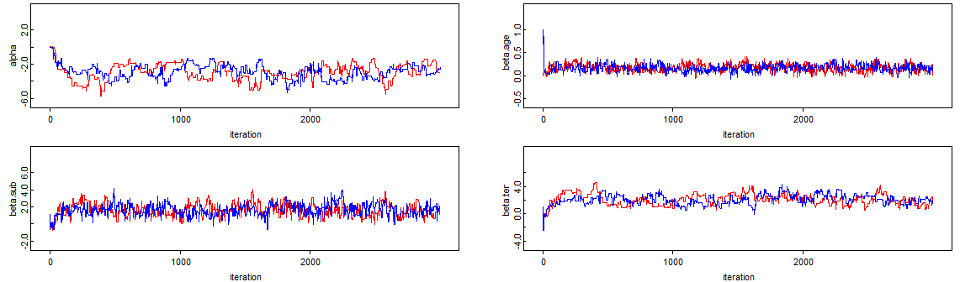

(b) DIC:

The DIC for logit link function is **45.29**.

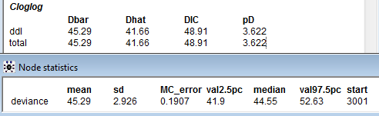

**4. Summary:** (OpenBugs’ ouputs on next page)

1. Since the DIC for probit = 44.98 is the smallest among all three DICs, we say **probit is estimated to be the best model** to predict a replicate dataset of the same structure as we currently observed.

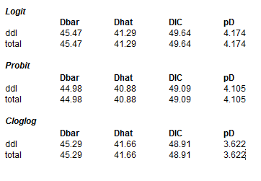

2. Since the 95% CS of betas for age, ter, and sub do not contain 0, we could say **that age, living in new suburb, and treatment of residence for termites are significant predictors** to dieldrin levels in breast milk.

