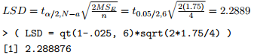LSD by hand (LS)

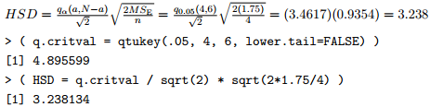

HSD by hand (LS)



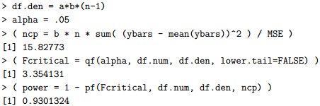Random Factor (LS)

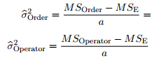Estimate variation of blks (LS)



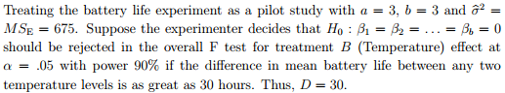

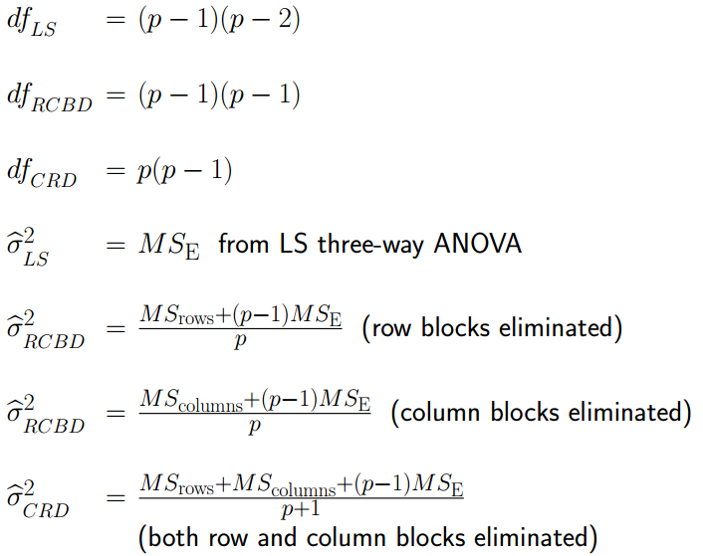 RE (LS)





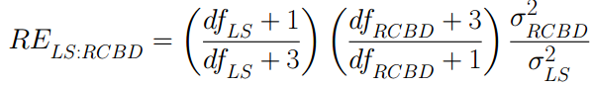

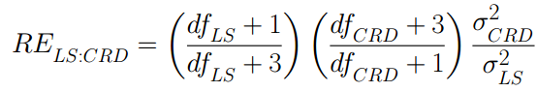

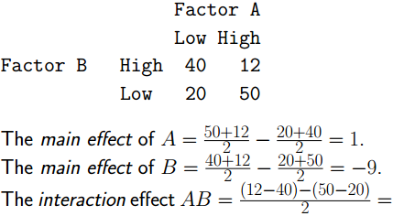Main effect (22 factorial)

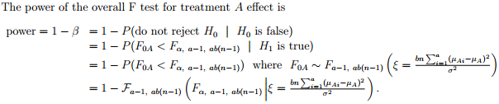

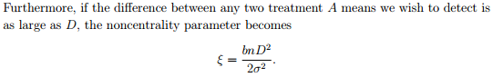Interaction Plot (2-factor FD)

HSD (FD)



Power and Sample Size (FD)



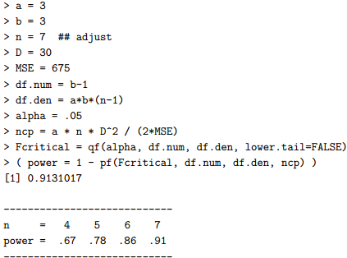

F test for A effect (FD)

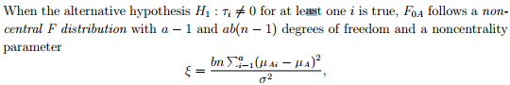

Interaction Plot (3-factor FD)

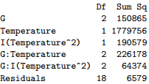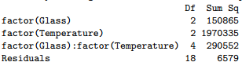ANOVA (with 1 quantitative)

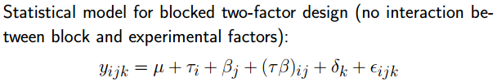Blocking in FD

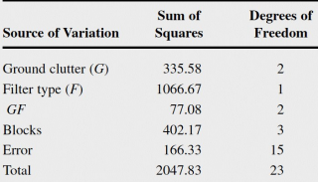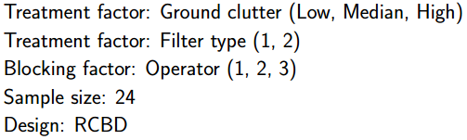

|  |  |  |
| --- | --- | --- |
| a = 2 | CRD: pooled/un-pooled | RBD: paired t |
| a ≥ 2 | CRD: 1-trt-factor | CRBD: blk-factot |
| Factorial Design:  Multi-trt-factors | LS: 2-blk-factors |
| G-LS: 3-blk-factors |

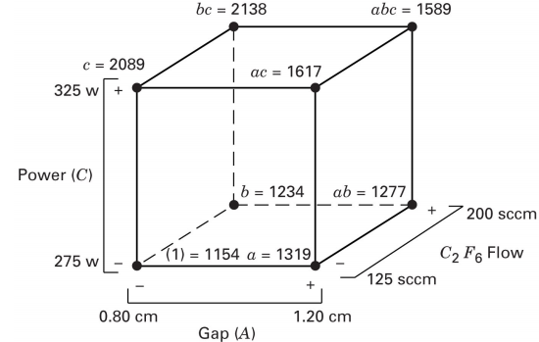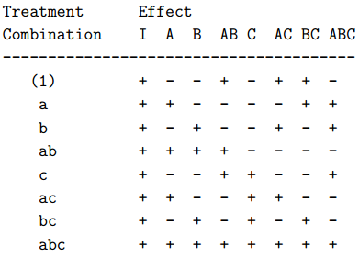 Contrast coefficient

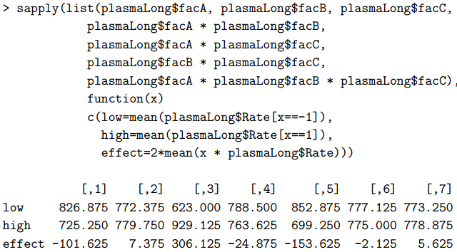 Estimated Effects

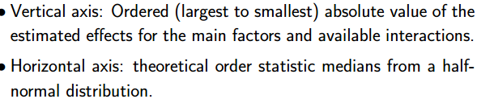 Half-normal

 PSE

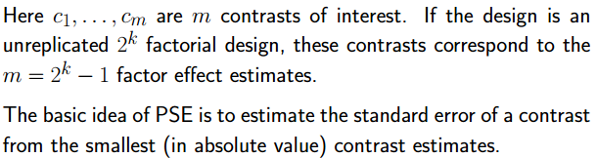

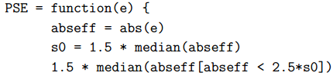

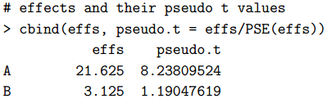

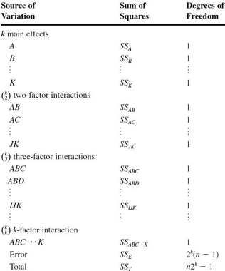Degree of Freedom of 2k FD

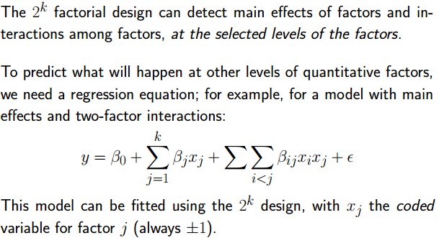 Extending Design

