Leverage:

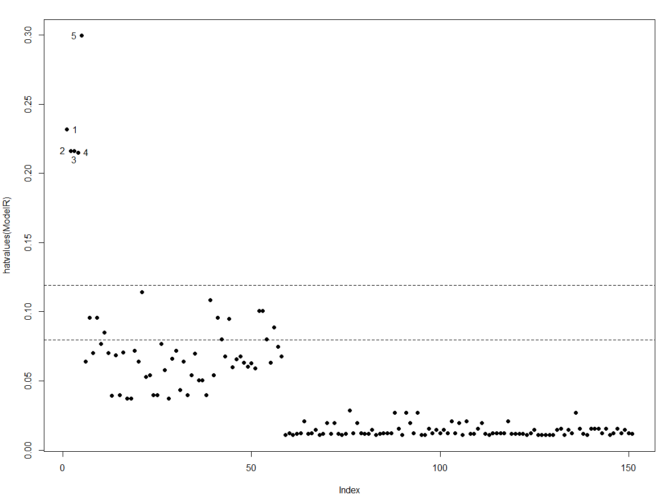After computing the hat value and comparing it with the average, we discover 5 points with high leverage. They are point #1, #2, #3, #4 and #5.

Influence:

