To run the program you double click on run file wherever the program is installed:

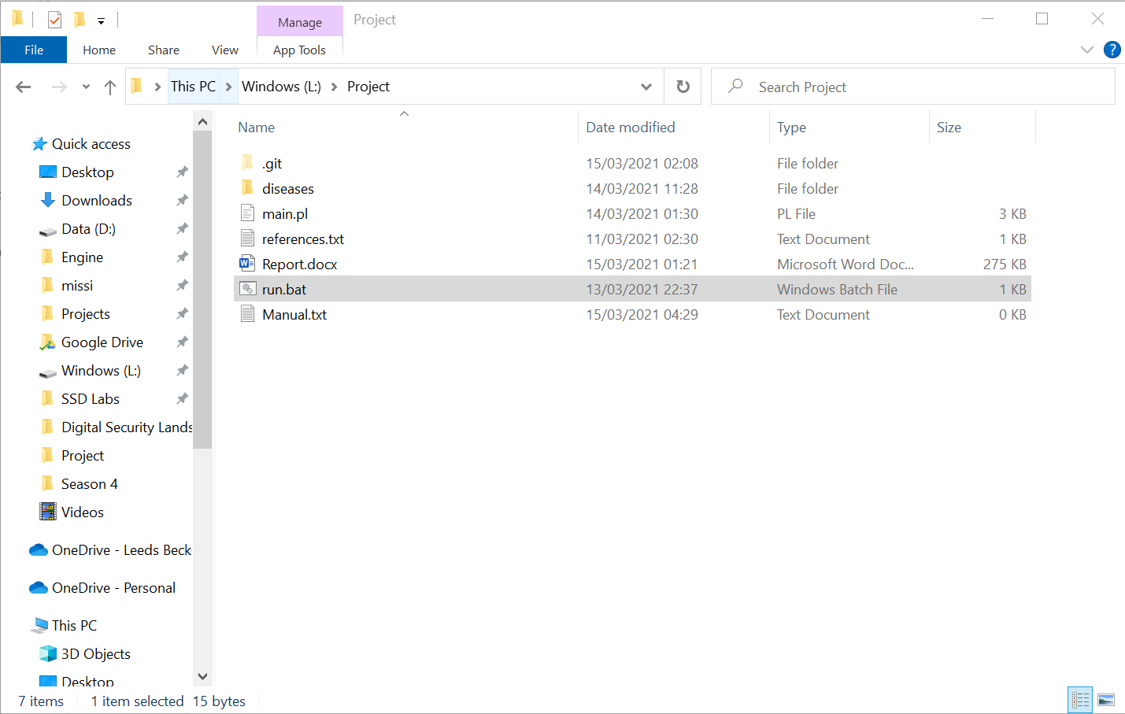

You then get a screen that looks like this:

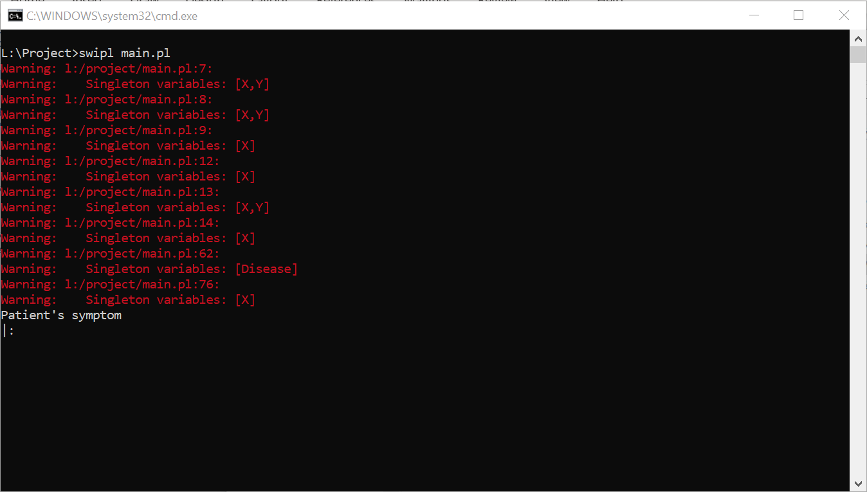

You type the symptoms you need followed by a dot like this:

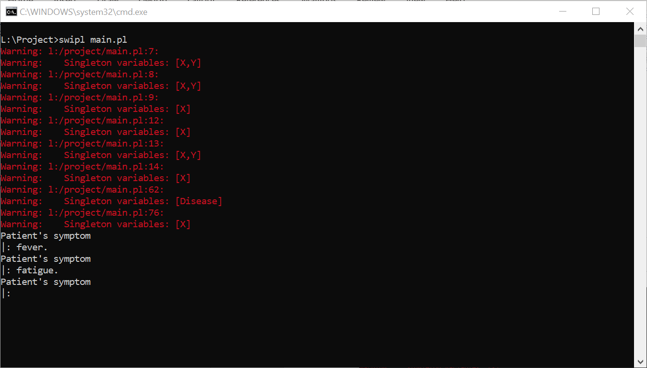

You then type stop. after the last symptom and it should give you a list of possible diagnosis like this:

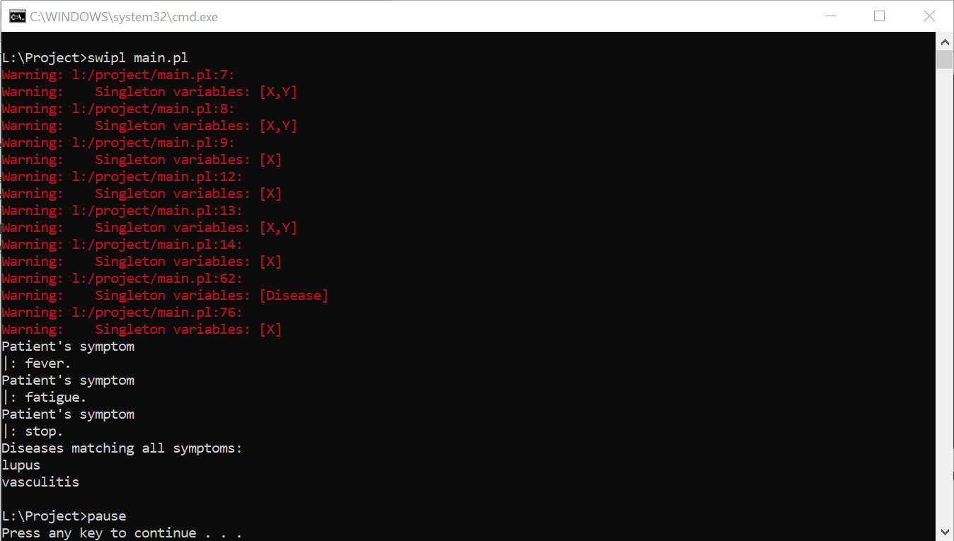

When you are ready to exit the program hit enter.