January 21 2022

Technology(and method) to end hunger:
We introduce a machine the size of a 40 foot shipping container that produces food everyday.

What each machine does:
Every hour, from 9:00h to 15:00h, up to 7 hot baked sweet potatoes are served by each machine, totaling up to 40 every day.
The sweet potato is the food that produces the most carbohydrates per square meter.
É uma estufa pequena tecnológica que será localizada em locais de venda direta ao consumidor como as rolotes de farturas

About the machines:
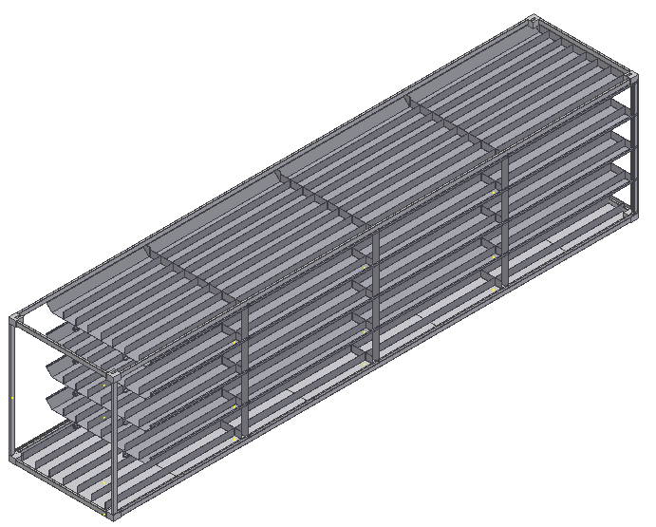
The machines are fundamentally high performance greenhouses, having 30 square meters and 4 floors, making a total of 120 square meters of culture, growing sweet potatoes. Each machine has a robot inside that waters, plants and harvests the sweet potatoes in precise time. The robot harvests a row of ten plants each day, planting new ones on the same local.
The robot takes the harvested sweet potatoes to the oven placed on the front of the machine and roast them during the day, starting at 9:00h, then at each hour, the robot take the roasted sweet potatoes and put another set of up to 7 on the oven, 6 times, 6 hours baking sweet potatoes, baking all of the harvested sweet potatoes of the day until about 15:00h.
The power comes from solar panels and from a wind turbine wich are placed on the roof of the container, after the container is parked.

Method to end hunger:
The machines work well if they are spread out as close to the tribes as possible, they are left where a semi-trailer can go.
Each machine is transported only once to the site, which then produces minimally enough food for 20 people every day.
Each machine is good for places with climatic changes since it can withstand up to 8 months of drought.
The method to end hunger does not only depend on donations.
It has rentable sustainability, as these machines will also be in the civilized world selling each baked sweet potato for arround 70 cents, and people are encoraged because the awareness of the charisma of the project that will save many innocent people from hunger, with machines distributed in strategically places, where there are people without nothing to eat, distributing there baked sweet potatoes free of charge.

Cost of the machines:
Each machine costs about 20.000 euros, and calculating 2 baked sweet potatoes as the minimum diary intake for each person,

Sustainability:
Each million dollars saves a multitude of one thousand innocent people from starving to death with this project.
The calculated sustainability make the investment more rentable, saving more innocent people.
With the grow of the project, In 27 years the cost to save 1 innocent people is 1 dollar. As follows:

Charity
This 40ft container machine only has to be sent once, and it will be producing food everyday and only have mantenaince every 10 years whith a pack of substituting batteries and grow leds, as that material have this wear.

What we need to advance:
We've got the knowledge and experience to do all the details of this project, but with help we can do it faster.
We don't have money to hire persons, as all the money avaiable is canalized to buy the material for the prototype that isn't yet finished.

Help we need to know for now:
• How to get 40ft high cube containers to Madagascar. Are there shipping containers to some port of Madagascar? We dont find "from where" ports yet. Please help.
• How to get 40ft high cube containers to Venezuela and surroundings, where there are concentrations of people that fled.

Plan ahead:
We are an international organization for charity startup, intending to spread arround the world with sustantibility. We intend tor harvest money from wealthier countries, and also helping the insecure people needing social attendance in locals.
• Help plan fo Mexico:The official measurement of poverty in Mexico carried out by Coneval indicated that there were 55.7 million people in poverty in 2020, 43.9% of the total population, of which 10.8 million (8.5%) were in extreme poverty.
We intend to send 40ft machines to Mexico.
extreme poverty

Hint to WFP:

Hint to elon musk:
Save a crowd of 6 million innocent people with 6 billion dollars with this projet.

Current status of development:
The robot is under development, the software, code and drawings are avaiable in https://github.com/vivision1/robot.
The software of the robot runs on linux, but we have it compiled for windows and can be downloaded here.
Robot:
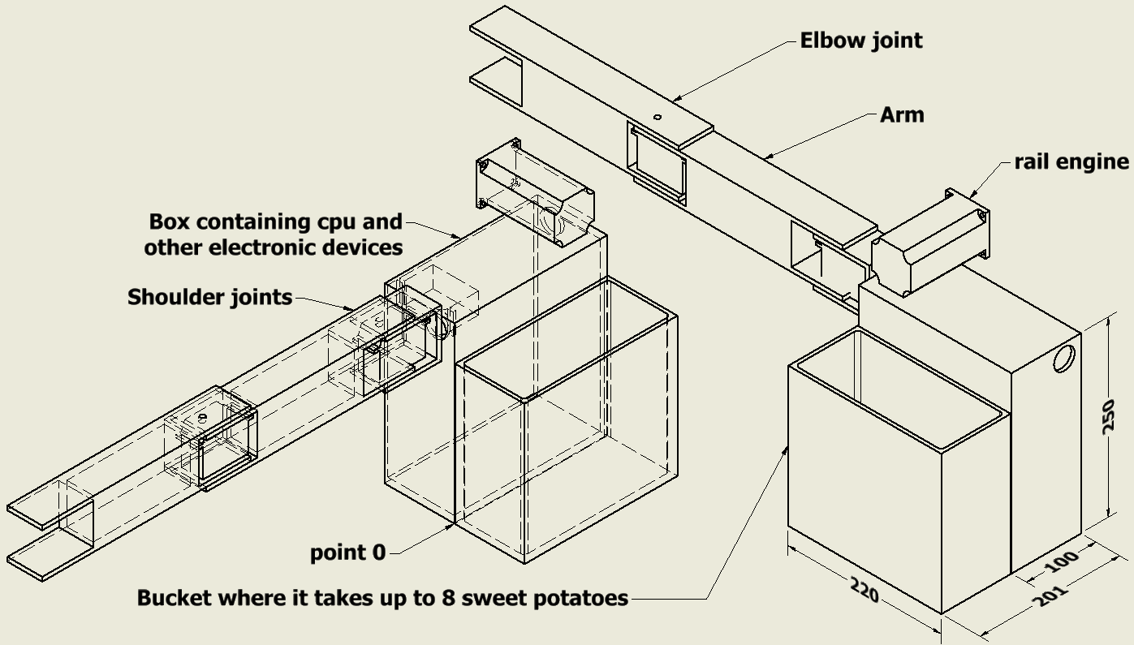
Each of these robots saves up to 20 innocent people.
Assembly drawing of the robot:
