Part 1 Amazon EC2 Server Instance

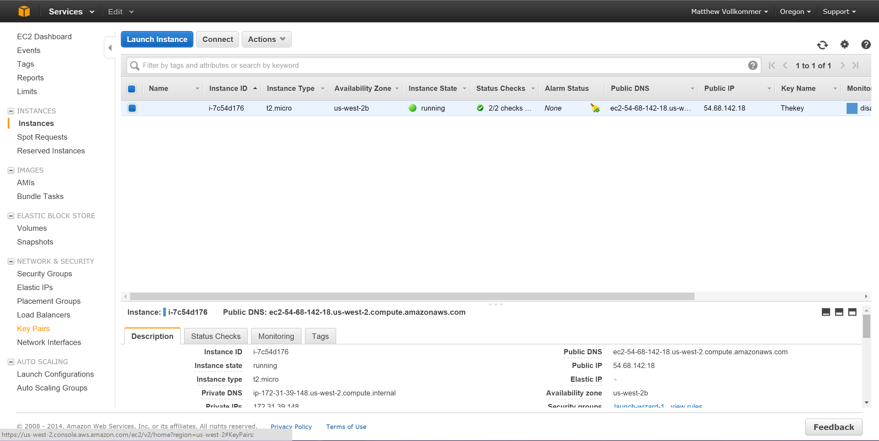

Amazon EC2 Server Instances are virtual machines. An organization would set one up instead of hosting their own physical server. By using a virtual machine, they will not need the expertise of managing their own server hardware in house. They can also easily configure the server as it is needed. They can also only pay for what they use. Organizations can use EC2 instances with ELB to scale up or down as needed automatically.

Part 2 AWS Data Storage with S3

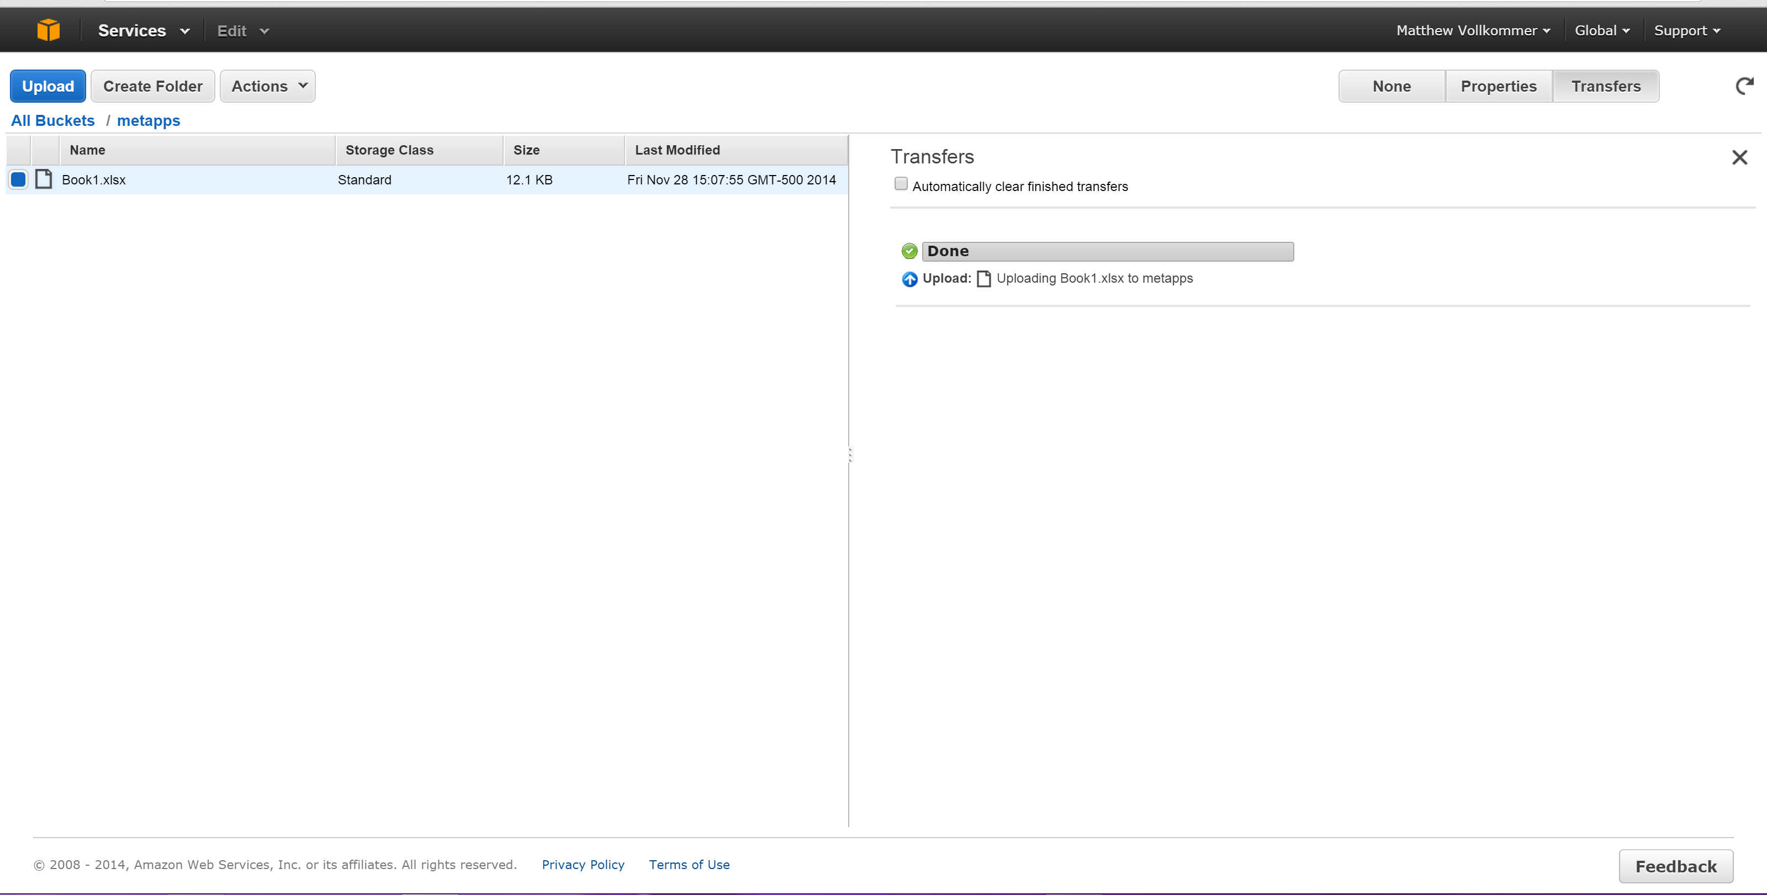

S3 buckets are used to store and distributed files. An organization will benefit from an S3 bucket from ease of use and lower costs. It is easier to use and cheaper than setting up an ftp server on a company’s own hardware. It will also scale as needed. Organizations will only pay for what they need as files are uploaded and downloaded.

Part 3 AWS Elastic Beanstalk

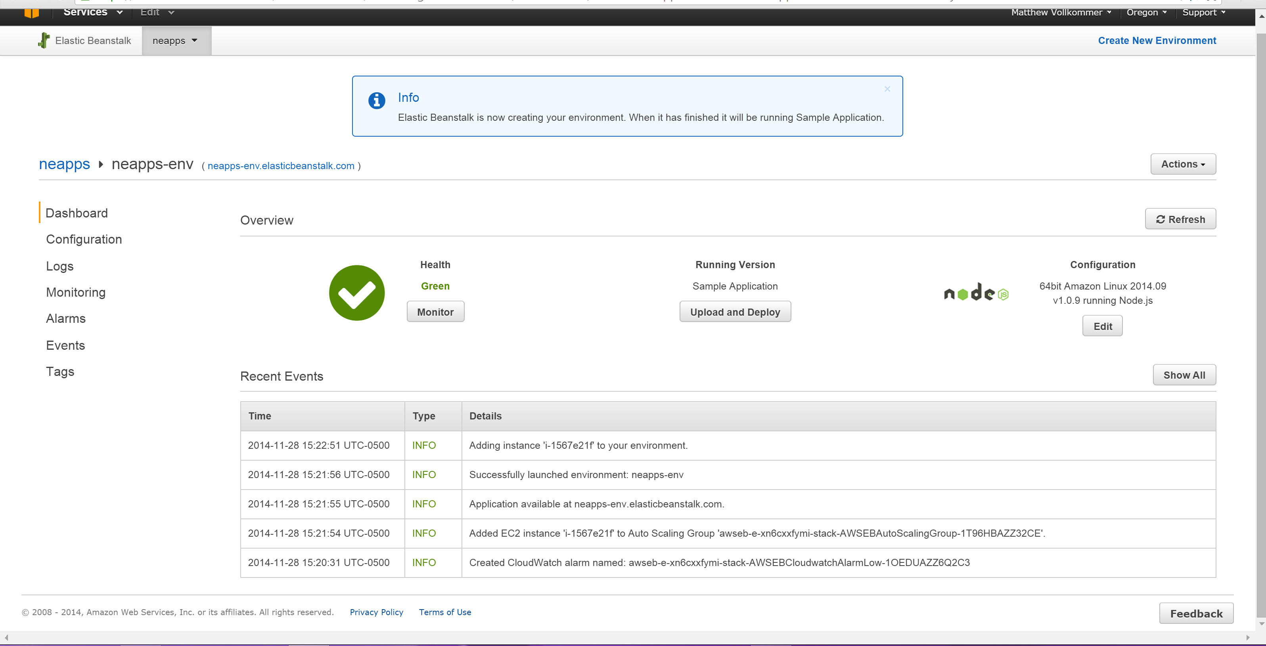

Elastic Beanstalk is a platform as a service that allows users to create application and push them to a definable set of AWS services, including EC2, S3, SNS, Cloudwatch, auto scaling and elastic load balancers. Elastic beanstalk will grow the application backend as needed. Elastic Beanstalk uses EC2 and S3 for computing and storage respectively. Using Elastic beanstalk would be easier to manage and scale than using EC2 and S3 independently.