R

TOTK WHO ARE WE OUR STORIES CONTACT

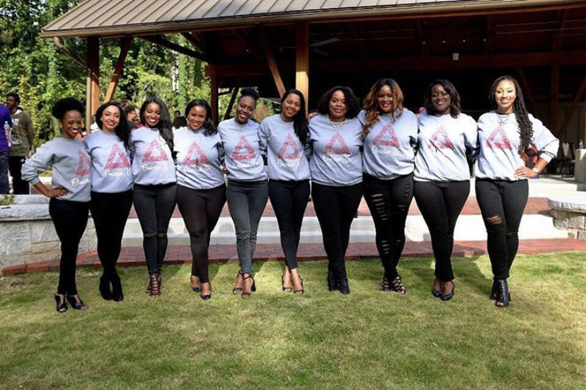

WHO ARE WE

WE STRIVE TO BE ONE

The phenomenal Omicron Xi chapter of Delta Sigma Theta Sorority, Inc. welcomed 10 dynamic women into the illustrious sisterhood on April 10, 2010, and reintroduced us as the Tenets of the Kingdom. TOTK were born in Alabama, Georgia, Florida, Minnesota, Pennsylvania, and Virginia. We hold several degrees and professional certifications, and we work in business, dentistry, nonprofit, optometry, pharmacy, real estate, and public health. In addition, TOTK serve as mentors, community organizers, social justice advocates, ministry leaders, and leaders in various organizations.

Scroll Down

JAMI #5

Decatur, Georgia

1 Corintians 12:9. Cajun Seafood. Purple.

We are passionate