**BTech (Computer Engineering) 2025-26**

**Principles of Green Technology (Open Elective)**

**Assignment I**

Name – Aditi Dhaygave Final Year B. Tech AI-DS Panel C PRN: 1032230604

**Answer any 7 questions.**

1. **Mention in brief about twelve principles of green chemistry.**

Ans:- Twelve Principles of Green Chemistry are as follows :-

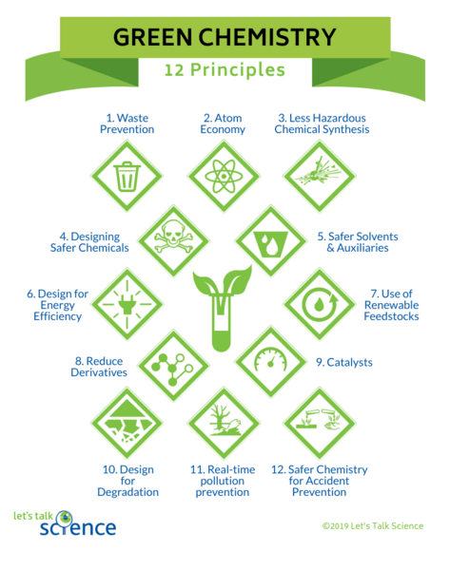

* Prevent waste - It is better to avoid creating waste than to treat or clean it after formation.
* Maximize atom economy - Design reactions so that most reactant atoms end up in the final product.
* Use less hazardous synthesis methods - Use procedures whose toxicity to human beings and the environment is low.
* Design safer chemicals - Design chemicals that are efficient but not too hazardous.
* Use safer solvents and auxiliaries - Reduce or eliminate use of volatile/spurting solvents in favor of safer substitutes such as water.
* Increase energy efficiency - Conduct reactions at ambient temperature and pressure wherever possible to save energy.
* Use renewable feedstocks - Choose raw materials that are renewable (e.g., plant-based) rather than depleting fossil sources.
* Reduce derivatives (e.g., avoid unnecessary steps) - Avoid unnecessary steps like protection/deprotection that produce additional waste.
* Use catalysis instead of stoichiometric reagents - Catalysts are more efficient and reduce waste compared to excess reagents.
* Design chemicals for degradation (non-persistent) - Ensure products break down into harmless substances after use.
* Real-time analysis to prevent pollution - Monitor processes continuously to detect and minimize hazardous byproducts.
* Design safer chemistry to prevent accidents - Choose conditions and substances that reduce risks like explosions, fires, or leaks.

1. **Write in brief about sustainable development and green chemistry.**

Ans:-

Sustainable Development

Definition: Sustainable development is the balanced fulfillment of current human needs (economic growth, food, housing, power, healthcare, etc.) without harming the future generations' capability for fulfilling their own needs.

Three Pillars:

Economic viability - steady growth and job prospects.

Environmental sustainability – conserving ecosystems, biodiversity, and minimizing pollution.

Social sustainability – guaranteeing equity, learning, and social justice.

e.g.: Solar power, green buildings, waste recycling, organic farming.

Importance: Prevents overuse of resources, combats climate change, and promotes long-term human survival.

Green Chemistry

Definition: Green chemistry (or sustainable chemistry) is a definition of the engineering of chemical processes and products to achieve the elimination or minimization of toxic chemicals and environmental harm.

Main Aims:

Employ safe solvents and renewable feedstocks.

Lower energy use and reduce waste output.

Make it biodegradable and non-toxic.

Methods: Atom economy, catalysis, alternative energy (microwave/ultrasound), solvent-free reactions.

Example:

Substitution of undesirable organic solvents with supercritical CO₂.

Biodegradable plastics from corn starch.

Catalytic hydrogenation rather than dangerous methods of reduction.

Importance: Makes industries more eco-friendly, reduces pollution at the source, and supports the vision of sustainable development.

1. **Explain – Atom Economy**

Ans:- Atom economy is a crucial concept in green chemistry, measuring the efficiency of a chemical reaction in converting reactants into desired products . It quantifies the proportion of the mass of all reactants that ends up in the useful product, rather than in unwanted by-products.

Atom economy is a measure of the amount of starting materials that end up as useful materials, calculated as the ratio of the molecular mass of the desired product to the sum of the molecular masses of all reactants, expressed as a percentage. It is a key metric for assessing the environmental and economic sustainability of chemical processes.

The calculation for atom economy is expressed as a percentage:

$$Atom Economy =\frac{Molecular mass of desired product}{Sum of molecular masses of all reactants} ×100$$

A high atom economy (ideally 100%) signifies that most of the atoms from the starting materials are incorporated into the desired product, leading to minimal waste. This is highly desirable in industrial processes for several reasons:

* **Sustainability and Environmental Impact**: Reactions with high atom economy reduce the generation of waste products, thereby minimizing environmental pollution and the need for costly waste disposal. This aligns with the principles of sustainable chemistry, conserving resources and reducing the ecological footprint of chemical manufacturing .
* **Resource Conservation**: By maximizing the conversion of raw materials into useful products, atom economy helps conserve valuable resources. Less material is wasted, making the process more efficient and less reliant on continuous input of new reactants.
* **Economic Benefits**: Reducing waste directly translates to lower production costs. Less raw material is consumed per unit of product, and expenses associated with waste treatment and disposal are minimized. Furthermore, higher atom economy often means less energy is expended in separating desired products from unwanted by-products .
* **Process Efficiency**: Reactions with high atom economy are generally more efficient. For example, addition reactions often have 100% atom economy because all reactant atoms are incorporated into a single product . In contrast, substitution or elimination reactions typically have lower atom economies due to the formation of by-products. Chemists strive to design synthetic routes that prioritize high atom economy to optimize overall process efficiency.

1. **Write in brief about Integrated Pollution Prevention and Control (IPPC)**

Ans:- The Integrated Pollution Prevention and Control (IPPC) is a regulatory framework primarily focused on minimizing pollution from industrial sources within the European Union. It requires operators of industrial installations engaged in activities listed in Annex I of the IPPC Directive to obtain an environmental permit from the authorities in EU countries . This permit ensures that industrial activities are conducted with measures to prevent and control pollution, promoting a high level of environmental protection as a whole .

The Integrated Pollution Prevention and Control (IPPC) is a European Union directive aimed at minimizing pollution from various industrial sources. It mandates that industrial installations undertaking activities specified in Annex I of the IPPC Directive must secure an environmental permit from the relevant authorities in EU member states**.** This permit outlines conditions designed to prevent and control pollution, ensuring a comprehensive approach to environmental protection . The IPPC framework emphasizes the application of Best Available Techniques (BAT) to achieve a high level of environmental protection, considering the entire environmental performance of an installation. The goal is to prevent or, where that is not practicable, to reduce emissions to air, water, and land from industrial activities, as well as to minimize waste generation. The IPPC Directive has since been replaced by the Industrial Emissions Directive (IED) (2010/75/EU), which consolidates and streamlines several directives, including the IPPC Directive, to enhance industrial environmental performance.

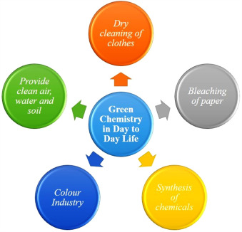

1. **Mention in brief about the concept and methodology of inherently safer design.**

Ans:-

**Concept of Inherently Safer Design**

The core concept of ISD revolves around preventing hazards from existing in the first place or minimizing their potential impact, rather than simply controlling them. It's a shift from managing risk to eliminating or reducing the inherent danger of a process. This philosophy can be applied throughout the entire lifecycle of a chemical plant, from initial research and development to design, operation, and even shutdown and decommissioning . The goal is to make processes "inherently safer" rather than "inherently safe," acknowledging that no chemical process is entirely without risk.

ISD is a foundational component of the hierarchy of hazard controls, which ranks control measures based on their effectiveness. Inherent safety is considered the most effective level, followed by passive engineered controls, active engineered controls, and administrative controls.

**Methodology of Inherently Safer Design**

The methodology for implementing Inherently Safer Design (ISD) involves a systematic approach to identify and integrate design solutions that inherently reduce or eliminate process hazards. This process typically includes:

* **Defining Study Objectives:**Clearly outlining the goals of the ISD study, such as reducing specific process hazards or improving overall safety performance.
* **Identifying Process Hazards:**Utilizing various process hazard analysis (PHA) techniques (e.g., HAZOP, What-If analysis) to comprehensively understand potential hazards and accident scenarios.
* **Applying Inherent Safety Principles:**This is the core of the methodology, focusing on:
  + **Minimization:**Reducing the quantity of hazardous materials.
  + **Substitution:**Replacing hazardous materials or processes with less hazardous alternatives.
  + **Moderation:**Reducing the severity or impact of a hazard (e.g., lower temperature/pressure).
  + **Simplification:**Reducing process complexity to minimize errors.
  + **Error Tolerance (or Inherent Protection):**Designing systems to withstand faults or provide passive protection.
* **Identifying Design Alternatives:**Brainstorming and exploring various design options that offer inherent safety benefits.
* **Evaluating Design Alternatives**: Systematically assessing alternatives for hazard reduction, risk mitigation, technical feasibility, and cost-effectiveness.
* **Quantifying Risk Reduction:**Using risk assessment techniques (e.g., QRA) to compare the risk reduction potential of different designs.
* **Selecting Optimal Design:**Choosing the design that offers the highest level of inherent safety, balancing safety with other factors.
* **Implementation and Monitoring:**Developing a plan for implementing chosen design changes and continuously monitoring their effectiveness.
* **Documentation and Communication:**Thoroughly documenting all findings, recommendations, and decisions, and communicating them to stakeholders.
* **Continuous Improvement:**Regularly reviewing and assessing implemented changes and incorporating lessons learned into future projects.

1. **Mention in brief about how non-conventional energy sources are important in promotion of green technology.**

Ans:- Non-conventional energy sources, often synonymous with renewable energy, are vital for promoting green technology because they offer a sustainable alternative to fossil fuels, directly addressing climate change and environmental degradation. These sources, such as solar, wind, hydro, geothermal, and biomass, replenish naturally and produce significantly fewer greenhouse gas emissions during operation compared to traditional energy sources. The shift towards these technologies is driven by global crises, including worsening climate change, volatile fossil fuel prices, and health consequences.

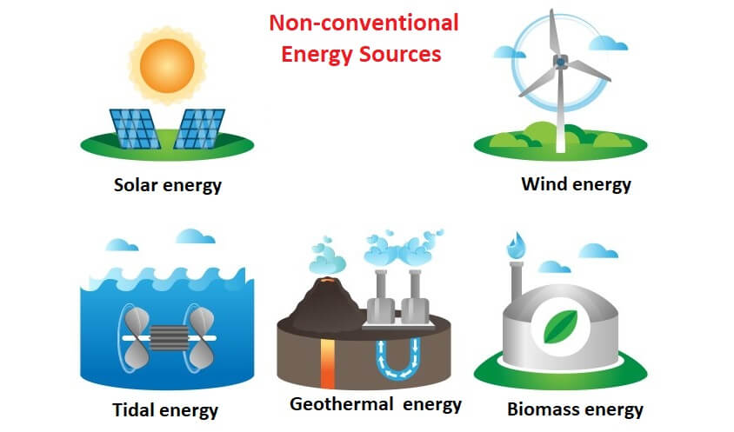

**The importance of non-conventional energy sources in promoting green technology can be understood through several key aspects:**

* **Environmental Mitigation:** They significantly **reduce greenhouse gas emissions and air pollution**, directly combating climate change and improving air quality.
* **Resource Conservation and Sustainability:** As naturally replenishing and inexhaustible resources, they ensure **long-term energy availability and reduce reliance on finite fossil fuels**, aligning with sustainable resource management.
* **Economic Development and Job Creation:** The sector fosters **innovation, creates new jobs**, and stimulates economic growth.
* **Energy Security and Affordability:** They enhance national energy security by **reducing dependence on imported fuels** and are becoming increasingly cost-effective, leading to more affordable energy.
* **Decentralization and Empowerment:** They enable **local energy production and ownership**, promoting energy access and empowerment, especially in remote areas.
* **Innovation and Technological Advancement:** Their development drives **significant advancements in energy technologies**, crucial for overcoming challenges and integrating renewables into the grid.

1. **Explain - microwave assisted reactions**

Ans:- Microwave-assisted reactions, also known as Microwave-Assisted Organic Synthesis (MAOS), represent a significant advancement in chemical synthesis, offering numerous advantages over conventional heating methods. This technology leverages microwave energy to rapidly and efficiently heat reaction mixtures, leading to accelerated reaction times, improved yields, and enhanced purity, all while promoting more environmentally friendly processes.

**Advantages of Microwave-Assisted Reactions**

* **Faster Reaction Times:** **Microwaves dramatically reduce reaction times, often from hours or days to minutes or even seconds, by accelerating the heating process and enabling higher reaction temperatures in sealed vessels**.
* **Improved Product Yields and Purity:** The rapid and uniform heating provided by microwaves leads to better control over reaction kinetics, often resulting in higher yields and purer products by minimizing side reactions and decomposition.
* **Energy Efficiency:** Microwave reactions typically require less energy input than conventional methods because they directly heat the reaction medium, minimizing heat loss to the surroundings.
* **Environmental Friendliness (Green Chemistry):** MAOS contributes to green chemistry by reducing reaction times, energy consumption, and often the need for hazardous solvents or catalysts, leading to lower environmental impact.
* **Selective Heating:** Microwaves can selectively heat materials based on their dielectric properties, which is particularly useful in heterogeneous catalytic reactions where the catalyst can be heated preferentially.
* **Scalability:** Modern microwave technology, including continuous-flow reactors, allows for the scaling up of reactions from milligram to kilogram scales.
* **Enhanced Safety:** Dedicated microwave reactors offer precise control over temperature and pressure, significantly improving safety compared to early domestic microwave oven experiments.

**Applications of Microwave-Assisted Reactions**

Microwave-assisted synthesis is widely applied across various fields of chemistry:

* **Organic Synthesis:** Used extensively for numerous organic transformations, including cycloadditions, condensations, and rearrangements. It has been particularly effective in the synthesis of nitrogen-containing heterocycles such as pyrroles, indoles, pyridines, pyrrolidines, imidazole, pyrazoles, pyrazolines, lactams, and 1,2,3-triazoles, which are crucial in medicinal chemistry.
* **Material Science:** Instrumental in the synthesis of nanomaterials, ceramics, and polymers, enabling rapid and uniform heating for high-quality material production.
* **Pharmaceutical Industry:** Facilitates the rapid synthesis of pharmaceutical intermediates and active ingredients, improving throughput in drug discovery and production.
* **Environmental Catalysis:** Explored for the decomposition of hazardous compounds, with reactions proceeding more efficiently under microwave irradiation due to selective absorption by catalysts.