

Training Management System
SRS

Project Code: <TRMS>
Document Code: TRMS_SRS_v1.0

Hanoi, June 2013
Record of change
*A - Added M - Modified D - Deleted
Effective Date | Changed Items | A*  M, D | Change Description | New Version
10-Jun-2013 |  | A | Create new Training Tool Guideline | 0.1
SIGNATURE PAGE

ORIGINATOR: Nguyen Quoc Ly 10-June-2013
Developer

REVIEWERS: Ton Duc Hai 19-June-2013
Project Manager

APPROVAL: <Name> <Date>
<Position>

TABLE OF CONTENTS
1. Quick start 5
How to use this manual 5
Typography convention 5
Term and abbreviation 5
2. Introduction and overview 6
3. Getting started 7
Main Function 7
System Users 7
4. system Functional description 8
Account 14
Course 18
Account Course 20
Language Score 23
Account Certificate 24
Report 26
Security 27
5. Appendix 38

Quick start

How to use this manual
- This manual provides information on using the Training Tool program to manage all training courses in FSOFT. If you are new to the program, we suggest you read through this publication before using the software.
The document is divided according to functions:
- Account function: is used to manage FSOFT’s members
- Course function: is used to manage courses in FSOFT
- Account Course function: is used to manage which FSOFT’s members in each course
- Static Data function: is used to manage organization information. Ex: User, Department information, Level, Rank, etc.
- Change Config function: is used to change data viewing (in Account grid and Account Course grid) and system source (database, server address, etc)
- Import function: is used to import Account list or Account Course list into the system. Import file is an Excel file
- Report function: this function creates some statistical reports which support the user to write reports, analyze and make decision

Typography convention
N/A

Term and abbreviation
N/A

Introduction and overview
This system is used to manage training courses in FSOFT to identify what training courses every FSOFT’s member has participated. Besides, this system also provides statistical reports about training courses according to years, months, training course kind, etc.

Getting started

Main Function
- The system includes seven main functions: Account, Course, Account Course, Employee Certificate, Language Score, Static Data, Report, Import and Change Config.
- Account function: is used to manage FSOFT’s staff.
- Course function: is used to manage training courses in FSOFT.
- Account Course function: is used to manage FSOFT’s staff in each training course.
- Static Data function: is used to configure data such as: Certificate, Certificate Category, Certificate Provider, Contract Type, Course Category, Currency, Department, Course Feedback, Instructor, Job Title, Job Function, Language Type, Level, Location, Log, Officer Code, Rank, Role, Skill, Status Accountant, Topic, and User.
- Change Configuration function: is used to show/hide columns in Account grid, Account Course grid and change system such as source database, server address, etc…
- Import function: is used to import Accounts list or Account Course data into the system. Import file will be an Excel file.
- Report function: is used to create some statistical reports which support the user to create reports, analyze and make decision on the reports.

System Users
- The Training Management Tool’s users are people who manage training courses or manage Training Tool. There are 2 kinds of users: Administrator (Admin) and Normal User (User).
- Normal User: can work on Account, Course, Account Course, Report functions, etc… Static Data excepting “User” function and “Log” function.
- Administrator: can work on all functions in the Training Management Tool.

system Functional description

Training Tool Authenticate
Brief Description: This function is used for user can login to view website.
Actors: All users
- Open path http://10.16.56.27:81/ screen will display as the Figure 5.1.1
- Input valid username and password
- Click on Sign In button to access the Training Tool program
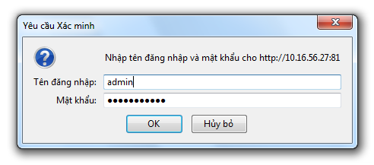
Figure 5.1.1: Training Tool Authentication

Home Page
Brief Description: This function is used to view for all users in the company. In this user can see information myself. In Course user can see information about all courses which user join. In Certificate user can see all certificates which they have. And in Language Score user can see all points which they test, and in Announcement user can see information about your company.
Actors: All users
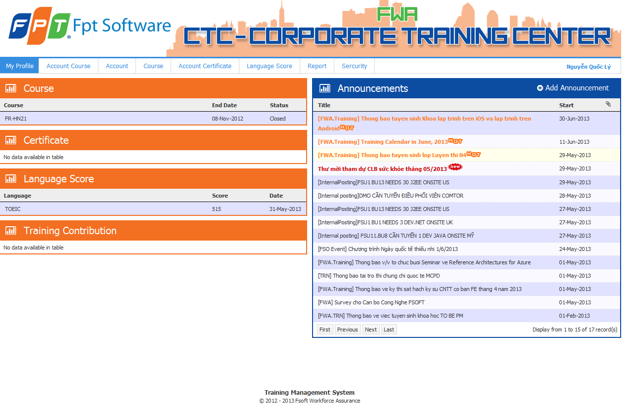
Figure 5.1.2: Home Page
- In screen Home page screen, user can click a link to see view detail of Detail Course (Figure 5.1.2.1), Detail Certificate (Figure 5.1.2.2), Detail Language Score (Figure 5.1.2.3), Detail Training Contribution, Detail Announcement (Figure 5.1.2.4).
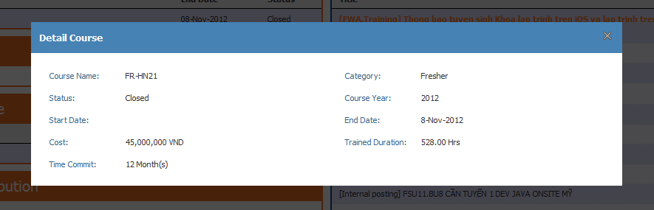
Figure 5.1.2.1: Detail Course
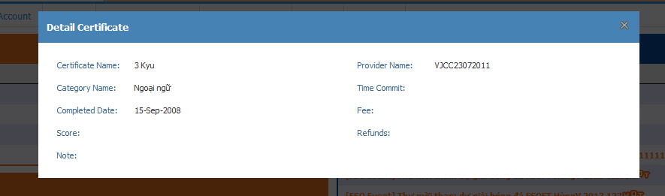
Figure 5.1.2.2: Detail Certificate
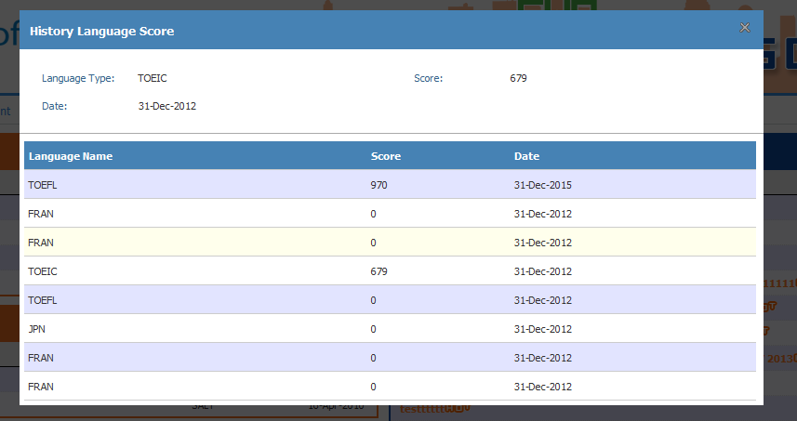
Figure 5.1.2.3: Detail Language Score
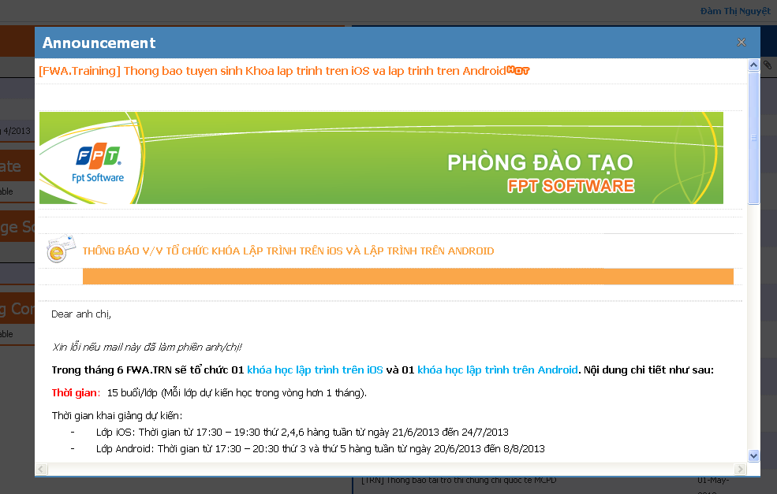
Figure 5.1.2.4: Detail Announcement

Add Announcement Function
Brief Description: This function is used to add announcement from company.
Actors: TRMS_Group
Basic Flow
- Go to home page, in screen choose Add Announcement.
- Brower will display the View Add Announcement as Figure 5.1.3

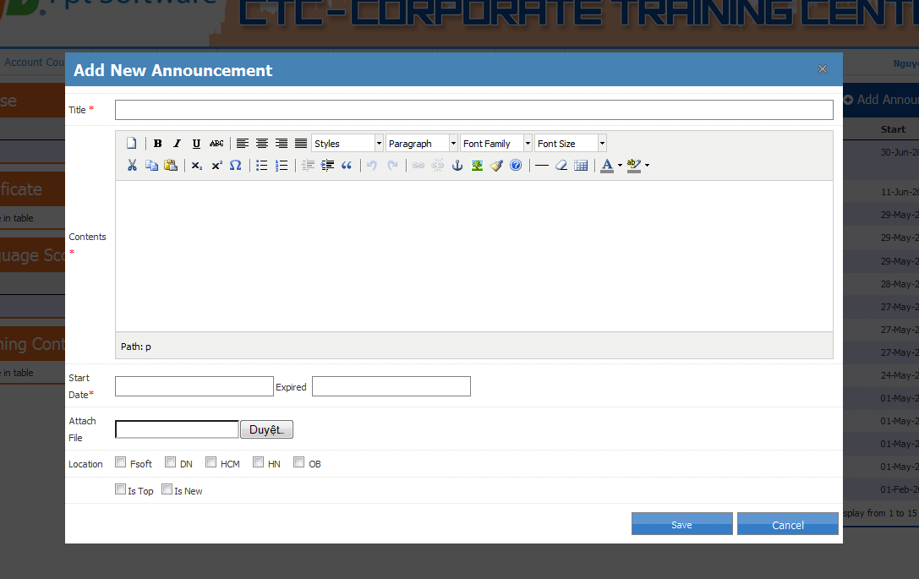
Figure 5.1.3: Add Announcement function

Edit Announcement Function
Brief Description: This function is used to edit announcement from company.
Actors: TRMS_Group
Basic Flow
- Go to home page, in screen choose detail an Announcement.
- Brower will display the View Add Announcement as Figure 5.1.4
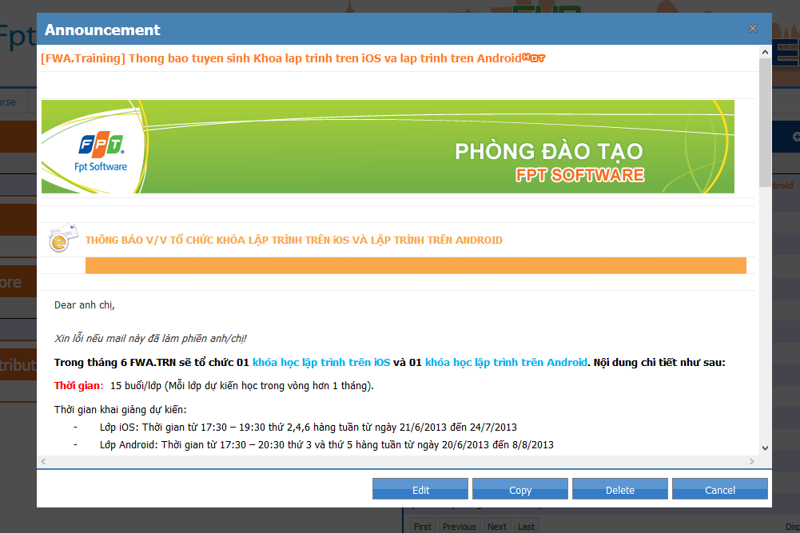
Figure 5.1.4: Edit Announcement function

Copy Announcement Function
Brief Description: This function is used to copy an announcement from company and add new an announcement.
Actors: TRMS_Group
Basic Flow
- Go to detail an Announcement and select copy function.
- Brower will display the View Add Announcement as Figure 5.1.5
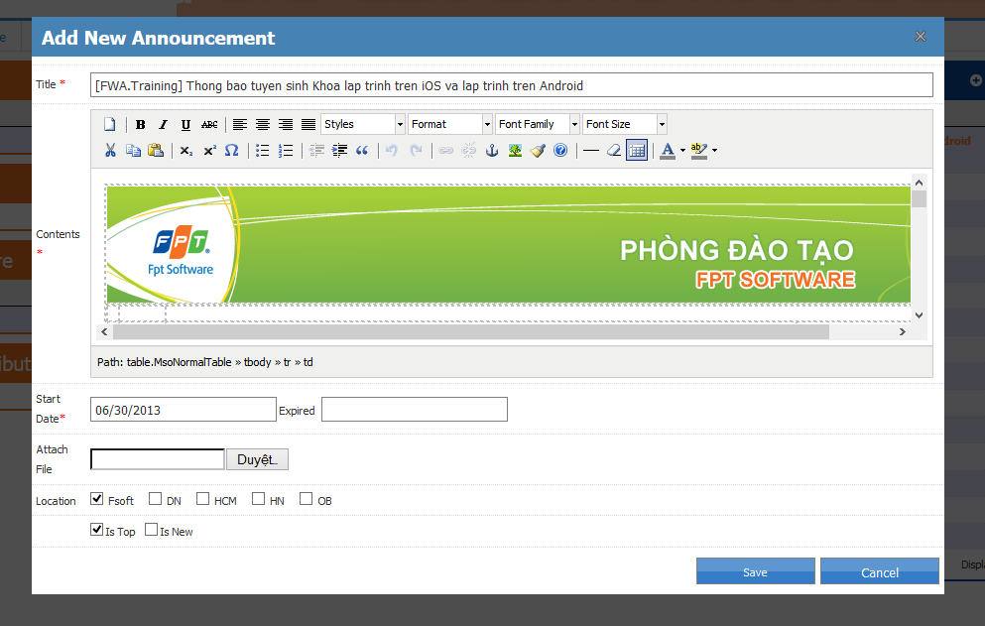
Figure 5.1.5: Copy Announcement function

Account
Brief Description: This function is is used to manage all FSOFT’s staff. An account is an employee in FSOFT. An account includes the following information: Employee ID, Account, Full Name, Location, Department, Job Title, Contract Type, Level, Rank, Descriptions, Status Account, Hired Date, Termination Date, Role, Officer Code, Job Function, DOB, Mobile Phone, and Address.
Actors: Manager Group
Basic Flow
- Open path http://10.16.56.27:81/ screen will display as the Figure 5.1.1
- Input valid username and password
- Click on OK button to access the website Training Tool.
- From the menu, choose Account. If User don’t have department screen will display as figure
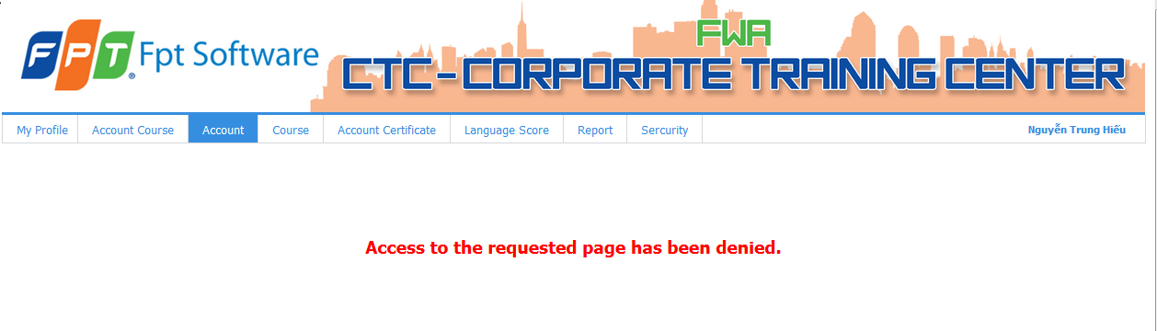
Figure 5.2.1: Account function (User don’t have department)
If User have permission screen will display as figure 5.2.2
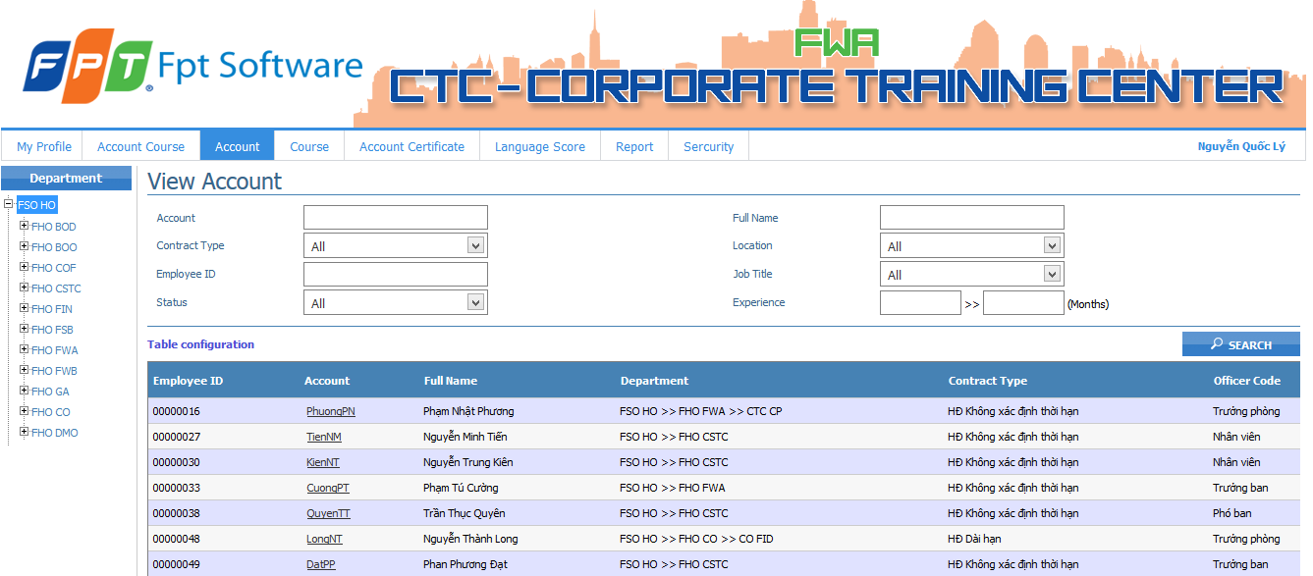
Figure 5.2.2: Account function (User have department)
- If User manage all department screen will display all department as figure 5.2.3
- The Account Course window will display as the Figure 5.2.3. The left menu of the Account window includes all departments in the company. You can select a department to display only account courses in this department

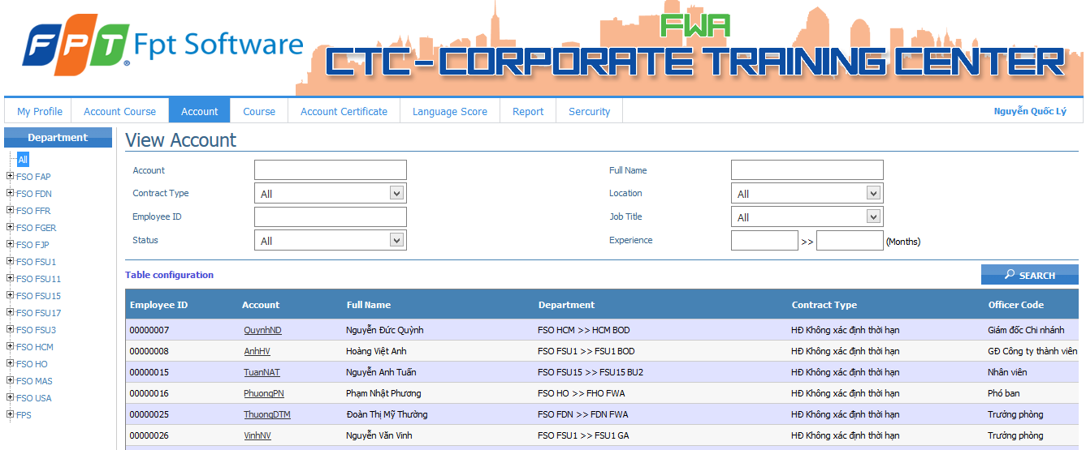
Figure 5.2.3: Account function (User manage all department)

Search Account
- Input search data into search fields (type all or part of values in Account, Full Name, Employee ID and Experience fields; Select values in dropdown boxes such as Contract Type, Location, Job Title and Status fields)
- Experience (months) = Current month - The month of hired date of the account. For example:
- User A has hired date = 23 Nov 2012, the current date = 5 Dec 2012. That means user has 1 month experience.
- Click Table Configuration Screen helps users can expansion result search, it will display popup Selected Fields as Figure 5.1.6.1. If user selected all other checkbox will checked. The default checkbox such as Employee ID, Account, Full Name, Department, Contract Type and Officer Code always checked and disenable.
- Click on Search button or press Enter key. The system will display all accounts that match the search criteria as figure 5.1.6.2
Note: You can search accounts in a specific department by selecting this department in the left menu. Then, input search data into search field. Click on Search button.

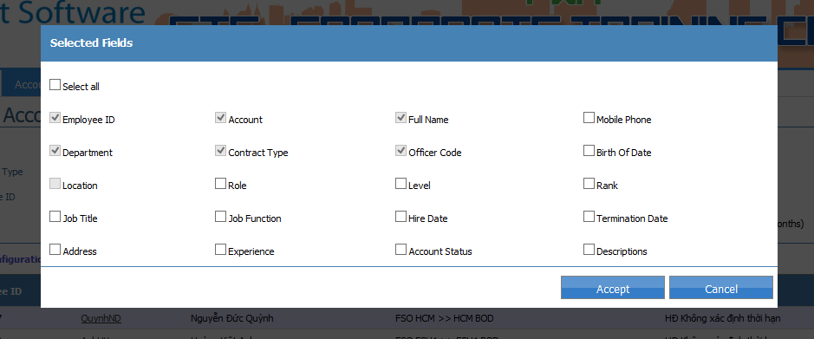
Figure 5.1.6.1: Popup Selected Fields Account
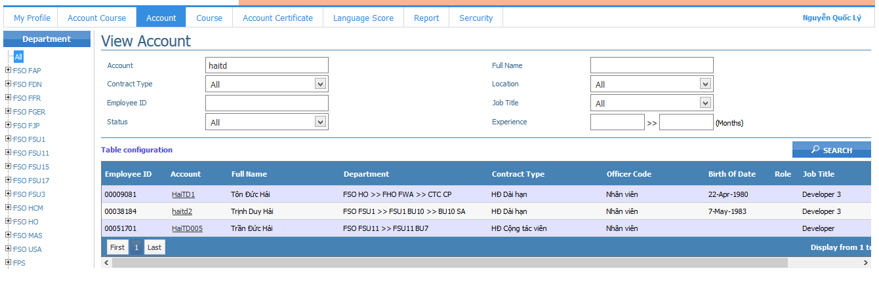
Figure 5.1.6.2: Search Account

Account Details
- Go to Account
- Click link in screen Account. Brower will display Account Details as Figure 5.1.7
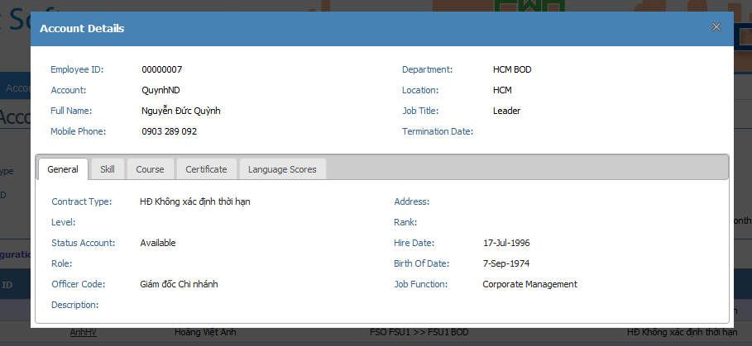
Figure 5.1.7: Account Details Popup
At screen ‘Account Details’ has General Tab, Skill Tab., Course Tab, Certificate Tab, Languages Scores Tab for user can see details.

Course
Brief Description: This function is is used to manage all training courses in FSOFT. A course includes following information: Course Name, Course Category (this information is managed by Course Category function), Start Date, End Date, Cost, Time Commit and Trained Duration (hrs).
Actors: Manager Group
Basic Flow
- Open path http://10.16.56.27:81/ screen will display as the Figure 5.1.1
- Input valid username and password
- Click on OK button to access the website Training Tool.
- From the menu, choose Course. Screen will display as figure 5.3.1:
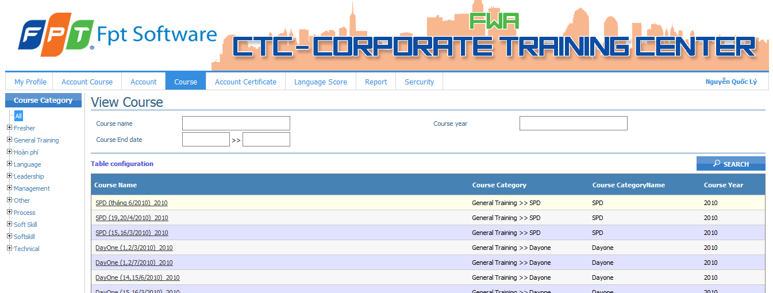
Figure 5.3.1: Course function

Search Course
- Input search data into search fields.
- Click Table Configuration Screen helps users can expansion result search, it will display popup Selected Fields as Figure 5.1.8.1. If user selected all other checkbox will checked. The default checkbox such as Course Name, Course Category, Course Category Name, Course Year always checked and disenable.
- Click on Search button or press Enter key. The system will display all courses that match the search criteria as Figure 5.1.8.2
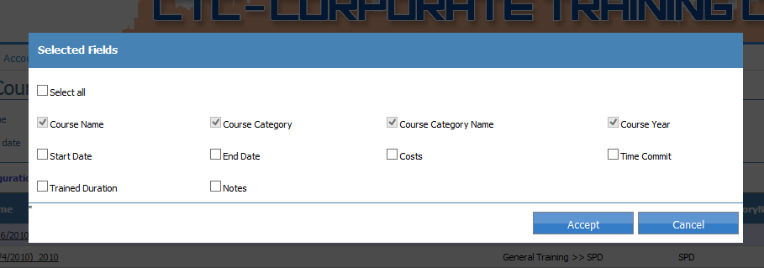
Figure 5.1.8.1: Popup Selected Fields Course
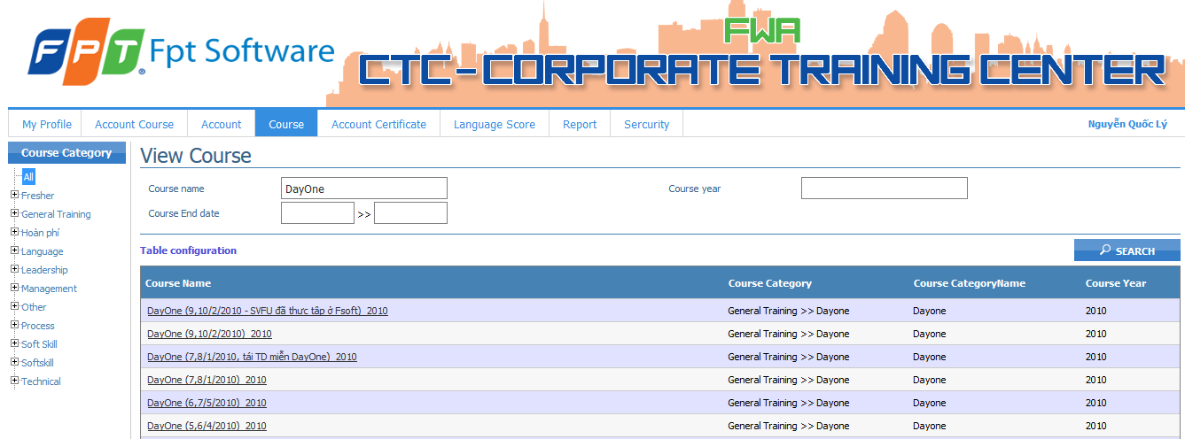
Figure 5.1.8.2: Search Course function

Course Details
- Go to Course
- Click link in screen Account. Brower will display Account Details as Figure 5.1.9
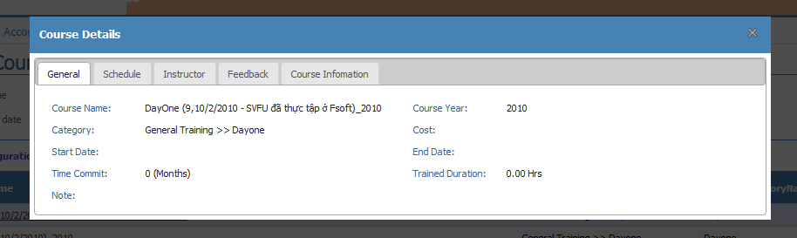
Figure 5.1.9: Detail Course popup
Note: At screen ‘Course Details’ has General Tab, Schedule Tab, Instructor Tab, Feedback Tab, Course Information Tab for user can see details.

Account Course
Brief Description: This function is is used to manage FSOFT’s employees in each course. An account course includes following information: Department, Course Category, Account, Course, Cost, Time Commit, Trained Duration, Pass Coverage, Final Result (Pass or Fail).
Actors: Manager_Group
Basic Flow
- Open path http://10.16.56.27:81/ screen will display as the Figure 5.1.1
- Input valid username and password
- Click on OK button to access the website Training Tool.
- From the menu, choose Account Course. If User haven’t permission screen will display as figure 5.4.1:
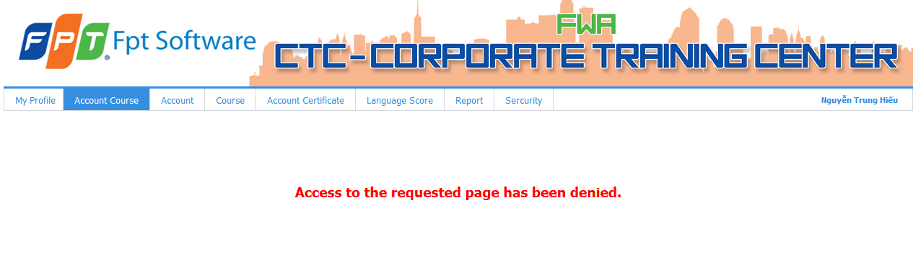
Figure 5.4.1: Account Course function (User haven’t permission)
- If User have permission screen will display all department as figure 5.4.2
- The Account Course window will display as the Figure 5.4.2. The left menu of the Account Course window includes all departments in the company. You can select a department to display only account courses in this department
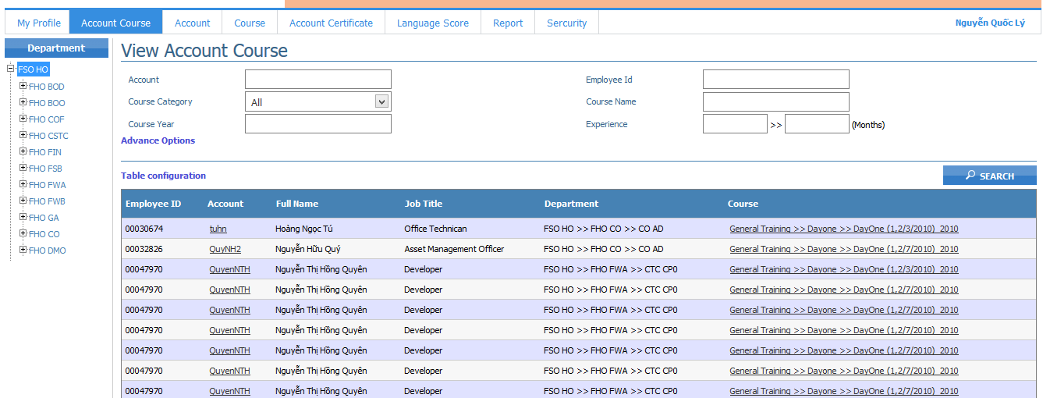
Figure 5.4.2: Account Course function

Search Account Course
- Input search data into search fields (type all or part of values in Account, Employee Id, Course Name and Course Year , Experience fields; Select values in Course Category field)
- Click Table Configuration Screen helps users can expansion result search, it will display popup Selected Fields as Figure 5.1.10.1. If user selected all other checkbox will checked. The default checkbox such as Employee ID, Account, Full Name, Department, Job Title, Course Name always checked and disenable.
- Click on Search button or press Enter key. The system will display all account courses which match with search data as Figure 5.1.10.2
Note: You can search account courses in a specific department by selecting this department in the left menu. Then, input search data into search field. Click on Search button
- Search Account Course using ‘Advance Options’
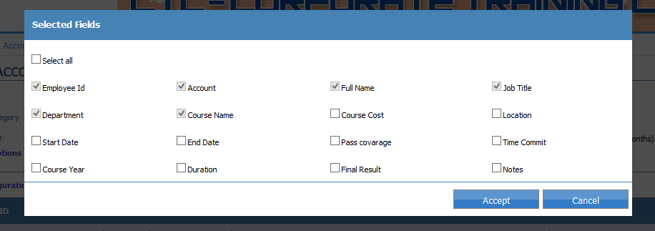
Figure 5.1.10.1: Popup Selected Fields Account
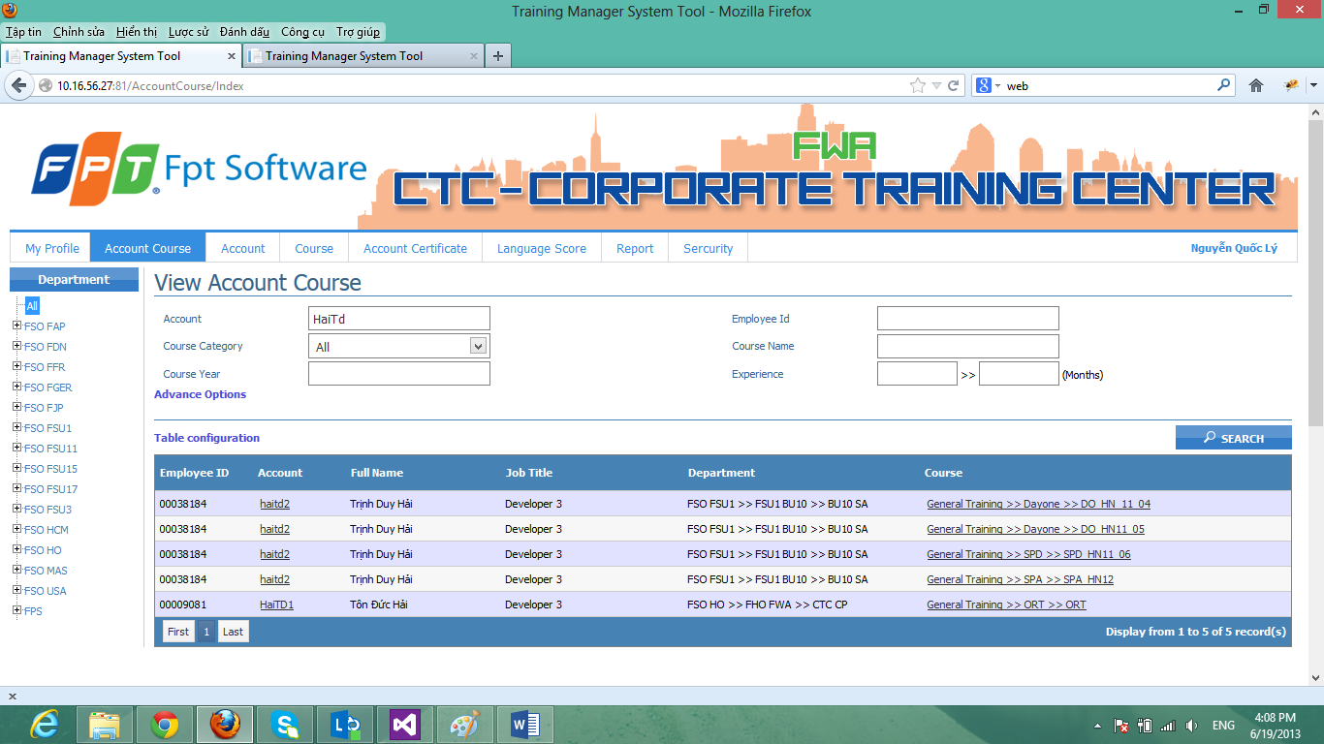
Figure 5.1.10.2: Popup Selected Fields Account

Account Course Details
- Go to Account Course function
- Click on link Account in screen. Window will display Account Details Popup as Figure 5.2.7
- Click on link Course in screen. Window will display Detail Course popup as Figure 5.1.9

Language Score
Brief Description: This function is used to manage all language scores of each account in FSOFT.
Actors: All users
Basic Flow
- Open path http://10.16.56.27:81/ screen will display as the Figure 5.1.1
- Input valid username and password
- Click on OK button to access the website Training Tool.
- From the menu, choose Language Score. If User haven’t permission screen will display as figure 5.5.1:
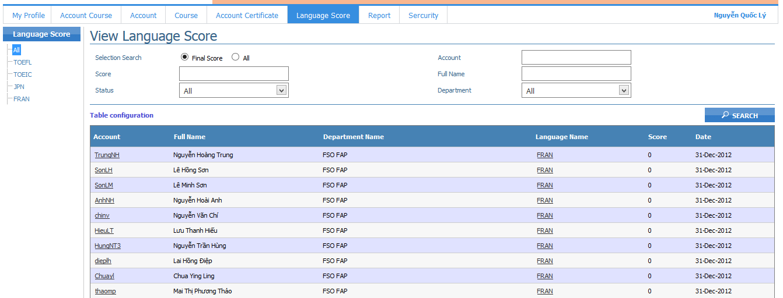
Figure 5.5.1: Language Score function

Search Language Score
- Input search data into search fields.
- Click Table Configuration Screen helps users can expansion result search, it will display popup Selected Fields as Figure 5.1.12.1. If user selected all other checkbox will checked. The default checkbox such as Account, Full Name, Department Name, Language Name, Score and Date always checked and disenable.
- Click on Search button or press Enter key. The system will display all account names that match the search criteria as figure 5.1.12.2
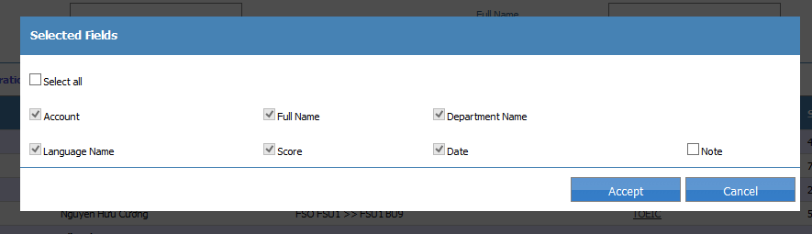
Figure 5.1.12.1: Popup Selected Fields Language Score
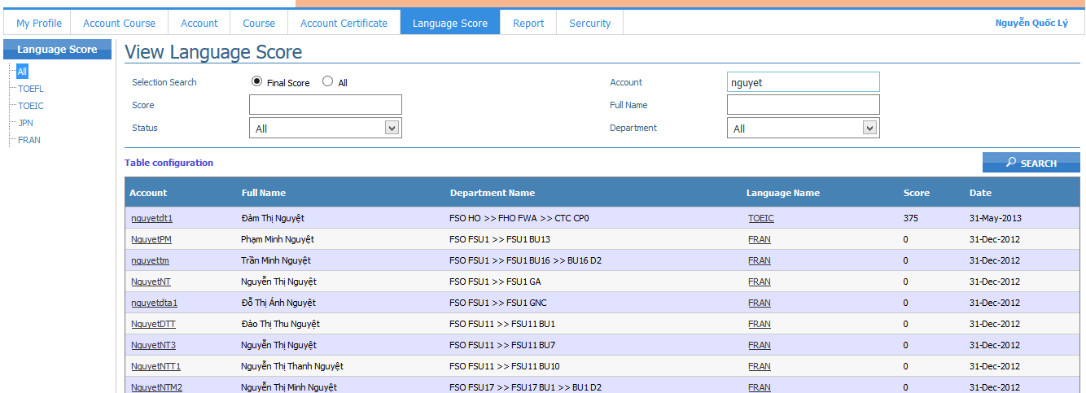
Figure 5.1.12.2: Search Language Score

Language Score Detail
- Go to Language Score function
- Click on link Account in screen. Window will display Account Details Popup as Figure 5.2.7
- Click on link Language Name in screen. Window will display Language Score Details popup as Figure 5.1.13.1
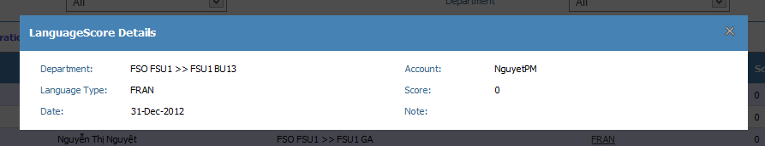
Figure 5.1.13.1: Language Score Details popup

Account Certificate
Brief Description: This function is used to manage all certificates of each account in FSOFT.
Actors: All users
Basic Flow
- Open path http://10.16.56.27:81/ screen will display as the Figure 5.1.1
- Input valid username and password
- Click on OK button to access the website Training Tool.
- From the menu, choose Account Certificate. If User haven’t permission screen will display as figure 5.6.1:
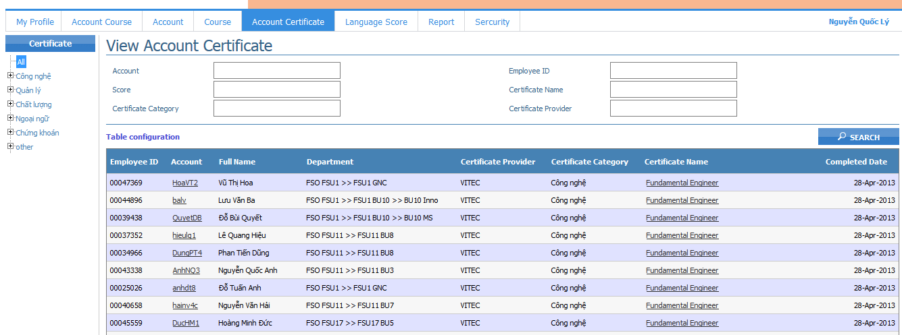
Figure 5.6.1: Account Certificate function

Search Account Certificate
- Input search data into search fields.
- Click Table Configuration Screen helps users can expansion result search, it will display popup Selected Fields as Figure 5.1.14.1. If user selected all other checkbox will checked. The default checkbox such as Employee Id, Account, Full Name, Department, Certificate Provider, Certificate Category, Certificate Name, and Completed Date always checked and disenable.
- Click on Search button or press Enter key. The system will display all account names that match the search criteria as figure 5.1.14.2
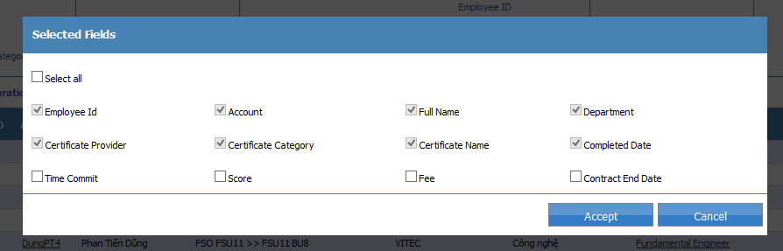
Figure 5.1.14.1: Selected Fields Account Certificate popup
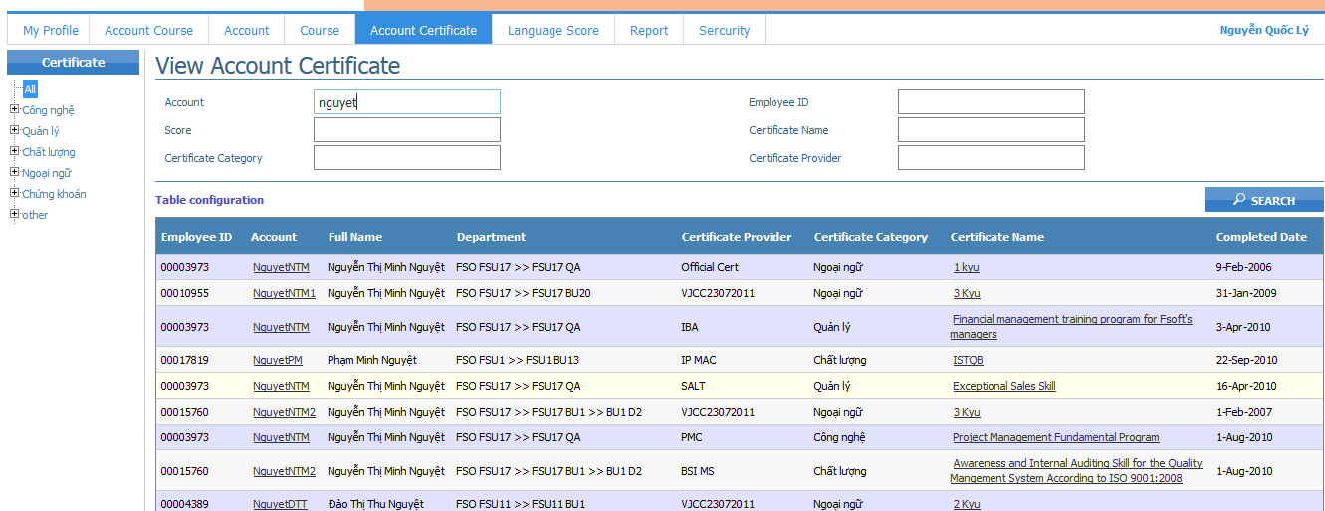
Figure 5.1.14.2: Search Account Certificate

Account Certificate Details
- Go to Account Certificate function
- Click on link Certificate Name in screen. Window will display Account Details Popup as Figure 5.2.7
- Click on link Language Name in screen. Window will display Language Score Details popup as Figure 5.1.15.1

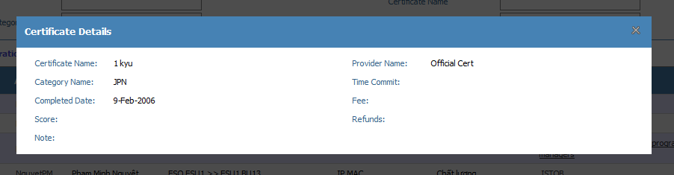
Figure 5.1.15.1: Account Certificate Details popup

Report
Brief Description: This function creates some statistical reports about training courses according to years, months, training course kind, etc. These reports will support the user to write reports, analyze and make decision. Currently, the Training Tool program includes a report with two displaying ways. A report is showed in Excel file and a report is show in Crystal Report.
Actors: all users
Basic Flow
- Open path http://10.16.56.27:81/ screen will display as the Figure 5.1.1
- Input valid username and password
- Click on OK button to access the website Training Tool.
- From the menu, choose Report. If User haven’t permission screen will display as figure 5.7.1:
- If User clicks button export windows will export to excel file.
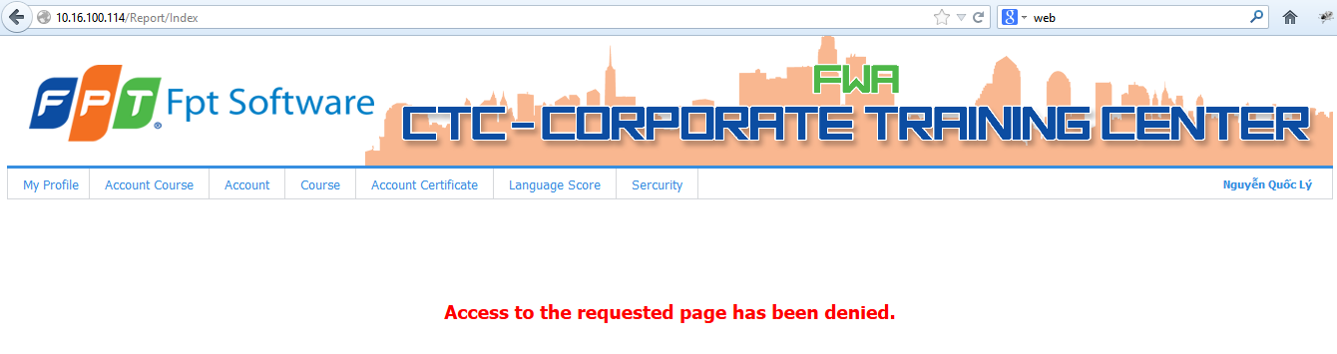
Figure 5.7.1: Report (User don’t have permission)
- If User have full permission screen will display all department as figure 5.7.2
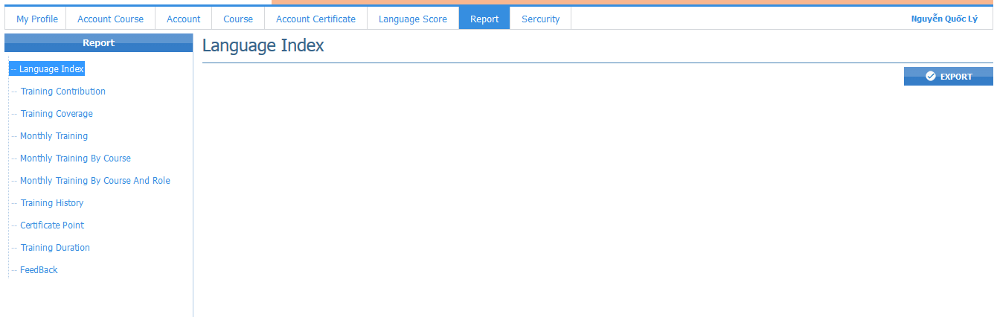
Figure 5.7.2: Report (User have permission)

Security
Brief Description: This function is used for admin manage user, allow who can have department, add role and assign role for account in FSOFT.
Actors: Admin
Basic Flow
- Open path http://10.16.56.27:81/ screen will display as the Figure 5.1.1
- Input valid username and password
- Click on OK button to access the website Training Tool.
- From the menu, choose Security. If User haven’t permission screen will display as figure 5.8.1:
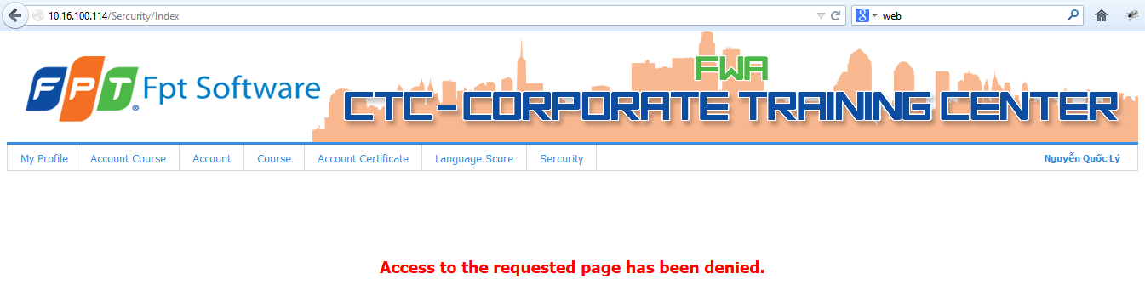
Figure 5.8.1: Security function (User haven’t permission)
- If User have full permission screen will display all department as figure 5.8.2
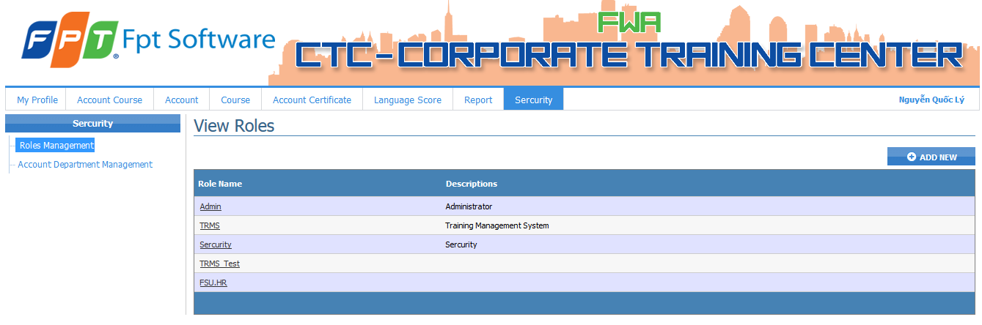
Figure 5.8.2: Security function (User haven’t permission)

Role Management
Brief Description: This function is used for admin manage Role and he can add new role to manage system and assign role for user.
Actors: Admin
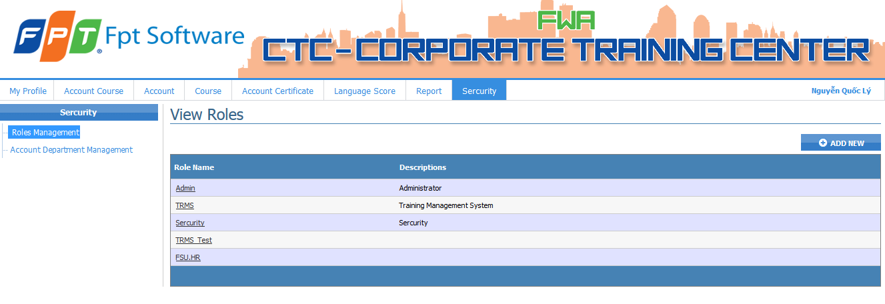
Figure 5.1.16.1: Roles Management function

Roles Management Details
Brief Description: This function is used to view Role.
Actors: Admin
Basic Flow
- Go to Security function.
- User click Role Name, screen display as figure 5.1.17.1
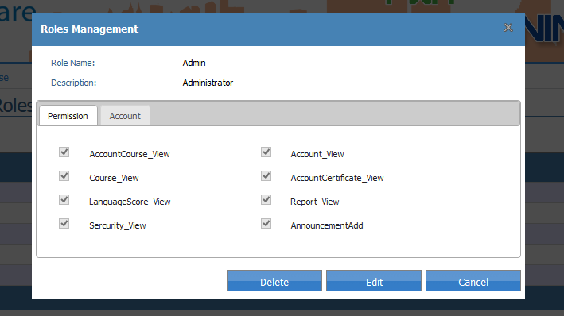
Figure 5.1.17.1: Roles Management Popup (Permission Tab)
At screen ‘Roles Management has Permission Tab, Account Tab for Admin can see details.
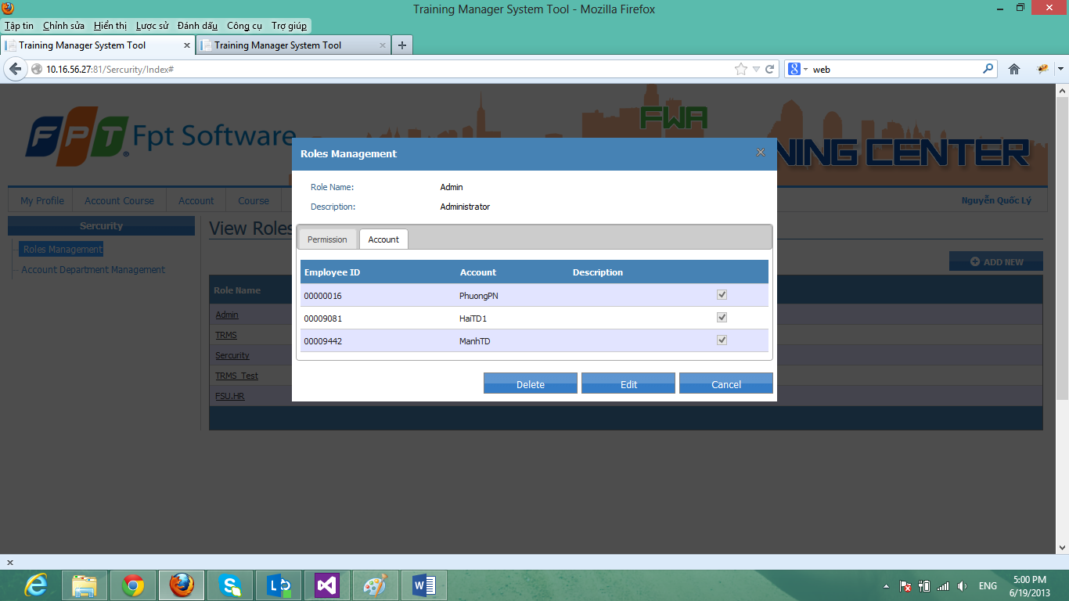
Figure 5.1.17.2: Roles Management Popup (Account Tab)

Edit Roles Management for Permission Tab
Brief Description: This function is used to edit Roles.
Actors: Admin
Basic Flow
- Go Roles Management details. User choose edit.
- Brower will display the View Edit Roles Management as Figure 5.1.18.1
- User choose tab Permission
- User Edit Role Name and Role Description to change and edit permission for role
- User click Save button for changing.
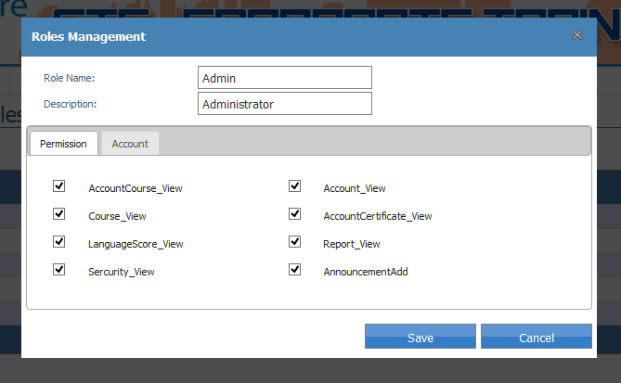
Figure 5.1.18.1: Edit Roles Management popup (Permission Tab)

Edit Roles Management for Account Tab
Brief Description: This function is used to edit Role Name and assign role for user.
Actors: Admin
Basic Flow
- Go Roles Management details. User choose edit.
- Brower will display the View Edit Roles Management as Figure 5.1.18.1
- User choose tab Account
- User Edit Role Name and Role Description to change and input Account and description to add this account for this role
- User click Save button for changing.
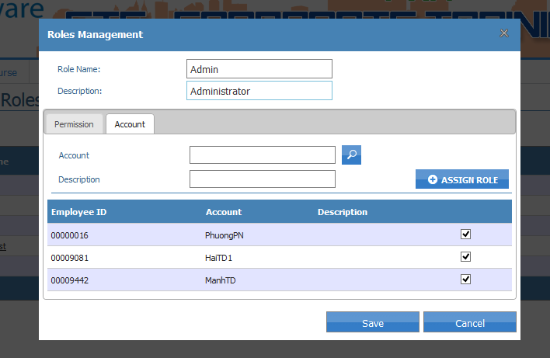
Figure 5.1.18.2: Account Certificate Details popup (Account Tab)

Add Roles Management
Brief Description: This function is used to add Role and assign role for user.
Actors: Admin
Basic Flow
- Go to screen Security and choose Add New.
- Brower will display the View Add Roles Management as Figure 5.1.20.1
- In Permission Tab User create role and choose permission for this roles and assign User for Roles.
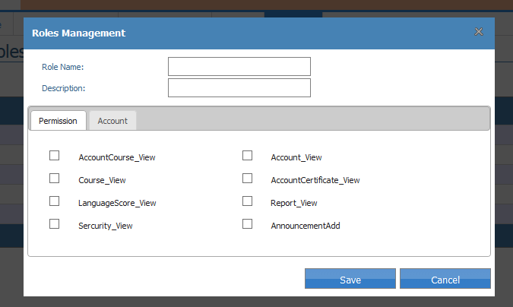
Figure 5.1.20.1: Add Roles Management popup

Delete Roles Management
Brief Description: This function is used to delete Roles.
Actors: Admin
Basic Flow
- Go to screen Roles Management Details user choose Delete button.
- Brower will display Popup as Figure 5.1.21.1
- User click Ok to delete this account
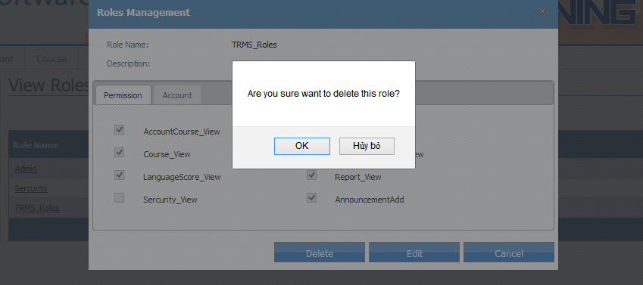
Figure 5.1.20.1: Delete Roles Management popup

Account Department Management Account Department Management
Brief Description: This function is used for admin manage Account of department and add department for user.
Actors: Admin
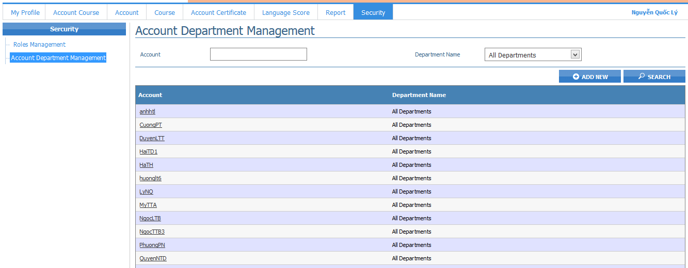
Figure 5.1.21.1: Account Department Management function

Account Department Management Details
Brief Description: This function is used to view Account Department.
Actors: Admin
Basic Flow
- Go to Security function.
- User click Account, screen display as figure 5.1.22.1
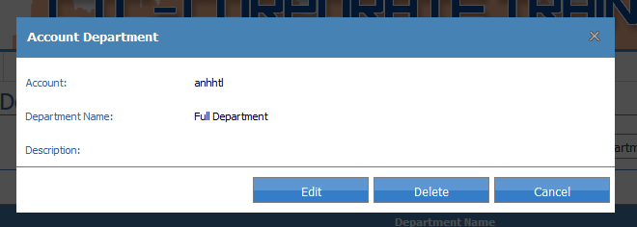
Figure 5.1.22.1: Account Department Management Details Popup

Edit Account Department
Brief Description: This function is used to edit Account Department Management.
Actors: Admin
Basic Flow
- Go Account Department Management details. User choose edit.
- Brower will display the View Edit Account Department Management as Figure 5.1.23.1
- User choose Department Name and Department Description
- User click Save button for changing.
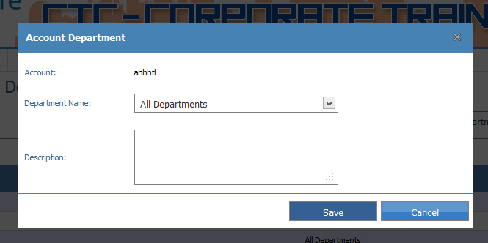
Figure 5.1.23.1: Edit Account Department Management popup.

Search Account Department Management
Brief Description: This function is used to search user have department.
Actors: Admin
Basic Flow
- Go Account Department Management details.
- User input account and select Department Name.
- User choose Search button and screen displays as Figure 5.1.18.1
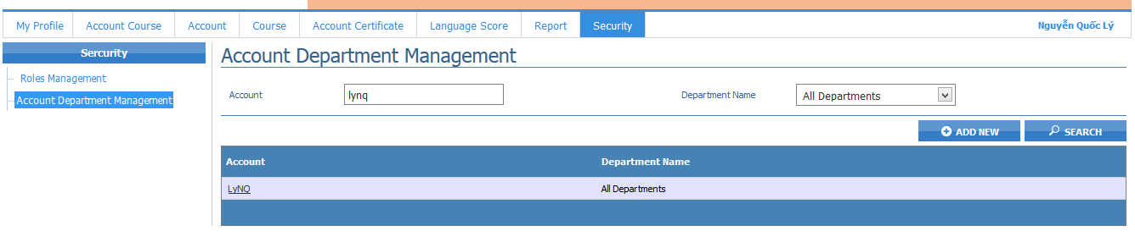
Figure 5.1.24.1: Search Account Certificate Details popup

Add Account Department Management
Brief Description: This function is used to assign the selected user (FSU Lead, BU Lead, GA…) as a department’s manager.
Actors: Admin
Basic Flow
- Go to screen Account Department Management function user choose Add New.
- Brower will display the View Add Roles Management as Figure 5.1.25.1
- In Permission Tab User create role and choose permission for this roles and assign User for Roles.
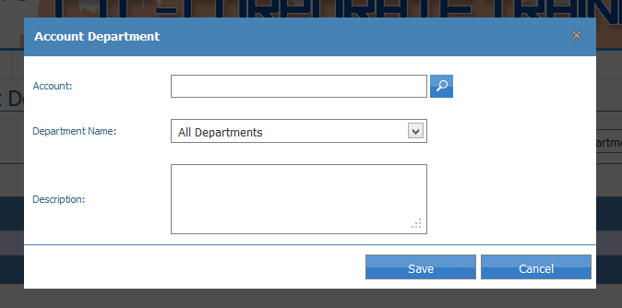
Figure 5.1.20.1: Add Account Department Management popup

Delete Account Department Management
Brief Description: This function is used to delete user don’t have department.
Actors: Admin
Basic Flow
- Go to screen Account Department Management Details user choose Delete button.
- Brower will display Popup as Figure 5.1.26.1
- User click Ok to delete this account
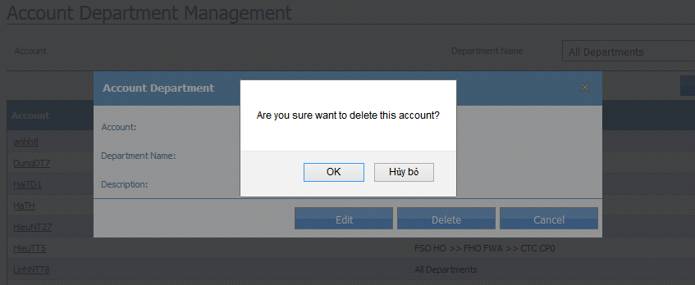
Figure 5.1.20.1: Delete Account Department Management popup

Appendix
List here all relevant references like error codes, functional code tables, FAQ (Frequently-asked-questions) or trouble-shooting guide...

