ML Model Hyperparameters

1. Linear Regression
Linear Regression is a fundamental supervised learning algorithm used to model the relationship between a dependent variable and one or more independent variables. It predicts continuous values by fitting a straight line that best represents the data.
Hyperparameters
- Learning Rate (for gradient descent): Controls how big each step is when the model updates itself. Too high = it overshoots. Too low = it learns very slowly.

- Regularization type (L1 / L2): L1 (Lasso) can shrink some weights to zero, removing useless features. L2 (Ridge) keeps all features but shrinks their weights.

- Alpha (regularization strength): How strongly regularization is applied. Higher alpha = simpler model, less risk of overfitting.

- fit_intercept: Whether to include a bias term. Almost always True. Set to False only if your data is already centered at zero.

- max_iter: Maximum number of passes through the data. Increase if the model has not converged.

Chart: Learning Rate Effect
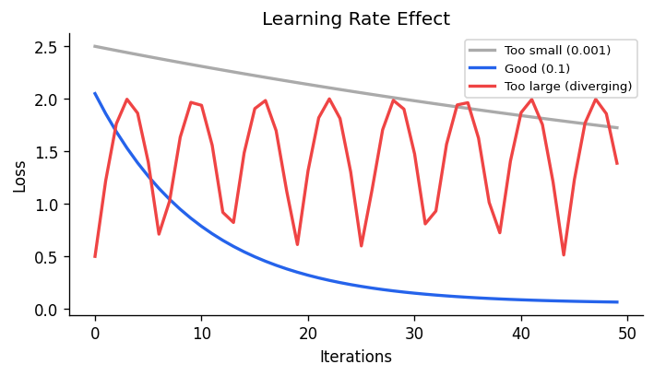

2. Decision Tree
A decision tree is a supervised learning algorithm used for both classification and regression tasks. It has a hierarchical tree structure which consists of a root node, branches, internal nodes and leaf nodes. It works like a flowchart that helps in making step by step decision, where:
- Internal nodes represent attribute tests
- Branches represent attribute values
- Leaf nodes represent final decisions or predictions.

Hyperparameters
- max_depth: How many levels deep the tree can grow. A deeper tree learns more detail but risks memorizing the training data (overfitting).

- min_samples_split: Minimum number of samples needed to split a node. Higher values prevent the tree from making splits on very small groups.

- min_samples_leaf: Minimum number of samples that must be at a leaf node. Acts as a smoothing mechanism.

- max_features: How many features to consider at each split. Reducing this adds some randomness and can improve generalization.

- criterion: The function used to measure split quality. "gini" (default) and "entropy" both work similarly; gini is faster.

3. K-Nearest Neighbors (KNN)

K-Nearest Neighbor (KNN) is a simple and widely used machine learning technique for classification and regression tasks. It works by identifying the K closest data points to a given input and making predictions based on the majority class or average value of those neighbors.
- Classifies data based on similarity with nearby data points.

- Uses distance metrics like Euclidean distance to find nearest neighbors.

- Since KNN makes no assumptions about the underlying data distribution, it makes it a non-parametric and instance-based learning method.

Hyperparameters
- K (n_neighbors): How many nearest neighbors to look at. Small K = more sensitive to noise. Large K = smoother but may miss local patterns.

- metric: How distance is measured. "euclidean" (straight-line) is common. "manhattan" works better for some data types.

- weights: "uniform" means all neighbors vote equally. "distance" means closer neighbors have more influence.

- algorithm: How to find neighbors internally: "ball_tree", "kd_tree", or "brute". "auto" picks the best one for your data size.

- leaf_size: Only relevant for ball_tree and kd_tree. Affects speed of building and querying the tree.

4. Support Vector Machine (SVM)
Support Vector Machine (SVM) is a supervised machine learning algorithm used for classification and regression tasks. It tries to find the best boundary known as hyperplane that separates different classes in the data. It is useful when you want to do binary classification like spam vs. not spam or cat vs. dog.
The main goal of SVM is to maximize the margin between the two classes. The larger the margin the better the model performs on new and unseen data.

Hyperparameters
- C (regularization): Controls the trade-off between a smooth boundary and correctly classifying all training points. Low C = smooth, tolerates errors. High C = tries to classify everything correctly, may overfit.

- kernel: Transforms data into a higher dimension to find a boundary. "linear" for simple cases. "rbf" (radial basis function)(Gaussian) is the most common for non-linear data.

- gamma: Only for "rbf" and similar kernels. Controls how far the influence of a single training point reaches. High gamma = very local influence (overfitting risk).

- degree: Only for "poly" kernel. The degree of the polynomial. Rarely needed unless you know your data has polynomial relationships.

- class_weight: Set to "balanced" if your dataset is imbalanced. It gives more importance to minority classes.

Chart: C Parameter Effect
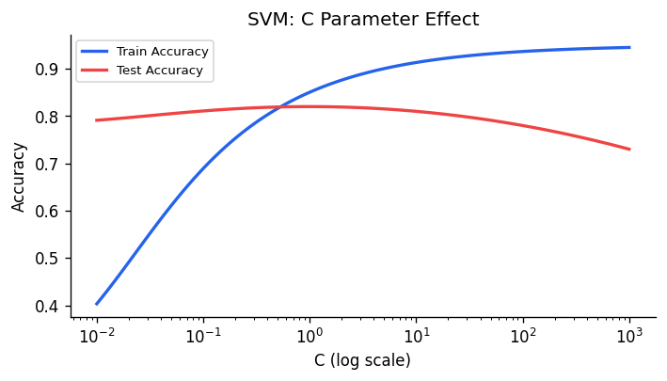

5. Random Forest
Random Forest is an ensemble machine learning algorithm that builds multiple decision trees and combines their predictions to improve accuracy and reduce overfitting. In Scikit-learn, the Random Forest Classifier is widely used for classification tasks because it handles large datasets and handles nonlinear relationships well.
Hyperparameters
- n_estimators: Number of trees in the forest. More trees = more stable results. Usually 100-500 is enough; beyond that, returns diminish.

- max_depth: Same as in Decision Tree. Controls how deep each individual tree can grow.

- max_features: Number of features each tree considers per split. "sqrt" (square root of total features) is the default and works well for classification.

- min_samples_split / min_samples_leaf: Controls minimum size of nodes, same concept as Decision Tree. Helps prevent overfitting.

- bootstrap: Whether each tree trains on a random sample with replacement. True by default. Turning it off makes trees more correlated with each other.

- oob_score: If True, uses out-of-bag samples (not used in training) to estimate accuracy. Free validation without a separate test set.

6. Neural Network (MLP)Multilayer Perceptron
A model made of layers of connected neurons. Each layer learns to detect increasingly abstract patterns. It can learn almost any relationship in data but requires more data and careful tuning than simpler models.

Hyperparameters
- Learning Rate: How fast the model updates its weights during training. One of the most important hyperparameters. Start with 0.001 and adjust based on training behavior.

- Epochs: How many times the model passes through the entire dataset. Too few = underfitting. Too many = overfitting (use early stopping to prevent this).

- Batch Size: How many samples the model sees before updating weights. Small batch = noisy updates but can escape local minima. Large batch = stable but may overfit.

- Number of Layers (depth): More layers allow the model to learn more complex patterns. But too many layers make training harder (vanishing gradients).

- Neurons per Layer (width): More neurons = more capacity to learn. Start moderate and increase if the model is underfitting.

- Dropout Rate: Randomly turns off some neurons during training to prevent overfitting. Common values are 0.2 to 0.5.

- Activation Function: "ReLU" is the standard choice for hidden layers. "Sigmoid" or "Softmax" are used in output layers for classification.

- Optimizer: "Adam" is the most popular — it adapts the learning rate automatically. "SGD" is simpler but needs more tuning.

- Weight Decay (L2 penalty): Adds a penalty for large weights, similar to Ridge regression. Helps prevent overfitting.

