**USER MANUAL**

**Introduction:**

This program will allow the user to view their coffee order/ orders. It will be displayed in a text file once they entered in all their options.

**How to get started:**

Start the program by clicking IDLE Icon, and open the Huckins_Tracey_Final_Project.py file.

**Main program:**

Open the main file Huckins_Tracey_Final_Project.py. Once you run the main program you will be prompted with a series of questions to answer about your coffee order. There are options that tell you if you are going to be inputting a number from the menu or if you are going to be typing out the data directly. Please refer to the image below.

**Coffee order choices:**

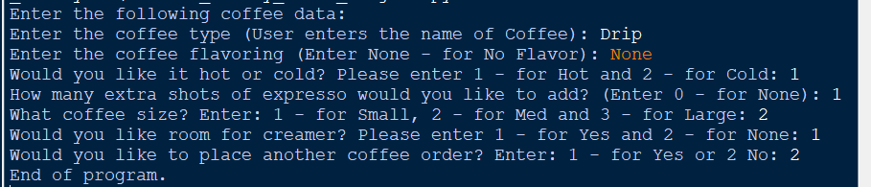

Once you close the program there will be a coffee.txt file that displays your order. Please refer to the image below to see what your coffee order will look like.

**Coffee.txt file:**

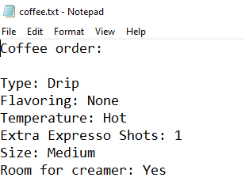

Once you are done with the file just close the python file and program.