1. **Given the provided data, what are three conclusions we can draw about Kickstarter campaigns?**
   1. Significant growth in the overall number of projects occurred in spring/summer 2014

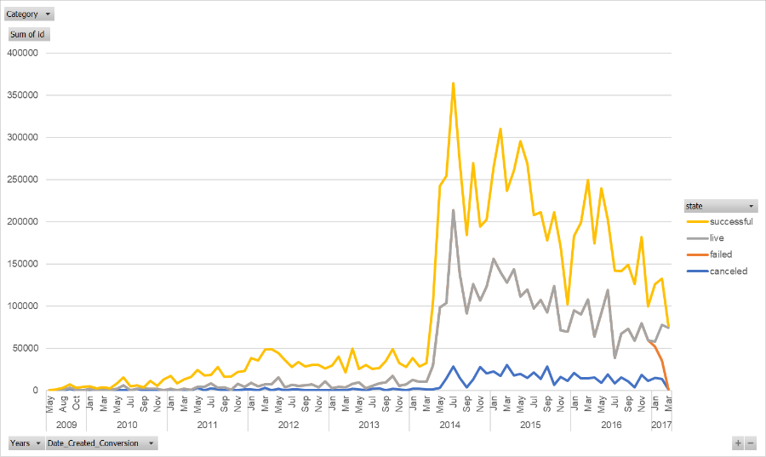

* 1. While several categories showed growth, ‘theater’ was the considerable majority of projects beginning in the same time period.

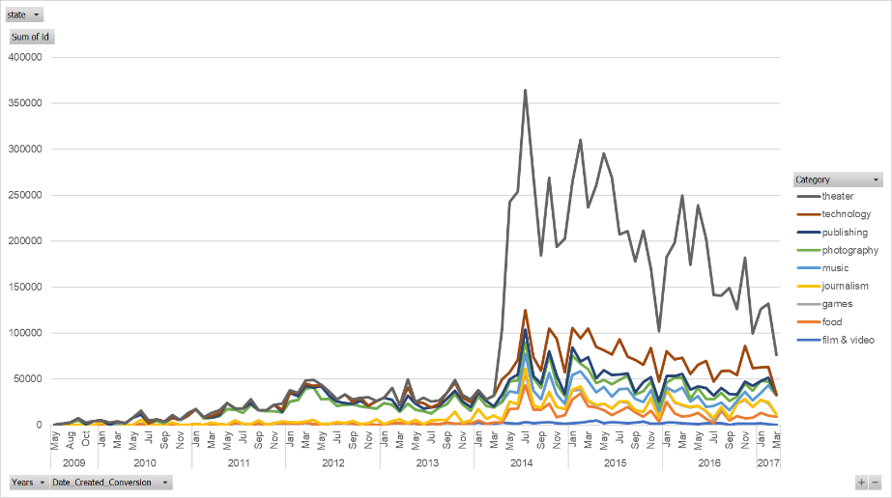

* 1. Both Theater and Technology projects are generally relatively well-funded. 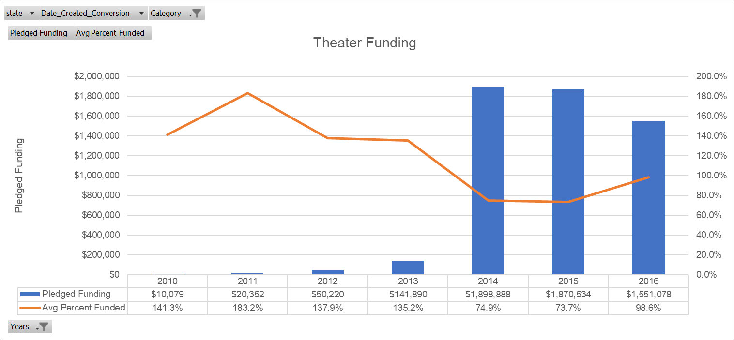

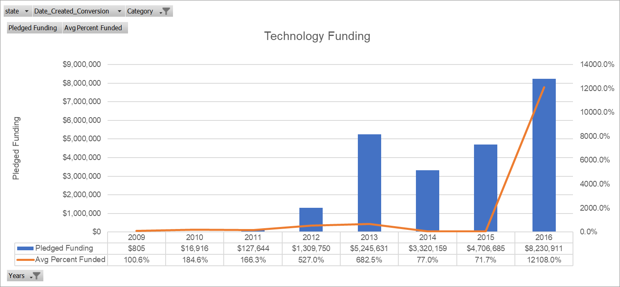

1. **What are some limitations of this dataset?**

* Dataset for 2017 is not complete, no information is available beyond mid-March 2017
* Extreme variability in funding

1. **What are some other possible tables and/or graphs that we could relate?**

