Decentralized RAG: Combining Retrieval Augmented Generation with Blockchains

Reed White (12367576)

# User Manual

Users for this system can be broken down into two categories: corpus administrators and end users. Corpus administrators are those administrative users, internal to their organization/company, that maintain their organization’s corpus. End users are those external users, generally customers of the organization/company, that interact with the public-facing chatbot/RAG system. The interactions of each user with this system differ greatly.

## Administrators

Corpus administrators primarily interact with the Corpus Administrator Frontend:

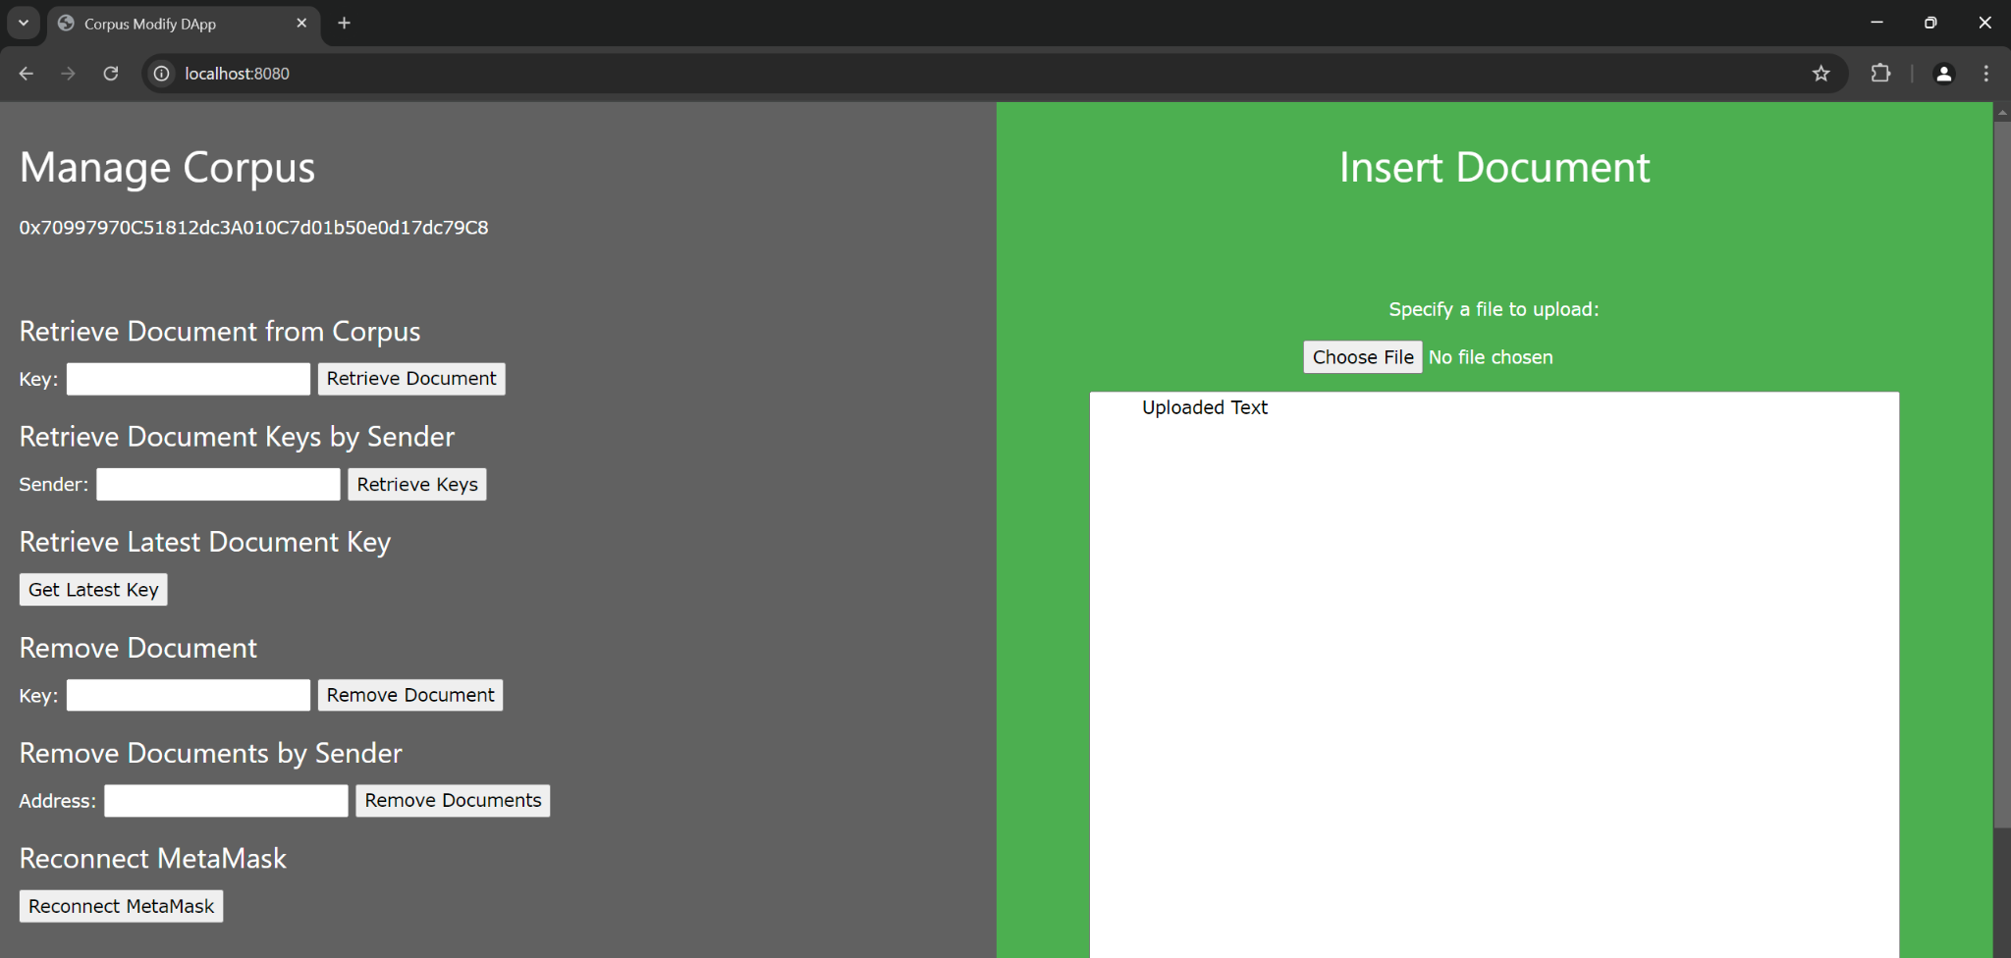

FIGURE I. Corpus Administrator Frontend

This frontend is installed on an internal web server by system administrators. The URL to this frontend will need to be documented and provided to corpus administrators by system administrators.

### MetaMask

Interaction with the Corpus Administrator Frontend requires the MetaMask browser extension and a valid blockchain account. MetaMask requires Google Chrome or another comparable browser and can be installed from:

<https://metamask.io/download/>

Once installed, a new account can be created by performing the following:

1. Open the MetaMask extension widget in the browser where it was installed.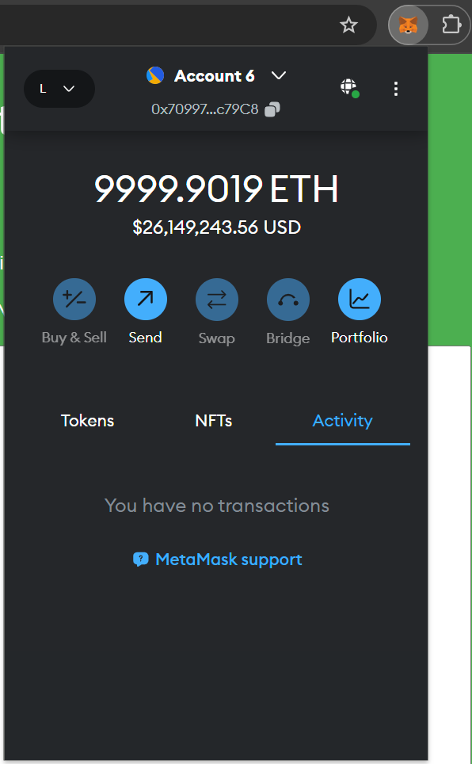
2. Click the Networks dropdown in the top-left corner of the widget and then “Add network”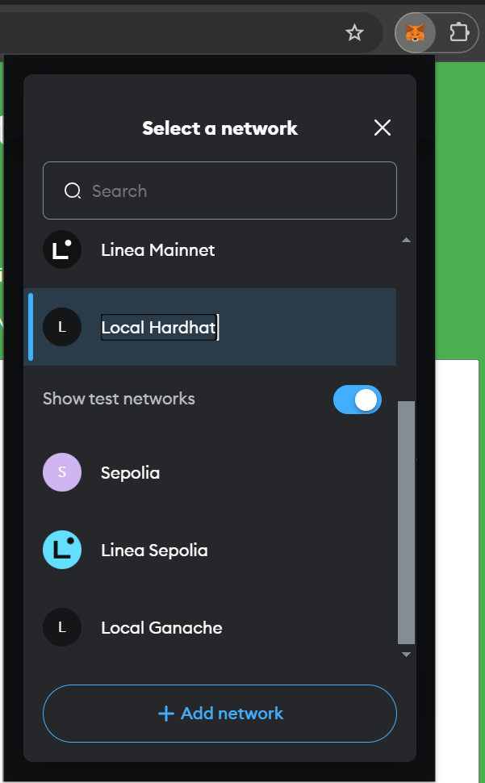
3. In the new MetaMask settings tab that opens, click “Add a network manually” at the bottom  
   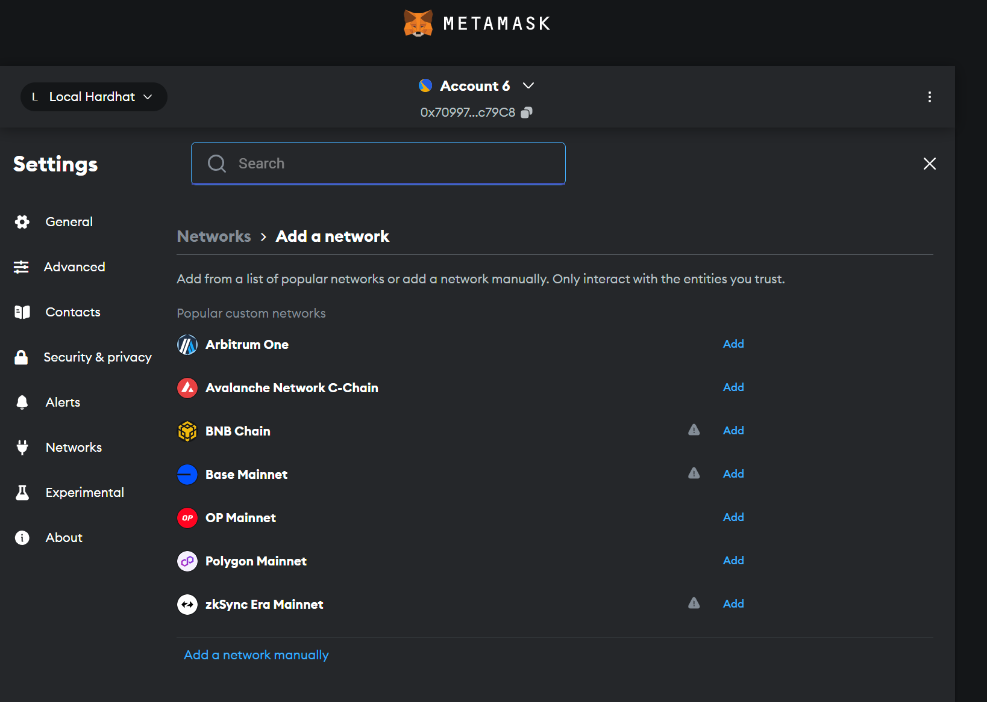
4. In the “Add a network manually” window, enter the following details:
   1. Network name: Enter any meaningful name, such as “Company Blockchain”
   2. New RPC URL: enter the URL of the blockchain, which can be obtained from the organization’s blockchain administrators (the team that deployed the blockchain)
   3. Chain ID: enter the blockchain’s ID, which must be retrieved as above
   4. Currency symbol: Usually “ETH”, but should be retrieved as above  
      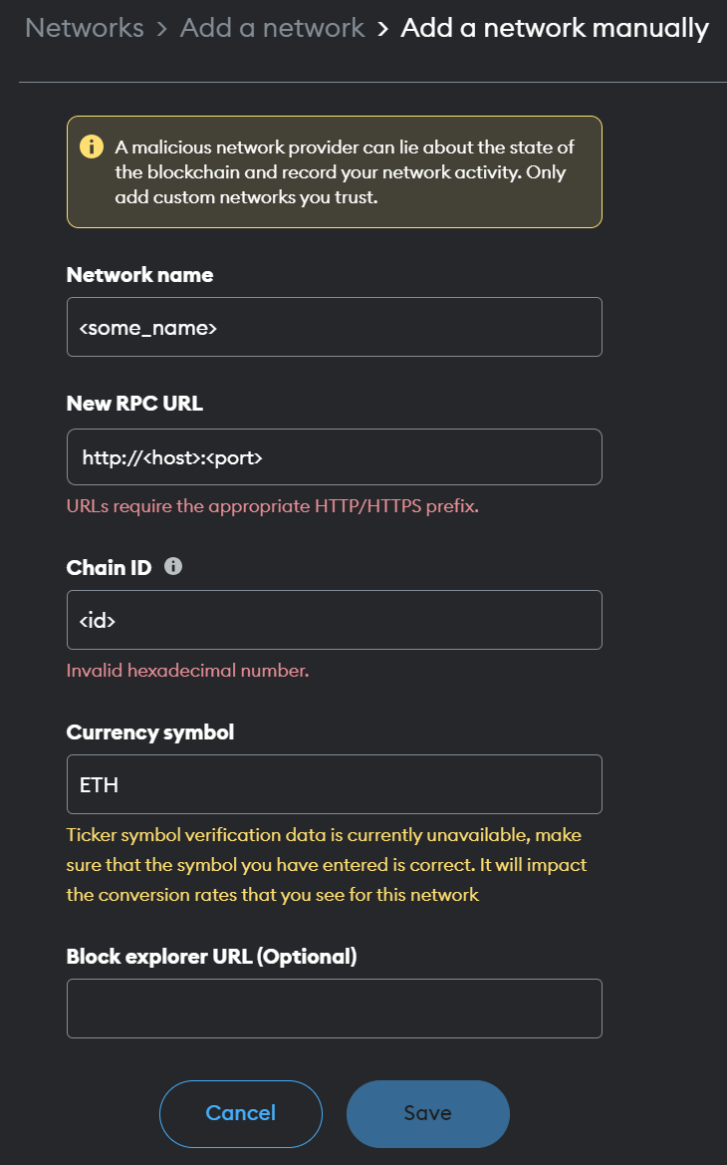
5. Click: Save
6. Once the network has been added without any errors, click the Accounts dropdown at the top of the settings page and then “Add account or hardware wallet”  
   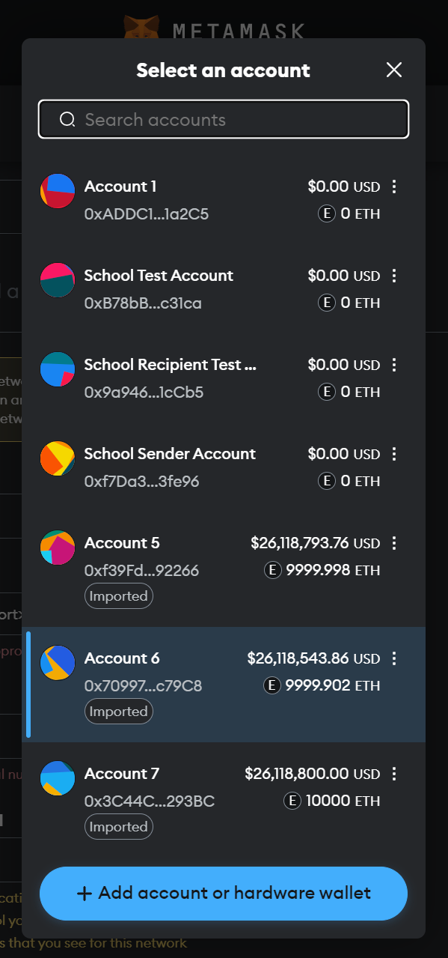
7. In the “Add account” widget, click “Add a new Ethereum account”  
   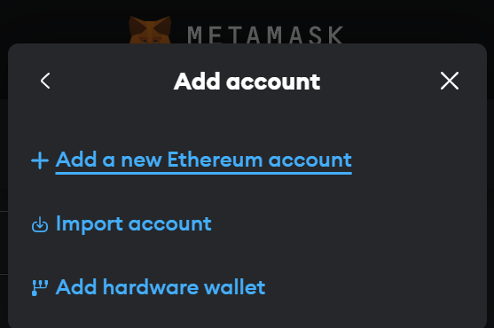
8. In the next screen of “Add account”, enter some meaningful account name and click “Add account  
   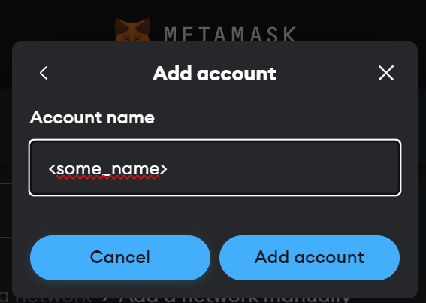
9. MetaMask should connect to the newly-added network and generate a new account address and personal private team. If any issues are encountered, please contact the organization’s blockchain administrators.

### Retrieving Documents from the Corpus

Documents can be retrieved from the corpus stored in the blockchain via a single method:

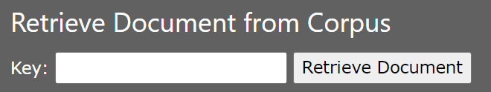

FIGURE II. Retrieve Document from Corpus

#### Retrieve Documents from Corpus

All documents in the corpus are given a unique, numeric key ID when uploaded into the blockchain. When given a valid key, this form will display the associated document in the textarea on the right-hand side.

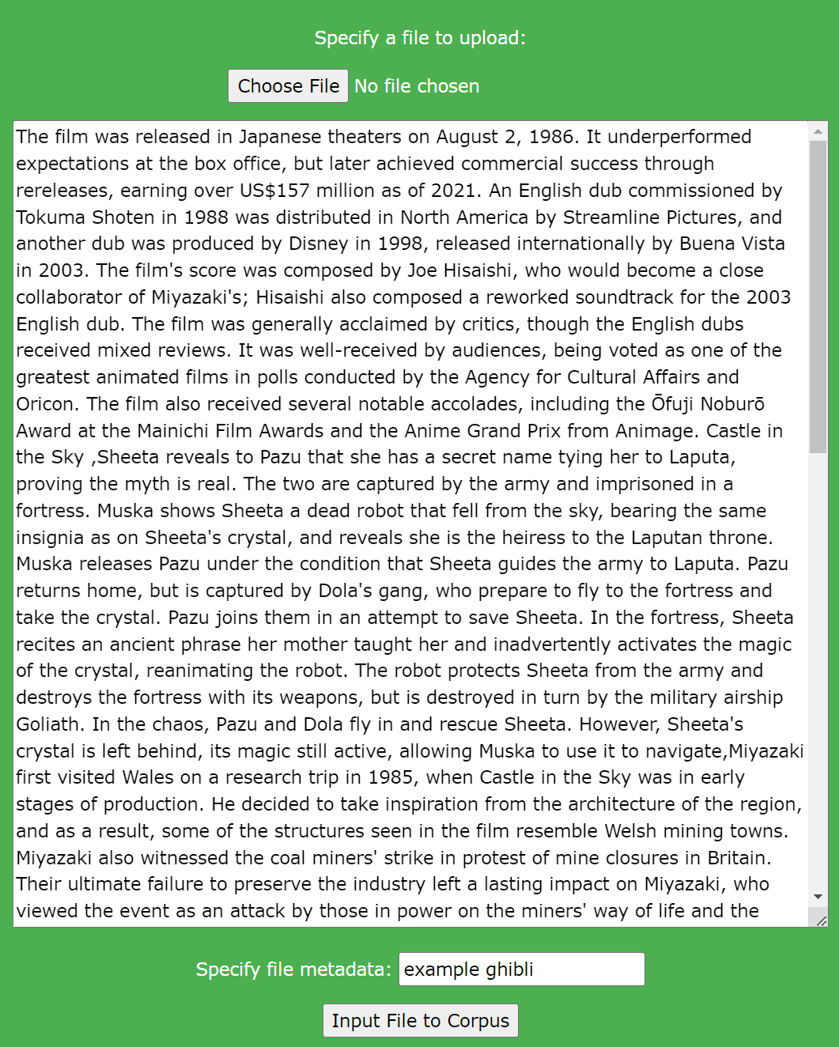

FIGURE III. Document Retrieval Example

### 

### Retrieving Document Keys

Keys for documents stored in the corpus in the blockchain can be retrieved via two methods:

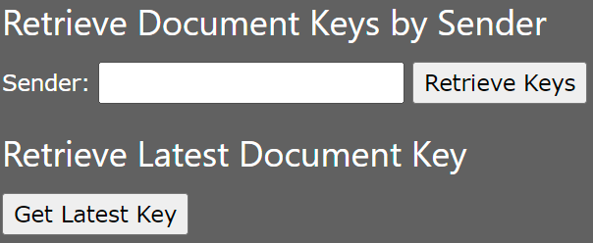

FIGURE IV. Retrieve Keys from Corpus

#### Retrieve Document Keys by Sender

When given a blockchain account address (in the form of 0x<account>), this form will search the corpus for any documents submitted by that account and return the related document keys.

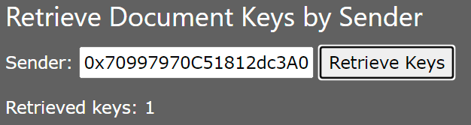

FIGURE V. Retrieve Keys by Sender

#### Retrieve Latest Document Key

When this button is clicked, the form will return the latest document key stored in the corpus.

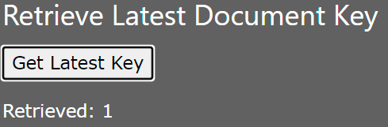

FIGURE VI. Retrieve Latest Key

**The following methods all require MetaMask confirmation and a valid amount of the blockchain’s token.**

### Removing Document from the Corpus

Documents can be removed from the corpus stored in the blockchain using two methods:

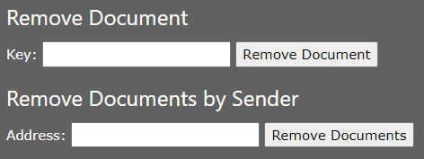

FIGURE VII. Remove Documents from Corpus

#### Remove Document

When given a key for a document stored in the corpus, this form will remove that document from the corpus.

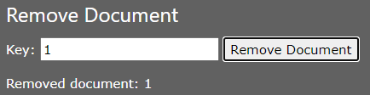  
FIGURE VIII. Remove Document from Corpus via Key

#### Remove Document by Sender

When given a blockchain account address (in the form of 0x<account>), this form will search the corpus for any documents submitted by that account and remove them.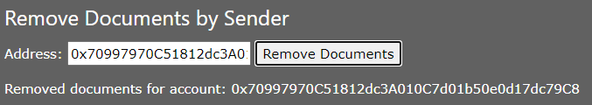

FIGURE IX. Remove Document from Corpus via Key

### 

### Inserting Documents into the Corpus

Documents can be inserted into the corpus in the blockchain using the following method:

#### Input File to Corpus

When a file is selected using the “Choose File” button, this form will take the selected file and the given metadata and insert it into the corpus. Please note that this method requires MetaMask confirmation, as shown above.

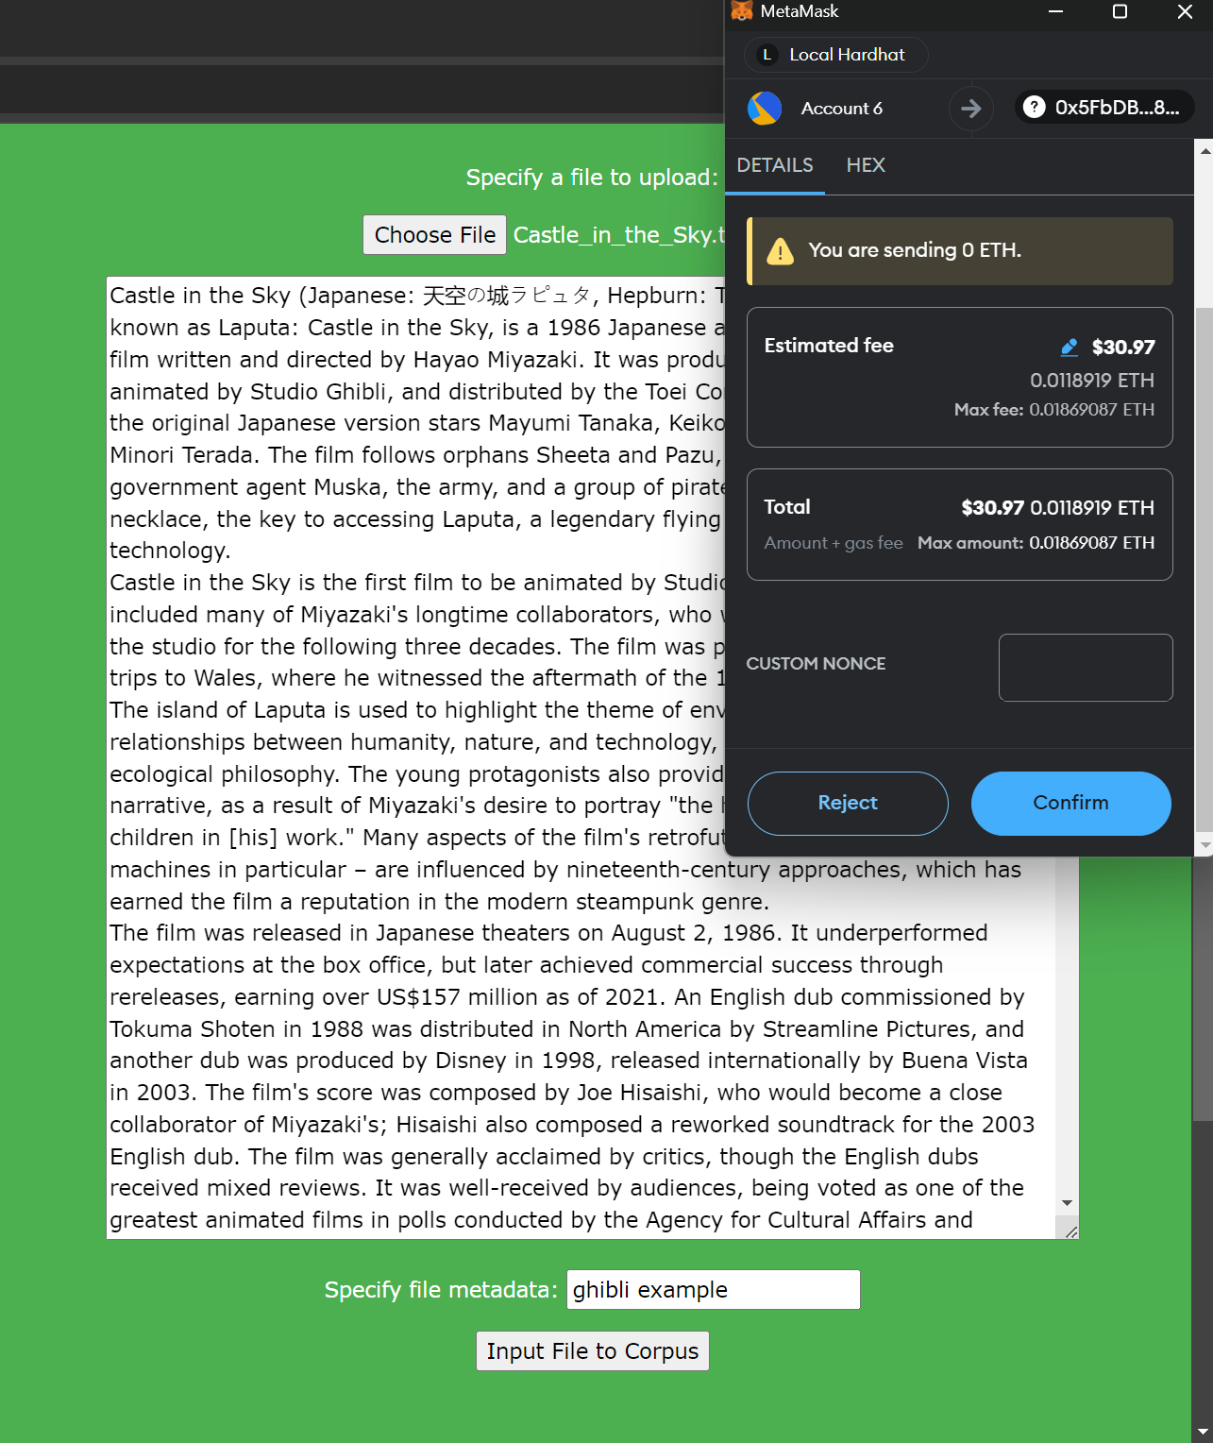

FIGURE X. Input File into Corpus

**Please note:** documents should have unique and specific names. If a document with an existing name is uploaded via this frontend, it may overwrite the existing document with the same name. This depends on which version of this system the system administrators have installed: if the estimated fee is less than roughly $2, then the existing document will be overwritten. If it is not, both documents will be uploaded.

### Reconnecting MetaMask

In the event that the MetaMask connection is lost or modified, the following method can be used to reconnect it:

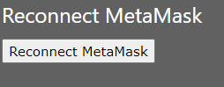

FIGURE XI. Reconnecting MetaMask

## 

## End Users

End user interactions with the system are extremely simple. They interact with the RAG chatbot frontend:

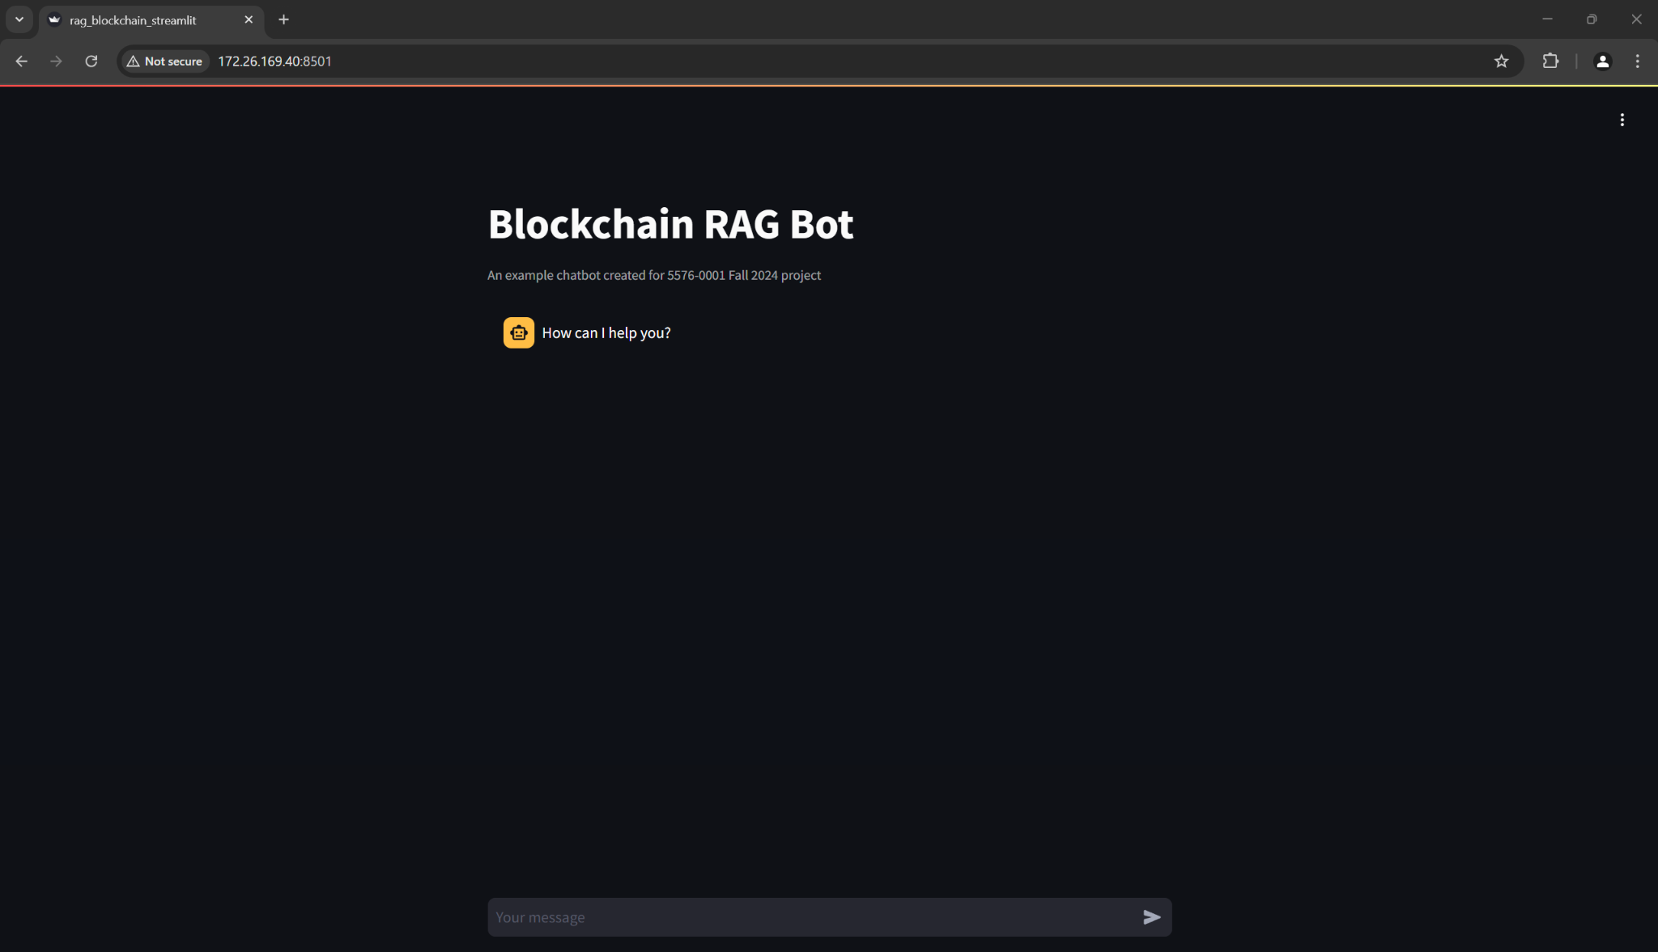

FIGURE XII. RAG Chatbot Frontend

Users access this frontend via their browsers. The URL will need to be exposed to end users by system administrators. The URL will need to be documented and provided to end users. Authentication is not enabled by default but may be implemented by system administrators. There are no other additional requirements for end users (no MetaMask, no blockchain access, etc.). Once users access this chatbot, they should interact with it as they would with any other chatbot (asking it questions, asking for advice, asking for documentation, etc.).