Decentralized RAG: Combining Retrieval Augmented Generation with Blockchains

Reed White (12367576)

# User Manual

Users for this system can be broken down into two categories: administrators and end users. Administrators are those administrative users, internal to their organization/company, that maintain their organization’s corpus. End users are those external users, generally customers of the organization/company, that interact with the public-facing chatbot/RAG system. The interactions of each user with this system differ greatly.

## Administrators

Administrators primarily interact with the Corpus Administrator Frontend:

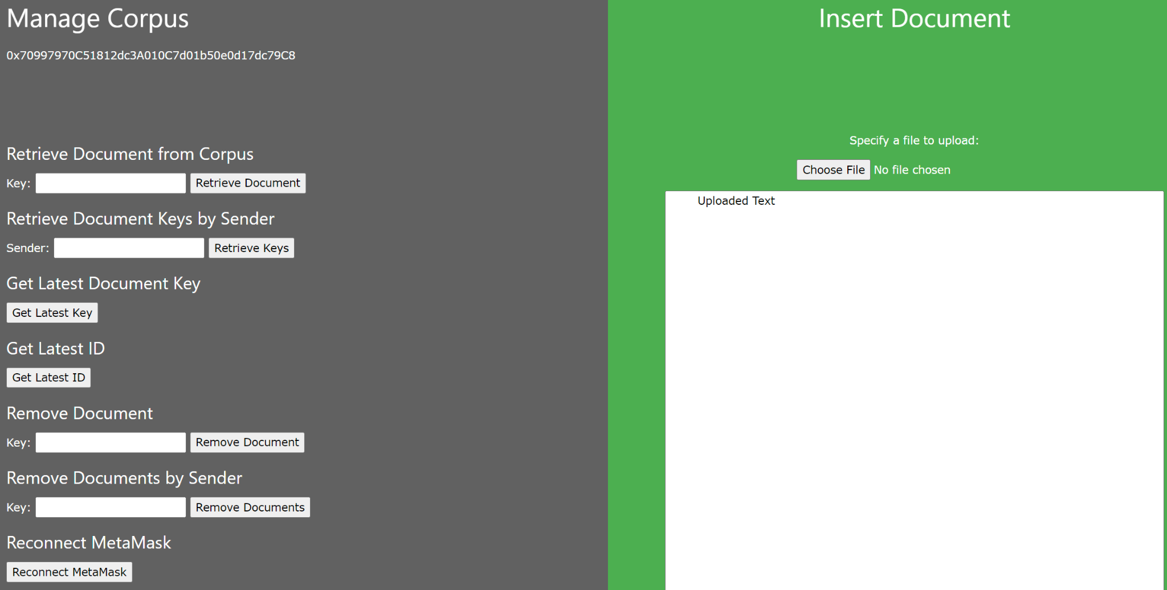

FIGURE I. Corpus Administrator Frontend

### MetaMask

Interaction with the Corpus Administrator Frontend requires the MetaMask browser extension and a valid blockchain account. MetaMask requires Google Chrome or another comparable browser and can be installed from:

<https://metamask.io/download/>

Once installed, a new account can be created by performing the following:

1. Open the MetaMask extension widget in the browser where it was installed.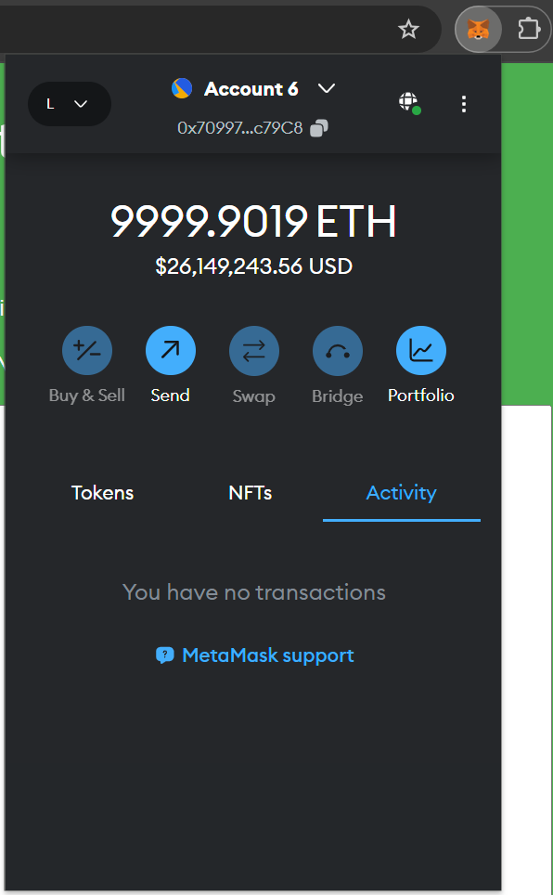
2. Click the Networks dropdown in the top-left corner of the widget and then “Add network”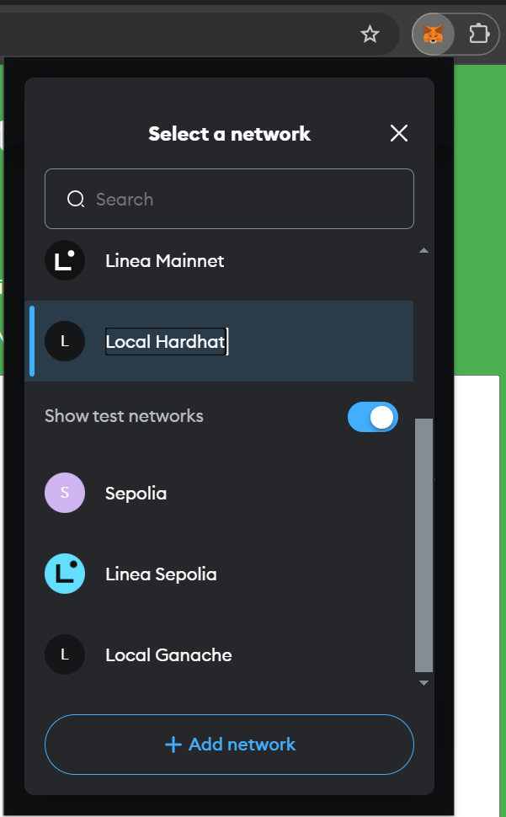
3. In the new MetaMask settings tab that opens, click “Add a network manually” at the bottom  
   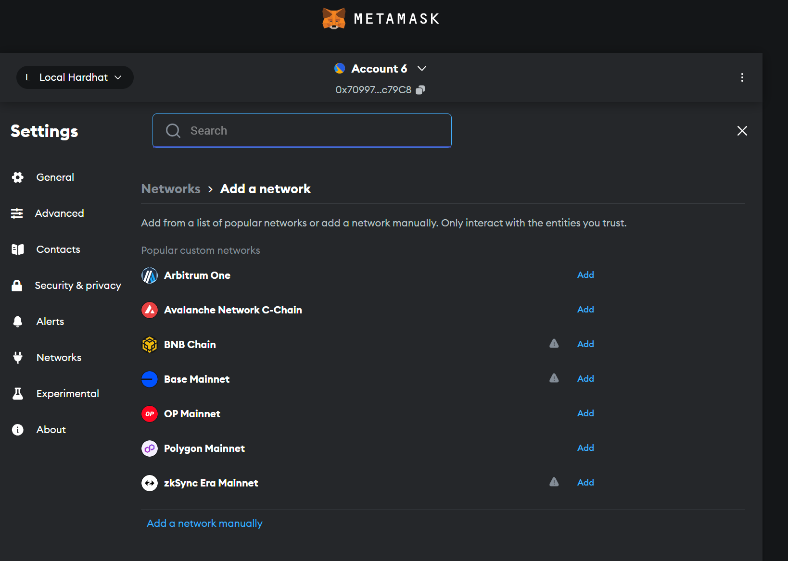
4. In the “Add a network manually” window, enter the following details:
   1. Network name: Enter any meaningful name, such as “Company Blockchain”
   2. New RPC URL: enter the URL of the blockchain, which can be obtained from the organization’s blockchain administrators (the team that deployed the blockchain)
   3. Chain ID: enter the blockchain’s ID, which must be retrieved as above
   4. Currency symbol: Usually “ETH”, but should be retrieved as above  
      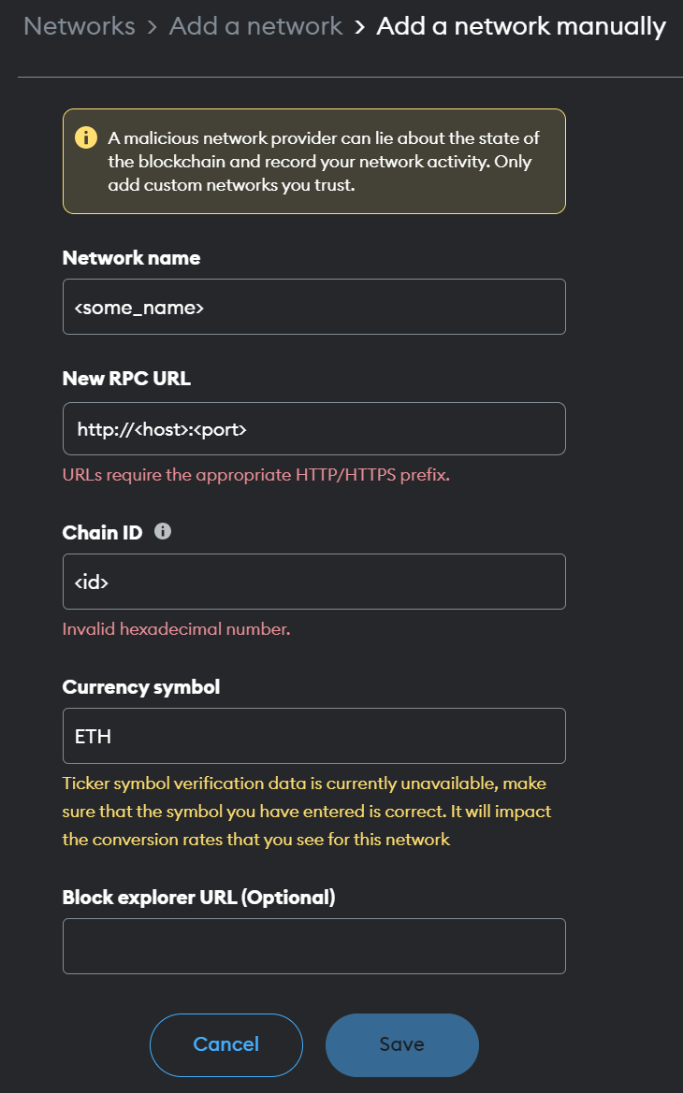
5. Click: Save
6. Once the network has been added without any errors, click the Accounts dropdown at the top of the settings page and then “Add account or hardware wallet”  
   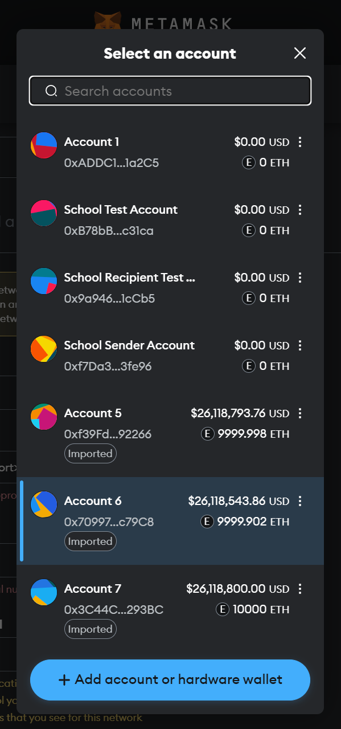
7. In the “Add account” widget, click “Add a new Ethereum account”  
   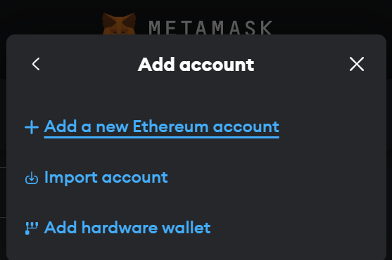
8. In the next screen of “Add account”, enter some meaningful account name and click “Add account  
   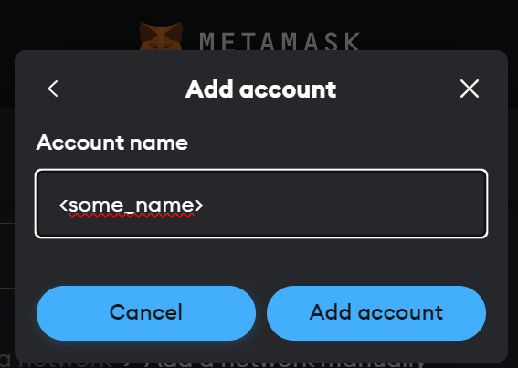
9. MetaMask should connect to the newly-added network and generate a new account address and personal private team. If any issues are encountered, please contact the organization’s blockchain administrators.

### Retrieving Documents from the Corpus

Documents can be retrieved from the corpus stored in the blockchain via a single method:

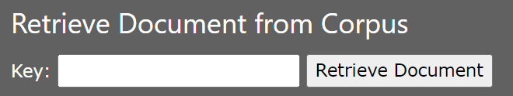

FIGURE II. Retrieve Document from Corpus

#### Retrieve Documents from Corpus

All documents in the corpus are given a unique, numeric key ID when uploaded into the blockchain. When given a valid key, this form will display the associated document in the textarea on the right-hand side.

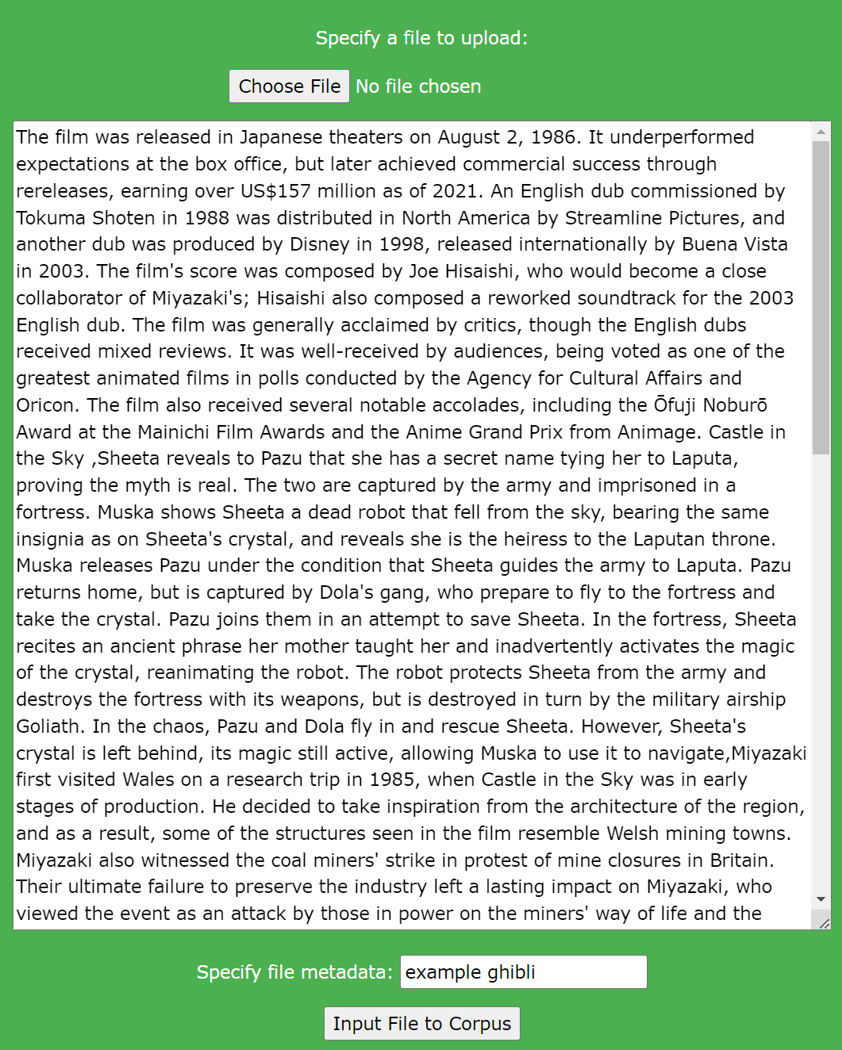

FIGURE III. Document Retrieval Example

### Retrieving Document Keys

Keys for documents stored in the corpus in the blockchain can be retrieved via two methods:

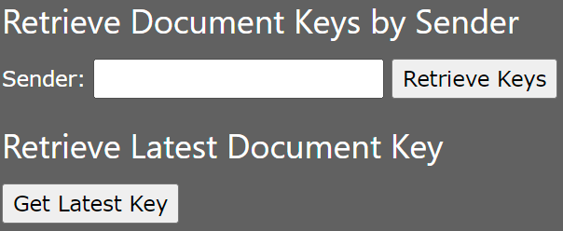

FIGURE IV. Retrieve Keys from Corpus

#### Retrieve Document Keys by Sender

When given a blockchain account address (in the form of 0x<account>), this form will search the corpus for any documents submitted by that account and return the related document keys.

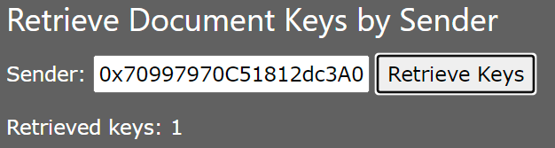

FIGURE V. Retrieve Keys by Sender

#### Retrieve Latest Document Key

When this button is clicked, the form will return the latest document key stored in the corpus.

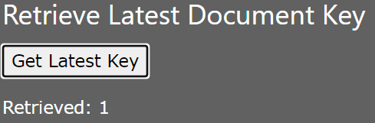

FIGURE VI. Retrieve Latest Key

### Removing Document from the Corpus

### Inserting Documents into the Corpus

